**How to Download Grail Indicator No Repaint**

**The Grail Indicator No Repaint**  
  
The process of pattern recognition is what allows artificial neural networks to predict future business patterns in the short and long term. This Forex grail Indicators specifically research data and read subtle relationships inside and between data points to generate entry-arrows on the MT4 platform.  
  
They detect repeating trends in global market data and use this knowledge to generate highly accurate predictive buy-sell signals. The indicator's custom filters are one of its distinguishing features. These filter options help traders decide whether they want their signals to be reversals, trend tracking, or a mix of both. Thus, the Neural Network Indicators have a framework that employs machine learning algorithms to predict potential Forex movements.

[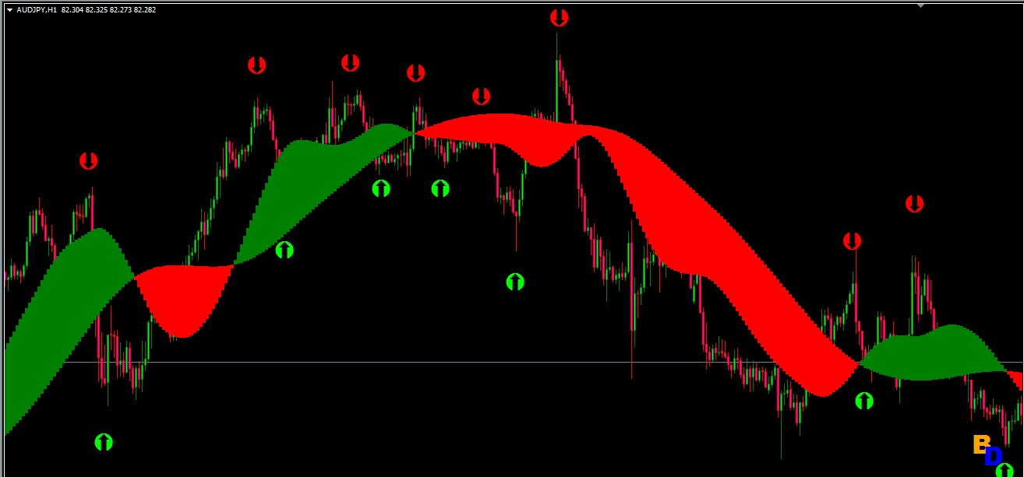](https://forum.mt5.com/attachment.php?attachmentid=357115&d=1617512997)

The Grail Indicator Neural Network does not repaint itself. The arrows you get are permanent, and they stay set on the charts even if you change time frames or close and restart Mt4. You can rely on the arrows to stay on the map while you conduct your technical analysis to enter a trade.  
  
Grail indicators are dedicated to assisting traders in identifying what is likely the most difficult skill in trading, namely, upcoming trend reversals, either before they occur or just as they begin. When loaded onto the maps, the difference is immediately apparent. The indicator's first edition incorporates Harmonic patterns, volume spread analysis, and divergences, and it only shows arrows after receiving live ticks from the markets. The second edition, on the other hand, is a mixture of complicated equations based on historical evidence. It employs a proprietary formula that is more advanced than the ones given by the Mt4 platform's native oscillators such as MACD, CCI, WPR, Stochastics, and so on.  
  
This Grail Indicator Neural network is completely non-repaint. The forex grail indicator is widely regarded as the best MT4 indicator available online. It is a non-repaint MT4 Indicator with a very high win rate, it works in all market situations, and it is extremely simple to use.

[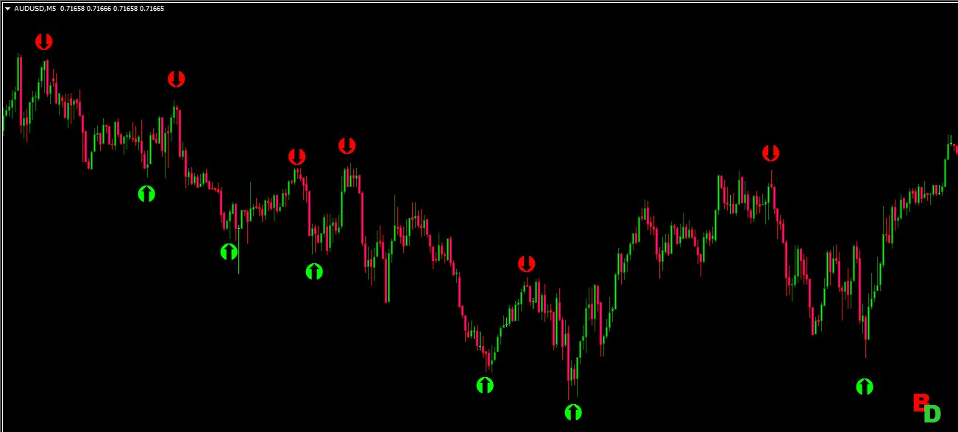](https://forum.mt5.com/attachment.php?attachmentid=357116&d=1617513022)

The Forex Grail Indicator is a neural network-based indicator. The indicator is designed primarily for trading, but the m1 and m5 candle timeframes are recommended. The Forex Grail Indicator does not repaint the map.

**Forex Grail Indicator Characteristics**

1. Metatrader4 as a forum
2. Asset – Any Currency Pair
3. Candle Timeframe - 1 or 5 Minutes
4. Expiry Time - 1 minute for 5 minutes and 5 minutes for 25 minutes.
5. Trading Hours - 24 hours a day, seven days a week.
6. Do not speculate about the timing of Medium and High Impact news releases.

The Forex Grail Indicator only displays signals in real-time. As a result, when you install the prototype on the map, you will not see any arrows right away. You should keep an eye out for the signal in real-time.

[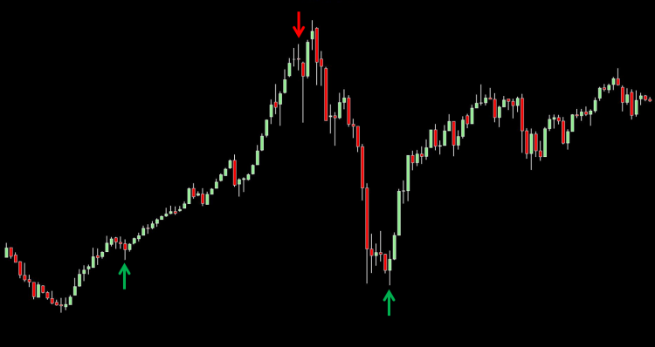](https://forum.mt5.com/attachment.php?attachmentid=357117&d=1617513071)

**How to properly set the Forex Grail Indicator**  
  
Some people want to recommend that the shift be one, because shift zero counts the bars from this bar that isn't closed yet to provide you with some problems, and anything higher than one will cause a lot of lag, so it should keep that to one, the last closed bar. The Duration variable is set to fifteen by default and works well on M15; if you use a different TF, you can change it to any value you see fit.  
  
The Counted Bars indicator does not make the indicator less or more accurate since it counts all bars on the chart specified in the Options/Chart section of your MT4 settings. This variable explicitly instructs the indicator to highlight the last x number of reversals; however, this does not mean that it counts them. So, if you set it to a low value, it will simply make it easier for your computer to render those red/green arrows if you have a sluggish laptop.

However, the accuracy is unaffected in some way, and the margin of error variable is only expected if you have shift zero; otherwise, it is prudent to leave it at zero.

[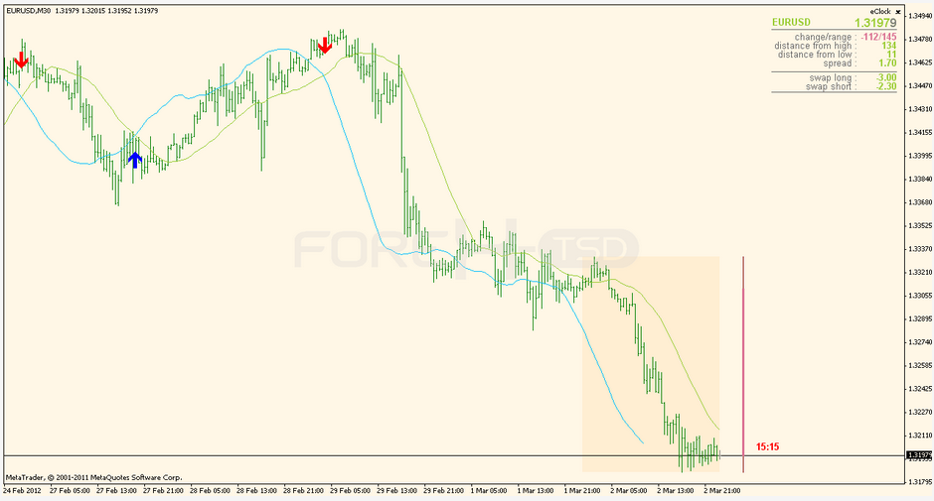](https://forum.mt5.com/attachment.php?attachmentid=357119&d=1617513096)

The standout sheet begins by adjusting the rates and other aspects of the currency combination and demonstrates that the currency is weak, neutral, rising, and robust. The MT4, as well as the stand-out sheet, should be receptive. obtain the most recent updates Please keep in mind that this indicator is unfamiliar to you, but please check it out. The entry and exit rules have been updated.  
  
The unfold sheet is only used for overall currency direction to choose the best currency combination. The unfold sheet is not used for basket commercialism, but rather to buy or sell a single currency. The entry is predicated on the observation of various maps, for which we are going to use the following indicators:

* Auto pivot
* EMA one hundred with shift ten
* MACD twelve twenty-six-nine
* Time Frame H one

**How to entry?**  
  
The spreadsheet depicts one strong currency and one weak currency. Assume GBP is strong and JPY is weak. Open the GJ 1 hour chart, and if the Candles are above the 100 EMA, there is a good chance that a strong pattern is forming for a make GJ. You could be using the Pivot indicator to gain a better understanding of the support and resistance levels.  
  
For example, if the one-hour candles are on top of the hundred EMA, as supported by the pivot indicator, and the candles are touring weekly S1 or S1, a buy order is put based on the strength of the currency.

Furthermore, the contracts have been closed to facilitate the following move to the R1 or R2 stages. If a bargainer has to keep the deal going, he will adjust the stop loss accordingly. For a few main currency pairs, the resulting stop loss is driven.  
  
**Conclusion**  
  
Indicators cannot presumably predict since they are calculated on past meaning activity. The only indicators that are worthwhile are those that include some kind of information, such as the ATR or Divergences, and so on. Save yourself the pain by learning the importance of action, encouragement, and resistance. It's everything you'll ever need. People are aware that it seems sophisticated, but once mastered, your trading will be easy.