**How to use Volatility 75 Index MT4**

**What is the Volatility 75 Index?**  
  
The Volatility 75 Index (VIX) is an index that measures the volatility of the S&P 500 stock index. The VIX, also known as the "Fear Gauge," is a consumer fear indicator. If the VIX reading is greater than 30, the market is fearful. The higher the Volatility Index value, the greater the fear. When the VIX falls below 30, however, it indicates a degree of market complacency. The lower the VIX, the greater the complacency. The Volatility 75 Index is an excellent tool for anyone looking to trade market volatility, and it can also be used as short-term protection during market turbulence.  
  
**Strategy of Volatility 75 Index on MT4**  
  
Many methods can be used to trade the Volatility 75 Index, but one basic strategy that can yield good results is to track the news and buy the VIX when things tend to be out of control and volatile, and if volatility reaches high levels relative to historical norms, you can take the opposite direction and short the VIX. High volatility tends to last for short periods, and when it is extremely high, it is likely to fall slightly.  
  
Playing volatility fluctuations can be a successful trading technique in volatile markets. Note that volatility never remains too high for long, so if it hits exceptionally high levels, it is most likely to drop quickly.

* Volatility measures the amount of uncertainty, ambiguity, and variability that occurs in the market, and, most specifically, the number of price changes that take place over some time on the money system.
* It is a statistical measure of the spread of returns for a specific instrument.
* Volatility can be divided into two types: historical and expected.
* Traders prefer to monitor the Volatility Index (VIX), which can be thought of as a gauge of investor anxiety or pessimism.
* During periods of high market volatility, markets appear to be very dynamic, changing rapidly within a short period. When markets are not volatile or "locked," market movements and patterns emerge more slowly.

Volatility may occur in the market following a significant reading of macroeconomic data or unexpected events such as a natural disaster or a major political event.  
  
More experienced traders prefer to invest during periods of high uncertainty, attempting to open and close positions in a short period.  
  
**Volatility at work**

[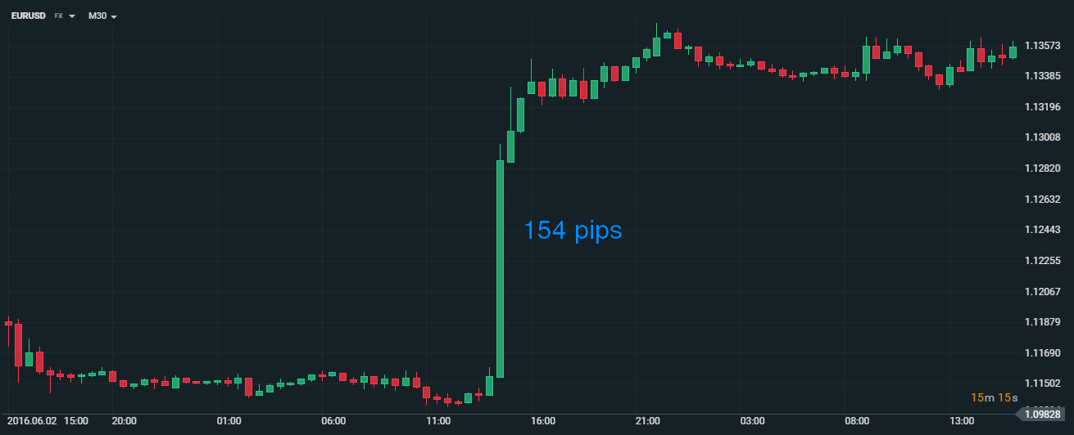](https://forum.mt5.com/attachment.php?attachmentid=354385&d=1617163447)

The above chart is an outstanding example of both low and high volatility. This usually happens before a large macroeconomic reading, as traders are waiting to see how the reading will work out. Following the publication of the reading, strong or substantial movement may evolve quickly, as seen on the EURUSD chart above.  
  
This particular example occurred following the release of the US non-farm payrolls, which came in well below market expectations. It's also worth mentioning that after the initial shock of the reading passed, the market lost its volatility and returned to range-bound trading.

[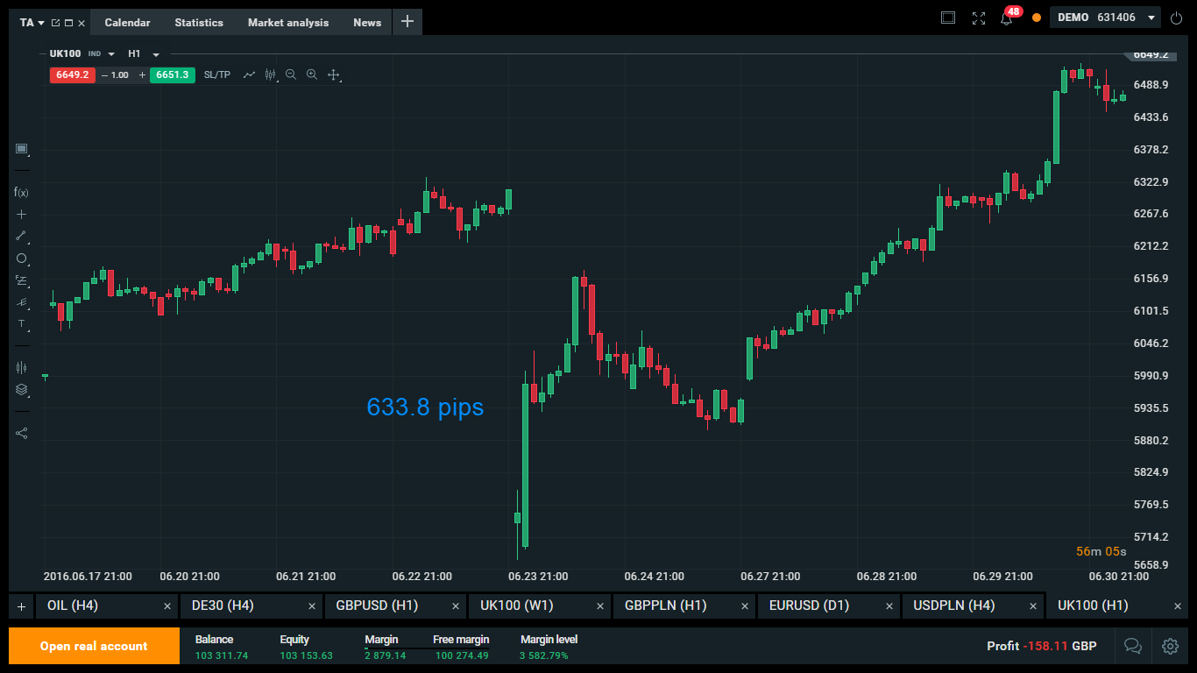](https://forum.mt5.com/attachment.php?attachmentid=354389&d=1617163677)

The above example illustrates the results of a UK referendum, in which the UK100 chart dropped by more than 600 pips in less than an hour. In the short term, they can experience a substantial increase in risk aversion.  
  
**Volatility Index**  
  
The Volatility Index, also known as the VIX, is a weighted index of implied volatility in options contracts on the S&P 500 index in the United States. In essence, it is a predictor of apprehension or pessimism in the market of 500 high capitalization US stocks listed in the US, and thus a barometer of overall market trust and risk appetite  
  
The VIX Index has historically been inversely linked to US financial markets. The lower the VIX, the more stable market morale, and the greater the rally in stocks. Similarly, the higher the VIX, the more volatile the financial markets have become and the more price declines have occurred.  
  
The chart below compares the VIX index to the US30 (underlying Dow Jones Index), and it shows a clear inverse association between the two indices.

[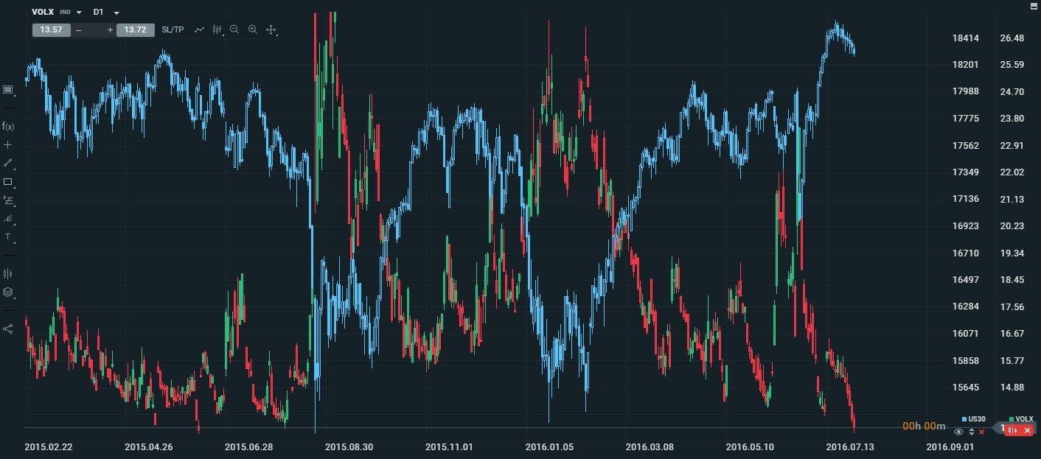](https://forum.mt5.com/attachment.php?attachmentid=354390&d=1617163755)

**What exactly is the VIX?**  
  
The VIX (Volatility Index) is generally regarded as the most important measure of stock market volatility and investor sentiment. It is an indicator of the market's anticipation of S&P 500 stock index option prices' near-term volatility.  
  
Since its inception in 1993, the index has evolved into the gold standard for predicting market volatility in the US stock market. This has given it the nicknames fear index and fear gauge.  
  
Encouraged by the index's increasing value, the issuing bodies revised the VIX in 2003 to reflect its benchmark status. The VIX is now focused on a broader index, the S&P 500, providing a much more reliable representation of anticipated market volatility.  
  
**The VIX - Explained**  
  
The VIX, as an uncertainty predictor, typically depicts investor anxiety or complacency. The most common indicative value is 30. When the VIX reading is greater than 30, it indicates that the market is volatile and fearful. When the reading is less than 30, it suggests complacency or less stressful periods in the business.  
  
In periods of high volatility, investors tend to be more cautious in the markets, and vice versa. This naturally correlates the VIX with the S&P 500. As the S&P 500 falls, the market interprets this as market uncertainty, which causes the VIX to rise. Nonetheless, the VIX tracks uncertainty and does not always forecast future market paths.  
  
The VIX reached an all-time high of 80.86 on November 20, 2008, during the global financial crisis. It was all intraday lower of 8.56 is set on November 24, 2017, as well as the reason that it was Black Friday likely aided the VIX's performance.  
  
**Trading Data for the VIX**

* MT4 Symbol: VXXB
* Trading Hours: Monday – Friday 08:00 – 17:00 Eastern Time
* Country: USA
* Currency: USD

**VIX Calculation**  
  
The VIX is a volatility index, as opposed to stock indexes such as the S&P 500, which are measured using the prices of component stocks. It computes the near-term volatility of option prices by combining the weighted prices of SPX (S&P 500) Puts and Calls through a broad range of strike prices.  
  
As previously noted, the only significant update to the formula occurred in 2003, when the index was extended from the S&P 100 to include the broader S&P 500. Previously, only at-the-money options were included in the index computation; however, since it was updated, a broader variety of strikes is now included. When computed, the VIX formula follows the mathematical step-by-step logic below:

* Options with expiry dates ranging from 23 to 37 days are chosen
* The contribution of each option to the total variance is calculated
* The total variance for the first and second expirations is calculated
* The 30-day variance is derived by interpolating the two variances.
* The square root is used to measure volatility as a standard deviation.
* The VIX is then determined by multiplying the standard deviation (volatility) by 100.

According to the formula, the VIX is simply Volatility multiplied by 100. As a consequence, if the VIX reading is 20, It effectively means that the 30-day annualized volatility is 20%.  
  
**Management Risks**  
  
Aside from trading signals, VIX can be an important risk management method. Prudent traders use a variable method for optimum position sizing in the market, based on the current rate of volatility.  
  
The VIX, as a method that offers details on possible levels of implied volatility, will assist traders in employing a dynamic position sizing strategy that will help them minimize trading risks while maximizing potential rewards.  
  
As a general rule, traders can trade smaller lot sizes during periods of higher volatility, whereas larger lot sizes can be exchanged during periods of lower volatility.