**Master Candle Trading Strategy**

**What's the Master Candle?**  
  
First of all, we're going to explain what the master candle is. These are essentially candles with large bodies and wicks (sticks over and under the candle body) marking a new high or new low and the extension or range of which covers the following 4 or more candles.  
  
Typically, if we watch the formation of a master candle, we will calculate the range between the maximum and the minimum of the candle, which will be higher the more candles within the range. It is also predicted that, in the case of a rupture, the prince would make a reasonably strong step in the direction in which the rupture occurs. For this purpose, it is recommended that this trading strategy be applied to instruments and assets that are sufficiently volatile to catch a strong movement. For example, the developer of this strategy suggested the use of these systems with currency pairs such as GBP/JPY and 1H charts.  
  
Simply placed, the master candle is one tall candle that engulfs the following four candles on the map. This means that the top of the master candle is higher than the top of the next four candles, and the bottom of the master candle is lower than the bottom of the next four candles.

[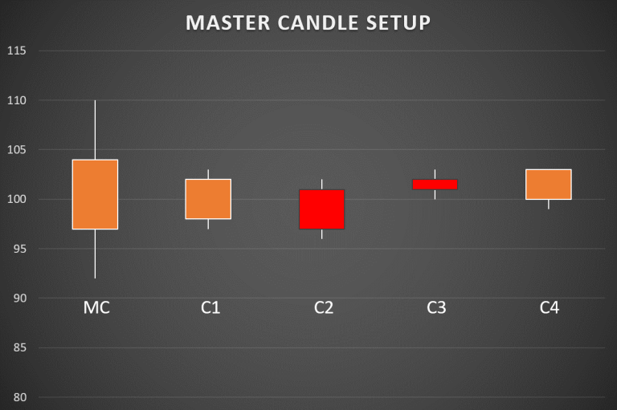](https://forum.mt5.com/attachment.php?attachmentid=328354&d=1612846708)

MC is a master candle that completely engulfs the four children's candles C1, C2, C3, and C4.  
  
**The Beginner Guide to Master Candle**  
  
Undoubtedly, Price Action Trading is one of the easiest ways to reliably bet on stock market changes. It is a science and validated technique that relies on particular chart trends following supply-demand to forecast stock prices. And when it comes to trading in price action, Master Candle is a lesser-known but very effective pattern used by skilled traders.  
  
**Meaning of Master Candle**  
  
Master Candle means the point in time where the price falls within a tight range and both bulls and bears are trying to get out of this range. The four child candles that follow the master candles reflect a state of a dilemma between bulls and bears. You can opt to look at just three children's candles and disregard the fourth.  
  
Since the market is primarily guided by crowd psychology, Master Candle truly symbolizes this crowd activity and their fight to shift prices up and down.  
  
**Master Candle Understanding and Trading Techniques**  
  
The most popular way to interpret the master candle is to exchange it.  
The master candle is usually a collection of 5 candles, a mother candle, and 4 child candles within the mother candle range.  
  
If any subsequent candle outside this 5 candle series breaks above or below the mother candle, it means that either the bulls or the bears have taken over and the one-sided action can continue for some time.  
  
**See the following examples:**

[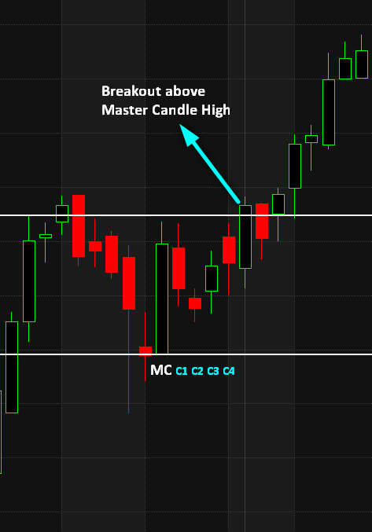](https://forum.mt5.com/attachment.php?attachmentid=328356&d=1612846911)  
  
[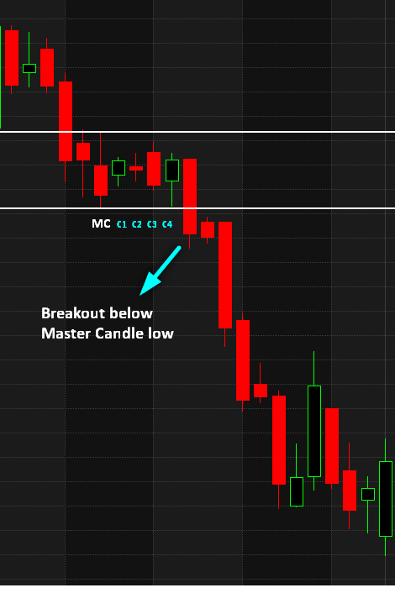](https://forum.mt5.com/attachment.php?attachmentid=328357&d=1612846921)

So, the trick is to place a purchase order when the price breaks above Master Candle High, and to place short order when the price breaks below Master Candle Low. It's best to check just 3-4 candles for a breakout after the master candle setup since something above that will invalidate the entire setup.  
  
**Stops and Goals**  
  
Stops should be put high or low at the master candle, depending on the trade you took.  
For example: if you're going long based on the master candle breakout high, then the stop should be placed at the master candle low. If the master candle range is too high, you can position the stop loss at the lowest of the child candles.  
  
The optimal target should be the same size as the master candle. For example: if you enter for 100, and the size of the Master Candle (High-Low) is 10, then your profit target should be 110.  
  
**Timeframe**  
  
Master candle trading strategy works well in both the Intraday and EOD timeframe. Intraday, 30 min or more is better. Higher timeframes like 5 min or 1 min can be too noisy.  
  
Master Candle is a fantastic set up, and we've been using it successfully for years. Generally, the precision of the master candle breakout varies between 30-50 percent, but the risk-reward ratio is too good. So in the long run, if you consistently pursue a master candle-based strategy, you're going to be profitable for sure.  
  
**Master Candle Trading Strategy**  
  
This is a breakout trading strategy. The trader must locate the master candle in the price chart and wait for the breakout to occur in one direction or another. If the breakout has been verified, the trader will open a position in the direction of movement, taking care of whether it is a false breakout, and the price returns to the range of the master candle.  
  
**Trade instruments**  
  
This trading method can be used for any instrument or asset but is recommended for volatile instruments with strong movements. In the case of the Forex market, volatile currency pairs such as GBP/JPY may be used.  
  
**Indicators**  
  
This trading technique can be implemented for almost any time frame, but the author suggests that it be used with the following chart configuration:

* 1 candlestick of 1 hour for volatile currency pairs including GBP/JPY.

**Rules of the trading system**

* Define a master candle with at least 4 candles within its length.
* Draw a line at the top and bottom of the master candle (including the wicks) to create a range.
* Wait until a breakout happens in the range of the master candle and the place is opened in the direction of the rupture.
* Stop loss: The developer of this strategy sets a stop loss of 50 pipes, but that can be changed depending on the business conditions and the instrument.
* Take benefit: in this situation, the author proposes a profit of 50 pipes. However, as in the case of a stop loss, it can be changed depending on the instrument and the market conditions.
* The levels of stop loss and benefit can be modified according to the number of candles accumulated within the range. For example, if there are 7 accumulated candles, take benefit and stop-loss can be set at 60 pipes. If the number of accumulated candles is 10 or more, we can increase the stop loss by up to 70 pipes.

**The following criteria can be used to assess the intensity of the signal produced by the master candle:**

* The master candle was shaped at a significant psychological level (for example .00, .25, .75, etc.).
* The longer the price is inside the range. At this point, the author of this strategy recommends a 24-hour filter, a time during which, if no break has occurred, it is best to discard the pattern.
* The more the price has rebounded to the extremes of the spectrum. For example, the more times the price has hit the maximum range and has been restored when the upward breakout happens, the more probabilities will result in a strong movement in the direction of the breakout.
* Finally, if the maximum or minimum of the master candle hits a new minimum or maximum on a regular, weekly, monthly, annual, or even historic level (a significant help and resistance), it is almost assured that the opening of the Master candle range would be an excellent signal to join the market.

**The Master Candle**  
  
The Master Candle Concept is a Candlestick Map Breakout Concept The primary advantage of the Master Candle is that it is free of bias and makes breakouts without paying attention to the key trend.

[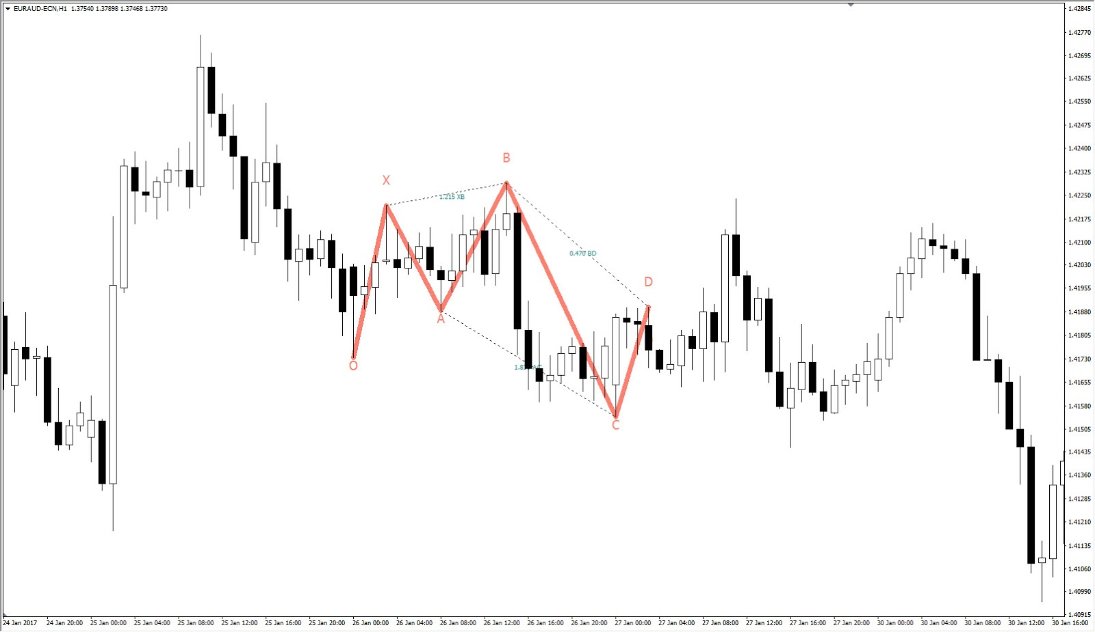](https://forum.mt5.com/attachment.php?attachmentid=328388&d=1612849855)

**The Master Candle Map**

* Classify the MC
* The 1st, 2nd, 3rd, and 4th candles in the MC are labeled 'Setup' candles.
* The 1st, 2nd, and 3rd candles after the 4th setup candle need to split the MC high/low for the breakout to be accurate.
* That's the 5th, 6th, or 7th candle after the MC candle.
* Valid Master Candle has a range of 30-150 pips depending on the pair traded.
* Buy/Sell entry is put at 3 pipes and distributed above/below the MC high/low.

The Master Candle is traded solely on a timeline of H1 and is very suitable for open range breakouts and intraday breakouts. Before you introduce new techniques in your trading system, make sure you practice demo trades first.

**Conclusion**  
  
Of the different trading patterns used, the Master Candle trading strategy is common because it has consistent patterns and helps to recognize breakout points. This makes it perfect for long-term profits. If you follow proper laws, such as not trading in the Help Resistance zone, and trading only when the candle breaks high or low, you will make excellent profits. Eve