**ADR Indicator**

**The Best Average Daily Range Indicator**

The average daily range indicator is a personalized indicator optimized for the MT4 trading platform. As the name suggests, the average regular range displays the average protection range over some time. ADR is useful for traders using metrics such as Bollinger bands or momentum oscillators such as the Stochastics oscillator or the relative strength index. It is helpful to understand when the momentum is rising and dropping.  
  
It plots the values on the map. Traders then need to look at the recent market action to consider how current prices are moving in comparison to the previous volatility. The ADR also helps to consider the instability of the system. Volatility is a positive thing for intraday traders. Large price spikes can offer possible trading opportunities to the trader. In this respect, when the volatility is rising, traders may use the ADR to display this information.  
  
However, the ADR measure is focused on the price, which means that you can only look back to understand the changing price behavior and the uncertainty that comes with it. Volatility is not expected by the indicator. As a consequence, there are several disadvantages in the way that the ADR can be used. Traders have, of course, designed a range of trading systems that use inputs from the ADR indicator for MT4. In this post, we look at what the average daily range indicator is and how you can use this indicator on your MT4 trading platform.  
  
**What's the average daily range (ADR)?**  
  
The average daily range is the average of the daily range of protection. This measure has been developed specifically for forex markets. As the name suggests, the average daily range indicator displays the average daily range of prices over time.  
  
The ADR is a good way to grasp and see the uncertainty of the security being analyzed. Based on the average daily safety spectrum, You will be able to see the current level of protection that you are analyzing and be able to tell if markets have a range higher or lower than the normal regular range.  
  
Usually, when the ADR is beyond its normal regular price level, it means that market volatility is increasing. Similarly, the ADR reading below the average daily price range may imply decreasing market volatility. ADR can be a valuable method for evaluating intraday trading reversals.  
  
The value of the ADR shall be determined based on the average daily range of the preceding periods.  
  
This means that if you set the lookback time to too high a value, the average daily range will be even more lagging. However, setting the ADR look-back duration to a small period would make it more unpredictable. Let's look at it with an example to understand the average daily range.  
  
If you find that the market action for the last 5 daily sessions has been flat, this can be seen with the average daily range indicator showing lower values. However, if you see that the volatility spiked, based on a powerful bullish or bearish candlestick, you might expect the previous range to be broken.  
  
The ADR may be useful in this way, but the ADR indicator only plots the average daily range as a numerical statement on the MT4 trading charts. It also displays two horizontal lines showing the previous average daily range. As a consequence, when rates begin to break out of these ranges periodically, you may expect the pattern to restart.  
  
Traders must realize that momentum is the precursor to a pattern. It is only when the momentum is that that the trend begins to take place. The ADR can therefore be useful in this way to show you the previous average set. You should then equate the previous values to the new regular set to see what the momentum is. The ADR can be helpful if you are trading breakouts or dealing with trend corrections.  
  
It can also be used in the long-term table. The ADR indicator operates only on an intraday timeline map. You can see the indicator up to the H4 chart, therefore. If you turn to a daily or weekly time frame map, the indicator will not work. That's because the ADR indicator is based on the daily scale, so the indicator doesn't work on a daily or higher time frame.  
  
If you drag and drop the indicator to your maps, you will have the choice to customize the settings.  
  
**Configuration of the ADR Indicator**  
  
**The indicator shall have the following settings:**  
  
**TimezoneofData:**  
The default reading is 0 and represents a GMT broker. You can change the value by offsetting the default by the number of hours before or behind GMT. Based on your preferences.  
  
**TimezoneOfSession:**  
You can also set the ADR for a particular time zone. The default is set to 0 and you can change it to 1, 2.  
  
**ATRPeriod:**  
The setting of the ATR period is based on the average true range. The default ATR is set to 15 sessions per day. You may change this to higher or lower readings. Bear in mind that this sensitivity would affect the readings of the ADR values.  
  
**LineStyle:**  
This is a cosmetic environment and you can see how high and low daily ranges are plotted on your chart. You can choose between a dashed, dotted, or continuous line by adjusting the value.  
  
**LineThickness1:**  
This setting helps you to customize the thickness of the line displayed on your map.  
  
**LineColor1:**  
The color of line 1 helps you to change the color of the line.  
  
**LineThickness2/LineColor2:**  
The settings for this are the same as the previous two, except that modifying these variables means you'll change the line settings for the low of the ADR.

**DebugLogger:**  
This is often used by developers. Setting this to true would write a log to a file that can be used for debugging. This can also be useful if you want to create an expert advisor based on the average daily range indicator. You should see anything like this after the indicator has been configured and placed on your map.

[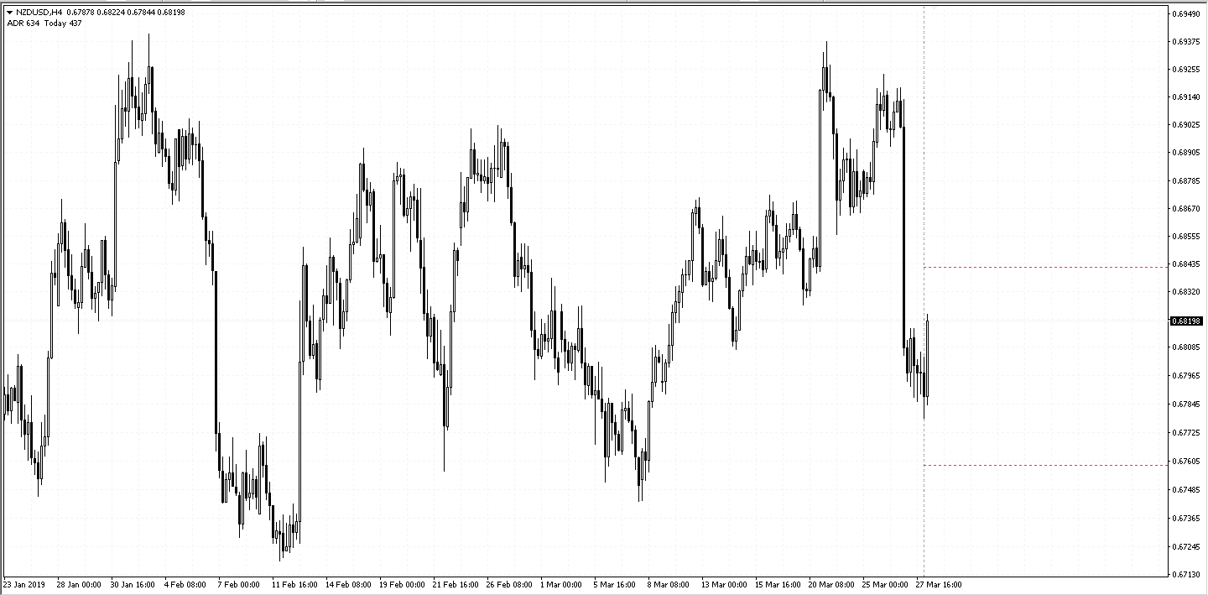](https://forum.mt5.com/attachment.php?attachmentid=330129&d=1613200282)

**Indicator of Average Daily Range**  
  
The indicator shows the vertical line indicating the average daily range for the next week. As rates change, the lines of the ADR will begin to move.  
  
The horizontal lines you see are essentially high and low in the regular range. You may assume that prices will either break past the high regular range, or the low range, or that prices can continue to develop within these preset ranges.  
  
The easiest way to customize vertical lines is by pressing Ctrl+Y on your MT4 chart to show the opening session of the day. Depending on the start date as indicated by your broker and the BestADR indicator, you can then change the time zone configuration in your BestADR indicator to adjust it accordingly.  
  
This is a really good way to compensate for the timing if you're not trading with a GMT-based broker. It should be noted that the horizontal lines shown above and below the previous day were as configured in the settings row. It is not to be confused about the contrast between the high and the low of the past times that you have chosen.  
  
**Trading with the adr indicator**  
  
Since the Best ADR indicator for MT4 is a custom indicator, Trade techniques are also highly personalized. Most traders use the ADR as a method of trading breakouts, combined with uncertainty.  
  
When the price breaks the high or low ADR, traders can be started in the direction of the breakout. It's nothing different from how you'd trade a daily breakout when prices settle in a range. The advantage of trading ADR breakouts is that the breakout is always focused on the momentum that comes first before patterns are formed. You can then use this technique and capitalize on the momentum of price action changes on the map.  
  
Stops and goal levels are often based on the same pattern of daily breakouts. You can set a 1:2 risk and reward ratio and trade based on this at a recent high before the breakout. You may also combine other metrics, such as the Bollinger bands, which can also display rising and decreasing volatility based on band contraction and expansion. And, of course, the use of momentum indicators such as stochastics can also benefit this form of trading.  
  
Some traders are taking a different approach to trade with the ADR indicator.  
They use the peaks and lows of the ADR as a method of reversing trade. Thus, when price rallies high to the ADR, but then begins to withdraw, you can take short positions, or when prices are behaving in the opposite direction, You should take long positions near the lows.  
  
Again, trading solely based on the ADR indicator is not advisable. You may also need to validate trading signals based on the validation of other technical indicators.  
  
ADR-based investing is not a long-term trading strategy. It is mainly suited for short-term, intraday traders or scalpers. You can also use this measure alongside the regular pivot levels to find a confluence and trade based on these levels.