**How to Register in the Stock Market ?**

**What is Stock Market Registration?**

[](https://forum.mt5.com/customavatars/922675051.jpg)

A company's registration to be in the stock market is considered as a source of pride for them. It permits a company's securities to be openly sold to the public and it allows the company to generate more funds for its activities. Due to the large number of regulations that control the listing process, the process may appear to be a daunting endeavor for new companies planning to go public.  
  
The decision regarding selling stock on a stock exchange not only helps businesses raise capital but it also gives them a sense of status. No company is allowed to just start selling stock from them and demand to be included in a listing on the NASDAQ or NYSE. There is a need for the legal requirements for an initial public stock offering (IPO). Once the company has completed the requirements then they must go through the exchange process before they can begin trading.  
  
**Important Terms About the Stock Market**  
  
Understanding the stock market and the process of being registered on it needs the market players to know some important terms. These are the terms that will always be used on a daily basis so investors must take note of them. Here are some of the important terms.

1. **Capital Market-** The financial market where securities are bought and sold is known as the capital market. It is made up of two parts including the primary market which is related to IPOs and the secondary market related to stock exchange. Capital markets primarily work with long-term investments.

[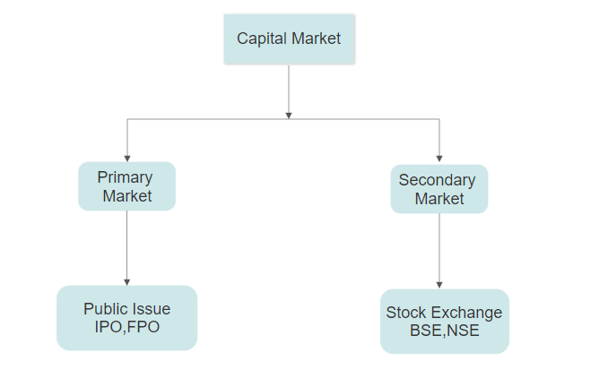](https://forum.mt5.com/customavatars/1109175978.png)

1. **Initial public offering (IPO)-**The initial public offering is often known as an IPO. It refers to a public offering that serves as a starting point for a company that is planning to be listed on a stock exchange. It is usually backed with investment banks that aid companies in becoming listed on a stock exchange.

[](https://forum.mt5.com/customavatars/2130358897.png)

1. **Securities-**Securities are a type of financial instrument that is allowed to be sold on the stock exchange. These instruments are used to assist both public and private companies to raise funds they need. There are three types of securities namely equity, debt, and hybrid. The equity securities are the ones that allow investors to own a piece of a company while debt securities appear as loans. The hybrid securities present a combination of the features from both debt and equity securities.
2. **Stocks & shares–** The terms stocks and shares are most of the time used interchangeably in the trading world like it is just similar but there is a distinction. Shares are considered as a kind of ownership in a corporation that are allowed to be bought and sold individually. In contrast, Stocks appear as a collection of shares that are commonly held and sold together.

[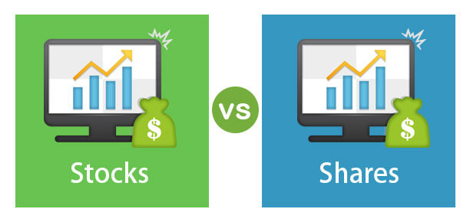](https://forum.mt5.com/customavatars/2107284135.jpg)

1. **Stock Exchange-** The stock exchange is an area where different financial instruments including commodities, stocks, and bonds are being traded. It provides facilitation for the exchange of goods between sellers and purchasers to happen. After going through the Initial Public Offering, or IPO, a stock is traded on the stock exchange.

See also: Explore the infinite possibilities of online trading with a reliable broker. [Join now](https://www.instaforex.com/real_account_whiterabbit?x=MBZKY&uifd=657)!

1. **Stock market–** The stock market presents a broad phrase that refers to all stock exchanges in a certain area like a whole country.
2. **Dividend–**A dividend refers to a payment that a corporation pays to its shareholders once it achieves a profit. It may or may not be reimbursable and it depends on current employer policy.

[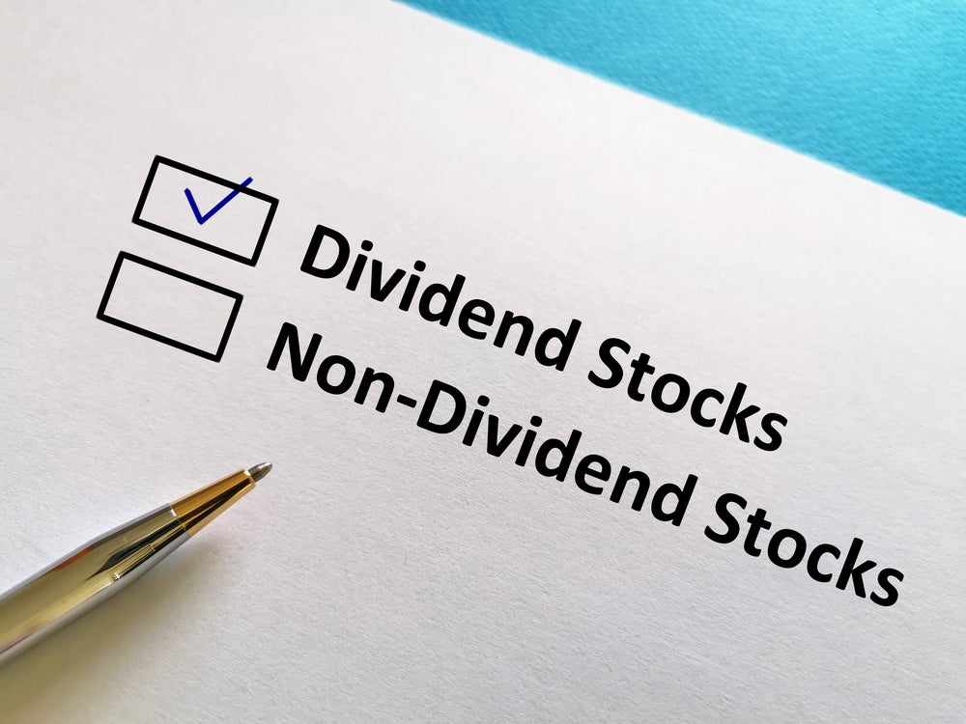](https://forum.mt5.com/customavatars/1641305382.jpe)

1. **Brokerage firms and stockbrokers –** Stock brokerage firms are known as regulated companies that function as a middleman between the buyers and sellers of securities within the stock exchange.
2. **Investment banking firms–**These are corporations that act as go-betweens for public companies and investors. Investment banking firms serve as advisors to public companies that are preparing to list on stock markets.
3. **Prospectus-**Any document issued as a prospectus does include red-herring prospectus or the Section 32 or shelf prospectus or Section 31. It might also involve any notice, advertisement, circular, or any other document trying to invite offers from the public for the purchase of securities of the company. These all are defined as a prospectus under Section 2(70) of the Companies Act of 2013.

**How to Get Listed on the Stock Market?**

* **Go Public in the Stock Exchange**

[](https://forum.mt5.com/customavatars/930328031.jpg)

The first thing to do is to fill out a registration statement, Form S-1, with the Securities and Exchange Commission to start the process of becoming a newly stock exchange listed company. The prospectus which is the one a company disseminates to anyone interested in buying the company’s stock, is included in the statement. The company operations, financial condition, management, and risk factors must all be adequately described in the prospectus. It also includes financial statements that have been audited. Aside from what the company published in their prospectus, the SEC prefers to get additional financial information. If the SEC believes the information the company provided is false, deceptive, or incomplete then it may reject the registration. Smaller businesses can take advantage of a simplified SEC registration process.

* **Qualifying on the Board**

[](https://forum.mt5.com/customavatars/968748698.jpg)

Each kind of stock market establishes its own set of rules. If a company does not qualify for one board then it should not lose hope because there is a chance to be accepted to another. To some companies that are not big enough for the big board classification, the NYSE operates a second market called NYSE American.  
  
Each company has the power to choose their ticker symbol, or shorthand for their company after deciding on the right market. In an instance, the New York Times is abbreviated as NYT. The company must select a symbol that complies with its board's standards, the SEC's requirements, and most importantly not identical to any other symbol. Investors respond better to symbols that seem like words they can pronounce, according to marketing theory. It is advisable to make symbols that have recall and are easy to remember.

* **Hiring an Underwriter**

[](https://forum.mt5.com/customavatars/1892948420.jpg)

Companies will likely need to hire an underwriter to function as a middleman between the company and its potential investors. Underwriters are the financial world's risk experts, and investors rely on them to decide whether a business risk is worthwhile or not. Before a firm can be listed on the stock exchange, the underwriter must agree to take on the risk of purchasing its entire stock inventory. It should be done before selling stocks to the public. An underwriting agreement is used to express this kind of commitment.The underwriter drafts a prospectus to show to potential investors after finalizing the underwriting agreement. At the same time the Securities and Exchange Commission should have reviewed the company.

* **Register to the Exchange**  
    
  Companies can apply to the exchange or exchanges where they want to be listed. They can do this once they have formulated their prospectus and ticker symbol. Along with the application form, the companies will need lots of new supporting documents. They need a letter from their underwriters stating that the company will be able to meet the listing requirements. Another document refers to a statement from the company confirming that it can work in accordance with the board's shareholder obligations. The document shows one of the company’s executive officer’s signed listing agreement. There should also be a copy of the corporation's charter and its bylaws. The last document includes a certificate from the state where the firm is chartered and it should be stating that it is currently and maintaining good conditions. Once all these documents are ready and passed for registration, the company is gearing up to sell shares on the exchange as the next step.