**How to Trade an With Exhaustion Bar Indicator?**

**What is an Exhaustion Bar?**

[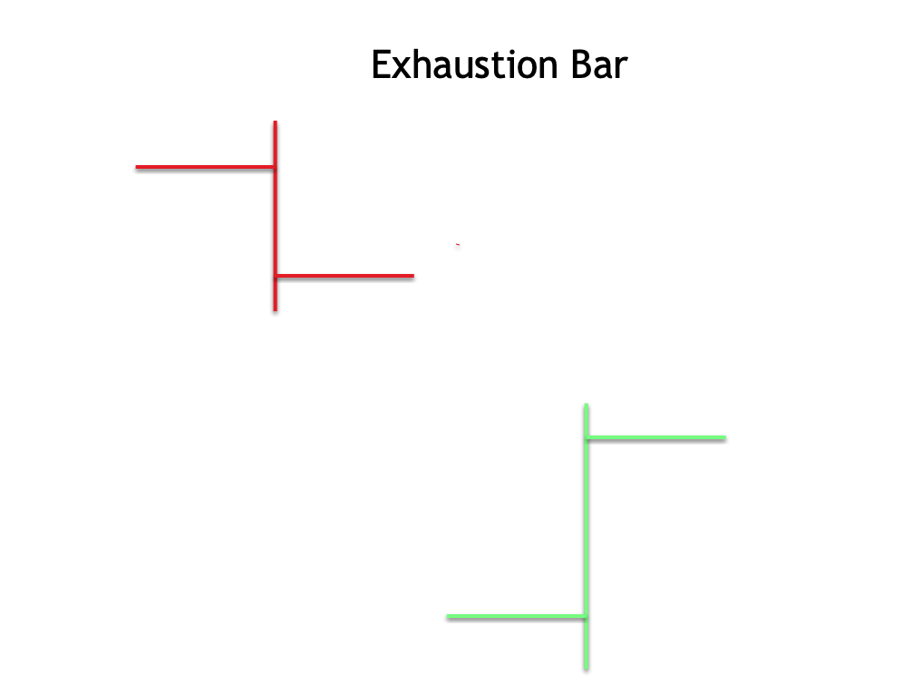](https://forum.mt5.com/customavatars/921236533.png)

Trading strategies display great importance in increasing a trader’s probability to profit from trading. The price-based trading strategy includes more than just employing bar patterns. Exhaustion bars are characterized to be larger than usual or huge bars that appear later within a trend. Exhaustion bars can form after the occurrence of a quick upward or downward movement. It is a pattern that is a type of key reversal and they differ significantly to justify their classification.  
  
Exhaustion bars could either be identified as bullish or bearish. It primarily depends on the inbound trend's direction. In a situation where the overall price trend is up then an exhaustion bar appears. It is a good idea for the traders to either take a short position or sell a long position. In contrast, the inbound price trend appears to be down then opening a long position or closing a short position is recommended upon detection of an exhaustion bar. One exhaustion bar that appears as bullish presents a downtrend that may be reversing to a new upswing. It is the pattern indicating a short-term forecast for the economic instrument.  
  
Exhaustion bar patterns can either be one- or two-bar patterns that reflect shifts in investor sentiment which may have a very short-term effect on future prices. It usually appears as fewer than ten bars. Trend exhaustion which is followed with a reversal refers to what is frequently called the initial influence. These patterns are ideal for investors who are searching for clear entry and exit points. If seen as month-to-month bars then these are usually not acceptable as signals for long-term investors.  
  
**How to Trade With an Exhaustion Bar?**

[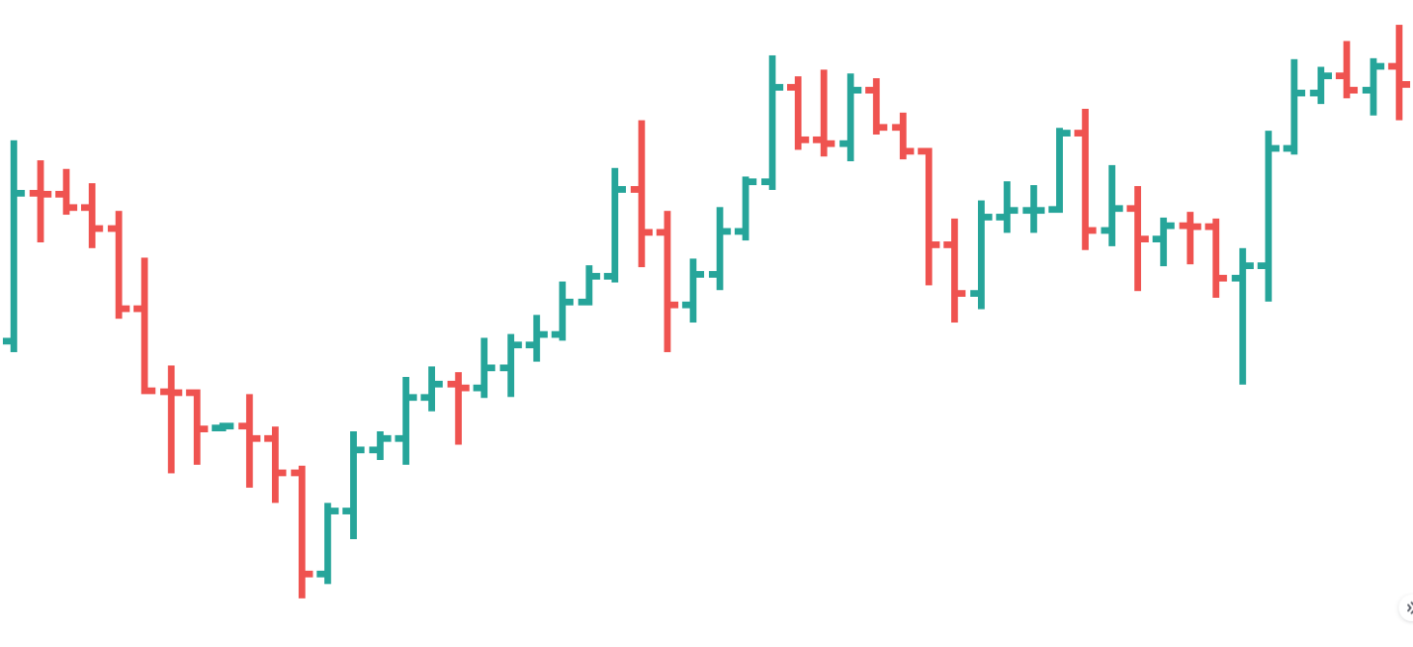](https://forum.mt5.com/customavatars/1584988694.png)

Different bar patterns are excellent for timing trades and locating reasonable stop-loss points because they are short-term patterns. Understanding the concepts of bar patterns is essential knowledge for any price action trader. The market gained support below the prior bar's low which is known as the exhaustion bar in Forex which shows a bullish pattern. The support appeared powerful enough to drive the bar higher than the preceding bar or the exhaustion bar. It might be the first indicator of a bullish reversal.  
  
In contrast, the market that encountered resistance just above the prior bar's high is for the bearish pattern. In addition, the resistance appears to be strong enough to push the existing bar lower. A key reversal bar is a type of reversal bar that reveals more obvious evidence of reversal. Key reversal bars open with a price gap according to its definition. A powerful down push is referred to as a down gap. In a particular situation where the gap upwards hits clear resistance then the market may have exhausted itself and turned bearish.  
  
A major reversal bar or exhaustion bar in Forex is a powerful display of strength that indicates a change in market sentiment. The gap stays empty in both circumstances. Coming up with the exhaustion bar requires a lot of volumes.

[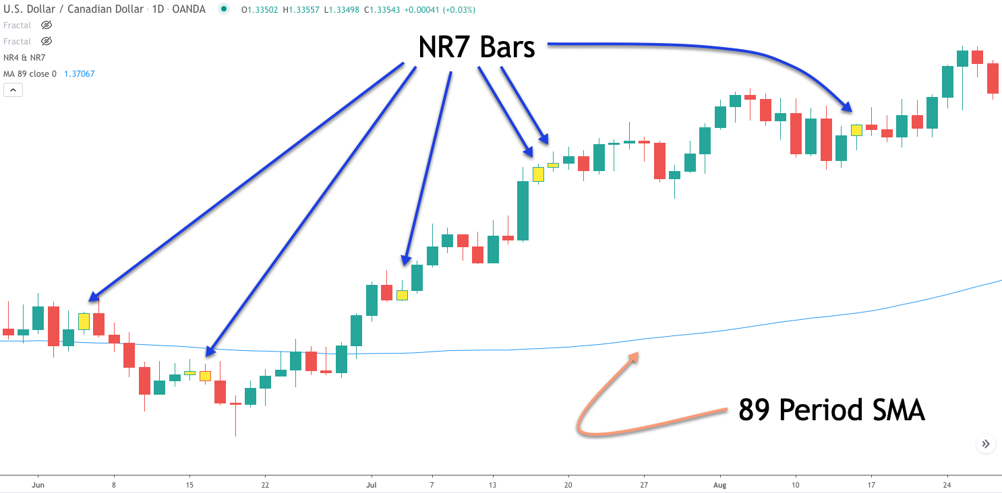](https://forum.mt5.com/customavatars/1006849773.png)

Most of the time, it is also unclear whether the bulls or bears have succeeded in the appearance of the exhaustion bars in Forex. The only clear thing is that there will be more volatility. Its bar design necessitates the use of seven bars. It refers to an NR7 pattern especially if the last bar appears to have the shortest bar range in the sequence. The NR7 pattern is identified as a good sign of diminishing volatility because the lower exhaustion bar forex occurs within the context of seven bars rather than a single bar as in the case of an inner bar. A price move in the absolutely opposite direction beyond the extreme point of the exhaustion bar indicates a problem with the particular pattern.  
  
**What is the Exhaustion Bar Indicator?**

An exhaustion bar refers to a bar that indicates a signal whose present trend has reached its limit. In a downtrend, an exhaustion bar presents a bar of the last seller. In contrast, an exhaustion bar within an upswing is known as a bar of the last buyer. If one side is unable to move the price further in their favor then the other party naturally steps in, assumes command, and reverses the trend all at the same time.

* **Leledc Exhaustion Bar MT4 Indicator**

[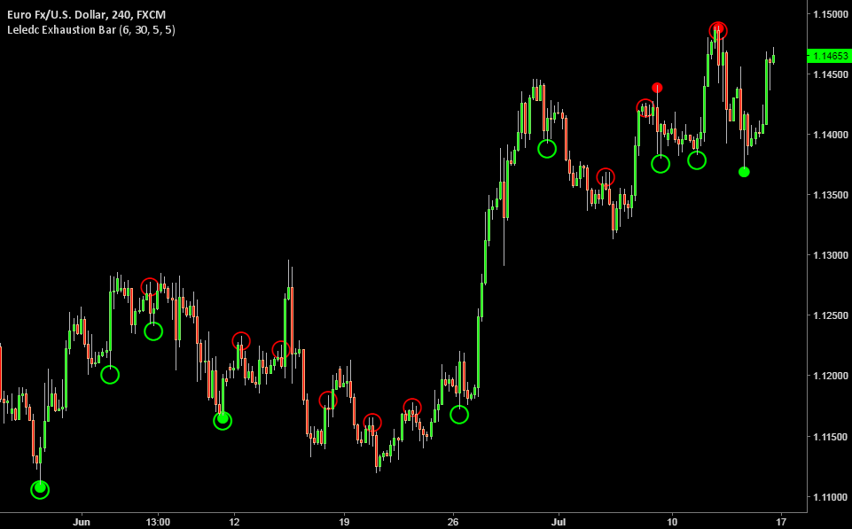](https://forum.mt5.com/customavatars/324311939.png)

The Leledc Exhaustion Bar is known as an indicator for the famous MT4 platform. It is one of some price-action trader’s favorite indicators in employing the exhaustion bar pattern. The Leledc Exhaustion Bar indicator offers a strong ability in making predictions for any upcoming reversals.  
  
Traders will see two colors of points such as red and green. The red color indicates that the trend is either making a reversal in the downside or appearance of pause within the uptrend. The green color signals the trend either having a reversal in the upside or a pause appearing in a downtrend.  
  
Traders use the Leledc Exhaustion Bar indicator in combination with a moving average indicator as to the one that will filter any trend present. The signals found within the trend should only be the ones traded. The indicator is able to signal the end of a pullback and the continuation of the trend.

**Conclusion**  
  
The degree to which the price bars and volume aspects reflect the exhaustion bar description is likely to have an impact on the strength of the post pattern price movement. These signals should not be used alone according to good trading training. It is best to use it along with the fundamental data, sector and market evidence, and other technical indicators. Traders can choose to employ indicators such as support/resistance and moving average indicators. Traders should employ these ideas and indicators to back up their trading decisions.  
  
The presence of an exhaustion bar generally indicates a psychological reversal. Once a trader has a wide opening space then it makes them witness the outcomes of extreme sentiment. In case the width trading range eats a major portion of the opening space and the bar closes with the gap nearly closed then traders have a clear indicator of a bearish to bullish sentiment reversal. Traders can download the indicators they would like to combine with their exhaustion bar indicator from InstaForex from this link <https://www.instaforex.com/>.