**What are the Capital Market Trading Instruments?**

**What is the Capital Market?**

[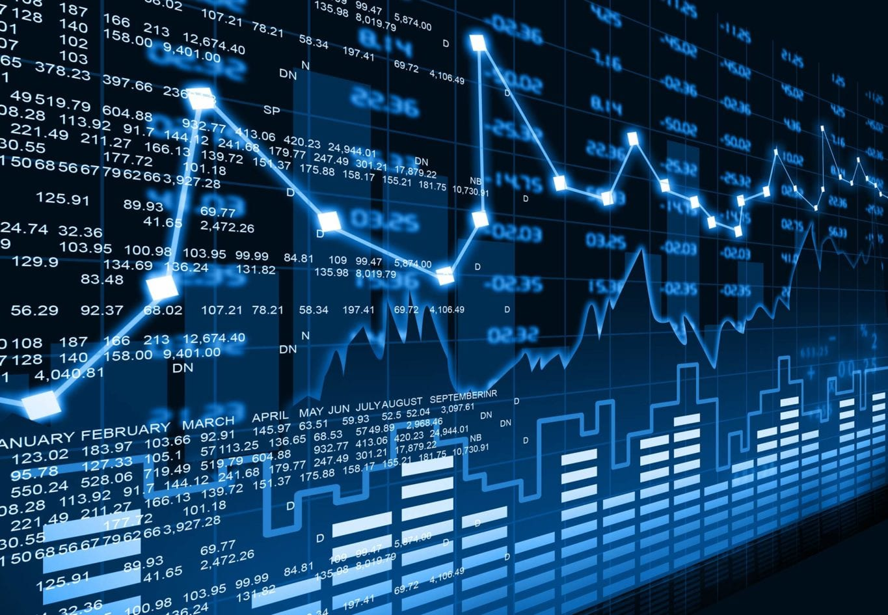](https://forum.mt5.com/customavatars/1873238815.jpg)

Savers come to capital markets to put their money in long-term investments including corporate debt, equity-backed securities, and government bonds. In understanding the savers' role, they are the individuals that come with their money to invest and those in need of money come to borrow. Businesses decide to turn to the capital markets to loan money to fund new infrastructure projects which are referred to as corporate bonds due to the need for money.  
  
Long-term debt is dealt with and allowed within the capital markets. It is a market that allows businesses and governments to access funds to invest and deliver public services. Long-term debt is defined as something that lasts longer than a year. Anything with a maturity of less than one year is regarded to be in the money markets, where money is significantly greater in liquidity.

[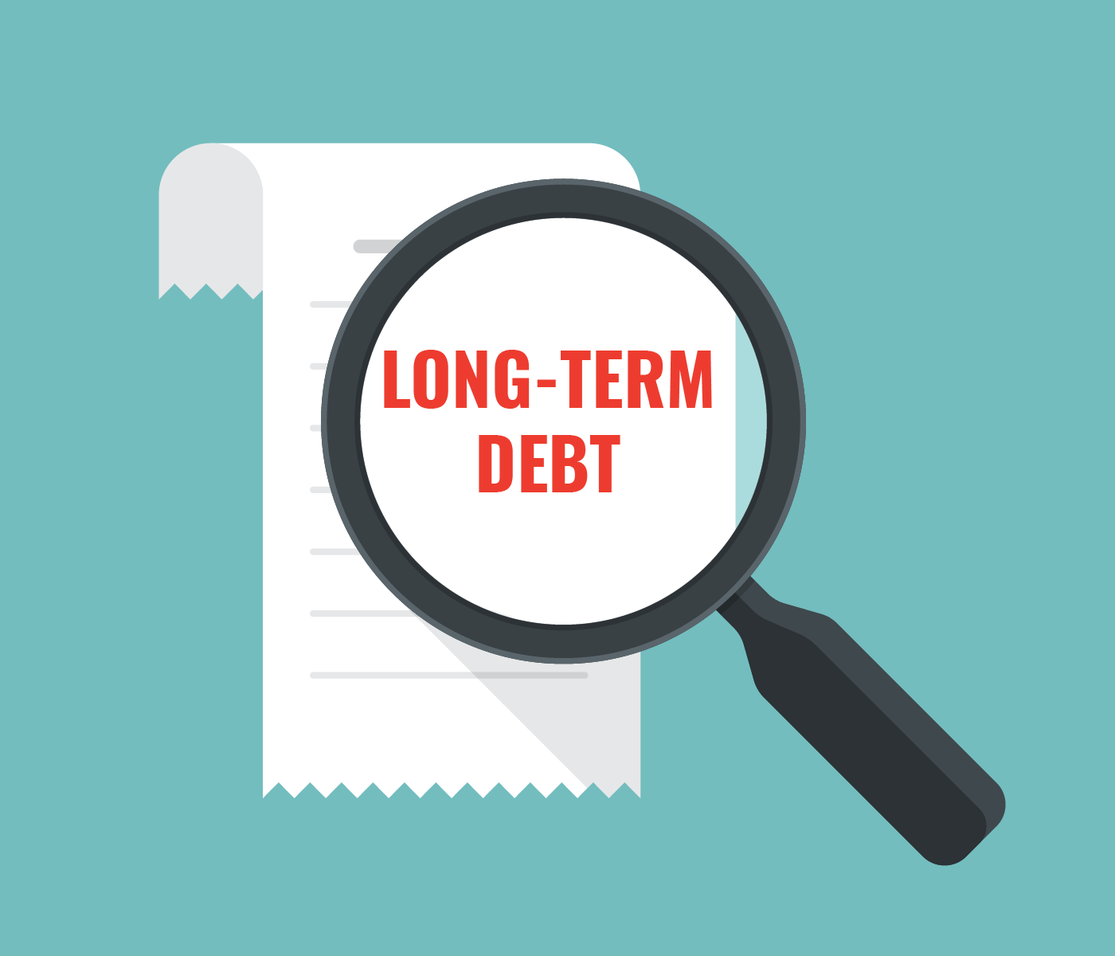](https://forum.mt5.com/customavatars/2101080535.png)

Basically, capital markets are concerned with long-term debts that include stocks and bonds which are both utilized to help fund long-term investments. These investments mostly grow a company's operations and create more income. In contrast, the money market focuses on short-term debt used to fund day-to-day activities such as deposits, collateral loans, acceptances, and bills of exchange.

The primary market and the secondary market are known as the two types of capital markets. Businesses and governments feel the need to resort to the primary market to obtain additional funds. In other words, investors decide to go into the capital markets to make loans out of using newly issued debt.  
  
**What are the Major Functions of the Capital Markets?**  
  
Capital markets play a lot of functionality. It presents as the connection between investors and savers. Capital markets facilitate the capital movement that ensures its productivity in boosting the national income of different countries. Basically, it helps in boosting economic growth. Since it finances long-term investments, it primarily works to help in mobilizing savings. Capital markets also improve capital allocation effectiveness. The most important function of capital markets refers to its help in providing continuous availability of funds that is both for different companies and governments around the world.  
  
**What are the Two Types of Capital Markets?**

[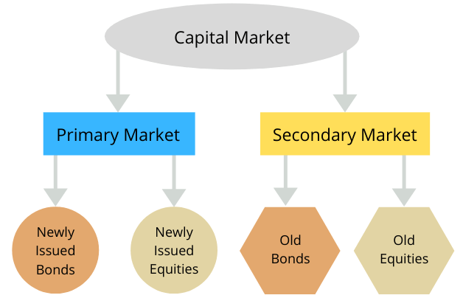](https://forum.mt5.com/customavatars/54947591.png)

1. **Primary Market-**The new debt or stocks are issued within the primary capital market. These new debts or stocks could be in the form of government bonds or firm shares, for example. It is also known as the New Issues Market. It presents the market where corporations and governments go to seek new money. The newly acquired funds are then invested in the company's debt or stock. It is either securely locked in until they are sold on the secondary market until the loan matures, or the corporation issues a stock buyback.
2. **Secondary Market-**The secondary capital market is where investors may trade existing loans or stocks. In contrast to the primary market where debt has already been issued, from the terms used it is a secondary market. In effect, the debt works like it was real money. The debt’s value is derived from the interest that is paid on it. It makes it a passive source of income. The debt is an illiquid asset in the sense that it must be sold to purchase goods and services in the market. Investors who are in need or required to sell their bonds and equities are found on the secondary markets.

**What are the Financial Instruments Traded in Capital Markets?**  
  
Financial instruments are records that prove rights, profits, or assets. It also presents any transaction that creates a financial asset for one company and a financial liability or equity instrument for another. Here are the financial instruments available in capital markets.

* **Bonds-** Bonds are generally a fixed-income instrument that is intended to fund infrastructure projects and other investments through sovereign and state governments, municipalities, and even businesses. It can be thought of as a loaning instrument with the issuer of the bond acting as the borrower. Bondholders are categorized as creditors involved under this kind of company. They are entitled to receive interest payments on a regular schedule. Bonds also have a specified lock-in duration. As a result, bond issuers are required to pay back bondholders the principal amount on the maturity date.

[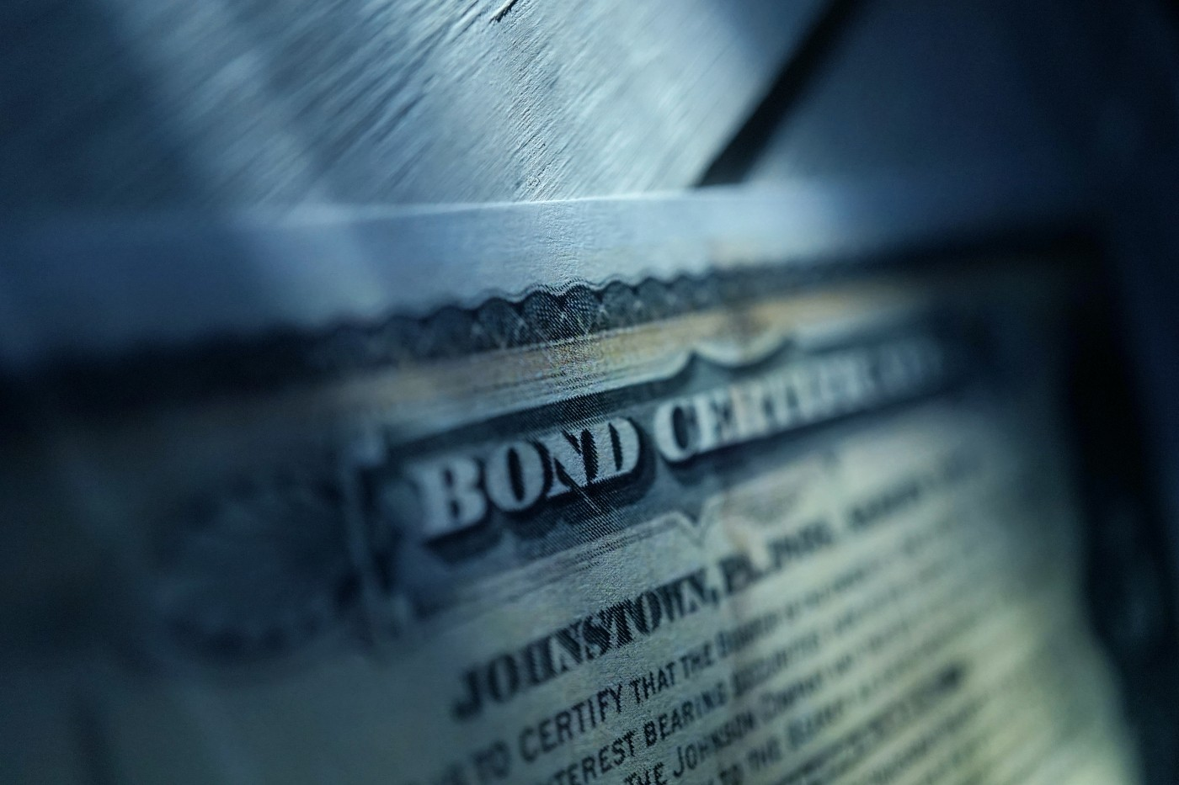](https://forum.mt5.com/customavatars/1546210288.jpg)

* **Debentures-** Debentures are a type of unsecured investment. Being an unsecured investment, they come with no assets or collateral to back them up. Investors operate as potential creditors of an issuing institution or corporation, and lending is totally dependent on mutual trust.
* **Derivatives-** Derivatives might appear as a complex concept but they also constitute a large market. They are adaptable with the ability to arrange and generate features which also include certain risk and return for other securities. Forwards, futures, options, and interest rate swaps are the four most prevalent types of derivative securities.
  1. **Forward:** A forward is a contract involving two parties wherein the exchange occurs at a specific price at the end of the contract.
  2. **Future:**A future is a derivative transaction in which derivatives are exchanged at a fixed price at a future date.

[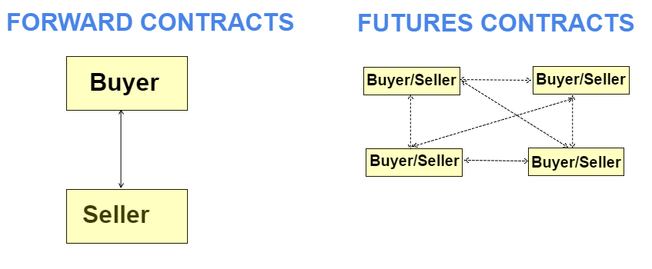](https://forum.mt5.com/customavatars/1743120715.png)

* 1. **Option:**An option is a contract among two parties in which the buyer has the right to buy or sell a specific number of derivatives at a specific price for a specific time.
  2. **Interest Rate Swap:** An interest rate swap is a contract involving two parties in which both parties commit to paying each other interest rates on their loans in different currencies, options, and swaps.
* **Exchange-Traded Fund (ETF)-** Exchange-traded funds are a collection of various investors' financial resources that are collected to buy various capital market items including stocks, bonds, and derivatives. ETFs with characteristics of both shares and mutual funds are commonly traded in the stock market as shares produced through blocks. ETF funds are traded on stock exchanges and can be purchased and sold as needed during stock market hours.

[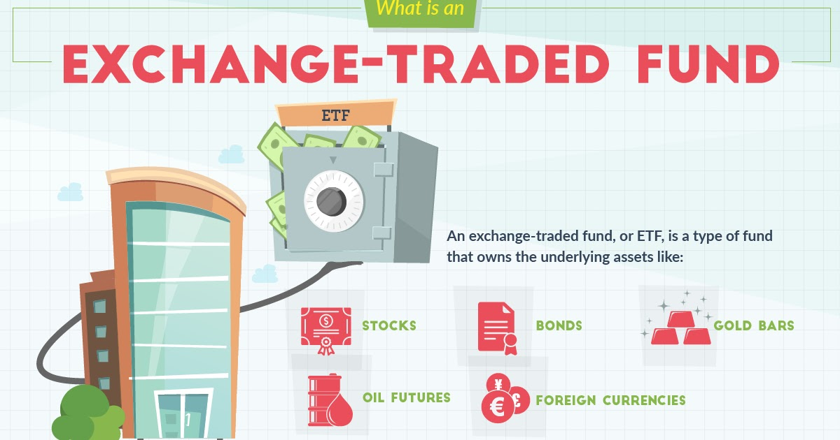](https://forum.mt5.com/customavatars/622080912.jpe)

* **Equities-** Common stock is another term used to identify equities. It is a type of instrument that businesses issue. It can either be purchased on the primary or secondary markets. Due to the fact that the contract remains in existence unless sold to another investor in the secondary market, an investment in this type of business converts to ownership of the business. The investor holds their specific rights and privileges within the company. It includes their ability to vote and occupy positions. The stockholder receives dividends that the amount may or may not be disclosed whereas the debt investor may be entitled to the interest that must be paid. The instrument does have a high-risk factor while it is likely to result in a larger return when it becomes successful. Holders of this instrument rank last on the scale of preference in the case of a company's liquidation because they are regarded as the company's owners.

**Conclusion**  
  
The buyer of debt or securities is related to the investors' readiness and willingness to take a risk and transfer their capital to various uses through capital markets. It usually works through brokerage firms that charge investors a nominal fee to process the transfers. The capital market is beneficial in increasing national incomes and improving a country's overall economic growth. Investors need to grasp the fundamental concepts to gain a thorough understanding of the capital market's meaning, forms, operations, and significance. Capital markets present a wide range of financial instruments which an investor can choose from to start their trades and investments. Investors can start investing through the