**What Currency Should You Buy Now?**

**Analysis of the Forex Market**

[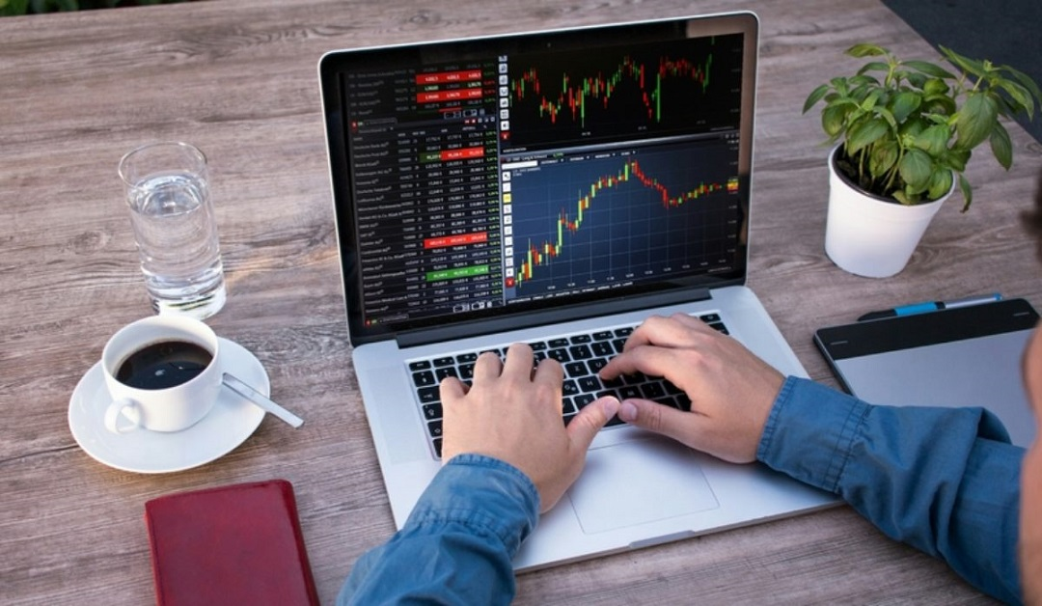](https://forum.mt5.com/customavatars/861659735.jpg)

One of the most active marketplaces found in the world refers to the foreign exchange market. The average daily volume of the Forex market in 2019 was more than 4 pounds which can be considered higher than the stock market's average volume per day. Investors should take into account the fact that they are allowed to trade for 24 hours a day and five days per week. It is good that market players are not restricted to trading during active trading sessions. It is not a surprise that many traders want to participate in the Forex market and trade currency pairs. In case anyone is interested, they should understand the differences between currency pairs and the factors that can drive the Forex market before deciding which currency pair to trade.  
  
The large percentage of central banks involved in industrialized economies have decided to lower their interest rates which affects the value of the currencies found in their countries. In this type of measure, the number of benefits associated with the general economy remain unclear. It resulted in the Forex market to be characterized with lesser volatility.  
  
**What is the Current Condition of the Forex Market?**  
  
A variety of factors such as advances in international trade that includes the event called Brexit or the United Kingdom departing from the European Union during the first quarter of 2020 affected the overall performance of the global economy. Events including the US/Iranian tensions, US presidential elections, and the spread of the Coronavirus are all likely to have an impact on the Forex market in 2020. Investors' choice for more stable currencies like the Japanese yen or the Swiss franc may be influenced mostly due to the uncertainty created from these variables.

Many analysts expect that in the upcoming year the US Dollar (USD) will be subject to depreciation. It is due to the expectations that the Federal Reserve Bank (FED) will decide to limit the interest rate rises and the lower demand for US dollar because of the decrease of investments in the global financial market. Investors are advised to be critical in watching the condition of the US dollar because it also has the potential to rise during election years. The US dollar is one of the most popular currencies in the world and it is under the pressure of the trade war at present.  
  
Interest rate movements of central banks are nearly impossible to predict but analysts believe that there is a nearly equal likelihood that rates will either be reduced or increased in the future. In 2020, interest rate unpredictability will continue to affect the Forex market's uncertainties.  
  
**What is Foreign Currency Trading?**

[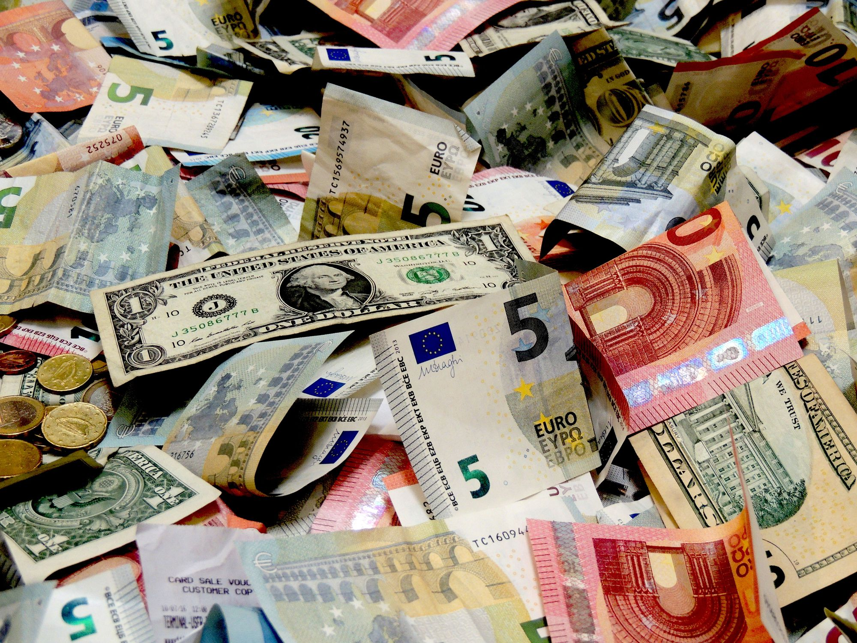](https://forum.mt5.com/customavatars/1927112314.jpg)

The foreign exchange market (Forex) is a market where currency pairs that come from two distinct countries are traded. Forex currency trading is the term for this definition. Identifying the fittest Forex currency pair to trade will need traders to study and read articles to help them choose. They should also consider what is suitable for their trading style and preferences.

The goal of Forex trading which is also commonly known as foreign exchange trading is to buy and sell currencies in pairs. Traders have the need to know how much each currency in a pair is worth in respect to each other and for them to be able to buy and sell currencies effectively. A currency pair is identified with this connection. The value of the base currency or the first mentioned is given in the quote currency or the second one listed.  
  
**Top Currency to Buy In 2020**

* **United States Dollar or USD**- The US dollar (USD) has become a very volatile currency. In fact, according to bank experts, USD will continue to come with its uncertainty in 2021. Bank experts anticipate that the USD might become weaker than other currencies due to persistent uncertainty from the Coronavirus pandemic. Other reasons for this include the stumbling US economy and the increase in the USD money supply. There are several factors that could have an impact on US dollar movements and bank estimates in the coming months. Despite the fact that many people believe the US Dollar to be less stable, it remains as the world's reserve currency and its popularity is undeniable. In fact in 2019, the US dollar accounted for over 90% of all foreign exchange transactions.

[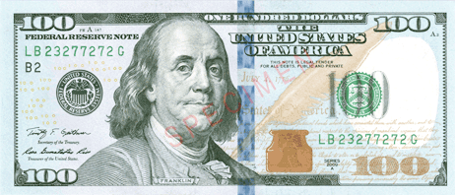](https://forum.mt5.com/customavatars/306272507.png)

* **Euro**- Euro appears next to the US dollar as the most commonly used currency in the world. After the pandemic crisis, the euro's international status has continued to be relatively stable. In international green bond markets, the euro plays a significant role. In 2020, the euro's international role remained mostly unchanged. It refers to one of the main findings from the European Central Bank's (ECB) latest annual review about the euro's international role that was released recently. An ECB official stated that the euro remains unchallenged as the world's second most extensively used currency behind the US dollar. The euro's share between several global currency indicators remained constant , averaging around 19% in 2020.

[](https://forum.mt5.com/customavatars/767532081.jpg)

* **Swiss Franc**- Switzerland and Liechtenstein both use the Swiss franc as their official currency and legal money. The currency is abbreviated as CHF with CH stands for Confoederatio Helvetica and letter F refers to Franc. Switzerland is frequently regarded as one of the world's wealthiest countries that comes with one of the highest GDP-per-capita figures. The Swiss franc surpasses the US dollar. One franc was bought at $1.10 during the end of trading hours on February 24, 2021.

[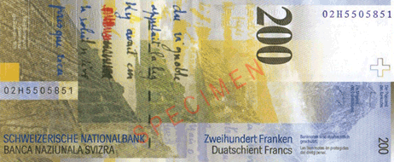](https://forum.mt5.com/customavatars/152530397.png)

The Swiss franc has always been regarded as a safe haven asset. In comparison to other safe havens like gold, the Swiss franc is more widely available. It appears as a very liquid asset. It is currently strengthened with the strong Swiss economy which is widely regarded as the world's major banking center. Swiss francs are popular among institutional investors and governments for this reason but ordinary investors are generally more interested in other assets.

* **Japanese yen or JPY**-The Japanese yen comes as a desirable currency to invest in for a variety of reasons. It follows the United States Dollar and the euro. The Japanese yen is known as the world's third most traded currency. In starting with, the country's inflation rates have been minimal for a long time. The particular currency is not connected to the US Dollar or the Euro so it preserves its purchasing power even during a crisis. Unless the Japanese yen is used in all transactions other than those in the United States, good trading connections help to keep the currency liquid.

[](https://forum.mt5.com/customavatars/580060804.jpg)

Due to the recent the COVID pandemic, the Japanese yen underwent a long-term trend of gain as what was seen in the exchange rate during 2020. In contrast, the yen experienced a large increase in value shortly before the pandemic hit Japan hard at the beginning of March. It is linked to the currency's safe-haven status. During the new year, the yen remained where it was in 2020 with reports predicting additional increases in the currency's value. A long-term appreciation of a currency is actually a good indication regarding a country's performance. It means Japan has a good performance since it is deeply concerned about its exports that may be priced out and become weak as a result of the massive increase in the yen.

**Conclusion: The Importance of a Good Trading Platform**  
  
Many elements are considered that includes having a well-written trading plan and sticking to it which can make or break the trader. It demonstrates that traders are aware of both of their entry and exit points. Trading includes a lot of psychology and can be challenging to handle if traders do not have a clear plan. The goal is to keep their emotions from having a psychological impact on trading performance.  
  
Except for the psychological aspect, traders who have a trustworthy broker and platform are critical. MetaTrader trading platforms are commonly considered to be among the top Forex trading platforms available. Several platforms are the most popular in the world and they include a variety of technical indicators to assist chart analysis. Several platforms are the most popular in the world and they include a variety of technical indicators to assist chart analysis.