**How to Invest in Cobalt Stocks?**

**Introduction to Cobalt Stocks**

[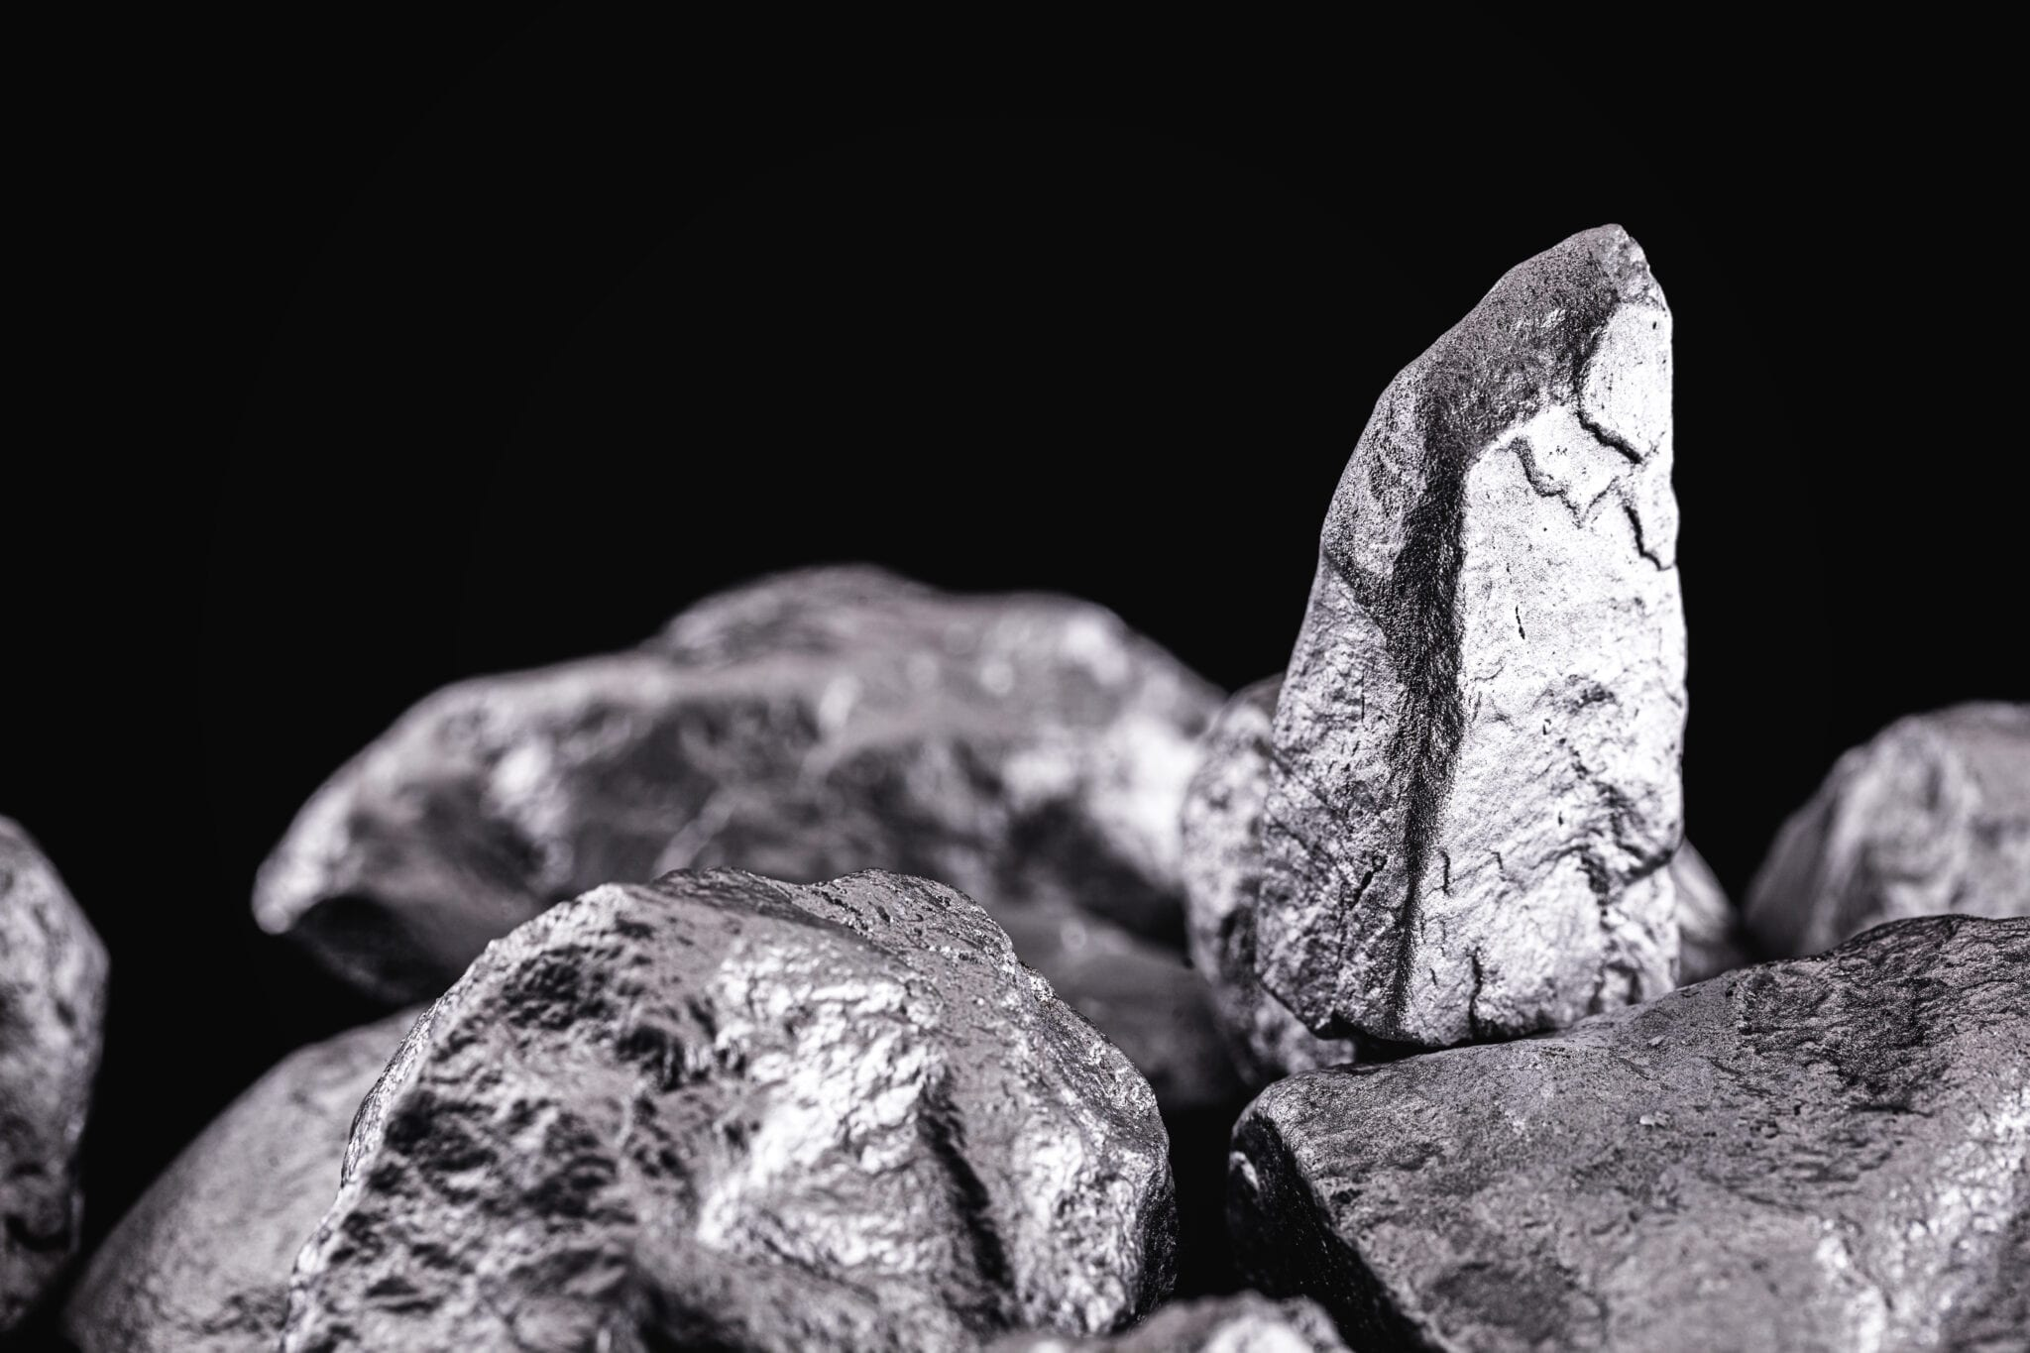](https://forum.mt5.com/customavatars/2021504227.jpe)

The world of investing offers a wide range of options to any possible investor. Investors can put their money in contracts, bounds, and even in elements found around the physical world. Cobalt appears to have similarities to its cousin nickel which is also a naturally occurring element. Cobalt is characterized to be hard and silver-gray in color. It is a metal derived from the earth’s crust in a very chemically combined form and apart from small deposits found in meteoric iron. Due to its low deposits within the earth’s crust which are estimated to be at 0.002%. Cobalt is not recognized as a native metal. Cobalt is commonly produced from copper and nickel-mining activities.  
  
Cobalt’s price and recognition around the world have significantly soared over the recent years. The element has emerged as a key material in a considerable range of applications in different industries. Cobalt can make a lot of things such as magnets, paints, and chemical catalysts. Its favorable increase in demand over more modern years has been right down to its crucial role in batteries utilized in both electrical devices and electric cars. Over half of all cobalt produced is used to make battery chemistry, with nearly a fifth used to make superalloys for rising items like aircraft engines.  
  
**What Are the Reasons to Invest in Cobalt?**

[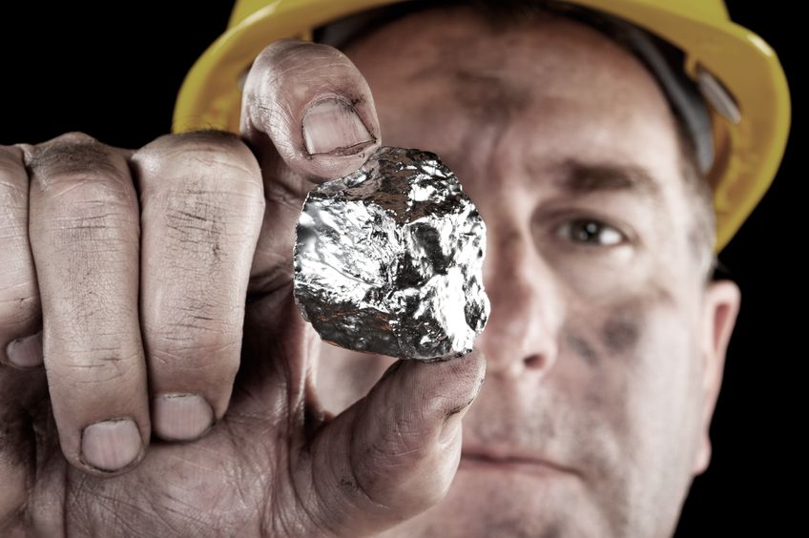](https://forum.mt5.com/customavatars/1603455209.jpg)

The majority of this interesting metal is mined from the Democratic Republic of Congo (DRC). Among all the countries of the world, Russia, Australia, and the Philippines are other major cobalt producers aside from DRC. These are the countries known to produce the rawest cobalt. In contrast, China produces the most quality cobalt. Cobalt has grown into a global sector and is currently one of the most in-demand precious metals. The price of cobalt has varied over the last few years but it is continuously changing.

[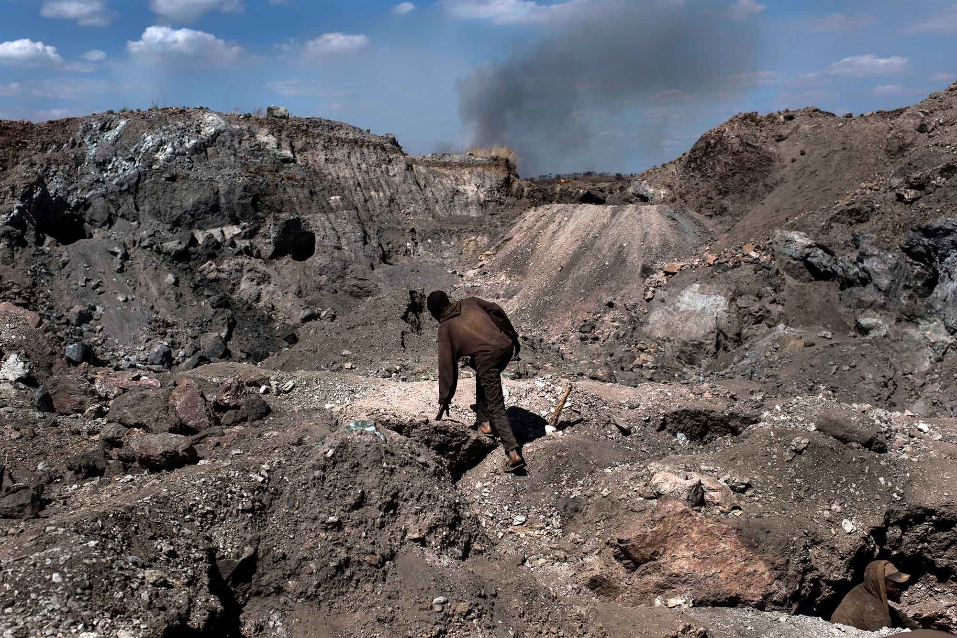](https://forum.mt5.com/customavatars/1202348316.jpg)

According to experts, the worldwide demand for cobalt is likely to expand up to four times its present level. One reason why cobalt’s demand is expected to rise is due to a lot of innovative technologies that are existing. It is uncertain that another metal or technology will be able to substitute cobalt's usefulness. Both cobalt and nickel are frequently used together in the technology industry. Cobalt appears with special properties that help to counteract some nickel instability.

[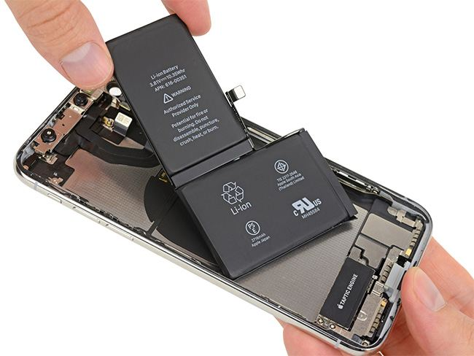](https://forum.mt5.com/customavatars/2087476770.jpg)

Investors can easily figure out why cobalt is so popular right at present times. Several technology corporations are shifting their focus on cobalt as a result of global climate change. It has come to a time that many people are devoting their interest, time, and efforts to environmentally friendly items such as electric vehicles.There are a lot of electric vehicles that now prefer to use rechargeable lithium-ion batteries. It means these vehicles do need cobalt for the companies to produce them. The rechargeable batteries found in smartphones, laptops, and other electronic devices also require cobalt.

[](https://forum.mt5.com/customavatars/523166877.jpg)

**What are the Risks of Investing in Cobalt?**

Investments come with risks regardless of their type and investing in cobalt appears to have some. Several potential downsides of cobalt appear to come with the need for investors to consider them. People’s cobalt exposure from the air can create long-term breathing issues. Cobalt can irritate the skin of those who have sensitive skin or skin diseases. Investing in cobalt companies is one of the world's best methods for investors to profit from the growing demand for the element. The majority of these businesses also work to mine both nickel and copper. It is because raw cobalt is frequently produced as a by-product of the mining of these other valuable metals. Companies that handle and finance cobalt can potentially be profitable investments.  
  
It is indeed necessary to keep in mind that cobalt stocks have a history of being somewhat volatile. Since this metal presents a lot of potential, it is also tough to predict what the future has in store. Some investors view investing in cobalt to be dangerous at the same time see investing in other precious metals as their safer bets.

[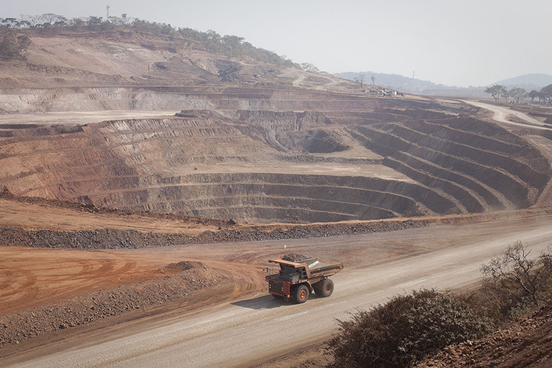](https://forum.mt5.com/customavatars/2050193603.jpg)

According to the previous reports, cobalt from the DRC is becoming increasingly investigated. Cobalt is not legally classified as a conflict mineral at present but some human rights organizations are asking for it to be. Numerous DRC cobalt operations and mines are characterized to be unsafe and poorly managed according to these human rights organizations. They also suggest that the users of the product of the metal should look for it elsewhere.

**What are the Ways to Invest in Cobalt?**

* **Supply and Demand**  
    
  In 2020, the Democratic Republic of the Congo (DRC) produced 95,000 metric tons of cobalt which greatly exceeded Russia's 6,300 metric tons. The Eastern European country was known as the world's second-largest cobalt producer within the same year. Australia produced 5,700 metric tons as the third-largest producer and the Philippines with 4,700 metric tons came as fourth. Cobalt is now manufactured in roughly a dozen nations throughout the world so it can boost the investors’ confidence in its supply.  
    
  The demand for cobalt is also something to consider. It is also difficult to predict how much demand for the metal will expand in the future years but many experts believe it will become huge. The lithium-ion battery market will likely be the major driver of that anticipated demand with battery output likely to increase as the number of electric automobiles increases. The continuous production of innovative gadgets that use lithium-ion batteries is also a reason for this possible increase.  
    
  The consensus presents the supply and demand dynamics that will result in the cobalt market into its shortage in the coming years. Several researchers predict that global cobalt demand will reach between 235,000 and 430,000 tons in 2030. It is less than two times the current global cobalt refining capacity. It is because cobalt comes from the nonrenewable resources of the earth.
* **Futures and Stocks**  
    
  Several reasons and circumstances were able to attract a significant number of investors to invest in the cobalt industry. There are two main ways to invest in cobalt including futures and stockpiling cobalt. The cobalt futures contract is present on the London Metal Exchange under the symbol CO. These are futures contracts that began trading in early 2010 and are denominated in US dollars/ton. The contracts have a duration of 15 months which allows investors to bet on the metal for different periods.  
    
  Investors can also get their exposure to the critical metal in investing in cobalt-mining companies because it might be hard to find a way to directly deposit on the primary cobalt. Several Canadian cobalt companies come with great profits which makes them ideal for inventors who are just starting.

**Conclusion**  
  
Investors who are considering cobalt stocks should still think twice and consider all possible situations and predictions. Weighing the cons and pros will help investors decide. Investors may find that there is a lot of critically acclaimed news about cobalt's potential in the investing industry. In contrast, reality appears to be a lot more simple. Individual investors have few options for adding cobalt to their investment portfolios and the limited number of cobalt stocks available have not yet proven to be good investments. The anticipation of the possible increase in the utilization of the cobalt for lithium-ion batteries will still need a few years so investors can decide whether to invest now or wait.