**What Are the Differences of Recession and Depression?**

**What is a Recession in Finance?**

[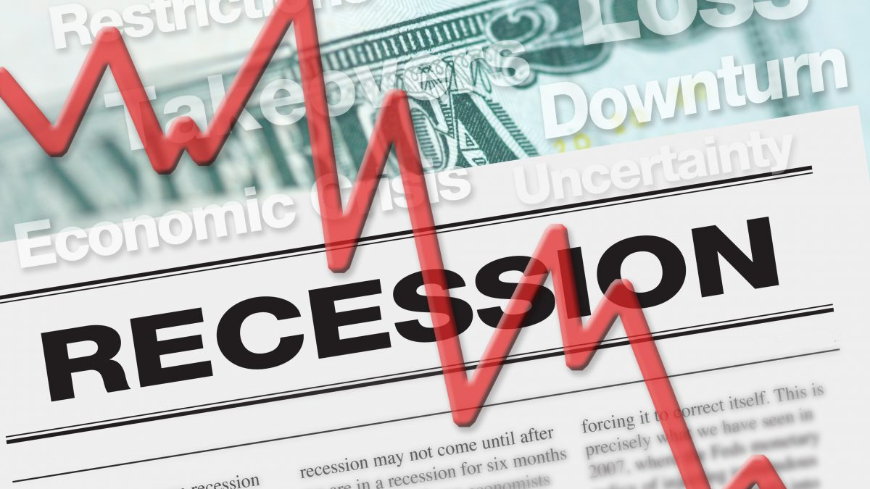](https://forum.mt5.com/customavatars/921773419.jpg)

A recession refers to a significant decline that takes place in economic activity. It can last for a span of months and years. Financial experts evaluate a nation’s economic condition. In cases where there is a negative gross domestic product (GDP) along with increasing unemployment rate, declining retail sales, and decreasing measures of income and manufacturing. These given conditions exist already for a long period.  
  
The occurrence of recessions is an inevitable thing to expect in the business cycle. It is also considered as a normal cadence of expansion and contraction events within the particular nation’s economy. Throughout the recession time, the economy is struggling while more people are unemployed and losing their jobs. A significant number of companies from different industries are achieving smaller sales so the country’s economic output is greatly affected and declining. A nation’s economy is declared to be under recession according to a set of different factors which most experts can set.  
  
An economist named Julius Shiskin was able to formulate a few indicators about the definition of recession. In 1974, Shiskin identified the two consecutive quarters that show declining GDP. It is a fact that an economy with a good condition takes time to form but having two quarters with contracting output may indicate serious economic problems. Shiskin’s definition of the recession became popular and used as a common standard over the years.  
  
The entity that holds the authority to figure out when a recession starts and ends in the United States refers to the National Bureau of Economic Research (NBER). NBER comes with its definition of recession. A recession is a significant decline within an economic activity that expands beyond the economy and usually exists beyond a few months. It is acknowledged well in GDP, real income, employment rate, industrial production, and retail and wholesale sales.  
  
**What Happened During the Great Recession of 2008?**

[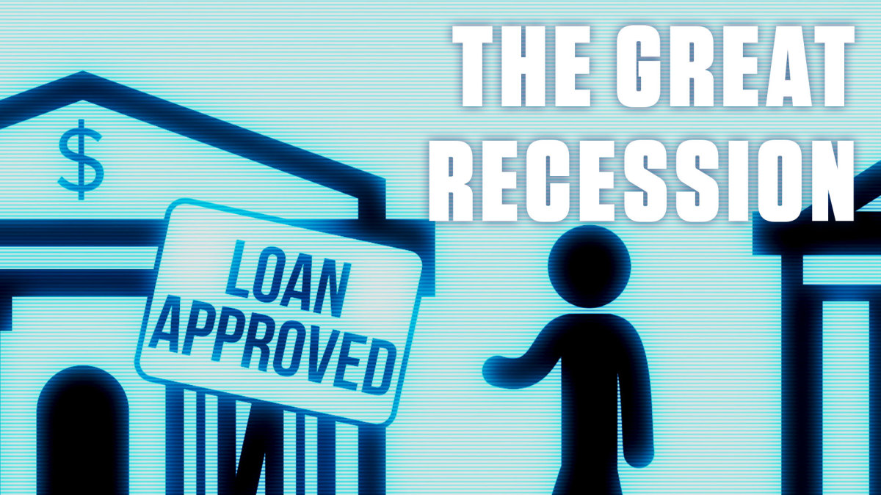](https://forum.mt5.com/customavatars/41640131.jpg)

The Great Recession of 2008 came but its early signs first occurred in 2006 due to the decline in housing prices. After the third quarter of 2008, the subprime crisis had spread throughout the economy along with GDP falling at 0.3 percent.  
  
The first signal came early in October 2006 according to some financial analysts. Orders for durable goods appeared to be lower than orders in 2005 which reveals a slowdown in housing construction. These orders also reflect the health of manufacturing orders which is a critical indication of national GDP growth.

The Great Recession of 2008 lasted from December 2007 to June 2009 which makes it the longest downturn ever since World War II. The Great Recession has shown a particularly painful impact in various ways despite its short duration. From reaching its peak in 2007Q4 to hitting its bottom in 2009Q2, the real gross domestic product (GDP) dropped by 4.3 percent. The decline in GDP is identified as the greatest drop in the postwar era based on available data. The unemployment rate grew from 5% in December 2007 to 9.5 percent in June 2009 before peaking at 10% in October 2009.  
  
The financial consequences of the Great Recession of 2008 were also significant. The home prices dropped 30% on average from their peak in mid-2006 to mid-2009 at the same time that the S&P 500 index dropped 57% from its peak in October 2007 to its trough in March 2009. The net worth of US individuals and charity organizations dropped from around $69 trillion in 2007 to around $55 trillion in 2009.  
  
Since the financial crisis and recession intensified, worldwide policies aimed at reviving economic growth were implemented. Many other countries including the United States enacted economic recovery measures that included a variety of government spending and tax reductions.  
  
**What Refers to Depression in Finance?**

[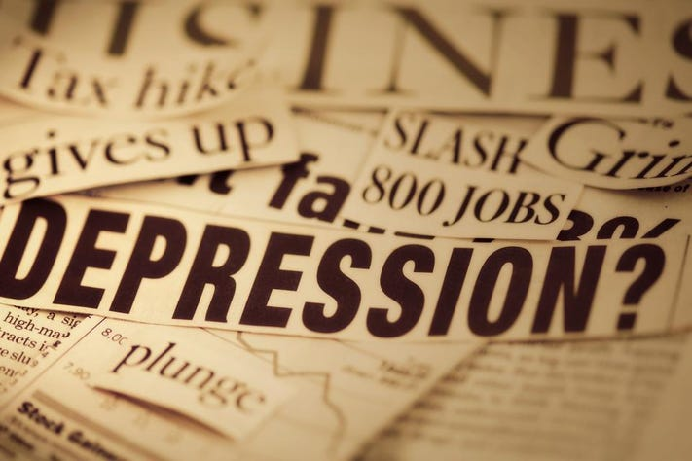](https://forum.mt5.com/customavatars/1725355197.jpg)

Depression is a nation’s economy is characterized to be an extreme downturn that is likely to last for several years. Depression appears to be worse than recession but it lacks a precise definition and definite specifications. Analysts can declare that there is a depression while most people take it as an economic event which is a severe recession and more extensive impacts. There is no specific time and event that can categorically identify the start of depression.  
  
The NBER considers the role of economists to modify the time that can identify an economic depression. Many experts claim that depression lasts only for as long as economic activity is falling, although the more widely held belief is that depression lasts until economic activity returns to near-normal levels.  
  
During the event of depression, an economy's productivity is characterized to drop down dramatically. Both the GDP (gross domestic product) and the GNP (gross national product) are declining which indicates a rise in business failures and unemployment.  
  
Once the recession continues to cause problems in an economy, the established process causes further reductions in investment and consumption expenses as investors and consumers lose confidence. In addition, the financial crisis may result in a reduction in credit availability. In the relative value of a currency, there are excessive fluctuations. Trade and commerce generally suffer a crushing defeat. The Great Depression of 1929 is widely regarded as the most classic example of an economic downturn in history.  
  
**What Happened During the Great Depression of 1929?**

[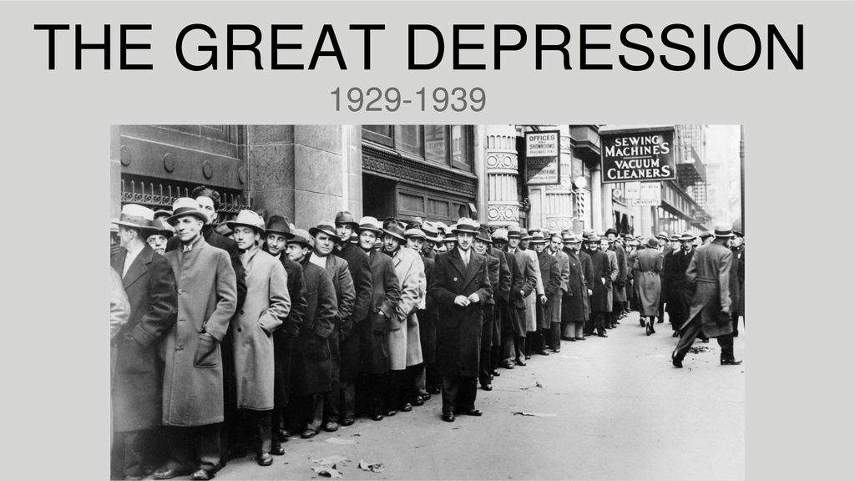](https://forum.mt5.com/customavatars/879103020.jpg)

One of the most severe economic downturns in history refers to the Great Depression of 1929. The span of this economic downturn lasted from 1929 to 1939 which is among the longest events that occurred. The Great Depression of 1929 started as a recession in America before spreading in other countries of the world especially in Europe.  
  
There was a series of events that led to the Great Depression to occur. The events include the stock market crash of 1929 and the severe drought of the Dust Bowl in 1930. Similar to any long-term economic crisis, a significant economic event is composed of a series of events.  
  
Before the actual crash, the economy was already on the decline. It came with rising unemployment rates and manufacturing appears to be falling which leaves stocks significantly inflated. On October 24th of the year 1929, the popularly known "Black Thursday" happened. During this day investors sold nearly 13 million shares of stock which gave signals to consumers that their lack of confidence was justified. The spending appeared to slow, debt significantly grew, homes were foreclosed on, and banks began to fail.  
  
The stock market crash in October 1929 triggered fear and confusion that resulted in a sharp decline in consumer spending and investment. It also in turn caused a decrease in manufacturing and contributed to greater unemployment and the failure of the majority of the country's banks.  
  
The Great Depression began in 1929 and lasted until 1933. The economy did not fully recover until nearly a decade later even during World War II. During the Great Depression, unemployment rose to 25% and the GDP fell up to 30%. It was the most unprecedented economic collapse in modern U.S. history.  
  
**Differentiating the Recession and Depression**

[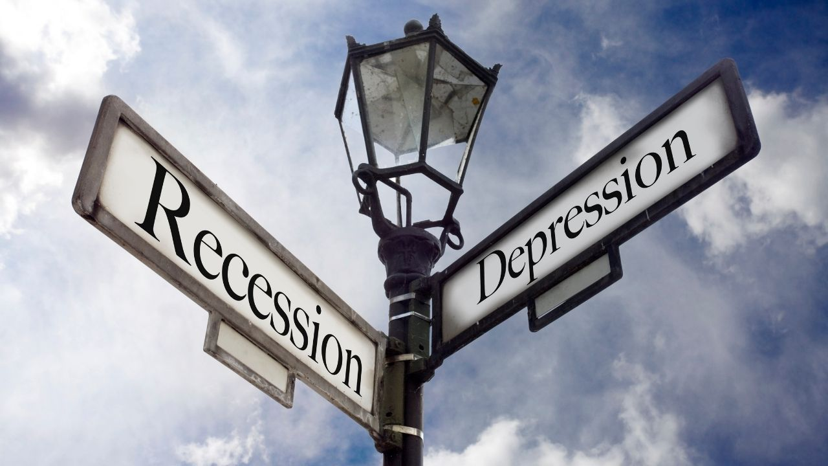](https://forum.mt5.com/customavatars/750446089.jpg)

Both recessions and depressions appear to have similar indicators and causes. Their severity, duration, and overall impact are the most significant differences between the two. Depression usually lasts for a couple of years but not months. It is marked with higher unemployment and a sharper drop in the GDP. In contrast, a recession is often limited to a single country at the same time that depression is usually severe enough to have global trade impacts.  
  
The fact that economists had not agreed on a definition for what constitutes depression. It results in the public sometimes confuse it with the term recession. These two terms are hard to precisely distinguish from each other. Historically speaking, there has only been one depression that happened in the United States which refers to the Great Depression of the 1930s that lasted for ten years.

In comparing the historical events of the Great Recession and Great Depression of all time, the former was acknowledged as the worst recession ever since the occurrence of the latter. At the time of the Great Recession, there was a significant increase in the unemployment rate and it lasted for a year and a half.  
  
The COVID-19 pandemic resulted in a recession which most economists fear to develop into a depression according to the time that it will stay. A substantial increase in unemployment was evident and characterized as the worst ever since the Great Recession.  
  
**Conclusion**  
  
Achieving a greater understanding of the world of trading and investing may require reviewing the past significant events that greatly impact the current state of the economy. Historical data display the same importance as the new data about the economy whether of a particular country or the world. The economy’s condition shows effects on businesses and industries as well as to individuals within a country even in the world. Differentiating recession and depression appear to help make a definite definition of the two as well as in anticipation of any economic event in the future. Reading more about the important concepts of trading and investing at the same time can help. Market players can access the InstaForex website to monitor the stock market and currencies of the world.