**What Is the Meaning of PMI?**

**What Refers to PMI?**

[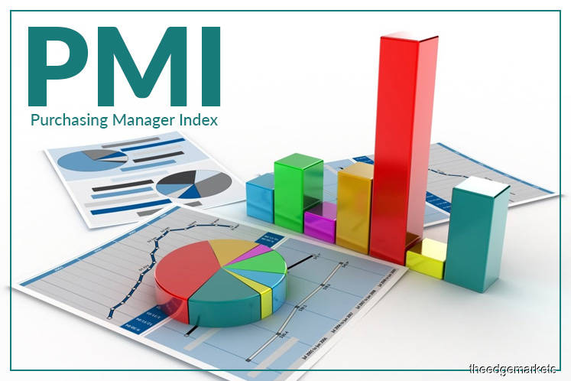](https://forum.mt5.com/customavatars/1028631380.jpg)

The PMI stands as an abbreviation for the Purchasing Managers’ Index which refers to one of the most used and monitored indicators of business activity around the world. PMI is generally an indicator of any business activity of the manufacturing and services sectors. PMI gathers information from conducting surveys as its measurement. The survey asks the respondents questions about changes on how they perceive some key business variables. It is usually conducted from the month before. PMI is computed separately for the manufacturing and services sectors.  
  
The survey for the PMI comes from a series of qualitative questions. The respondents of the surveys include executives from a big sample or samples from different companies. Questions are usually about the key indicators like outputs, new orders, business expectations and employment. Respondents are asked if they think that these key indicators appeared to be stronger during the previous month and they will likely be asked to rate them.  
  
PMI is released at the start of each month because it should come before the official data on industrial output, manufacturing and GDP growth is readily available. Most economists found PMI to be a useful indicator about the industrial output. PMI helps the central banks to come up with their decisions regarding the interest rates. In financial markets, PMI serves as an indicator of the corporate earnings. Investors monitor the PMI together with the bond markets.  
  
**What are the Uses of the PMI?**

[](https://forum.mt5.com/customavatars/222236350.png)

* The PMI appears as a key leading indicator that has the ability to influence financial markets. More than that, rather than making wholesale portfolio changes based on a single reading PMI takes more sources. Once the current index reading implies an unexpected reversal in the economy whether it is for better or worse then it may be wise to wait until additional indications validate the economy's recovery.
* Market players should think deeper from the headline PMI number presented to them. The ISM Manufacturing Report on Business provides essential data on critical aspects of the US economy. It includes the production, rate of employment, prices, and exports and imports. They can obtain a clearer picture of the US economy through giving effort to dig into the facts in contrast to relying solely on the PMI figure.
* Investors should position portfolios before the ISM data is released. Due to the fact that PMI can be a market-moving number, it could be a good idea to position portfolios before the data’s actual release. In times that the US economy appears to be rising quickly and the PMI figure is expected to contribute to the bullishness then buying US equities ahead of the report's release may be profitable. In another situation where a weak PMI figure is expected then it may be advisable to reduce some U.S. equities exposure before the report is released.

**What are the Major Advantages of the PMI?**

* PMI emerged as a timely indicator because it is released during the month’s first day after the previous month in which the survey was conducted.
* PMI is also characterized as an accurate indicator regarding the current state of the United States’ economy.
* PMI works to condense the current condition of the whole U. S. manufacturing sector to be a single number.
* The PMI’s Report on Business includes a huge amount of information regarding the main business activities.

**What are the Major Disadvantages of PMI?**

* Over the past few years, the importance of the manufacturing sector continuously lessens for the U. S. economy, but it is still included in the PMI.
* The Report on Business survey or the data that is needed in the calculation of the PMI may tend to be subjective. It also comes with the possibility of acquiring errors.

**Where to Find the PMI Data?**

Based on the organization and country, the purchasing managers' index is released in different areas but at the same time very accessible for investors. IHS Markit and ISM among others both publish their PMI data for the United States. The Chinese Bureau of Statistics publishes its own set of data. Regarding the PMI data, most investors rely on the two most common sources including the ISM and IHS Markit.

* **ISM-** The manufacturing release from the Institute for Supply Management (ISM) is released on the first business day of each month. It is at the same time that the non-manufacturing release is provided on the third business day. The index covers all prices paid for purchases such as imports and food and energy purchases except crude oil. The production index compares the current month's output to the previous month's output. The ISM is a non-profit organization with about 40,000 members working in supply management and purchasing.

[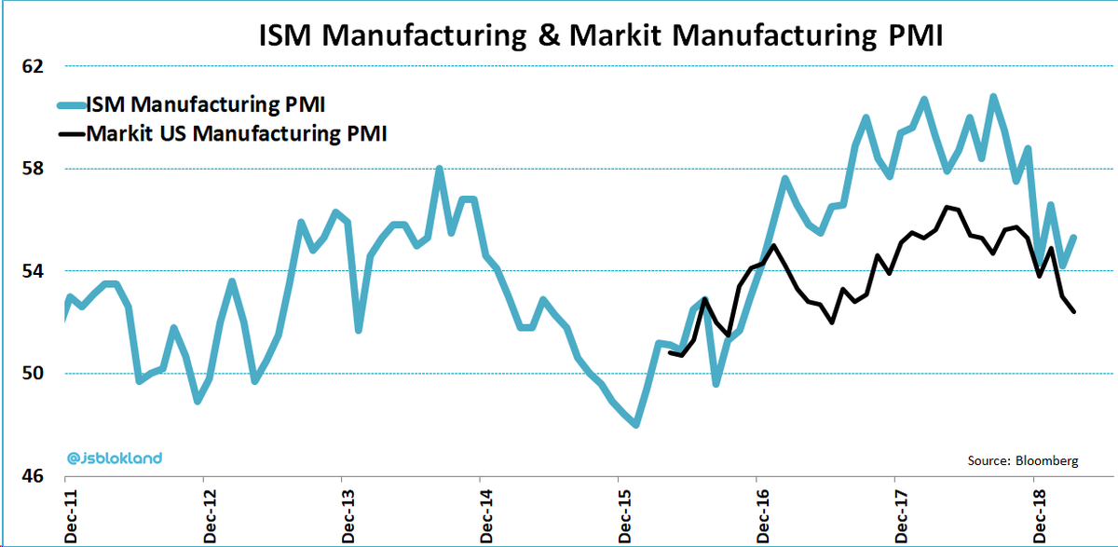](https://forum.mt5.com/customavatars/1597536127.png)

* **IHS Markit-** IHS Markit is an information services company that serves customers in key sectors, financial markets, and governments. The company comes with data, research, analytics, and technology. The company's fundamental capability is its ability to acquire and translate data into information and analytics that their clients can utilize to make operational and strategic choices.

[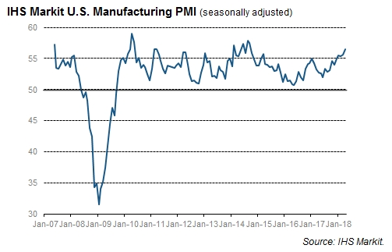](https://forum.mt5.com/customavatars/1817672440.jpg)

The link to reach the IHS Markit is <https://ihsmarkit.com/products/pmi.html> while to access the ISM the link is [https://www.ismworld.org/supply-mana...t-on-business/](https://www.ismworld.org/supply-management-news-and-reports/reports/ism-report-on-business/).  
  
Most western countries have their own PMI wherein the Bank of England in particular utilizes PMI as part of its economic monitoring when deciding on bank rates in the United Kingdom. Many developed countries including Japan, Australia, and much of Europe have their own PMIs. In fact it has reached the time that the whole world already has a world PMI.  
  
Utilizing services like Trading Economics help the international investors can find the most recent PMI data for different nations. Investors may quickly check into the impact of any changes because PMI data is routinely publicized in the financial media.  
  
At the time that a country's PMI falls then investors may likely consider reducing their exposure to the equity markets of that country. The set of rising PMI readings, investors can consider to boost their exposure to shares from other nations. In examining the impact of potentially greater inflation on overseas bonds, it is also useful to look at price-related statistics. In general, greater inflation estimates indicate that investors may want to minimize their bond market exposure due to the possibility of lower prices.  
  
**Conclusion**

The PMI is often used as an investment indicator within the financial markets. Large increases in supply being supplied can be seen as a pivot point for inflation in bond markets and investors usually closely monitor it.  
  
The Purchasing Managers Index (PMI) is characterized as a simple-to-understand indicator that governments, Federal and State banks, and the investing industry use. PMI emerged to be significant to all of these sectors.  
  
The PMI is a critical leading indicator that sheds light on the status of the overall economy and the manufacturing sector in particular across the United States. Since it is sometimes disregarded, new investors should become acquainted with this important economic indicator. New investors are more prone to making uneducated investments decisions so considering the PMI will greatly help their decisions.