**What Is Points in the Stock Market?**

**What Refers to a Stock Market?**

[](https://forum.mt5.com/customavatars/1464777207.jpg)

The stock market is interchangeably used with equity market or share market for they all mean the same. It refers to the gathering of buyers and sellers of stocks which are also known as shares. Both the activity of buying and selling do reflect ownership claims on companies. These may include ownership on securities listed on a public stock exchange and for private stocks. Private stocks include shares of private companies that are sold to investors through equity investing platforms. Stockbrokers and computerized trading platforms are among the most common ways to invest in the stock market. The majority of investments that traders and investors do are together with a specific investing strategy in mind.  
  
Through the years of the stock market’s operation, it arises as a popular way to make the most of one’s money. The stock market is characterized as a way to generate wealth for people who are up to its practice. It has also become the source for most companies to achieve funding and liquidity. Since stock ownership is becoming more popular, mainly as a result of participation in retirement plans. Another reason is that more media outlets are covering the stock markets in more ways in comparison to the attention it received before. The terminology can be complex at times especially for those who are just starting to invest or trade but it is easy to understand once they have some previous knowledge.

[](https://forum.mt5.com/customavatars/1614231338.jpg)

Media outlets are now reporting about the stock markets and it mostly includes the stock market points. The news usually refers to the current condition of major stock market indexes like the Dow and S&P 500. In an instance, a financial news channel reports the Dow was down 10 points today. In order to understand this kind of news, both traders and investors should be aware that there is a difference in value between the points involved in the stock indexes and share prices. Making a computation regarding how to convert these points to a percentage will help traders comprehend the actual value of the points.

**What Refers to Points in the Stock Market?**

* **Stock Index Points-** The point in the Dow Jones industrial average or the S&P 500 index is basically a whole number within the index value. The Dow Jones index will gain one point once it rises from 10,000 to 10,001. In discussing the concept of stock index points, whole numbers are used as a representation of gains and falls. It also includes fractional values after the decimal point but they are disregarded. Investors need to know the current value of a stock index to figure out what the points mean. In times when the Dow Jones industrial average was at 13,180 and the S&P 500 index was at 1,420, a point would represent a significant difference in value for the Dow index over the S&P 500 index.

[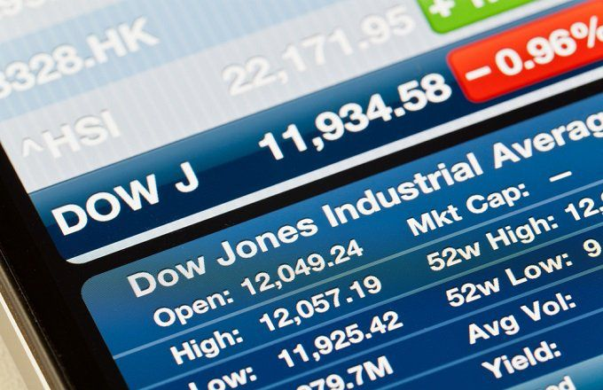](https://forum.mt5.com/customavatars/429484459.jpg)

* **Stock Share Points-** The concept of points in the stock market are used in two ways and the other way refers to the points in stock shares. The direction in which a single stock or the market as a whole is moving at present is revealed using points. Over the duration of a trading day, points may rise and fall many times. At the end of each trading day, points come as a reflection of whether stock values are up, down, or unchanged in proportion to their position at the start of the day. Recognizing what a point on the stock exchange represents is essential not only for the information it provides daily but also for what it means over time. Long-term investors might need the past and present points’ indications in making their investment decisions.  
    
  In an instance where a point from the standpoint of a single common stock share simply represents a single point and a single investor then a single point here is equal to $1. For example, a $100 per share stock increases to $105 per share or falls to $95 per share then the gain or loss is five points. It is the kind of data that can be used to track the performance of equities that an investor already holds and for the evaluation of a stock that they are considering buying.  
    
  Points represent whole dollar price movements for individual stocks. If someone reports that IBM is up for 10 points then it means the share price has increased up to $10. On a $10 stock, a point is a dollar, and it is similar for a $500 stock where a point is a dollar. Since the term points are so widely used in the stock market, a news reporter may not feel the need to specify whether a point is a dollar on a stock or the entire number of a stock index. In figuring out what a point implies about a certain stock or index, traders must first understand the stock or index current value.

**Understanding Points in Stock Market**

[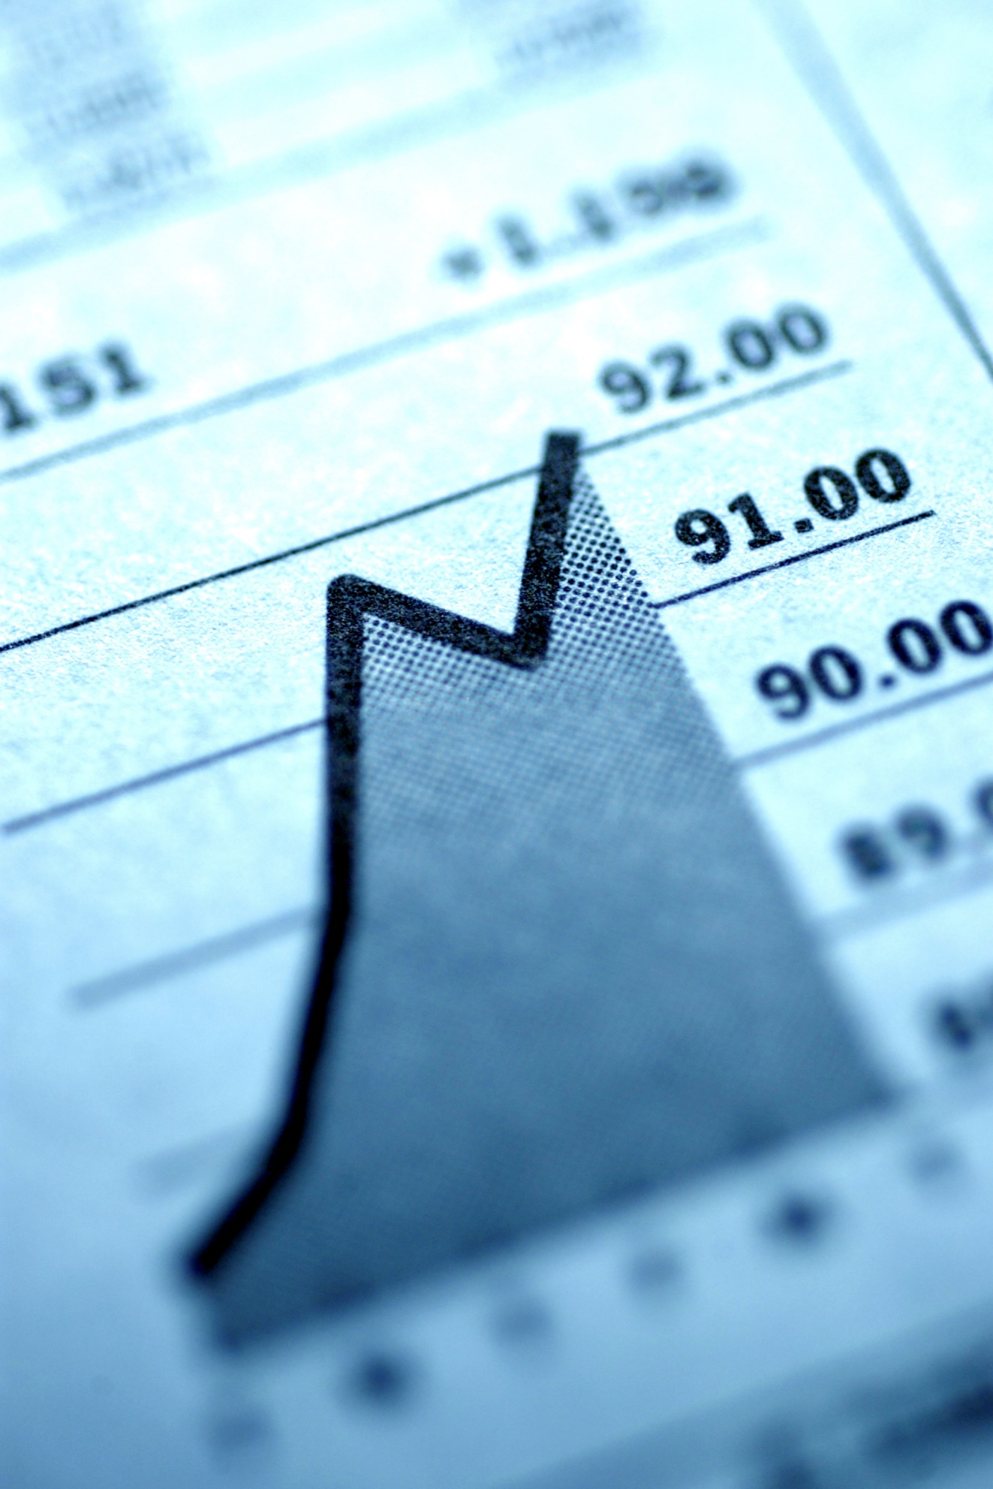](https://forum.mt5.com/customavatars/177898173.jpg)

Investors should specify the type of stock market data they are particularly looking at. There is a distinction to be made between points applied to individual stocks and points applied to stock market indexes which market players must know. If they are focusing on a single stock then they should read points as dollars.  
  
Individual stock fractional points should be acknowledged as percentages or fractions of a dollar. In history, stocks are usually traded in fractions of a dollar rather than dollars and cents. For example, 1/8 is literally a 1/8 of a dollar. Since stocks are now traded in cents rather than fractions, fractional points can be used to depict decimal points. For instance, 10 1/2 points equal $10.50, and 10.50 points equal $10.50 at the same time.

[](https://forum.mt5.com/customavatars/1996858601.png)

In discussing changes in stock market indexes, points refer to the "units of movement" and not dollar amounts. A 20-point gain in the Dow Jones Industrial Average, for instance, does not automatically imply a $20 increase but rather an increase in the number of units within the average. The Dow Divisor represents the fluctuation found in the value of a single unit.

**Conclusion**  
  
The term "points" is typically used to express stock index or share price increases over a short period that includes a day or a week. Most investors who follow the market will be aware of the worth of the points concerning the underlying index or stock. Longer periods such as year-to-date or 12-month returns are frequently reported in percentage terms in financial news reports. Day-to-day results are counted in points in the investment world while annual results are converted into percentage profits and losses.