**What Are the Swing Trading Chart Patterns?**

**What is the Concept of Swing Trading?**

[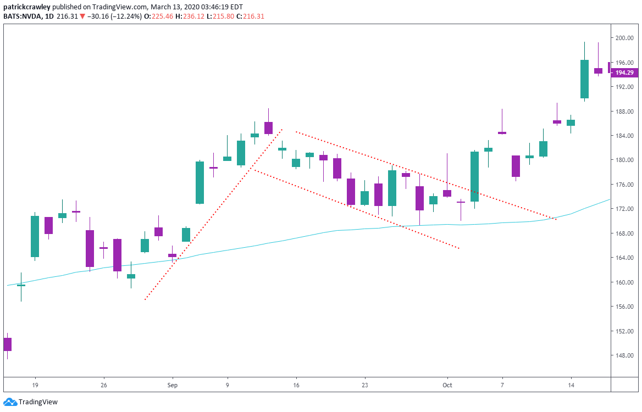](https://forum.mt5.com/customavatars/591491862.png)

Swing trading refers to a short-term trade that usually takes place more than a single day but does not last a month. In comparison with day traders, swing traders opt to get the whole leg or swing that is either upwards or downwards. Swing trading can appear in different forms. Several trade chart patterns such as head and shoulders, short-term sentiment readings, and other traders prefer to employ a quantitative approach.  
  
**How Do Swing Trading Strategies Work?**  
  
Swing trading methods are characterized to be straightforward and uncomplicated for traders. Swing traders spot market trends and open positions using an intermediate time frame. The time frame is usually within a few days to a few weeks. Swing trading gets its name from the fact that traders are seeking conditions in which prices are likely to swing upwards or downwards.  
  
Swing traders can have access to a large number of technical indicators. Swing trading is distinct in that it combines elements of day trading with the pace of position trading. Swing trading indicators are used to identify trends that last between three and fifteen trading periods.  
Traders will be able to see if there were any instances of resistance or support while examining these periods.  
  
The next thing to do is to determine whether the trend is either bearish or bullish and look for any reversals. Pullbacks and countertrends are terms used in describing reversals. Traders can choose their entry position once the countertrend is obvious. The objective is to enter a trade in the area where the countertrend will swiftly reverse and prices will swing. It is precisely how Jesse Livermore made the majority of his fortune as one of the greatest stock traders of all time.  
  
Swing trading is like every other type of trading that is highly dangerous. Swing traders face a variety of risks and the most prevalent of which is gap risk. It is a type of risk that occurs when a security's price rises or falls dramatically due to news or events that occur while the market is closed. It can occur whether overnight or on the weekend.

Any unexpected news will be reflected in the starting price. The larger the danger then the longer the market remains closed. Swing traders may lose out on longer-term trends through focusing on shorter holding periods. They can also lose due to abrupt shifts in the market's direction.  
  
**Two Profitable Swing Trading Chart Patterns**

**Swing Trap Chart Pattern**  
  
Swing trap chart patterns refer to the traps that both swing traders and momentum traders in the middle of a movement. The swing trap chart pattern is similar to an A-B-C pattern in Elliott Wave theory, but it appears to be on a smaller scale. It is more descriptive that is why it is called a swing trap.  
  
It makes a brief comeback but then fails and drops again. Swing traders who are long in this stock are usually caught in this kind of trap. The traders’ stop-loss orders were placed under the first rally attempt. In case the stock fell then it also means that the trader’s stop-loss orders were canceled. It results in most sellers being out of the trade while stocks can rally.  
  
Once it comes to this chart pattern, traders mainly look for the "shakeout." The final swing must be lower than the initial swing's low point. The final swing will frequently result in a hammer pattern. All of the stop-loss orders will be removed using this hammer and it will ready the trader to enter the trades.

[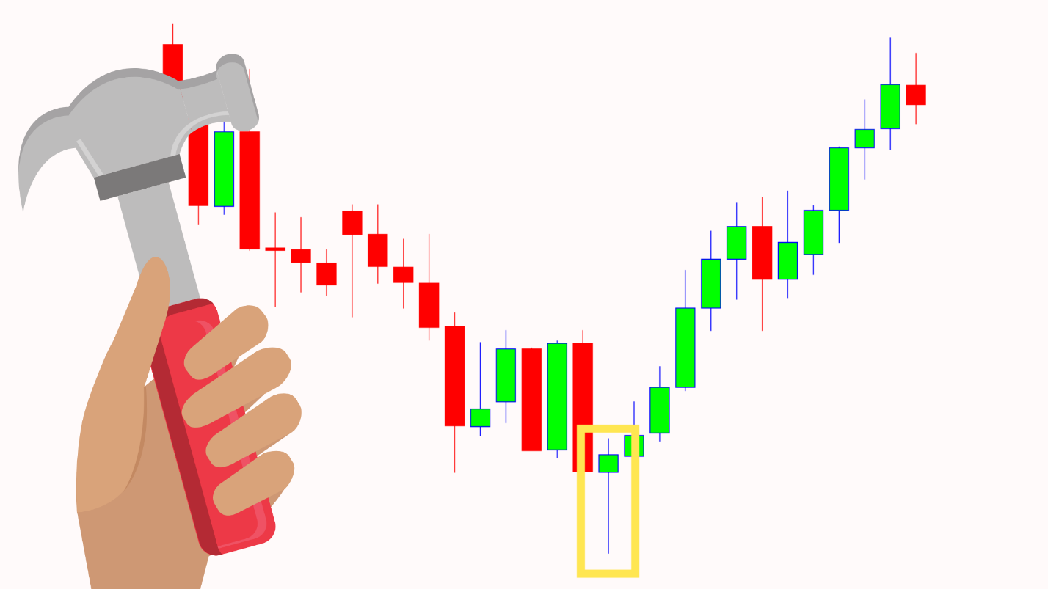](https://forum.mt5.com/customavatars/304803591.png)

On the last swing, traders should wait for a candlestick pattern to form like a hammer. Traders may either buy the stock during the same day that the pattern appears, or wait and place a buy stop above the candlestick pattern's high. Traders have the liberty of choosing the time and way to enter a trade.  
  
There is nothing exceptional about the stop-loss order placement for the swing trap chart pattern. Traders simply need to position their stop loss where it is most logical. In most typical situations, the stop loss order will be below the entry day's low but look to the chart's left for support and resistance levels. Traders will likely discover numerous alternatives for trailing their stops on their exit strategy plan. If a stock is beginning a stage two-cycle then traders should opt to give it a little time. It is advised for traders to trail the stops of the weekly chart.

The most important thing about this pattern is for the final swing to be lower than the initial swing's low point. The exact pattern can also be found on the short side. The pattern has simply been reversed. Traders will not only see this pattern within a daily chart. Traders will be able to notice it in all time frames.  
  
**Side Trap Chart Pattern**  
  
The side trap chart pattern exemplifies why a vast majority of stock traders fail. Stock traders end up on the wrong side of a move which makes them trapped. The stock's price may see some potentially explosive movements due to being trapped. In the same way, the swing trap chart pattern catches traders on the wrong side of a move.  
  
Most traders probably perceive that this kind of stock is consolidating or trading sideways because it is in an uptrend. It is the type of stock that is likely to break out shortly. Some traders are buying this stock while it is still consolidating because they are hoping for a breakout to occur. Swing traders can only wait for a breakout with this type of stock. Keep in mind that thousands of traders are scrutinizing this kind of stock.  
  
During the consolidation period, the stock will likely break down. It also ended with a bearish candle that closed near the intraday range's bottom. Some traders were stopped out because they placed their stop below the consolidation's lows and other traders aggressively shorted this stock. It is regardless of how a trader will look at it, this stock appears to be negative at this time.  
  
No follow-up will happen on the negative side. It indicates that no more sellers are willing to sell the particular stock at a cheaper price. Once all of the sellers are gone, this stock can now rise higher. Traders who short this stock during the day of the breakdown will most likely place their stop-loss orders above the consolidation. The stop-loss orders were removed when the stock climbed above that area which generates the gap up.

[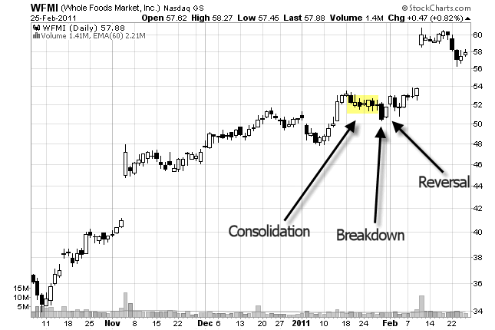](https://forum.mt5.com/customavatars/1536417695.png)

Trading with the side trap chart pattern includes consolidation, breakdown, and reversal. Sideways consolidation is required that should be followed with a breakdown that causes the chart to appear bearish, and lastly a reversal pattern. It is the reason why it is referred to as a side trap. The stock moves sideways which traps traders who bet against the breakdown.

[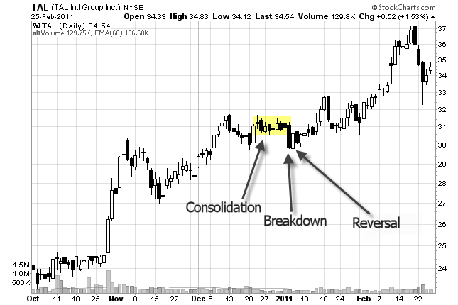](https://forum.mt5.com/customavatars/753817789.png)

On the day of the reversal candle, any trader who wants to open a position in this stock. At the same time, traders should not trade just any reversal candle. The candle should be a powerful one. Determine whether it closes at least halfway into the breakdown candle's range. A piercing candlestick pattern or a bullish engulfing candlestick pattern will likely appear. In taking profits during the side trap pattern, traders should trail their stops through the use of their favorite exit strategy. It is just like how the stock market gives the traders a gift. Traders should take some profits and trail their stops on others.  
  
Traders should remember that they want to see the stock break out of its sideways trading pattern or the consolidation. It is at the same time that the trades begin to heat up. The longer that a consolidation lasts, the greater the chance of an explosive move to take place. A strong reversal candle is required for this trade. In this trade, volume is not important but there is a high volume found on the breakdown candle.

**Conclusion**  
  
Swing trading is a simple way for beginner traders to get their valuable experience in trading. Traders often start with a little amount of money since it is allowed in swing trading. The most important guideline is that money invested must also be the money that the investor can afford to lose. Traders should keep in mind that even with employing the most stringent risk management, the possibility that any unexpected event can happen at any time.  
  
Swing trading does not need the same level of active attention in contrast with day trading. It allows the swing traders to begin slowly and gradually increase the number of their trades. Swing trading does involve a deep understanding of the technical analysis on the part of the investor so comprehension of charts and figures is required. Swing trading allows building attractive gains slowly but surely over time for the traders who are prepared to invest time researching equities and learning technical analysis.