**What is the Concept of Risk Management?**

**What Refers to Risk Management?**

[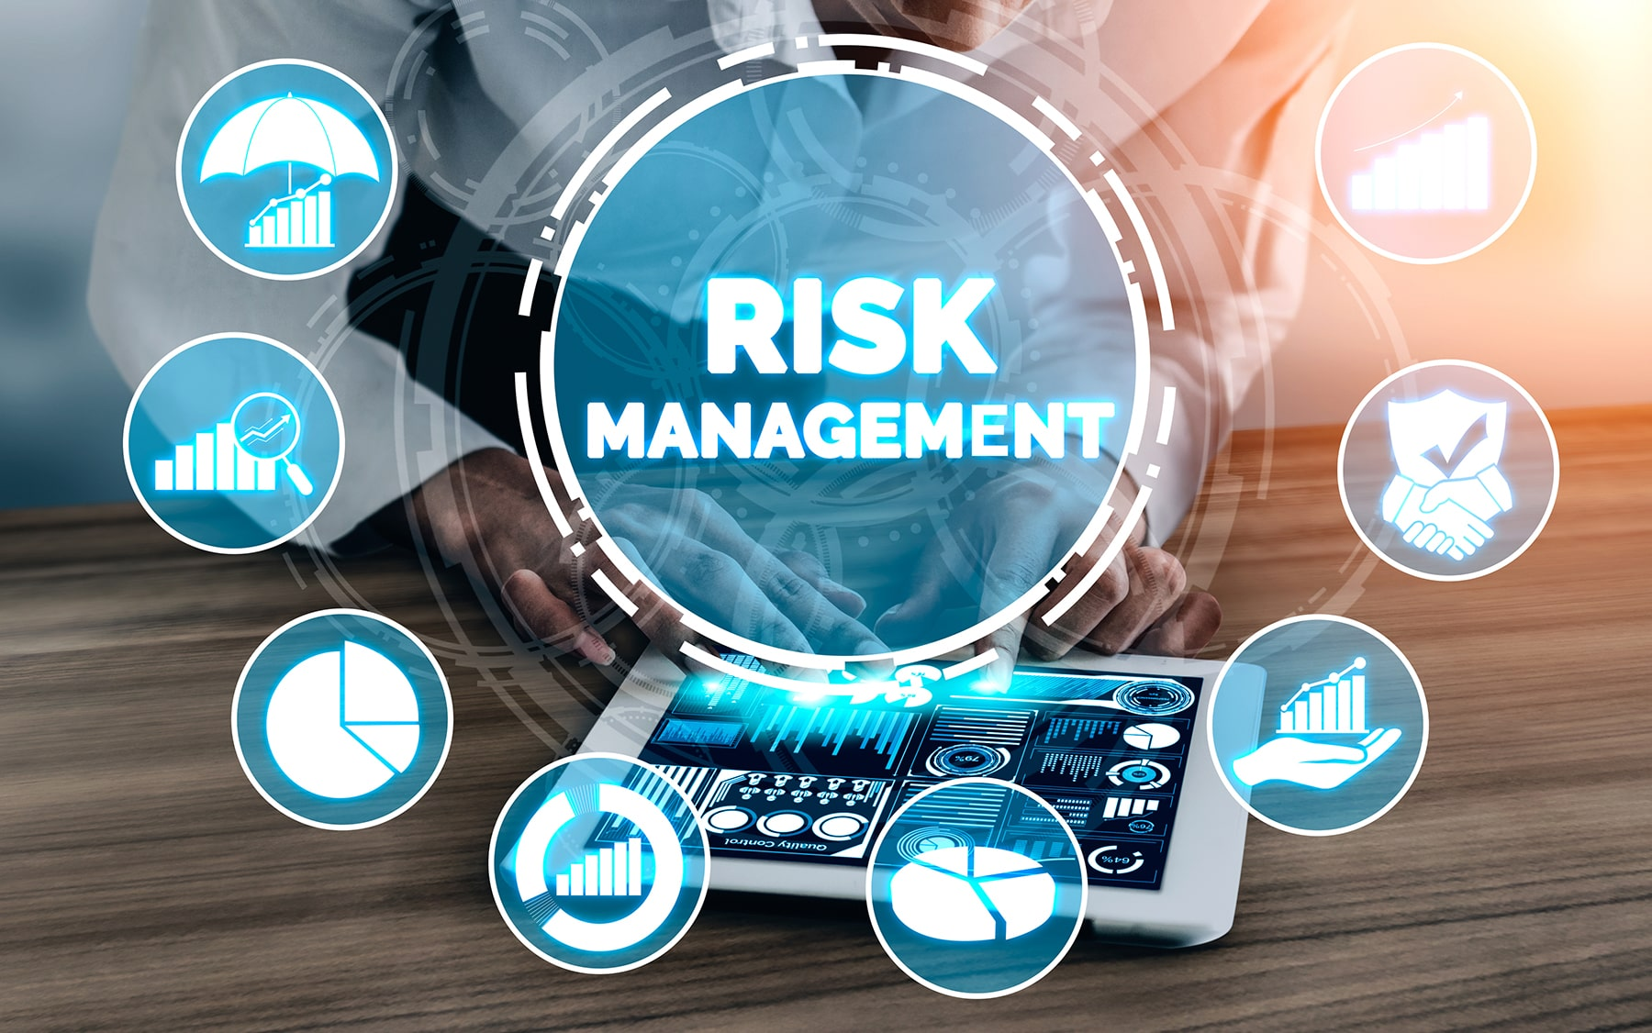](https://forum.mt5.com/customavatars/1657487013.jpg)

In the world of trading and investing, investors and traders are exposed to many risks that involve their investments and trades. It is very important to have a technique in managing and limiting these risks. The procedure of discovering, assessing, and controlling risks to an organization's capital and profitability is known as risk management. Financial uncertainties, legal liabilities, strategic management failures, accidents, and natural disasters are only some of the hazards or risks that could occur.  
  
At present times where digitized businesses are fast growing, they are also facing risks which are IT security threats and data-related hazards. They perform risk management measures with hopes to mitigate the possible risks that they will face. Risk management has emerged to be one of the important priorities that digitized businesses have. Due to the possible risks, companies are working on different techniques for identifying and controlling threats to their digital assets. The digital assets involve confidential corporate data, their customers’ personally identifiable information (PII), and intellectual property which all are increasingly being included in risk management plans.  
  
Any company and organization faces the possibility of risks even individual investors and traders are exposed to this type of events. Risks are damaging occurrences that could cost them all the money they invested or force them to close or stop trading permanently. Risk management enables businesses and traders to prepare for the unexpected events since they can reduce risks and any additional expenses before they occur.

**Understanding Risk Management Strategy**  
  
Risk management strategy is used in spotting, assessment and management of risks. It is characterized as a standardized and consistent approach that business and individuals can employ for their trades and investments.  
  
Risk management strategy incorporates a mechanism for updating and assessing the evaluation on a regular basis in light of new events or traders’ actions performed. Any smallest of groups or initiatives can form and create their risk management plan even individual traders or investors. It is also a strategy that can be incorporated into a multi-site worldwide organization's complicated plan in mitigating risks.

[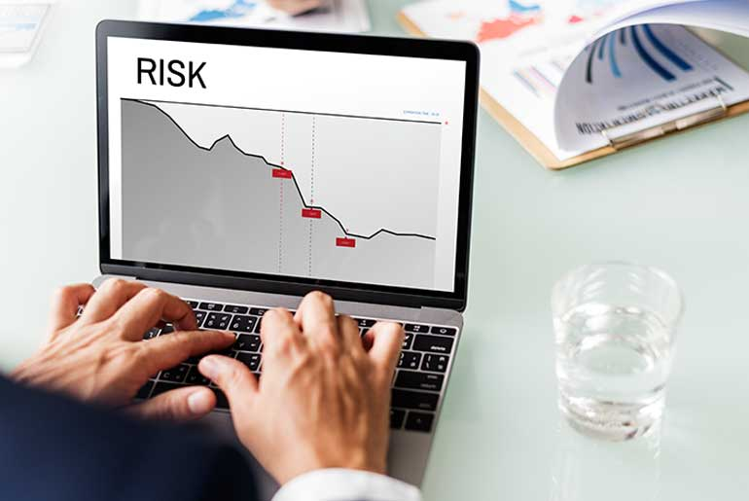](https://forum.mt5.com/customavatars/755053895.jpg)

Risk assessment refers to the process of identifying and evaluating the hazards that investors and traders face. The process of analyzing risks may need the investors and traders to be vigilant in identifying areas where there is uncertainty about events or outcomes. They can also figure out steps that they can take to protect their investments, trades, and for businesses it will protect the organization, its employees, and its assets. The plan used to accomplish these goals and the level of detail analyzed is different for each trader and company.

**What is the Importance of Risk Management?**  
  
One way for an organization to save money and protect its future refers to the decision of developing a risk management plan and considering the many potential risks or events before they occur. It is because of a solid risk management strategy that will assist investors and traders in establishing procedures to avoid potential threats, mitigate risks’ impact, and deal with the consequences once it happens. Traders and investors appear to be more confident in their decisions when they can recognize and handle these risks well.  
  
**What are the Major Risk Management Strategies?**

1. **Hedging-** Hedging is a popular investment strategy with goals of reducing the risk of a potential loss. Hedging is a way of investing that reduces risks. Hedging against market price risks entails securing a price lock which can shield oneself against possible occurrence of price fluctuations. A way to secure a price lock is to do hedging versus credit risks and utilize offsetting contracts in contrast to an investor’s default position. Hedging can be done with derivatives because the relationship between derivatives and their underlying is well defined. It is the strategy that happens in most circumstances. Other financial instruments used to hedge include insurance, future contracts, swaps, options, and a variety of over-the-counter products.

[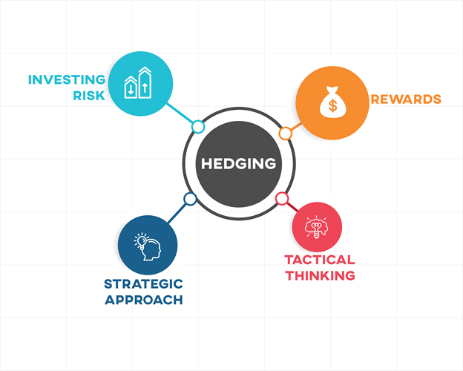](https://forum.mt5.com/customavatars/202490674.jpg)

1. **Stop Loss-** The most common risk management strategy is employing stop loss orders. A stop loss order refers to a buy or sell order that is triggered in times that the stock price hits a predetermined price called the stop price. The traders who do not wish to monitor the security on a daily basis are those who would benefit greatly from using a stop loss order. Other benefits of implementing a stop loss includes its protection for the trader to avoid excessive losses. It also gives them more control over their trading account. A stop-loss order is a pre-planned order in hopes to quit an identified losing transaction. On any broker platform, stop-loss orders can be done either manually or automatically. The primary goal of employing stop loss orders is to prevent losses from becoming too large. It acknowledges the most difficult thing for day traders to do consistently which is to exit a lost transaction. One of the drawbacks of the stop loss is that it is almost always a market order which tends to cause the loss to be exaggerated.

[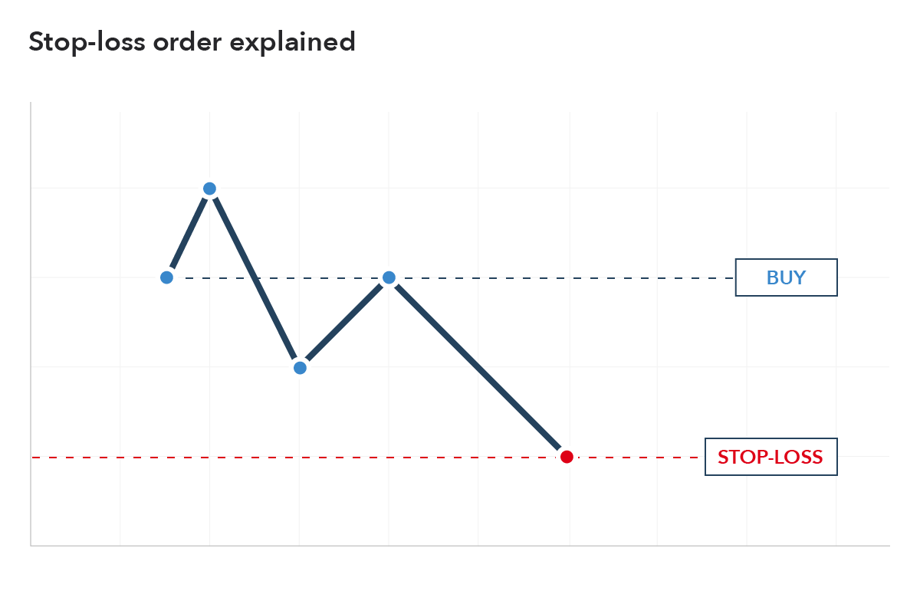](https://forum.mt5.com/customavatars/335084854.png)

1. **Backtesting the Trading Strategy-** Backtesting is the practice of determining the effectiveness of a trading strategy. It refers to testing the trading strategy against past data. Backtest results oftenly present a strategy's success in terms of common performance statistics. The common performance statistics help in the measurement of the strategy's return on risk. Traders can employ their trading strategy confidently once the backtesting results are good and fulfills the required requirements. In contrast, if the results are not what is expected then it is best that the strategy can be tweaked, altered, and refined to reach the desired outcome.

**Conclusion**

Risk management is just as necessary as putting together a great trading strategy. There is no such thing as a perfect trader and all traders will inevitably lose their money in some circumstances. Traders can lose a lot of money on tier trading transactions without creating irreversible damage to their accounts once they use a well-tuned risk management approach.  
  
Trading requires traders to ensure that their trades are secure and that proper risk management is in place. A thorough understanding of risk management procedures and strategies is advantageous to any trader since it allows them to limit losses while maximizing gains. Traders may successfully manage these risks if they correctly identify and evaluate them.