**What is the Portfolio Risk?**

**What is the Portfolio in Investing?**  
  
The concept of the investment portfolio refers to a collection of assets. The assets involve stocks, bonds, mutual funds, and exchange-traded funds. An investment portfolio is not a physical space but it is like an area where an investor can keep all their assets.  
  
**What is the Definition of Portfolio Risk?**

[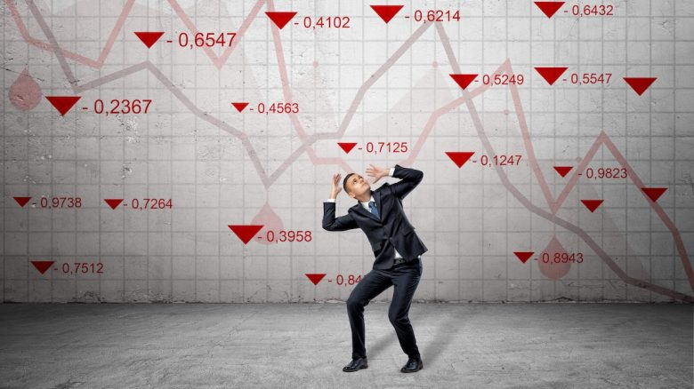](https://forum.mt5.com/customavatars/147708415.jpg)

Investors should keep in mind that each investment they own comes with a risk of loss and potential returns. The probability of getting high returns also comes with a high-risk possibility. The number of investments that an investor has within the portfolio does not change the risks each carries. The investment risk is constant within the investment portfolio but investors can do something to restrict the risks. It is best to always monitor the portfolio risk to assure the investor to keep different types of investments. Each investment can offset each others’ high and low risks.  
  
Portfolio risk is generally the possibility that the investment portfolio will meet difficulties in meeting the investment objectives and will not likely achieve them. Portfolio risk refers to the overall risk from all the individual investments in the portfolio. Several components make up a portfolio and each influences the range of the portfolio risk. Major portfolio risks include the market and other systemic risks. All of these risks require investors to do extra effort to manage them. Managing the portfolio risks help investors achieve their goals for their investments.  
  
**What are the Factors that Influence the Portfolio Risk?**

[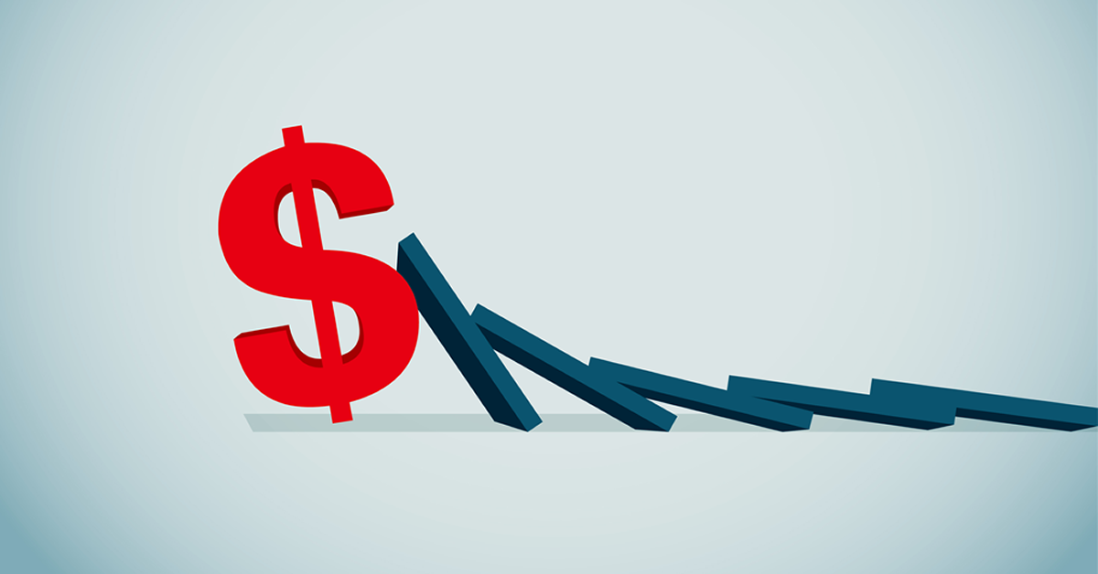](https://forum.mt5.com/customavatars/1903591527.png)

* **Systemic Risk-** Systemic risk is a risk factor that investors cannot do anything to totally get rid of. It is the risk linked with the interest rates, events like recession, war, and political events. All of these factors can have a substantial impact on companies and their stock prices. The risk factors under the systemic risk are something investors cannot predict. Investors may calculate the long-term trend of the interest rates but figuring out the specific amount that they will rise or fall is not possible. The stock market is the one to price within the forecasted change and it is usually prior to the time that an investor can expect it and include it in their investment decisions.
* **Unsystematic Risk-** Unsystematic risk is also called the specific risk and it is associated with getting the ownership of a particular company within an investment portfolio. Unsystematic risk in contrast with systematic risk appears to give investors the opportunity to control, limit or minimize the risks. Investors who add more different companies to their portfolios are the ones who also spread the risk in it. It is also the way of limiting the entire impact of a failing stock.

**What are the Types of Portfolio Risk?**

1. **Loss of Principal Risk-**Investing involves investor’s hard-earned money which is why it is very important for them to know whether they can get back their money once their investment fails or not have any back at all. Loss of principal risk is the type of portfolio risk that involves the investor’s chance regarding whether or not they can get all or a portion of their invested money back. The truth is investors are unlikely to get the original amount of the investment made. Loss of principal risk is the portfolio risk that conservative investors are worried about. They are focused on protecting the principal instead of looking for capital appreciations. Conservative investors are also at peace with getting lower returns because they are up for achieving stability with their trades. The loss of principal risk is likely to be present within all investments but not in interest checking or savings accounts.
2. **Sovereign Risk-** It is the portfolio risk that makes an assessment on the government or the state’s current condition on whether it will fail in paying the debts or go into bankruptcy. Sovereign risk also includes the possibility that the government or state will no longer acknowledge their loan agreements with other countries and private sectors. The assessment can come from events that result in the country facing financial difficulties which make them unfit to continue paying their existing debts. The government can also just decide to stop paying the debts and stop fulfilling their part within the loan agreements. Governments can refuse after forming laws that can twist these loan agreements. Sovereign risk can generate losses for investors who decide to buy the country’s debt.

[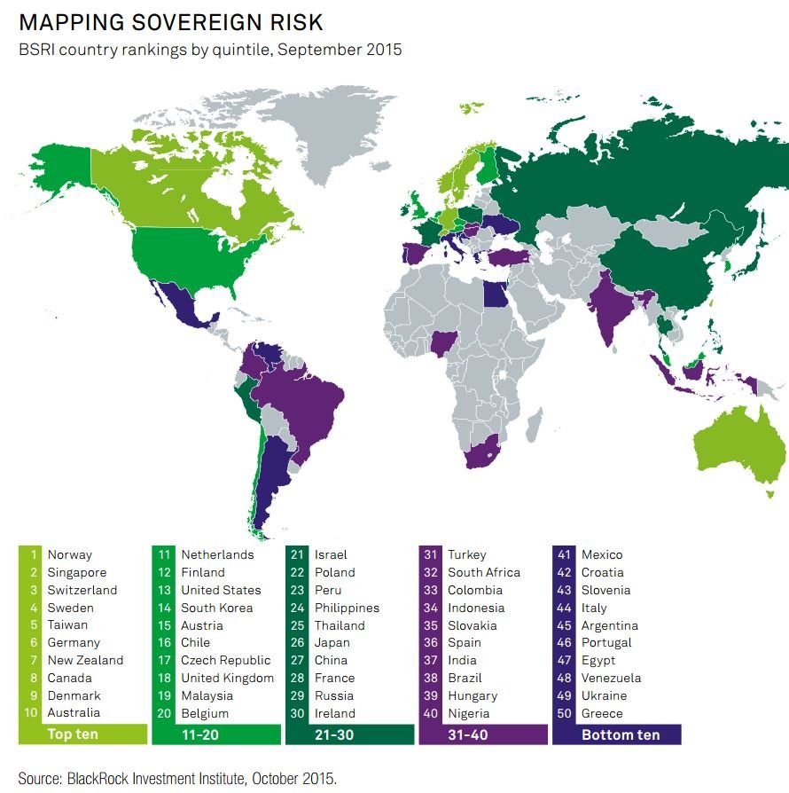](https://forum.mt5.com/customavatars/2019003566.JPG)

1. **Purchasing Power Risk-** Purchasing power risk is also referred to as the inflation risk. It is the risk that is very notable within bonds and other fixed-income securities. The likeness that the cash flows coming from the investor’s investment will not come in the same amount in the future. The reason why it will not be worth as much in the future is because of inflation. The investor’s nominal return holds the investment until its maturity so inflation will not majorly affect it but the real rate of return is greatly affected. Investors can make predictions regarding the returns they can get but inflation can lower down the real rate of return. The purchasing power risk is not just about the possible occurrence of inflation but that actual inflation will be larger than projected.

**Conclusion: How to Reduce Portfolio Risk?**  
  
Portfolio risk is according to the risk that each of individual assets comes with them. Portfolio risk is made up of several factors. Investors can minimize the portfolio risk. Investors should not keep their hopes high because they cannot totally get rid of the portfolio risks. Here are some tips to reduce portfolio risk.

1. **Diversification-** Diversification refers to the option of not placing all the money for investment in one company. It also appears as the most effective way in reducing specific portfolio risk. Diversification not only refers to the need to own a variety of businesses but investors also need to own businesses from several industries. Investors may lessen the impact of a single company on their money through investing all money in bank stocks. It might be a good idea for investing but investors have not totally eradicated the impact of the sector on their investments.

[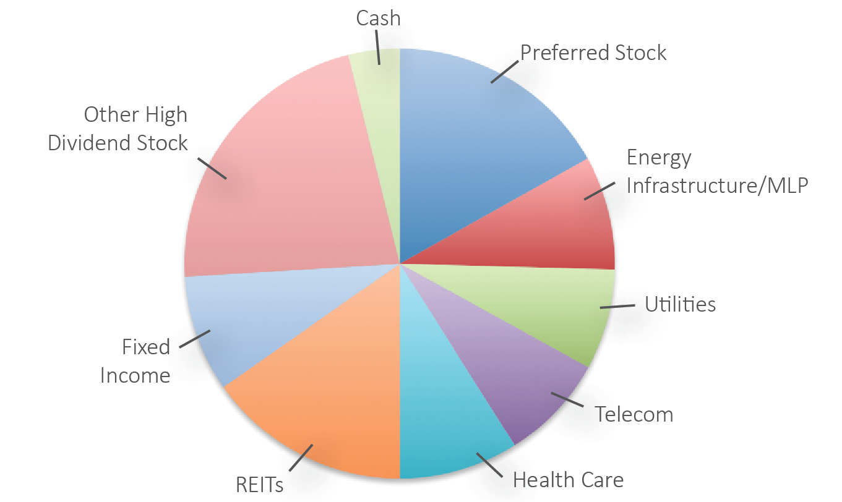](https://forum.mt5.com/customavatars/828865502.png)

1. **Monitoring Each Investments Consistently-**The asset allocation of an investor for the past year might not be appropriate for the present time given the changes within the market. It might not be the situation to happen at most times but it is very much possible. Investors must monitor their investments on a regular basis because the existing investment risks within an investment portfolio can surge without a warning. They should be aware of the importance of monitoring the investments holdings. Investors must assess the investment holdings consistently so it can guide them to an appropriate asset allocation. It is also a way of minimizing portfolio risks.
2. **Figure Out Risk Tolerance Capacity-** The idea of investing in the stock market requires everyone interested to have the ability to accept risks that come with it. In making investments, an investor must assess the level of risk they are willing to face based on their age, income, dependents, and other factors. Investors frequently face more risk than what is necessary. The risks are given attention when financial events happen. Understanding the risk tolerance and the possible risks in the investment portfolio can help investors avoid emotional involvement in their decisions. It is also the way to protect their money in times of adversity. Investors should be reminded not to only focus on getting returns out of their investments but also consider different factors on investments.

[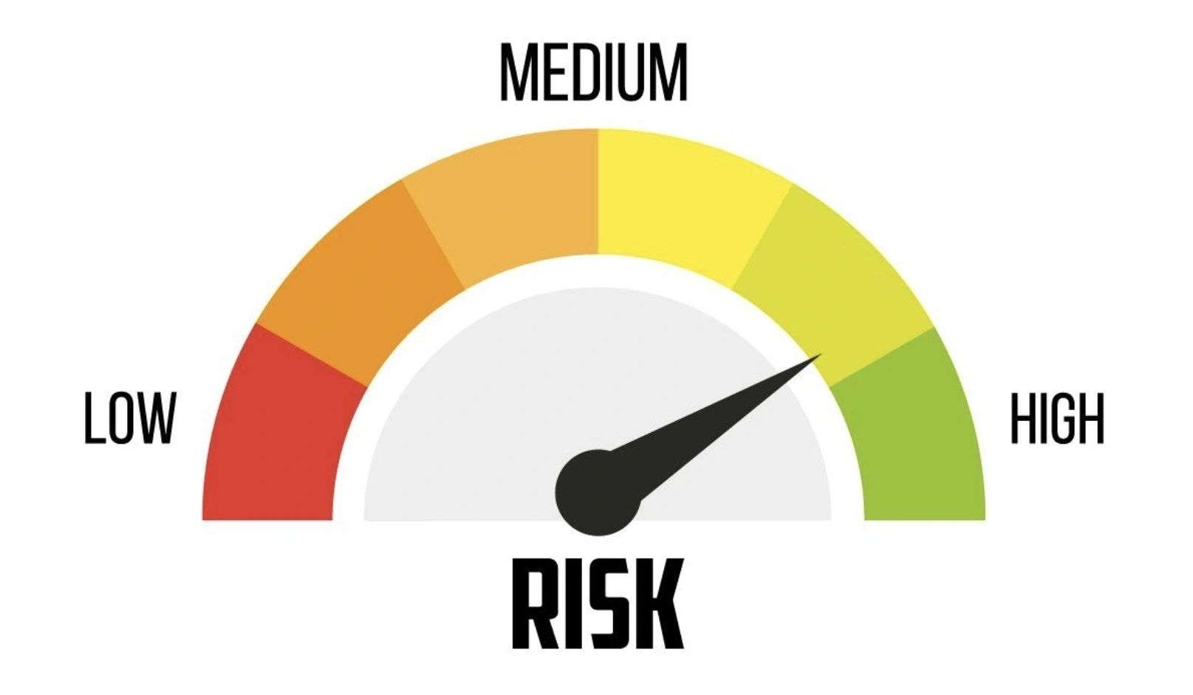](https://forum.mt5.com/customavatars/122360302.png)

1. **Maintain Enough Liquidity-** Investors should make it a point to keep their expenses within a few months or a year in liquid. They should also get if from asset types that are easily accessible for them. Accumulating high volatility products can lead to poor results if it requires investors more money during a down cycle for that product or asset. Investors can let their higher volatility goods achieve the anticipated effects. They do it after deciding to invest in them for the long term if they have a safety net of liquid assets.