**What Refers to CFD in Trading?**

**What is the Definition of CFDs?**

[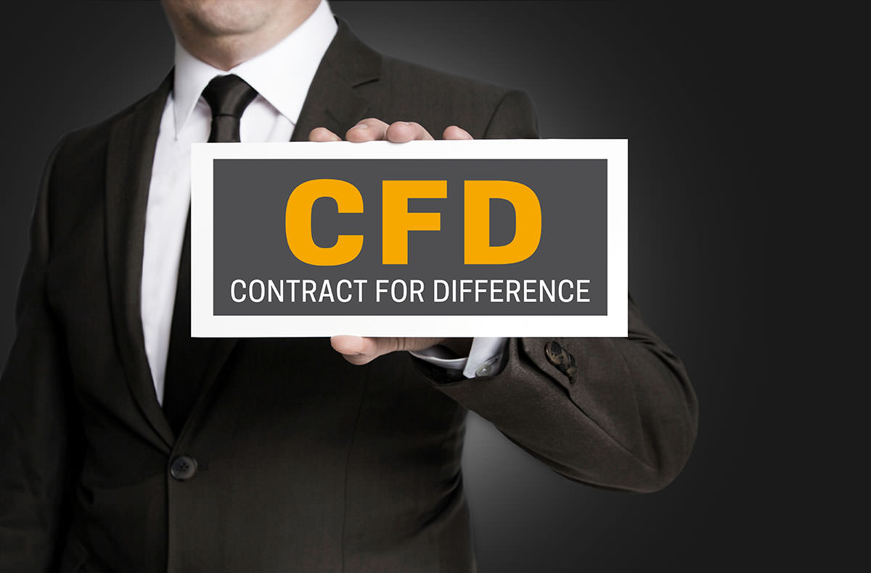](https://forum.mt5.com/customavatars/944526448.jpg)

The world of investing and trading is made of different concepts which traders and investors should fully understand to achieve good outcomes. Traders and investors should expect to meet different concepts and abbreviations during their trading and investing activities and one of the abbreviations they will meet is CFD. The concept of Contracts for Difference is a known way of investing over the different types of financial instruments. It is the financial instrument that does not obligate an investor to buy or sell the underlying asset.  
  
CFD refers to a contract that exists between an investor and an investment bank or spread betting company. The contact is likely to exist for a short period. At the end of the contract, both parties will exchange the difference that comes between the opening and closing prices of a particular financial instrument. The financial instrument can be Forex, shares, or commodities. Investors and traders who decide to trade CFDs indicate the possibility of them to get profit or loss. The outcomes depend on the movement of their assets and their direction.  
  
Most brokers in the trading world offer CFDs and it shows their flexibility. It works as a derivative product that allows investors to practice speculation within the foreign exchange, commodities, and indices.

**How Does CFD Work?**

[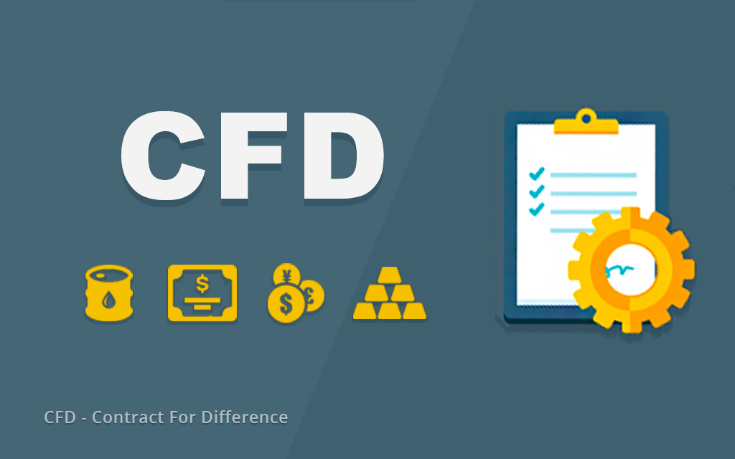](https://forum.mt5.com/customavatars/840977501.jpg)

In the stock market, CFD involves no physical ownership of any shares. Any CFD trader does not sell the underlying asset or purchase it. The traders' anticipation on whether the prices will rise or fall primarily result in them either buying or selling a big or small number of units of an underlying financial instrument. CFDs come as Forex pairs, commodities like crude oil, stocks from companies like Facebook, indices like NASDAQ, and treasuries. CFD instruments combine the up and down price fluctuations of shares and indices, as well as currency movements.  
  
Traders are set to gain multiples of the number of CFD units that they have decided to buy and sell. The gain is according to each price of the instrument that moves towards the traders’ benefit. In contrast, if the price movements are opposite to the trader then they will likely experience loss.  
  
Traders and investors should keep in mind that the total position value comes to be greater than the existing margin requirement. Margin refers to the percentage of the total position which traders should put down in opening trade of that specific size. Margin can be low at 2% for CFD traders which refer to trading on margin. CFD trades can boost traders’ potential profits at the same time that it can intensify their possible losses. Both profits and losses depend on the whole value of the CFD position. Traders must acknowledge the possibility of losing more than what they were able to invest for the CFD trade.

**Tips in Trading With CFDs**  
  
Achieving successful CFD trades can take time and the road might be long. Putting in the right and enough effort will likely result in a beneficial experience. Taking time to practice and follow advice can help traders to understand the markets and control leverage which both can achieve favorable profits. Here are some tips on trading with CFD.

1. **Learn About Position-** It might be cliche but researching about positions is a must to have more chances of getting favorable profits from the CFD trades. There are a lot of instances that traders will meet times which will tempt them to quickly decide in their trades and most traders who take these decisions are those who did not research well and have little experience. Traders should be serious in researching CFDs and they should not treat it as a game. CFDs are margin products and the total leverage on a trader’s trading account can confuse traders in showing up somehow large movements even though it is only small ones. Traders should know how to identify the size of the movements. They are in both directions. Figuring out the movement’s size might take time and effort from the trader but they should be patient. Traders have enough time to research and do revisions on their trades because the markets are open each day. It will lessen the possibility of losing their trades.
2. **Make a Comparison on Different CFD Brokers-** Researching about CFD trading involves the available CFD brokers. There are a bunch of CFD brokers that traders can find from the internet so the choices can confuse traders on deciding which they should choose. CFD brokers can influence the trading education and research of a trader. Finding the most suitable CFD broker is the wisest decision that a trader can make. Some traders have something to offer that others do not offer like having easy-to-use systems which can help in boosting confidence in trades. Traders should not easily believe the claims of the CFD brokers and they must consider looking for reviews about them. The comparisons between different CFD brokers are vital to happen before committing and signing up to any broker.

[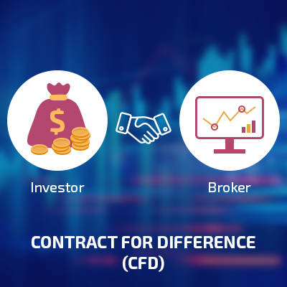](https://forum.mt5.com/customavatars/1647386797.png)

1. **Managing Leverage-** Monitoring the CFD trades should be consistent. It is better if trades will prefer to place position for sure stops per transaction. Traders should be open in constantly adjusting the stops in locking in their profits once they arise as an effective trick to reach trading objectives. Having too much confidence with CFD trades can be a bad thing as traders should monitor their positions while their trades are ongoing. The consequence of not monitoring can result in the trader covering each of their open positions that closed at their stops. Traders can lead into two sides of the leverage transaction which are positive and negative. If they land on the wrong side of the transaction then they should expect to lose more than what they invested.

**Conclusion**  
  
Contracts for Difference can lead traders into a lot of benefits and can give profitable opportunities for them. These profitable opportunities are more likely to benefit the traders’ who were able to learn about CFD trading through extensive research and who have the experience that helps in their skill development. Traders’ familiarity can greatly help in understanding the basic ideas under CFD trading.

CFDs present several unique features which show their distinction from other financial instruments. It is generally margin traded and highly leveraged instruments which are sold within different markets. CFDs can make good profits as a good tool but they can also be a dangerous tool in investing and trading. Traders and investors' most powerful shield against bad outcomes in their CFD trades is having the right and enough knowledge.

[](https://forum.mt5.com/customavatars/784996091.jpg)

Traders are advised to get the best CFD broker to increase the possibility of getting successful outcomes. One of the best CFD brokers is InstaForex. The link through the InstaForex website is <https://www.instaforex.com/cfd_trading> and they only need a few clicks to start immediately in case they are already equipped with enough knowledge.