**What is the Definition of Fiat Money?**

**What Refers to Fiat Money?**

[](https://forum.mt5.com/customavatars/1595162187.jpg)

The currency that exists without an underlying value refers to the concept of fiat money. Its value comes from government mandates. People’s trust within that specific country is an important factor regarding the value of fiat money. Fiat money is a currency with value that is generally due to the mandate from the government.  
  
In dissecting the terms within fiat money, fiat refers to a formal authorization or proposition. Fiat money will have value once an official law or order is established. It is the sole requirement. People’s trust is seen when they use it in their activities. Both consumers and business owners can put trust in fiat money when they acknowledge it as a store of value which makes it a means of exchange. People believing and trusting fiat money can influence others to do the same and the fiat money will likely keep its value.  
  
**Understanding How Fiat Money Works**

[](https://forum.mt5.com/customavatars/1537144983.jpg)

There is no physical commodity that supports fiat currency but the trust and faith of people and government law is needed for it to be valued. Fiat money or paper money serves as the storage platform both for buying power and practice of the barter system. People can buy different products and services that are essential in their life. They can purchase it without the need to engage with a barter trade or trading one product for another product.  
  
Fiat money can store buying power which people can decide and plan their economic activities. Economic activities depend on where to put their budget regarding the essential things they need at home and for their businesses.  
  
Fiat money’s value is based on a variety of factors. The total value of fiat money is based on the condition of a particular country’s economic performance. In case the country is facing a bad economy then the value of the fiat money is likely to decline. Some other factors include the governance within the country and all these factors affect the interest rates. The unpredictable political state of a country can weaken the currency and result in inflation of commodity prices. The people within that country can experience difficulty in buying the products and services they need.  
  
The best performance of fiat currency happens at the time that the public shows confidence regarding its function as a storage medium of their purchasing power. The biggest factor regarding its effectiveness is the government’s enforcement to produce more paper money. The government is also the most important voice on the legality of using fiat money for financial transactions.

In some cases where the government of a country prints more supply than the number of paper money used then hyperinflation is the result. Excessive amounts of money circulating in an economy can deflate its real worth. The public will likely lose their trust in how the government can maintain the fiat money’s worth. It is also likely to attract levels of consumption because consumers do not generally prefer to just hold cash for a long period with the possibility of losing value. Economic growth will be the casualty of high levels of consumption. The practice of immediately spending money results in shifting the capital far from saving and investment.  
  
The difference between traditional commodity-backed currencies and fiat currency refers to the latter having no chance to be redeemed nor converted. Fiat money is only used due to a particular government decree. The success of fiat currency is dependent on the government’s effort in protecting it versus any counterfeits. The government should also manage the money supply.  
  
**What are the Functions of Fiat Money?**

* **Way of Exchange-** The public is allowed to use fiat money in paying both goods and services without having to participate in bartering transactions. People are only required to bring out enough money for the price of the product or service that they are about to buy.

[](https://forum.mt5.com/customavatars/1760248048.jpg)

* **Account’s Unit-** People can utilize money in figuring the price of different goods, services, and other transactions that involve money. People who have businesses that produce goods or services can set their prices. The price is usually at a specific nominal value.
* **Ability to Store Value-** Fiat money can be utilized in saving which can help the economy of the country. Money can let people transfer their current money in their accounts which means they can use it for the future. The government has to maintain the value of the fiat money for it to stay stable until the future.

Each function of fiat money is likely to be effective for everyone at times when the economic condition is good. Ideal economic condition is a factor for the public to put trust in the fiat money’s ability to be a way of payment and use it in different transactions. In contrast to an ideal economic condition is economic and political instability. The confidence that people put in the currency is likely to weaken just like in times of hyperinflation. During the political and economical instability, the functions listed above may not work as they should be.

**Conclusion: Is it Safe to Use Fiat Money?**

[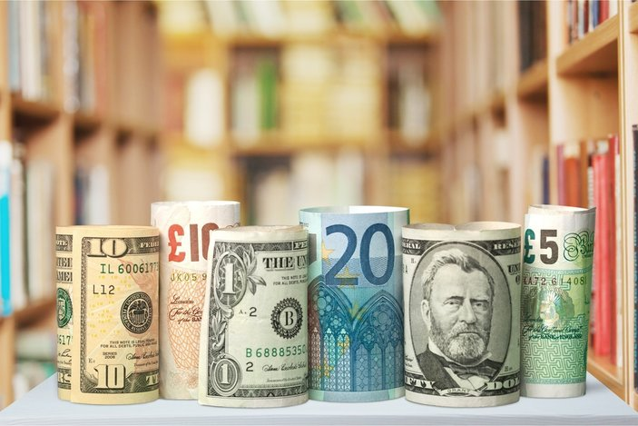](https://forum.mt5.com/customavatars/1135308734.jpg)

Fiat money’s worth generally comes from the government which means it is legal to use it in different transactions within the country. People need to trust fiat money to make the most out of it. The government’s role in giving value to fiat money makes it safe as a medium of exchange. One downside of fiat money is that there is no way for it to be redeemed or converted which is why other people do not prefer to use them. Some people at present are content with using fiat money as it is while others are finding a more modern alternative. People who are familiar with the currency world still see fiat money as a good investment and a way of saving their wealth which refers to its primary function. Anyone interested to try acquiring fiat money and using it in their transactions can be at peace that it is safe because governments are the ones who regulate it. The first step to investing in fiat currency is to have a bank account and most importantly to research and understand the concept through a reliable website like InstaForex.