FoodCart
Online Food Ordering App
Kubernetes + Azure DevOps CI/CD Project

Author : ddprasad
Azure Account : ddprasad7777@gmail.com
Date : June 08, 2026
App Live URL : http://57.162.160.199
ADO Project : Dev_project / foodcart repo

1. Project Overview
FoodCart is a full-stack online food ordering web application built and deployed using modern DevOps practices. The application is containerized with Docker, orchestrated with Kubernetes on Azure Kubernetes Service (AKS), and deployed automatically using Azure DevOps CI/CD pipelines.

Tech Stack
Component | Technology | Details
Frontend | React.js | User interface — menu, cart, order history
Backend | Python Flask | REST API — menu GET, orders POST/GET
Database | MongoDB | Persistent order storage in Kubernetes pod
Containerization | Docker | Multi-stage builds for React and Flask
Container Registry | Azure ACR (foodcartacr7330) | Stores all Docker images
Orchestration | Kubernetes on AKS | Manages all containers and services
CI/CD | Azure DevOps Pipelines | Auto build and deploy on git push
Source Control | Azure Repos Git | foodcart repo, main branch
Cloud Provider | Microsoft Azure | eastus region, Pay-As-You-Go

Azure Resources
Resource | Name | Details
Resource Group | foodcart-rg | eastus — contains all project resources
Container Registry | foodcartacr7330 | Basic SKU, admin enabled
AKS Cluster | foodcart-aks | 1 node, Standard_B2s, Kubernetes v1.34.8
Dev VM | devops-lab-vm | Ubuntu 22.04, Standard_B2s
ADO Project | Dev_project | foodcart repo, DP_service connection
Frontend IP | 57.162.160.199 | Public LoadBalancer — port 80
Backend IP | 52.226.194.79 | Public LoadBalancer — port 5000

2. Architecture
The solution follows a microservices architecture. Each component runs as an independent Kubernetes Deployment exposed via a Kubernetes Service. The CI/CD pipeline automatically builds Docker images and deploys them to AKS on every code push.

End-to-End Flow
Step | Action
1. Code Push | Developer pushes code to Azure Repos (foodcart / main branch)
2. Pipeline Trigger | Azure DevOps pipeline auto-triggers on push to main
3. Build Stage | Pipeline builds Docker images for backend and frontend
4. Push to ACR | Images pushed to foodcartacr7330.azurecr.io with build ID tag
5. Deploy Stage | Pipeline connects to AKS and applies K8s YAML manifests
6. Rollout | Kubernetes rolling update deploys new image versions
7. Live | App accessible at http://57.162.160.199 on the internet

Kubernetes Services
Service Name | Type | External IP | Port | Purpose
frontend-service | LoadBalancer | 57.162.160.199 | 80 | Serves React UI to users
backend-service | LoadBalancer | 52.226.194.79 | 5000 | Flask REST API
mongodb-service | ClusterIP | Internal only | 27017 | MongoDB database

3. Repository Structure
File / Folder | Purpose
backend/app.py | Flask REST API — menu items, order placement, order history
backend/requirements.txt | Python packages — flask, flask-cors, pymongo
backend/Dockerfile | Multi-stage Docker build for Flask API
frontend/src/App.js | React UI — Menu, Cart, Orders views
frontend/Dockerfile | Multi-stage Docker build — React build + Nginx serve
k8s/mongodb.yaml | MongoDB Deployment + ClusterIP Service
k8s/backend.yaml | Backend Deployment (2 replicas) + LoadBalancer Service
k8s/frontend.yaml | Frontend Deployment (2 replicas) + LoadBalancer Service
azure-pipelines.yml | CI/CD Pipeline — Build stage + Deploy stage

4. Application Code

4.1 backend/app.py
from flask import Flask, jsonify, request
from flask_cors import CORS
from pymongo import MongoClient
import os

app = Flask(__name__)
CORS(app)
MONGO_URL = os.environ.get("MONGO_URL", "mongodb://mongodb-service:27017/")
client = MongoClient(MONGO_URL)
db = client["foodcart"]

@app.route("/api/menu", methods=["GET"])
def get_menu():
items = [
{"id": 1, "name": "Burger", "price": 120, "category": "Fast Food", "emoji": "burger"},
{"id": 2, "name": "Pizza", "price": 250, "category": "Italian", "emoji": "pizza"},
{"id": 3, "name": "Biryani", "price": 180, "category": "Indian", "emoji": "curry"},
{"id": 4, "name": "Pasta", "price": 160, "category": "Italian", "emoji": "pasta"},
{"id": 5, "name": "Noodles", "price": 130, "category": "Chinese", "emoji": "noodles"},
{"id": 6, "name": "Sandwich", "price": 90, "category": "Fast Food", "emoji": "sandwich"}
]
return jsonify(items)

@app.route("/api/orders", methods=["POST"])
def place_order():
order = request.json
order["status"] = "confirmed"
result = db.orders.insert_one(order)
return jsonify({"message": "Order placed!", "orderId": str(result.inserted_id), "status": "confirmed"})

@app.route("/api/orders", methods=["GET"])
def get_orders():
orders = list(db.orders.find({}, {"_id": 0}))
return jsonify(orders)

@app.route("/api/health", methods=["GET"])
def health():
return jsonify({"status": "ok", "service": "foodcart-backend"})

if __name__ == "__main__":
app.run(host="0.0.0.0", port=5000)

4.2 backend/requirements.txt
flask==3.0.0
flask-cors==4.0.0
pymongo==4.6.0

4.3 backend/Dockerfile
FROM python:3.11-slim
WORKDIR /app
COPY requirements.txt .
RUN pip install -r requirements.txt
COPY . .
EXPOSE 5000
CMD ["python", "app.py"]

4.4 frontend/Dockerfile
FROM node:18-alpine as build
WORKDIR /app
COPY package*.json ./
RUN npm install
COPY . .
RUN npm run build

FROM nginx:alpine
COPY --from=build /app/build /usr/share/nginx/html
EXPOSE 80
CMD ["nginx", "-g", "daemon off;"]

5. Kubernetes Manifests

5.1 k8s/mongodb.yaml
apiVersion: apps/v1
kind: Deployment
metadata:
name: mongodb
spec:
replicas: 1
selector:
matchLabels:
app: mongodb
template:
metadata:
labels:
app: mongodb
spec:
containers:
- name: mongodb
image: mongo:6.0
ports:
- containerPort: 27017
---
apiVersion: v1
kind: Service
metadata:
name: mongodb-service
spec:
selector:
app: mongodb
ports:
- port: 27017
targetPort: 27017

5.2 k8s/backend.yaml
apiVersion: apps/v1
kind: Deployment
metadata:
name: backend
spec:
replicas: 2
selector:
matchLabels:
app: backend
template:
metadata:
labels:
app: backend
spec:
containers:
- name: backend
image: foodcartacr7330.azurecr.io/foodcart-backend:latest
ports:
- containerPort: 5000
env:
- name: MONGO_URL
value: "mongodb://mongodb-service:27017/"
---
apiVersion: v1
kind: Service
metadata:
name: backend-service
spec:
type: LoadBalancer
selector:
app: backend
ports:
- port: 5000
targetPort: 5000

5.3 k8s/frontend.yaml
apiVersion: apps/v1
kind: Deployment
metadata:
name: frontend
spec:
replicas: 2
selector:
matchLabels:
app: frontend
template:
metadata:
labels:
app: frontend
spec:
containers:
- name: frontend
image: foodcartacr7330.azurecr.io/foodcart-frontend:latest
ports:
- containerPort: 80
---
apiVersion: v1
kind: Service
metadata:
name: frontend-service
spec:
type: LoadBalancer
selector:
app: frontend
ports:
- port: 80
targetPort: 80

6. Azure DevOps Pipeline
The pipeline file azure-pipelines.yml is stored in the root of the foodcart repository. It triggers automatically on every push to main and runs two stages: Build (Docker images) then Deploy (to AKS).

6.1 azure-pipelines.yml
trigger:
branches:
include:
- main

variables:
ACR_NAME: "foodcartacr7330"
AKS_RG: "foodcart-rg"
AKS_NAME: "foodcart-aks"
IMAGE_TAG: $(Build.BuildId)

stages:
- stage: Build
displayName: "Build and Push Docker Images"
jobs:
- job: BuildImages
pool:
vmImage: "ubuntu-latest"
steps:
- task: AzureCLI@2
displayName: "Build and Push Backend"
inputs:
azureSubscription: "DP_service"
scriptType: bash
scriptLocation: inlineScript
inlineScript: |
az acr login --name $(ACR_NAME)
docker build -t $(ACR_NAME).azurecr.io/foodcart-backend:$(IMAGE_TAG) ./backend
docker push $(ACR_NAME).azurecr.io/foodcart-backend:$(IMAGE_TAG)

- task: AzureCLI@2
displayName: "Build and Push Frontend"
inputs:
azureSubscription: "DP_service"
scriptType: bash
scriptLocation: inlineScript
inlineScript: |
az acr login --name $(ACR_NAME)
docker build -t $(ACR_NAME).azurecr.io/foodcart-frontend:$(IMAGE_TAG) ./frontend
docker push $(ACR_NAME).azurecr.io/foodcart-frontend:$(IMAGE_TAG)

- stage: Deploy
displayName: "Deploy to AKS"
dependsOn: Build
jobs:
- deployment: DeployToAKS
environment: "foodcart-production"
pool:
vmImage: "ubuntu-latest"
strategy:
runOnce:
deploy:
steps:
- checkout: self
- task: AzureCLI@2
displayName: "Deploy to AKS"
inputs:
azureSubscription: "DP_service"
scriptType: bash
scriptLocation: inlineScript
inlineScript: |
az aks get-credentials --resource-group $(AKS_RG) --name $(AKS_NAME)
kubectl apply -f k8s/mongodb.yaml
kubectl apply -f k8s/backend.yaml
kubectl apply -f k8s/frontend.yaml
kubectl rollout status deployment/backend
kubectl rollout status deployment/frontend
kubectl get service frontend-service

6.2 Pipeline Run History
Run Number | Commit Message | Status | Duration
20260608.1 | Initial FoodCart application | Succeeded | 5m 24s
20260608.2 | Fix backend URL | Succeeded | 3m 34s
20260608.3 | Fix backend IP to 52.226.194.79 | Succeeded | 3m 9s

7. Deployment Screenshots

7.1 Azure Cloud Shell
Azure Cloud Shell was used for all Azure CLI and kubectl commands, pre-authenticated with the Azure account.
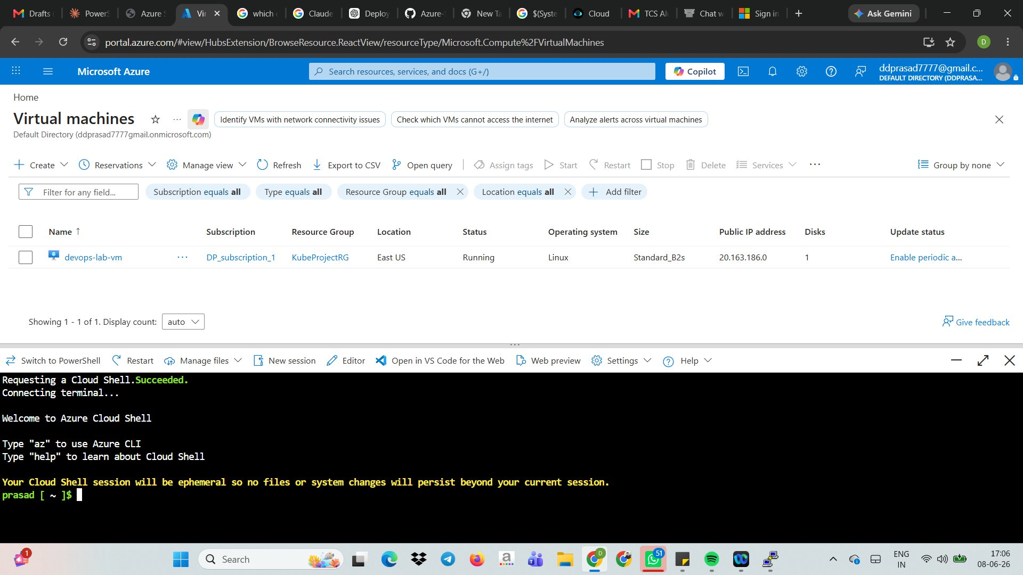

7.2 AKS Node — Ready
AKS cluster created with 1 node running Kubernetes v1.34.8. kubectl get nodes confirms STATUS: Ready.
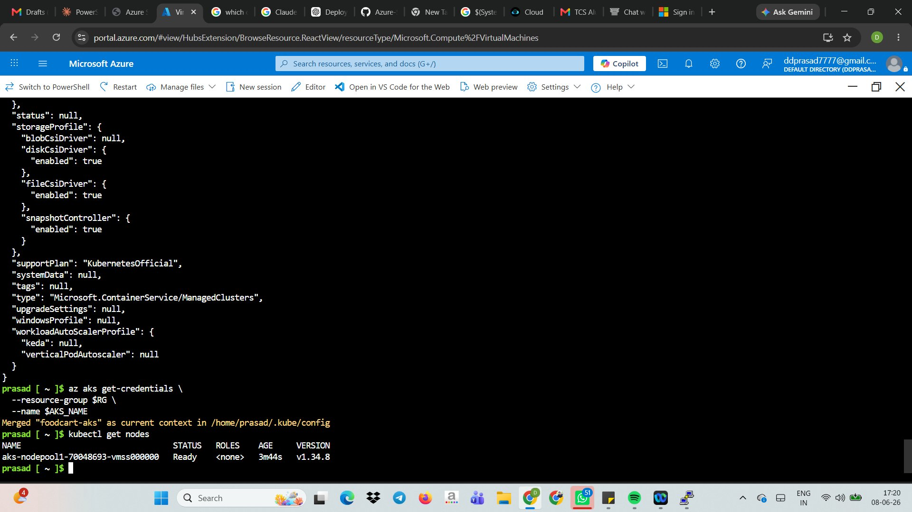

7.3 Kubernetes Services Running
All services verified with kubectl get services. Frontend and backend both received public LoadBalancer IPs.
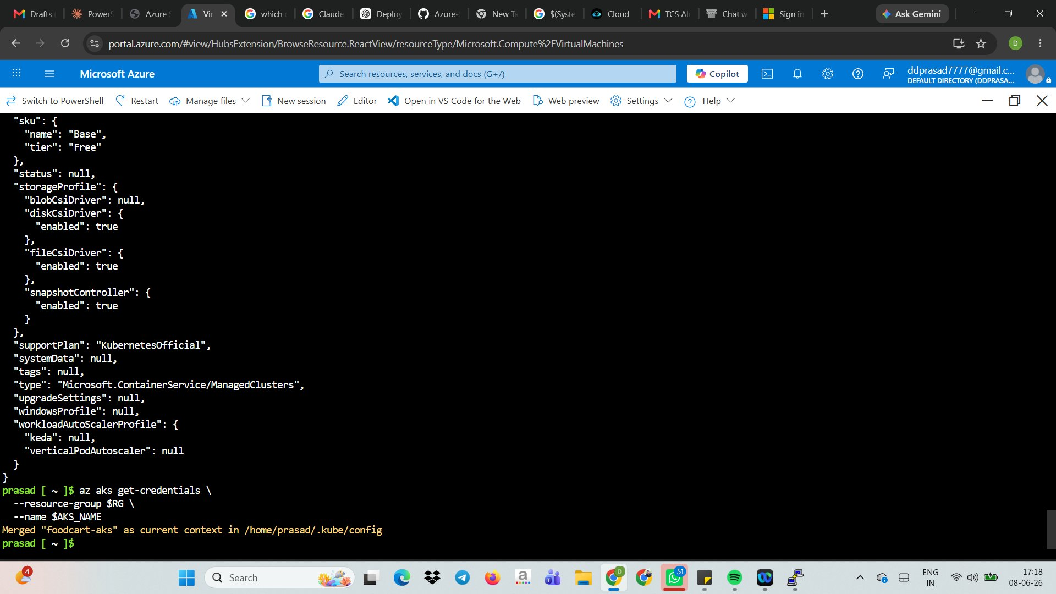

7.4 Pipeline — Deploy to Kubernetes Succeeded
The Deploy to Kubernetes stage completed all steps successfully — Initialize, Checkout, Deploy to AKS, and Finalize Job.
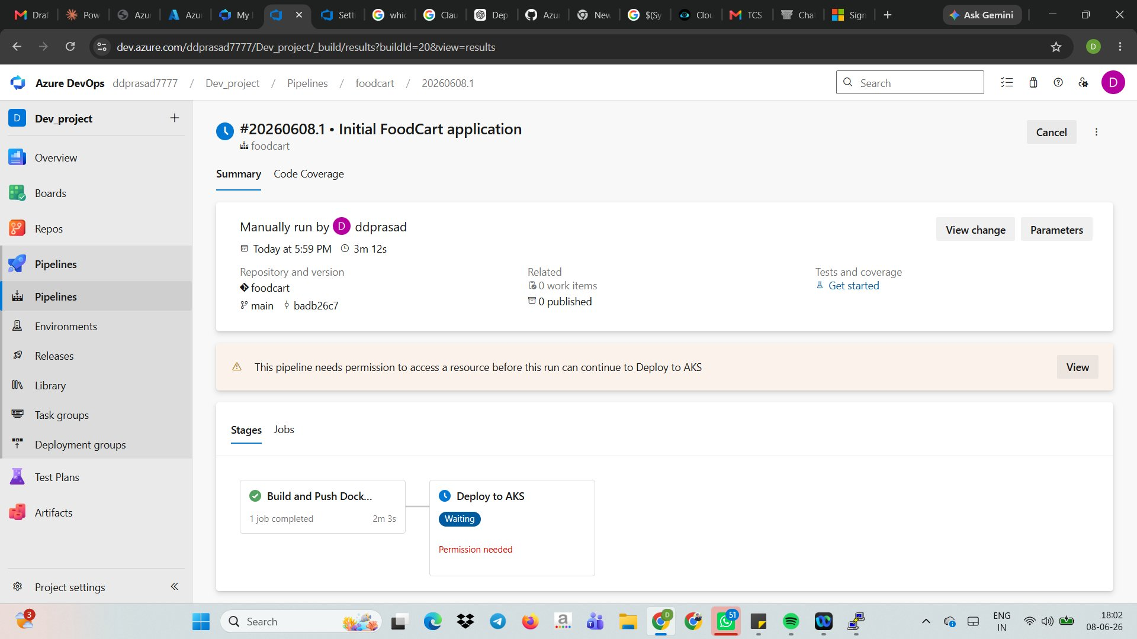

7.5 All Pipeline Runs Succeeded
Three pipeline runs completed. Each triggered automatically on git push. All Build and Deploy stages show green checkmarks.
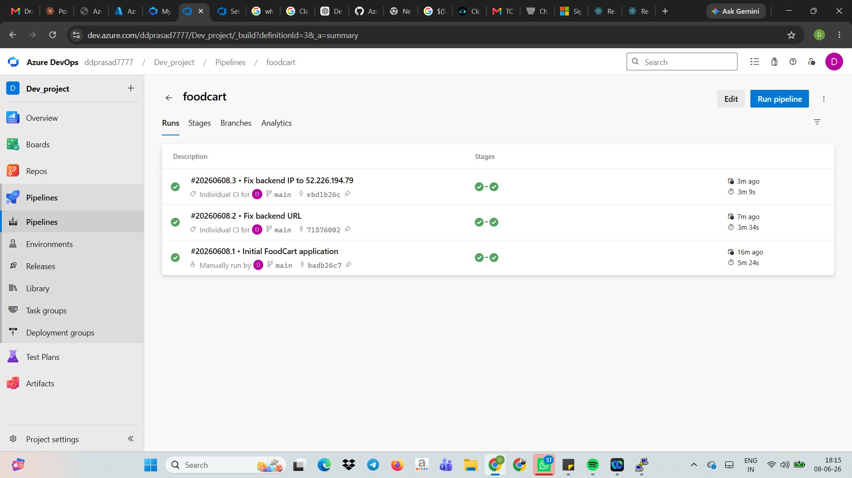

7.6 FoodCart App — Live on Internet
FoodCart is live at http://57.162.160.199. All 6 menu items (Burger, Pizza, Biryani, Pasta, Noodles, Sandwich) load correctly from the backend API.
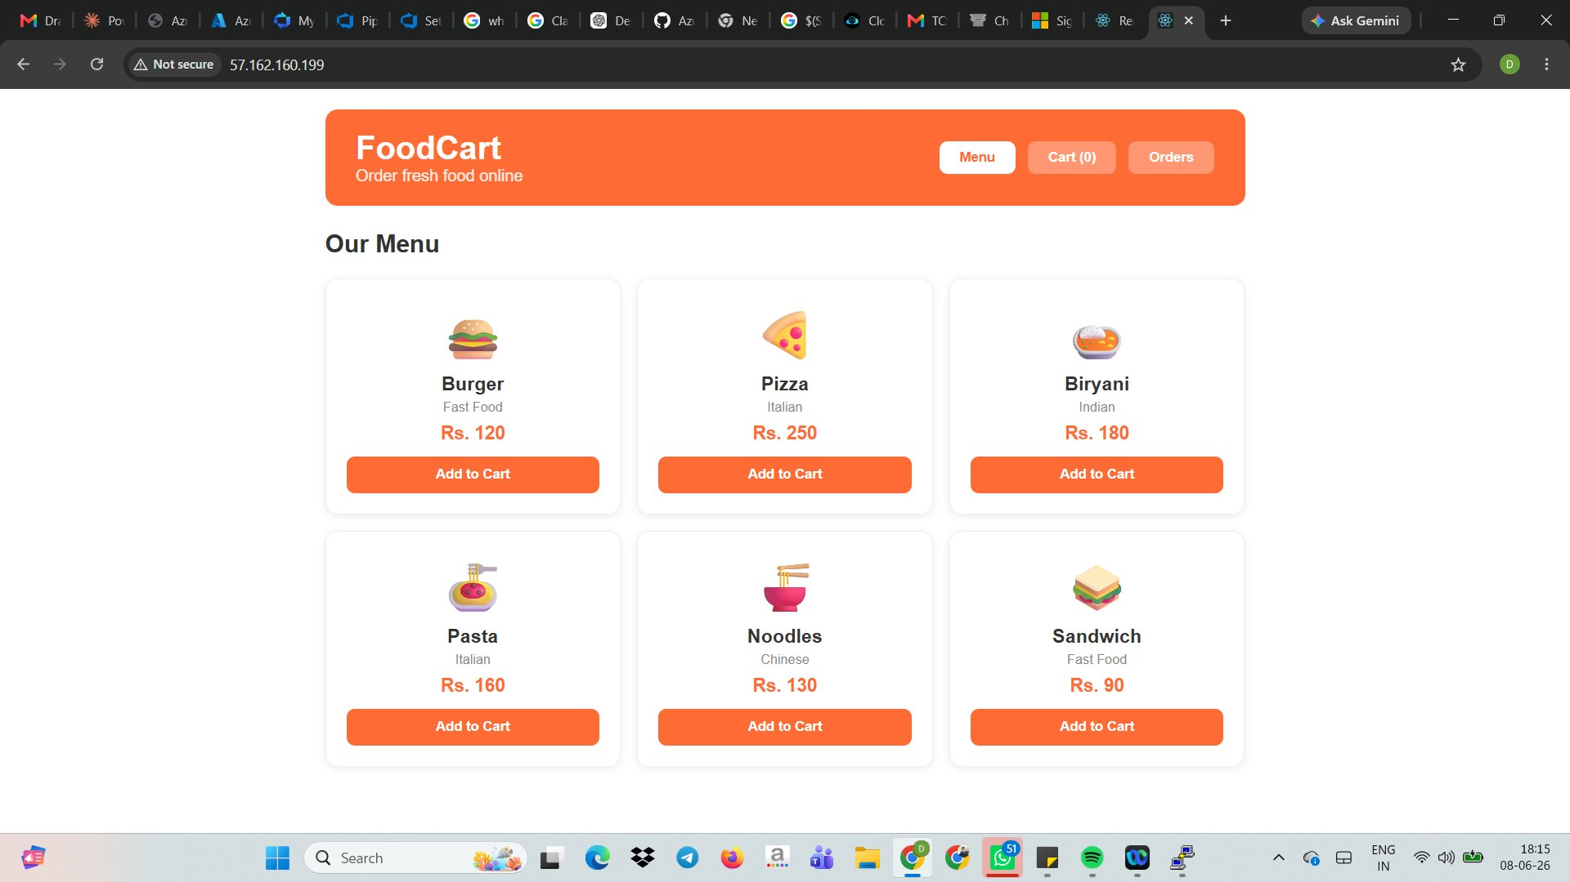

8. Setup Commands Reference

Phase 1 — VM Tools Installation
# Install Docker
curl -fsSL https://get.docker.com | sudo sh
sudo usermod -aG docker $USER

# Install kubectl
curl -LO https://dl.k8s.io/release/$(curl -L -s https://dl.k8s.io/release/stable.txt)/bin/linux/amd64/kubectl
sudo install -o root -g root -m 0755 kubectl /usr/local/bin/kubectl

# Install Azure CLI
curl -sL https://aka.ms/InstallAzureCLIDeb | sudo bash

Phase 2 — Azure Resources
RG="foodcart-rg"
LOCATION="eastus"
ACR_NAME="foodcartacr7330"
AKS_NAME="foodcart-aks"

az group create --name $RG --location $LOCATION

az acr create --resource-group $RG --name $ACR_NAME --sku Basic --admin-enabled true

az aks create --resource-group $RG --name $AKS_NAME \
--node-count 1 --node-vm-size Standard_B2s \
--attach-acr $ACR_NAME --generate-ssh-keys

az aks get-credentials --resource-group $RG --name $AKS_NAME
kubectl get nodes

Post-Deploy Verification
kubectl get services
kubectl get pods
kubectl get deployments

9. Skills Learned
Technology | What Was Practiced
Docker | Multi-stage builds for React (node+nginx) and Flask (python-slim)
Kubernetes | Write Deployments and Services YAML, apply manifests, check pod status
AKS | Create cluster, attach ACR, connect kubectl, LoadBalancer services
Azure ACR | Create registry, login via CLI, push and pull Docker images
Azure DevOps | Multi-stage YAML pipeline, AzureCLI@2 tasks, environment deployments
Azure Cloud Shell | Browser-based authenticated terminal, no local setup required
Git + Azure Repos | Init, add, commit, push, PAT authentication, trigger pipelines
Flask REST API | GET and POST endpoints, CORS config, MongoDB integration
React | useState, useEffect, API fetch calls, conditional rendering
MongoDB | Deploy in Kubernetes, connect via ClusterIP service DNS name

10. Cost Management
This project runs on a Pay-As-You-Go Azure account. Always stop resources when not actively practicing to minimize charges.

Resource | Approx Cost/Month | Cost Saving Tip
devops-lab-vm (B2s) | Rs. 2,500 | Deallocate VM when not using
foodcart-aks (1 node B2s) | Rs. 2,500 | Scale to 0 nodes when not practicing
foodcartacr7330 (Basic) | Rs. 400 | Minimal fixed cost
2 Public LoadBalancer IPs | Rs. 300 | Delete services when done with project

Stop / Save Commands
# Deallocate VM (stops billing for compute)
az vm deallocate --resource-group foodcart-rg --name devops-lab-vm

# Scale AKS to 0 nodes when not practicing
az aks scale --resource-group foodcart-rg --name foodcart-aks --node-count 0

# Scale back up when ready to practice
az aks scale --resource-group foodcart-rg --name foodcart-aks --node-count 1

# Delete ALL resources when completely done
az group delete --name foodcart-rg --yes --no-wait

FoodCart Project | ddprasad | June 08, 2026 | Azure DevOps + Kubernetes Learning Project

