**For the submission of your work:**

- Create a folder named **RollNo_Name_DBI202_PaperNo**, e.g. se01245_LongNT_DBI202_01. All file created will be located in the above folder.

- For each question, you are required to write a database script. Create a file with the name corresponding to the index of the question. For example, **for question 1**, we will create a file named **Q1.sql** and create a file **Q2.sql for question 2**. These files contain only the required workflow commands that do not include other commands including the database context switch (not including use [database name]).

- On completion, import your work by browsing to the above folder.

**From the 2nd question**, you should use the database provided in the DBscript.sql file which has the following database diagram. Please, run the provided script to create tables and insert data into your database.

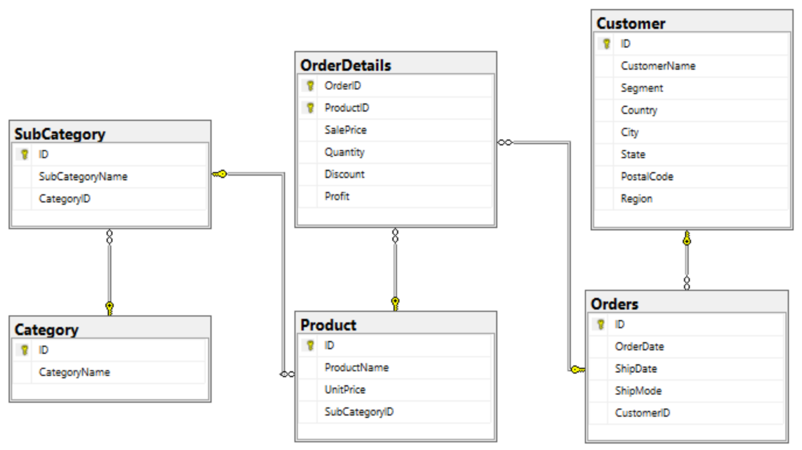

**Question 1:**

Create one database and then write SQL statements to create all tables derived from the ERD given in Picture 1.1. Those tables have to locate under the database that you have just created with appropriate attributes, primary keys and foreign keys.

NOTE that when creating the SQL commands as request, you MUST keep the name of tables, relationship and attributes and data type of attributes as SAME as given in the above ERD.

Attributes have written with underline are Primary Key of each entity.

When submitting the responses for this question, submit only SQL statements for creating tables with corresponding keys and foreign keys. Do not use “create database” or “use database_name” statements in your submission.

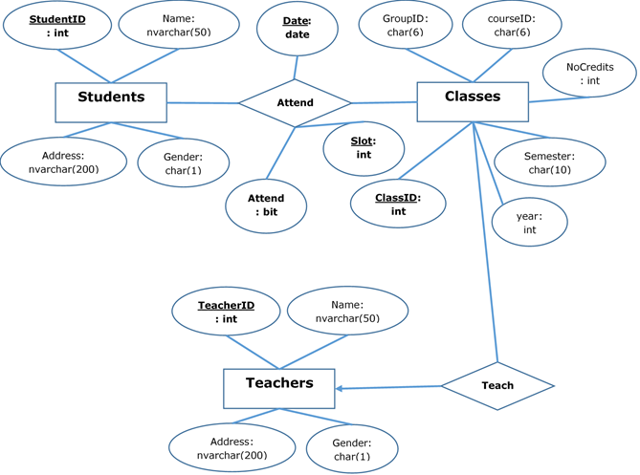

Picture 1.1

**Question 2:**

Write a query to display all customers who are ‘Consumer’ and are from Arlington city as follows:

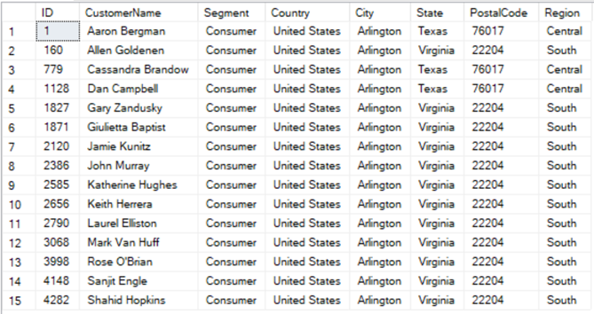

Picture 2.1

**Question 3:**

Write a query to display all customers having CustomerName starting with B and placed orders in December 2017. Display the result by descending order of Segment and then by ascending order of CustomerName.

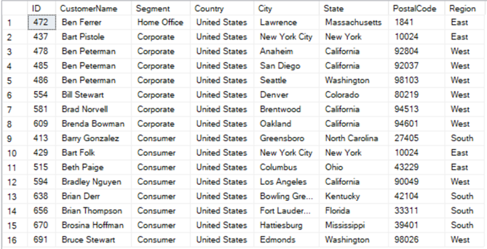

Picture 3.1

**Question 4:**

Write a query to display SubCategoryID, SubCategoryName and the corresponding number of products (NumberOfProducts) in each sub-category having the number of products greater than 100, by descending order of NumberOfProducts.

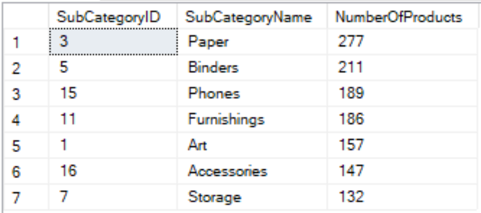

Picture 4.1

**Question 5:**

Write a query to display ProductID, ProductName, Quantity of all products which have the highest Quantity in one order.

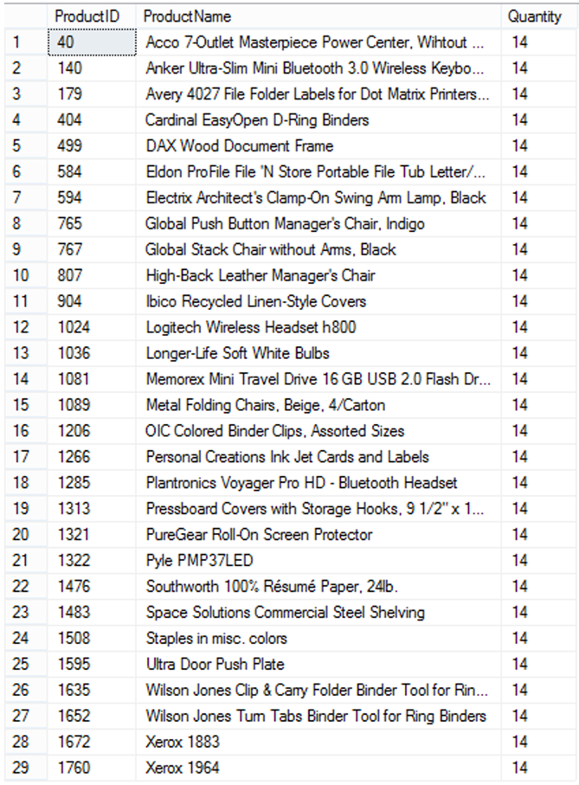

Picture 5.1

**Question 6:**

Write a query to display CustomerID, CustomerName and the number of orders (NumberOfOrders) of customers who have the highest number of orders.

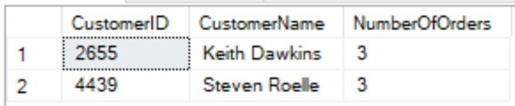

Picture 6.1

**Question 7:**

Display 5 products with the highest unit prices and 5 products with the smallest unit prices as follows:

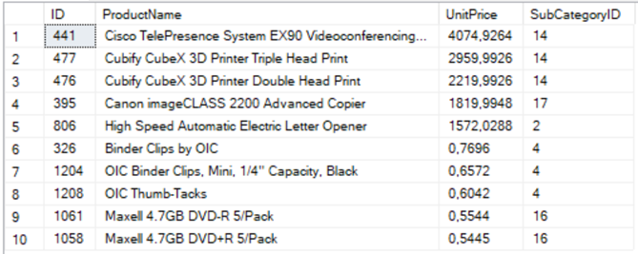

Picture 7.1

**Question 8:**

Write a stored procedure named CountProduct to calculate the number of different products in an order with OrderID (nvarchar(255)) is input parameter and the NbProducts (int) is the output parameter of the procedure.

For example, when we execute the following code, the result should be 1:

declare @t int

exec CountProduct 'CA-2014-100391', @t output

print @t

**Question 9:**

Create a trigger InsertProduct which will be activated by an insert statement into the Product table. The trigger will display the ProductName and the SubCategoryName of the products which have just been inserted by the insert statement.

For example, when we run:

insert into Product(ProductName, UnitPrice, SubCategoryID)

values ('Craft paper', 0.5, 3)

The result should be as follows:

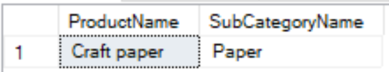

Picture 9.1

**Question 10:**

Insert the following information:

- A category named 'Sports' into table Category

- A subcategory named 'Tennis' and a subcategory named 'Football' into table SubCategory, both these two subcategories are subcategories of Category 'Sports'