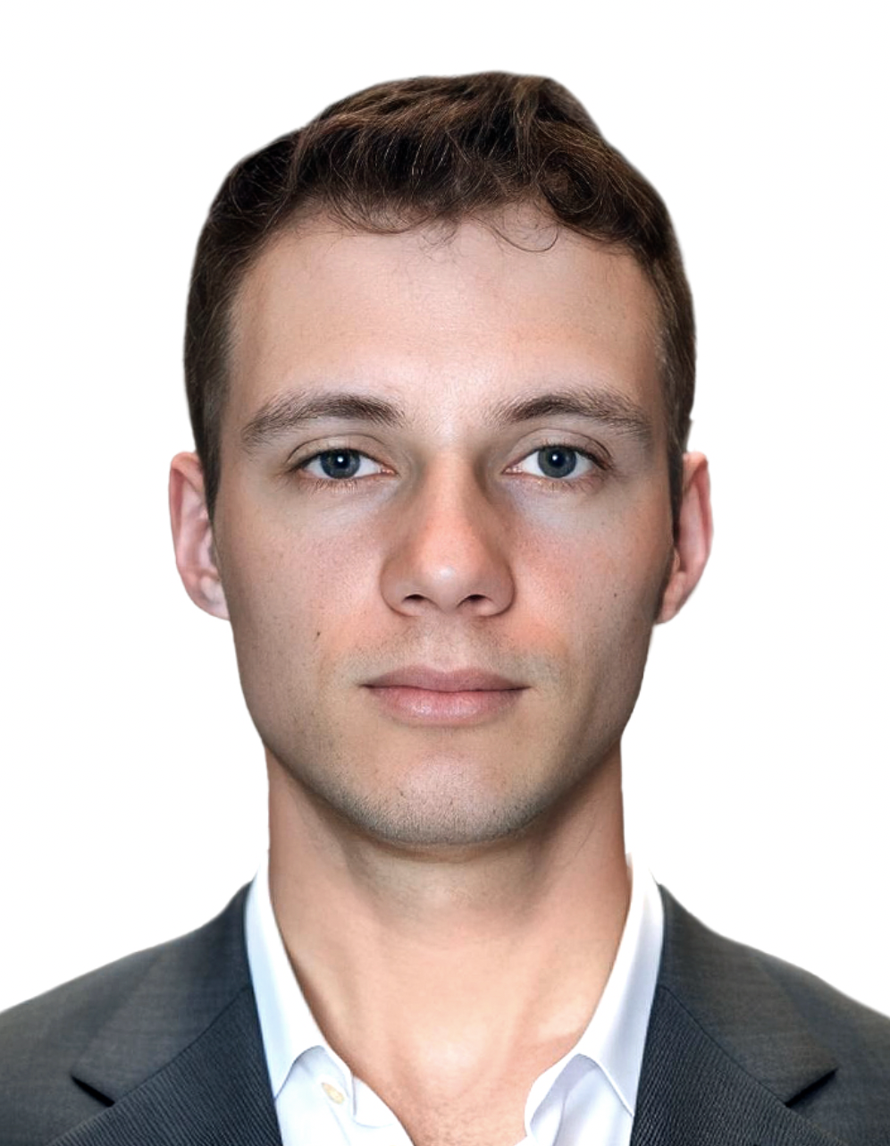 |  | Daniil Parshin  C++ Software Engineer | Systems & Performance

  Professional Summary  C++ Software Engineer focused on systems and performance engineering on Linux. I develop and optimize performance-sensitive C/C++ and Python software for profiling, graphics, and CPU inference, with hands-on experience in multithreading, benchmarking, build systems, CI/CD, debugging, and automated testing.    Experience  Huawei — Nizhny Novgorod, Russia  Software Engineer — Profiling Tools Team | November 2025 — Present  • Refactored the CMake superbuild of a performance profiling product comprising dozens of components, improving build speed by ~30% and decoupling package assembly from component builds.  • Maintain C/C++ and Python product code and Jenkins pipelines; automate builds, artifact handling, packaging, and Docker-based build/test environments.  • Develop unit tests with GoogleTest and integration tests with Robot Framework; automate test execution and reporting in CI.  Software Engineer — GPU Team | June 2024 — November 2025  • Improved BC1 texture compression quality by ~3% through dithering techniques and integrated ISPC-accelerated BC7 compression into the Mesa graphics driver; verified both through quality and performance benchmarks.  • Profiled OpenGL workloads on Linux using gdb and trace analysis; built Python/Bash tooling for automated quality evaluation and benchmarking.  • As a parallel cross-team project, developed IDet, a C++17 CPU inference library for text, face, and clothing detection using OpenCV, ONNX Runtime, and OpenMP.  • Optimized tiled inference and threading to p99 below 10 ms per detector on FHD frames on Kunpeng 920B.  • Built a Python pipeline for dataset preparation, YOLO training, evaluation, and ONNX export over 270k images.    Additional Experience  Resident and Ambassador — NEIMARK IT-Academy | September 2022 — September 2024  Delivered team software projects, mentored hackathon participants, and contributed to a winning AI ethics project. Program Page | Certificates  Private Tutor — Mathematics and Computer Science | September 2022 — Present  Prepared 35+ students for mathematics and computer science exams; taught algorithms and adapted learning plans to individual needs. |  |  Details  Nizhny Novgorod, Russia   Contacts  +7 930 810 67 22  daniil.d.parshin@gmail.com   Links  GitHub | LeetCode | Telegram   Technical Skills  Programming  C++, C, Python, Bash; algorithms & data structures  Build, CI/CD & Testing  CMake, Meson, Jenkins, Docker, Git, GTest, Robot Framework  Systems & Performance  Linux, gdb, NUMA, profiling, benchmarking, trace analysis, OpenMP, multithreading  Graphics  Mesa, OpenGL, BCn  Computer Vision & ML  OpenCV, ONNX Runtime, YOLO, DBNet, SCRFD, model training & export, CPU / GPU inference   Languages  Russian — Native  English — B1  Spanish — A1


Projects
IDet — CPU ROI detection library | GitHub
CPU-only library for ROI detection. Stack: C++17, ONNX Runtime, OpenCV, OpenMP, Meson.
YOLO Training and Deployment Pipeline | GitHub
End-to-end pipeline for dataset preparation, training, evaluation and ONNX deployment. Stack: Python, Ultralytics YOLO, ONNX Runtime, Bash.
iVoice — Local Audio and Text Command Processing | GitHub
Local-first pipeline for speech recognition and command normalization. Stack: Python, faster-whisper, Transformers, FastAPI.
Convex Polygon Intersection Calculator | GitHub
GUI application for computing intersections of convex polygons. Stack: C++, Qt.

Awards and Training
Alice & Yandex Smart Devices — Yandex × HSE × MIPT | April 2026
Completed a 72-hour intensive on smart-device architecture, embedded systems, and resource-constrained ML deployment; developed and defended a team R&D project. Certificate
Hack Lab — Sber × School 21 | November 2025
Won 1st place with the team in an HPC hackathon covering parallelization, OpenMP, hardware-level optimization, random number generation, and data integrity. Certificate
YADRO Winter School — Programming for RISC-V | February 2025
Completed intensive training in RISC-V programming, computer architecture, and low-level systems with practical project work. Certificate
Samsung IT-School — Mobile Development | September 2019 — June 2020
Studied Android, Java, OOP, algorithms, and data structures. Built a Firebase messenger and won 1st place in the regional round. Certificate

Education
HSE University — Nizhny Novgorod, Russia | September 2026 — Present
Master’s Degree in Applied Mathematics and Information Science. Program: Data Mining
HSE University — Nizhny Novgorod, Russia | September 2022 — June 2026
Bachelor’s Degree in Applied Mathematics and Information Science | Thesis

