**What is DNS?**

The domain name system (DNS) is a naming database in which internet [domain](https://www.techtarget.com/whatis/definition/domain) names are located and translated into [Internet Protocol (IP) addresses](https://www.techtarget.com/whatis/definition/IP-address-Internet-Protocol-Address). The domain name system maps the name people use to locate a website to the IP address that a computer uses to locate that website.

For example, if someone types "example.com" into a web browser, a server behind the scenes maps that name to the corresponding IP address. An IP address is similar in structure to 203.0.113.72.

Web browsing and most other internet activities rely on DNS to quickly provide the information necessary to connect users to remote hosts. DNS mapping is distributed throughout the internet in a hierarchy of authority. [Access providers](https://www.techtarget.com/whatis/definition/access-provider) and enterprises, as well as governments, universities and other organizations, typically have their own assigned ranges of IP addresses and an assigned domain name. They also typically run DNS servers to manage the mapping of those names to those addresses. Most Uniform Resource Locators (URLs) are built around the domain name of the web server that takes client requests.

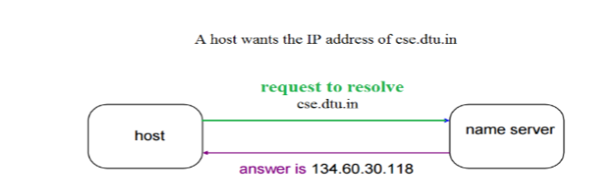

DNS servers convert URLs and domain names into IP addresses that computers can understand and use. They translate what a user types into a browser into something the machine can use to find a webpage. This process of translation and lookup is called DNS resolution.

The basic process of a DNS resolution follows these steps:

The user enters a web address or domain name into a browser.

The browser sends a message, called a recursive DNS query, to the network to find out which IP or network address the domain corresponds to.

The query goes to a recursive DNS server, which is also called a recursive resolver, and is usually managed by the internet service provider (ISP). If the recursive resolver has the address, it will return the address to the user, and the webpage will load.

If the recursive DNS server does not have an answer, it will query a series of other servers in the following order: DNS root name servers, top-level domain (TLD) name servers and authoritative name servers.

The three server types work together and continue redirecting until they retrieve a DNS record that contains the queried IP address. It sends this information to the recursive DNS server, and the webpage the user is looking for loads. DNS root name servers and TLD servers primarily redirect queries and rarely provide the resolution themselves.

The recursive server stores, or caches, the A record for the domain name, which contains the IP address. The next time it receives a request for that domain name, it can respond directly to the user instead of querying other servers.

If the query reaches the authoritative server and it cannot find the information, it returns an error message.

The entire process querying the various servers takes a fraction of a second and is usually imperceptible to the user.

DNS servers answer questions from both inside and outside their own domains. When a server receives a request from outside the domain for information about a name or address inside the domain, it provides the authoritative answer.

When a server gets a request from within its domain for a name or address outside that domain, it forwards the request to another server, usually one managed by its ISP.

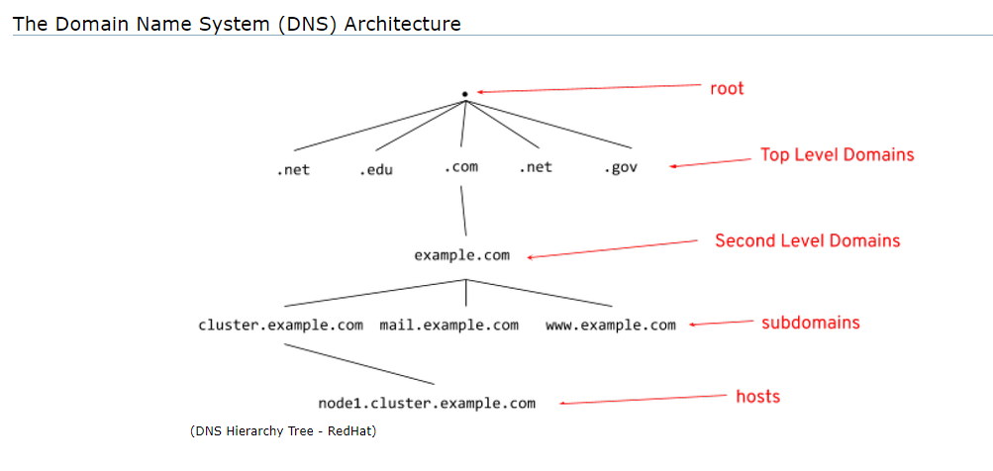

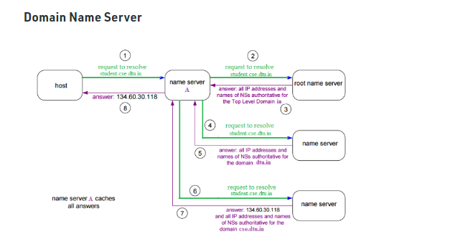

diagram of how DNS servers interact

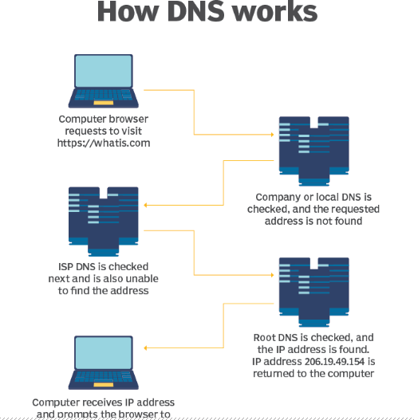

DNS servers talk to each other to answer a query from a client. Some DNS servers will have the necessary information cached and relay that back to the client so they can get online.

DNS structure

The domain name is usually contained in a URL. A domain name is made of multiple parts, called labels. The domain hierarchy is read from right to left with each section denoting a subdivision.

The TLD appears after the period in the domain name. Examples of top-level domains include .com, .org and .edu, but there are many others. Some may denote a country code or geographic location, such as .us for the United States or .ca for Canada.

Each label on the left-hand side of the TLD denotes another subdomain of the domain to the right. For example, in the URL www.techtarget.com, "techtarget" is a subdomain of .com, and "www." is a subdomain of techtarget.com.

There can be up to 127 levels of subdomains, and each label can have up to 63 characters. The total domain character length can have up to 253 characters. Other rules include not starting or ending labels with hyphens and not having a fully numeric TLD name.

The Internet Engineering Task Force (IETF) has specified rules about implementing domain names in Request for Comments (RFC) 1035.

DNS server types

There are several server types involved in completing a DNS resolution. The following list describes the four name servers in the order a query passes through them. They provide the domain name being sought or referrals to other name servers.

Recursive server. The recursive server takes DNS queries from an application, such as a web browser. It's the first resource the user accesses and either provides the answer to the query if it has it cached or accesses the next-level server if it doesn't. This server may go through several iterations of querying before returning an answer to the client.

Root name server. This server is the first place the recursive server sends a query if it doesn't have the answer cached. The root name server is an index of all the servers that will have the information being queried. These servers are overseen by the Internet Corporation for Assigned Names and Numbers, specifically a branch of ICANN called the Internet Assigned Numbers Authority.

TLD server. The root server directs the query based on the top-level domain -- the .com, .edu or .org in the URL. This is a more specific part of the lookup.

Authoritative name server. The authoritative name server is the final checkpoint for the DNS query. These servers know everything about a given domain and deal with the subdomain part of the domain name. These servers contain DNS resource records with specific information about a domain, such as the A record. They return the necessary record to the recursive server to send back to the client and cache it closer to the client for future lookups.