Can Internet Regulation Prevent Fake News?

Dr. John Smith

21 maggio, 2020

Table of Contents

Introduction 1

Theory 1

Method 2

Results 2

Descriptive statistics 2

Regression analysis 3

Discussion 4

# Introduction

Pellentesque et augue arcu. **Interdum et malesuada** fames ac ante ipsum primis in faucibus. *Duis sed ligula* iaculis, auctor quam at, iaculis enim. Donec tempus libero vitae velit rhoncus convallis. Donec tempus placerat imperdiet. Quisque vulputate elementum est. Phasellus quis ex ut lorem vulputate volutpat eget ut augue.

Aenean vel hendrerit lorem:

* Quisque luctus viverra purus, sed ultricies leo rhoncus congue.
* Proin lacus tortor, congue eleifend libero ut, pretium feugiat dui.
* Quisque nisl urna, vestibulum vel est et, auctor tristique felis.
* Ut feugiat neque at laoreet lacinia.

Nullam dapibus turpis suscipit elit sagittis pellentesque in at augue. Aliquam nec porta est. Vestibulum bibendum, ex quis accumsan auctor, est lacus suscipit purus, nec faucibus lacus dui sit amet augue.

# Theory

We hypothesize that better regulatory frameworks of the Internet can prevent the diffusion of fake news operated by government with the goal of propaganda:

H1. Regulations prevent fake news.

# Method

Pellentesque et augue arcu. **Interdum et malesuada** fames ac ante ipsum primis in faucibus. *Duis sed ligula* iaculis, auctor quam at, iaculis enim. Donec tempus libero vitae velit rhoncus convallis. Donec tempus placerat imperdiet. Quisque vulputate elementum est. Phasellus quis ex ut lorem vulputate volutpat eget ut augue.

# Results

## Descriptive statistics

The DSP data contains 3383 observations from year 1980 until 2019.  
The following histogram shows the spreading of fake news:

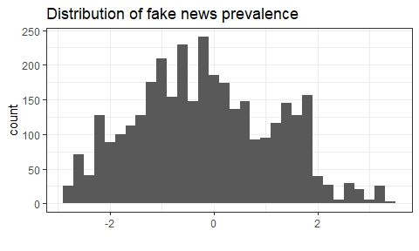

Countries also have different regulations:

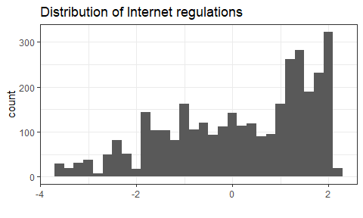

## Regression analysis

We first drop the obsevrations before 2007 because we think is right.

Then we estimate a linear regression model to test our hypothesis.

The analysis includes:

* 1966 observations
* 179 countries
* 11 years.

The following regression table shows the results.

|  |  |  |  |
| --- | --- | --- | --- |
|  | | | |
|  | gov_fakes | | |
|  | (1) | (2) | (3) |
|  | | | |
| regulation | -0.617*** | -0.707*** | -0.712*** |
|  | (0.015) | (0.037) | (0.035) |
| Constant | 0.051** | 0.660*** | -67.658*** |
|  | (0.022) | (0.111) | (5.056) |
| Country FE | No | Yes | Yes |
| Year FE | No | No | Yes |
| N | 1,966 | 1,966 | 1,966 |
| R2 | 0.470 | 0.931 | 0.937 |
| Adjusted R2 | 0.470 | 0.924 | 0.931 |
| Residual Std. Error | 0.974 (df = 1964) | 0.369 (df = 1786) | 0.352 (df = 1785) |
| F Statistic | 1,743.640*** (df = 1; 1964) | 134.246*** (df = 179; 1786) | 148.096*** (df = 180; 1785) |
| *p < .1; **p < .05; ***p < .01 | | | |

# Discussion

Nulla id laoreet purus, vitae luctus lacus.

1. Nunc finibus ex et accumsan dapibus.
2. Aenean vitae ornare nulla.
3. Aliquam hendrerit nulla eros, vel dictum dolor lacinia vel.
4. Pellentesque vitae enim viverra libero facilisis aliquam vel pretium tellus.
5. Vestibulum ante ipsum primis.