i.c. Stars – Cycle #30

**Developer Workstation Setup**

The following lists the software components required for software development. Additional tools *may* be required as the project progress.

*.: Required :.*

[Google Chrome](https://www.google.com/intl/en/chrome/browser/) – required for JavaScript/CSS debugging

[Mobile/RWD Chrome plugin](https://chrome.google.com/webstore/detail/mobilerwd-tester/elmekokodcohlommfikpmojheggnbelo?hl=en-US) – required to verify web content in Android screen size. Once installed you will see the plugin icon next to the Settings icon (see below)

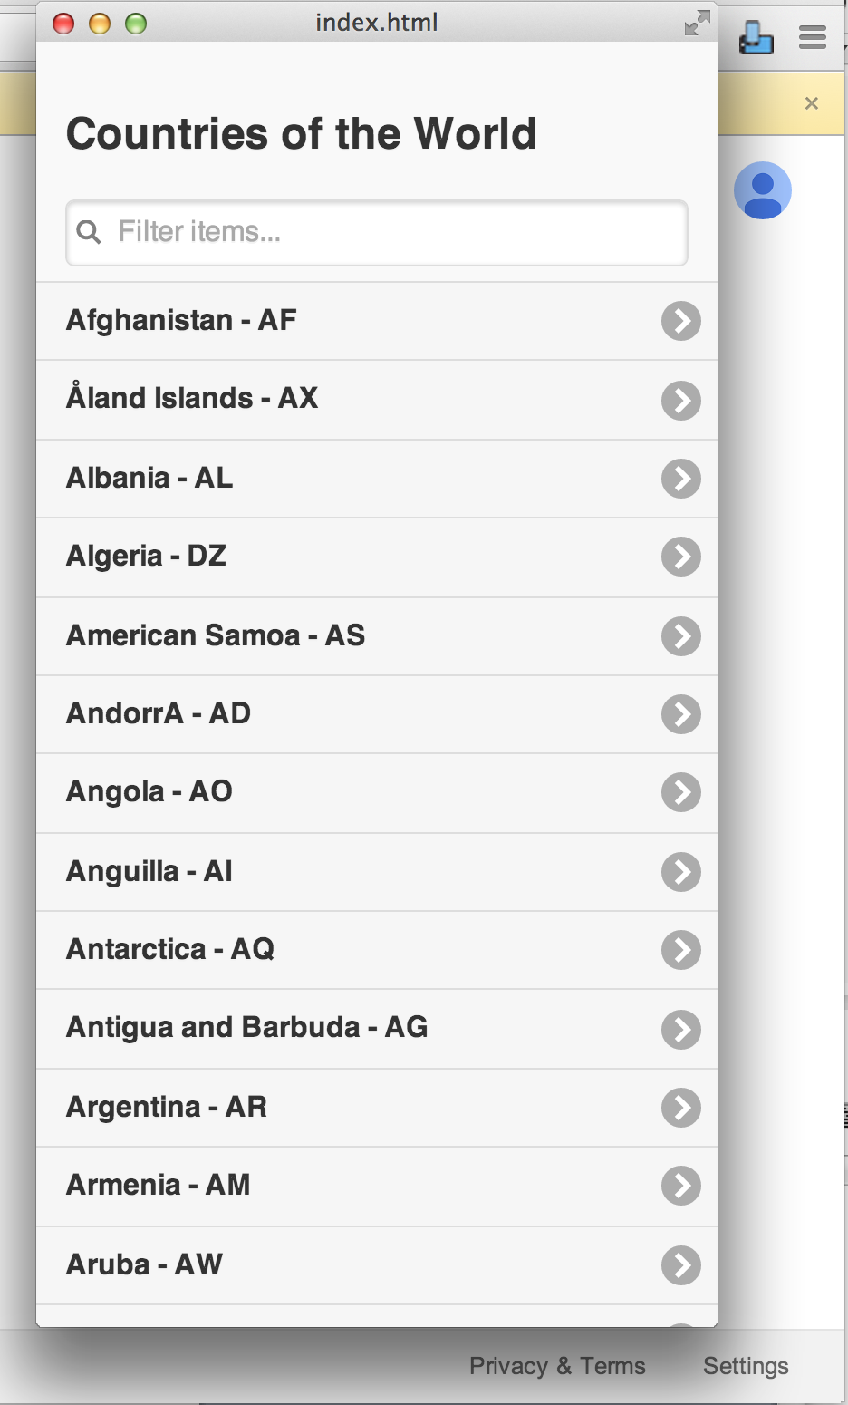

Code Editor – required for writing application code. Select one of the following or any editor of your choice.

* [Notepad++](http://notepad-plus-plus.org/download/v6.5.5.html)
* [Sublime](http://www.sublimetext.com/2)

*.: Optional Tools :.*

[SourceTree](http://www.sourcetreeapp.com/download/) – application that helps user visualize git source control

**Environments**

The project will have multiple server environments. Those environments are listed below.

< add environment info here >

**Mobile Solution Structure**

The mobile source code can be found for each platform off the repository root.

/mobilesrc

/mobilesrc/android

/mobilesrc/ios

*.: Where to create/save HTML, JavaScript and CSS files for each platform :.*

Each project will have a www folder, in the Android project it will live in the following path:

/mobilesrc/android/assets/www/

All source code needs to live under the www folder. HTML will live at the root, JavaScript and CSS files will be placed in the /js and /css directories respectively.

For example:

/mobilesrc/android/assets/www/index.html

/mobilesrc/android/assets/www/js/jquery.mobile-1.4.2.min.js

/mobilesrc/android/assets/www/css/jquery.mobile-1.4.2.min.css

Image files will be placed in a folder called “img”.

For example:

/mobilesrc/android/assets/www/img/apple.png

/mobilesrc/android/assets/www/img/orange.png

/mobilesrc/android/assets/www/img/grape.png

**Coding Standards and Developer Expectations**

*:: HTML ::*

* Use quotations marks around all element attributes
* Place a space between each element’s attributes



* Do not provide inline style for any HTML elements
* Do not create any JavaScript between <script> tags in HTML markup
* Ensure that the HTML5 doctype is used for all HTML pages
  + <!DOCTYPE html>
* Ensure that markup is properly indented
* Ensure your markup is consistent
* If you have questions, never hesitate to ask

*:: CSS ::*

* All styles should reside in CSS files located in the /css folder
* Ensure that styles are properly indented
* Be consistent
* Keep styles organized
* Use multiple style classes when applicable
* Use Google Chrome’s Developer Tools to dynamically to make and view style updates
* Span specific styles across multiple style sheets if you need to
* If you have questions, never hesitate to ask

*:: JavaScript ::*

* All JavaScript should reside in JavaScript files located in the /js folder
* All Boolean variables should be named with the prefix “is” – ex. isOpen, isConnected
* Variable names should be appropriate and make sense to the developers who follow you original path
* Provide code commentary anywhere you feel is necessary, when in doubt – provide comments.
* Ensure that code is properly indented

*:: Developer Expectations ::*

* Developers are expected to write legible and maintainable code, regardless of the obstacles. If you need help, feel to free to ask
* Developers should never commit code that has yet to be tested
* Developers should not critique the code style or output of their peers, writing an application requires a group of developers who respect each other’s effort and work.
* Developers should have fun and learn as much as they can – this is the best job in the world.