Q.1 Create group and user as given below

|  |  |
| --- | --- |
| **Groups** | **Members** |
| Red | apple, banana, cat, dog, elephant |
| Blue | fish, gun, horse, icecream |
| green | jelly, kitkat, lolipop, marshmallow |
| orange | new, oppo, vivo, china |

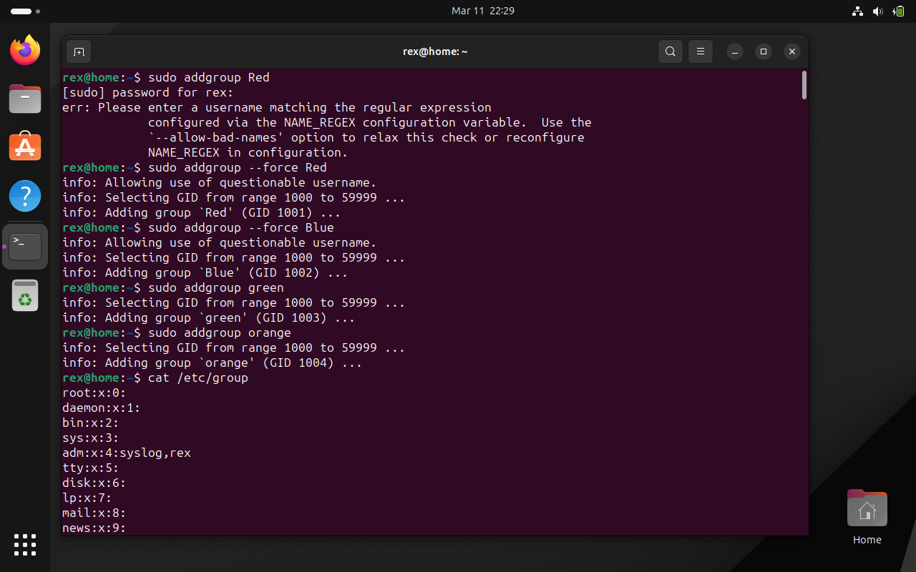

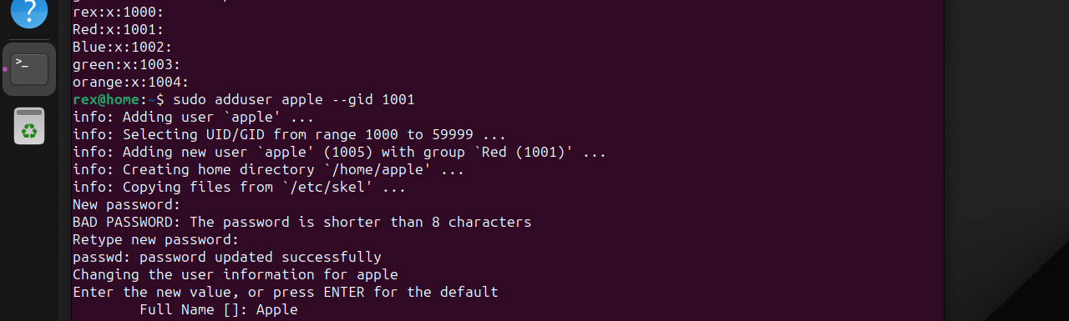

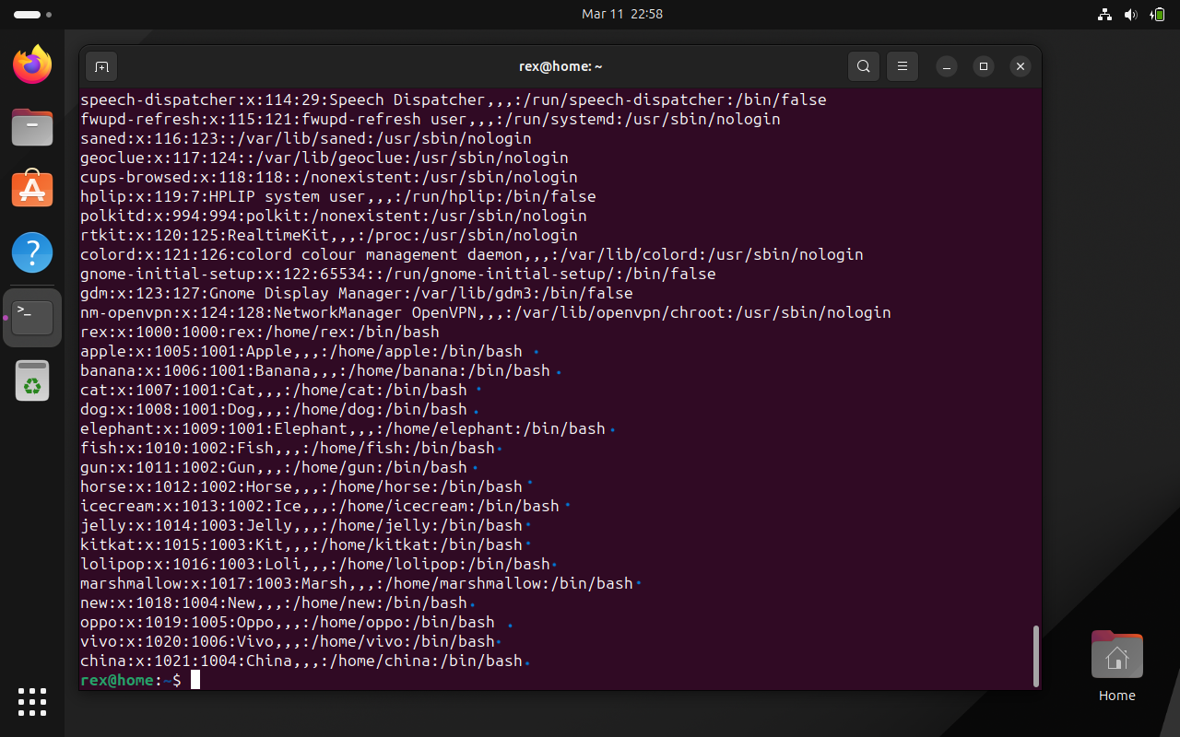

1. create directory named EVERYONE in /home. Give all permission to EVERYONE

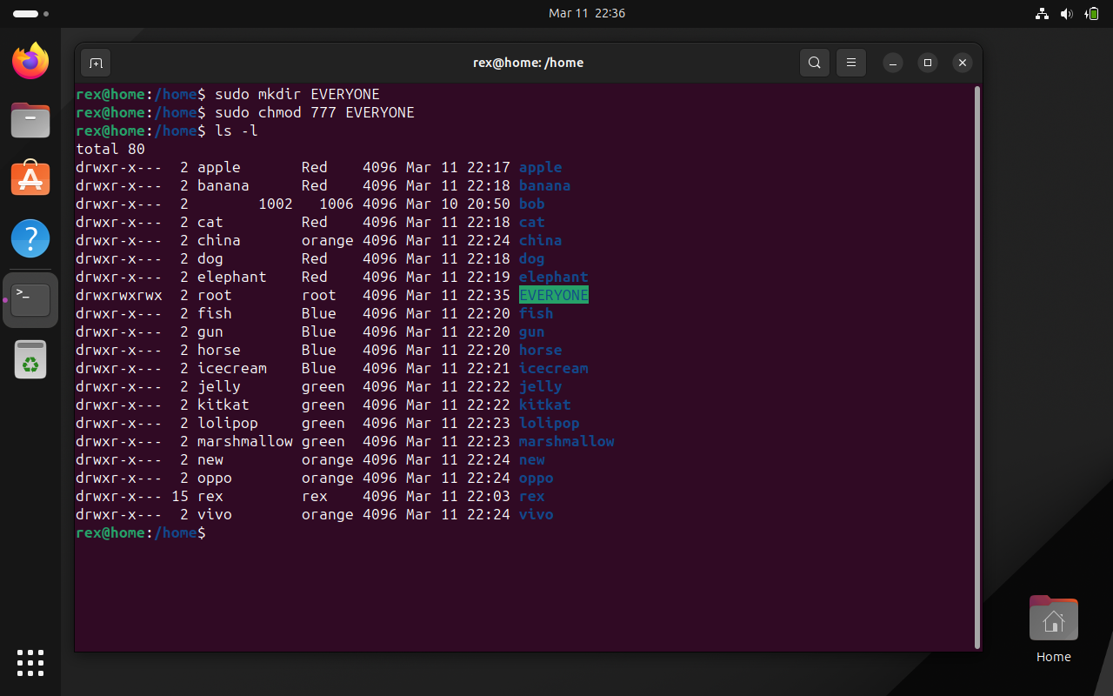

1. Create a file with every user (whoami >> username.txt)

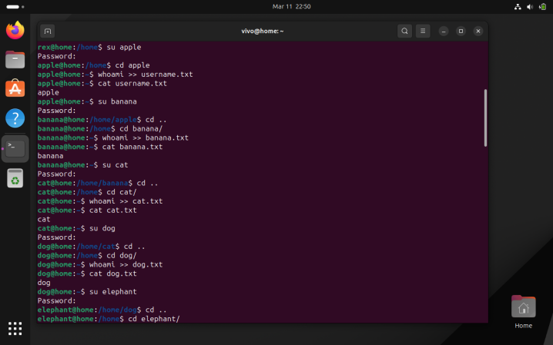 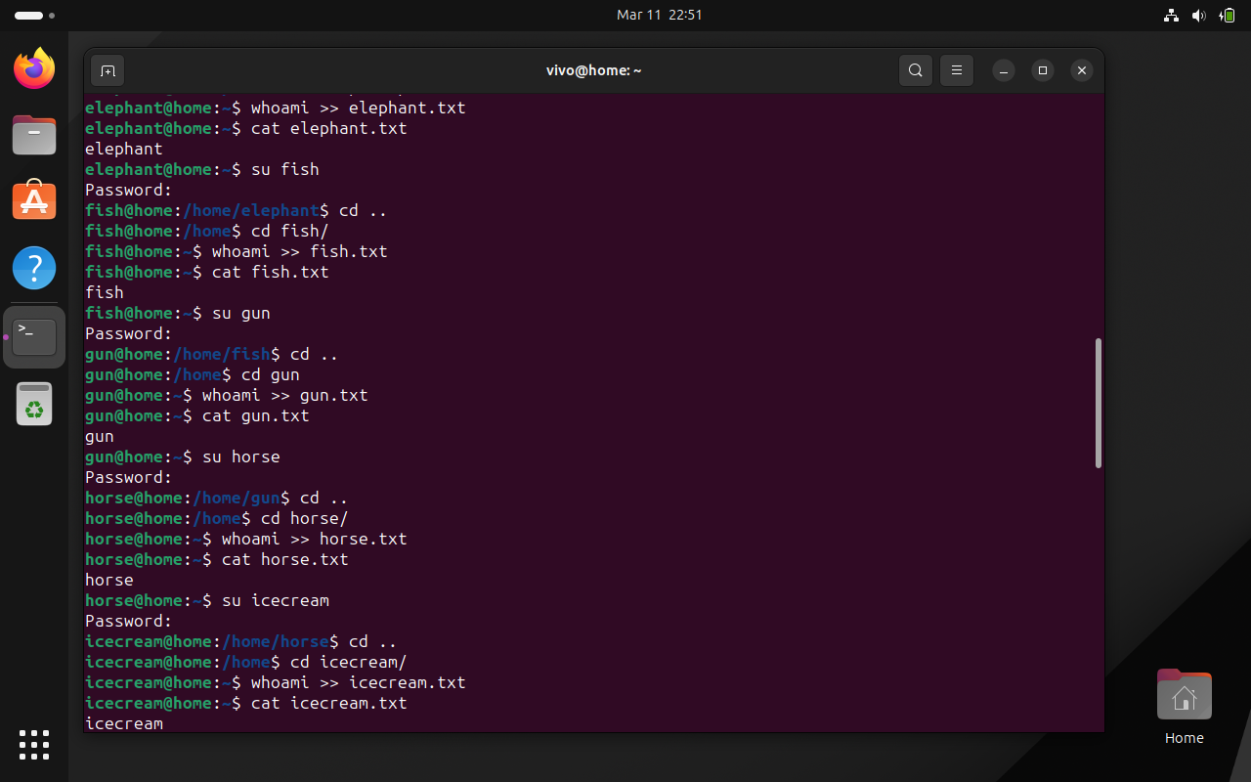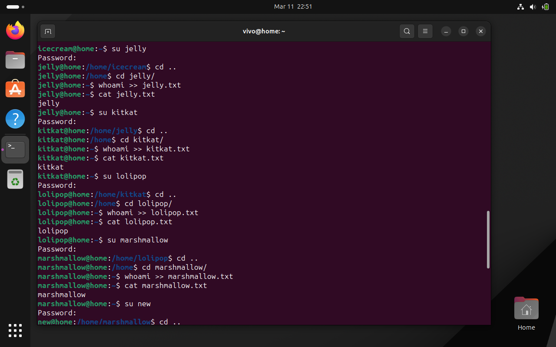 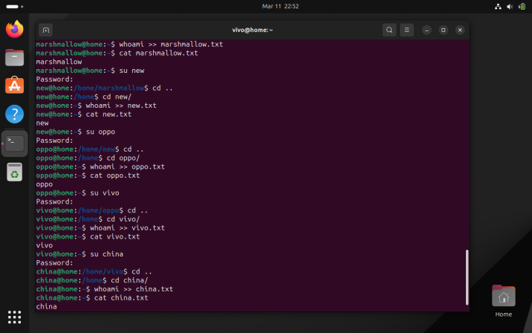

oppo -> primary group change -> one

vivo -> primary group change -> two

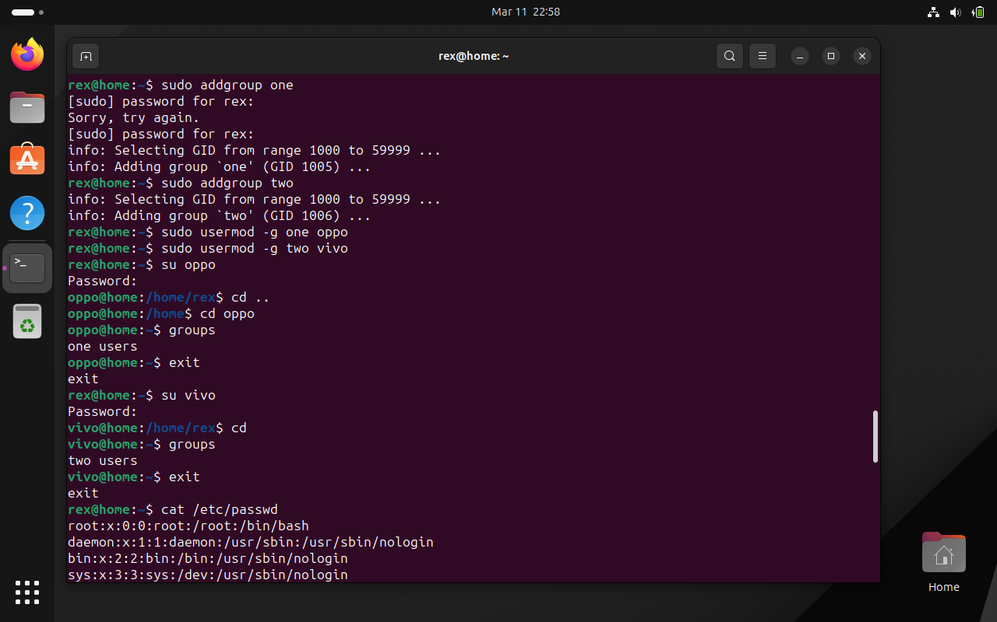

jelly,kitkat, lolipop, marshmallow -> add these users to sudo group.

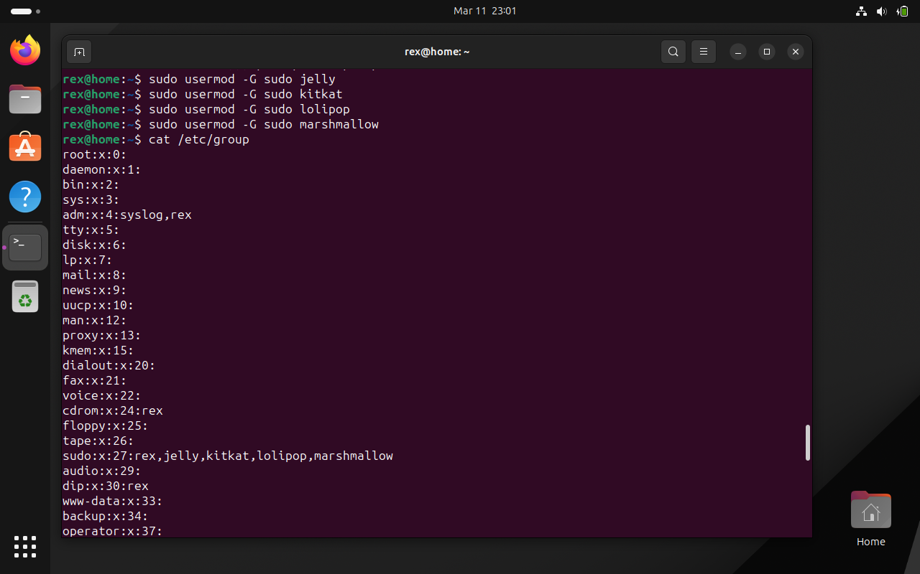

fish,gun -> add these users to one group as well (secondary group)

Ans.

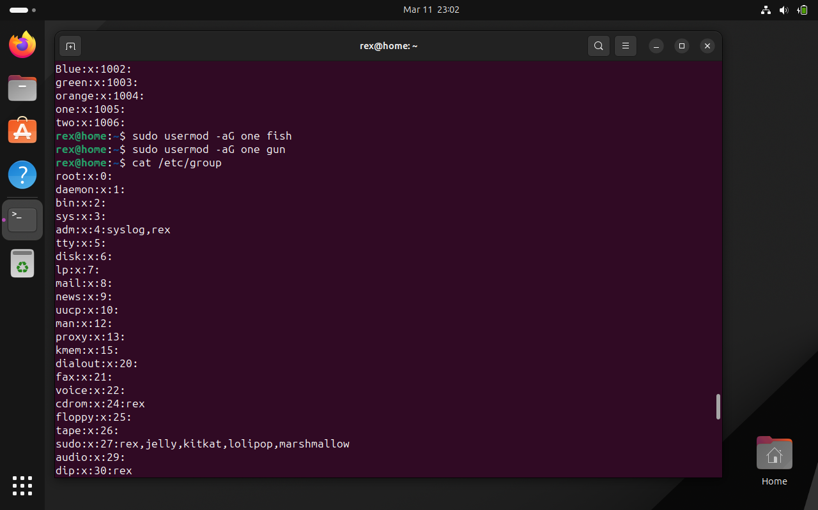 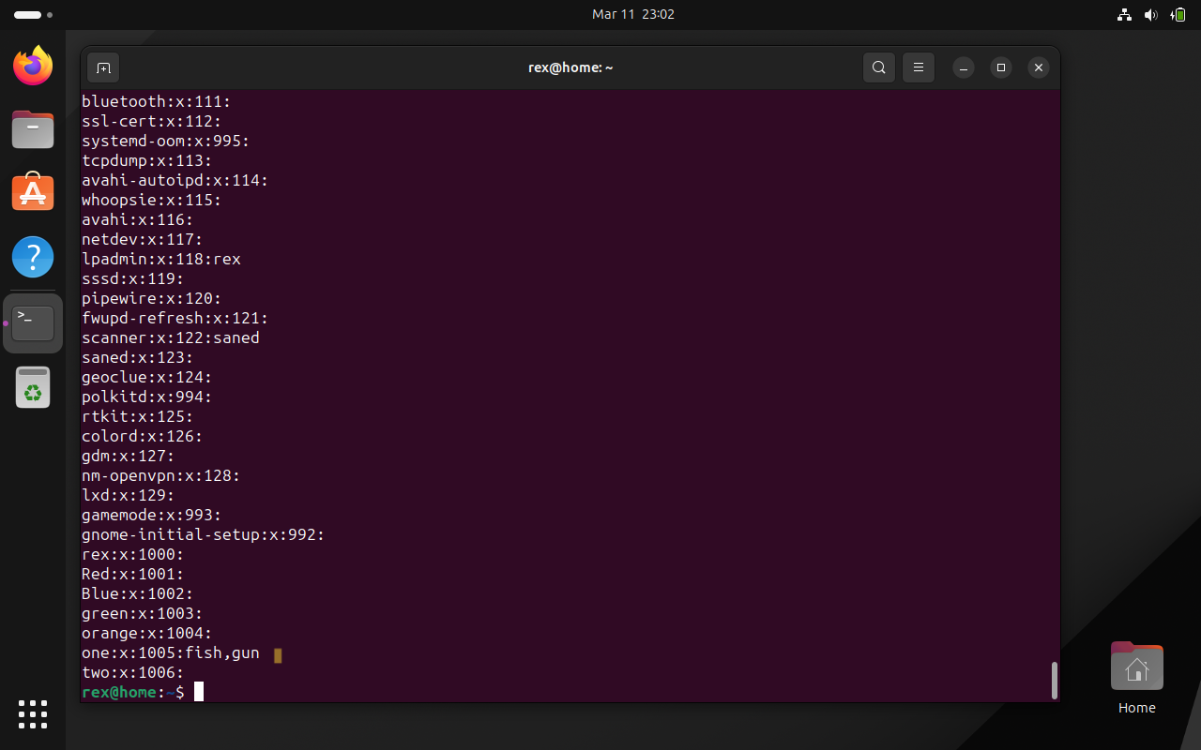

Q.2 Create Numbers.txt which will contain numbers from 1-50

a. display first 15 numbers

b. display last 10 numbers

a&b Ans.

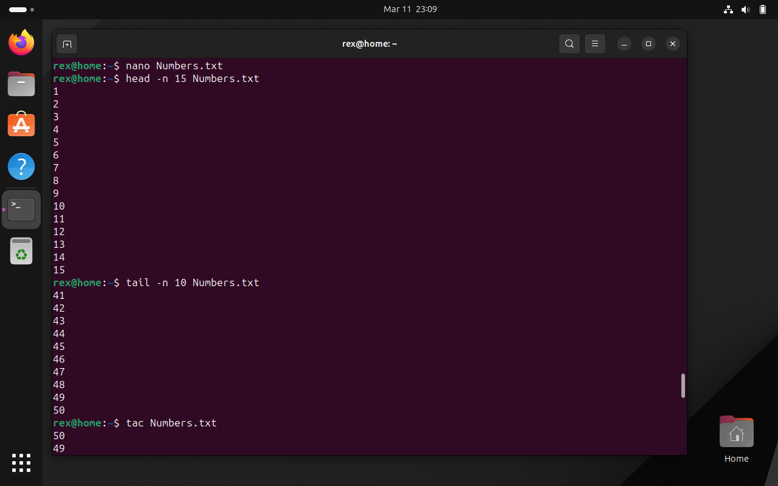

1. display numbers in reverse order.

Ans.

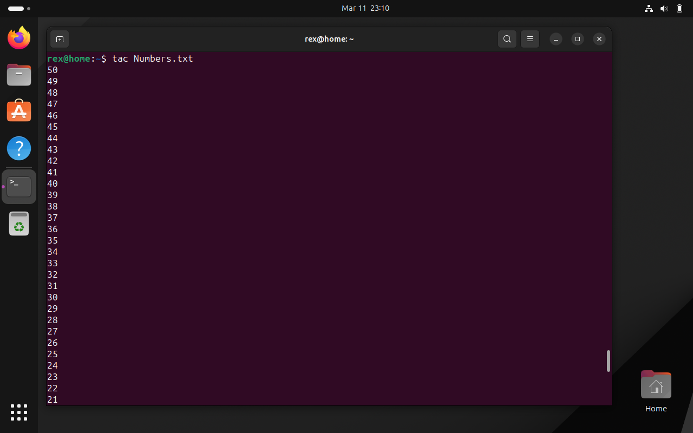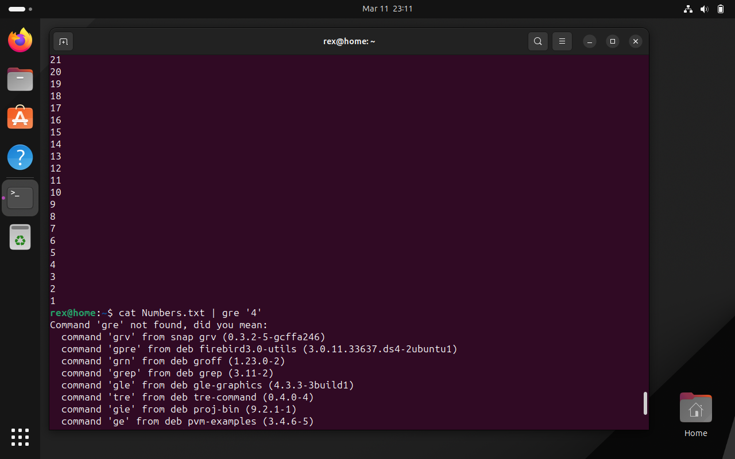

1. display numbers which includes 4 in it

Ans.

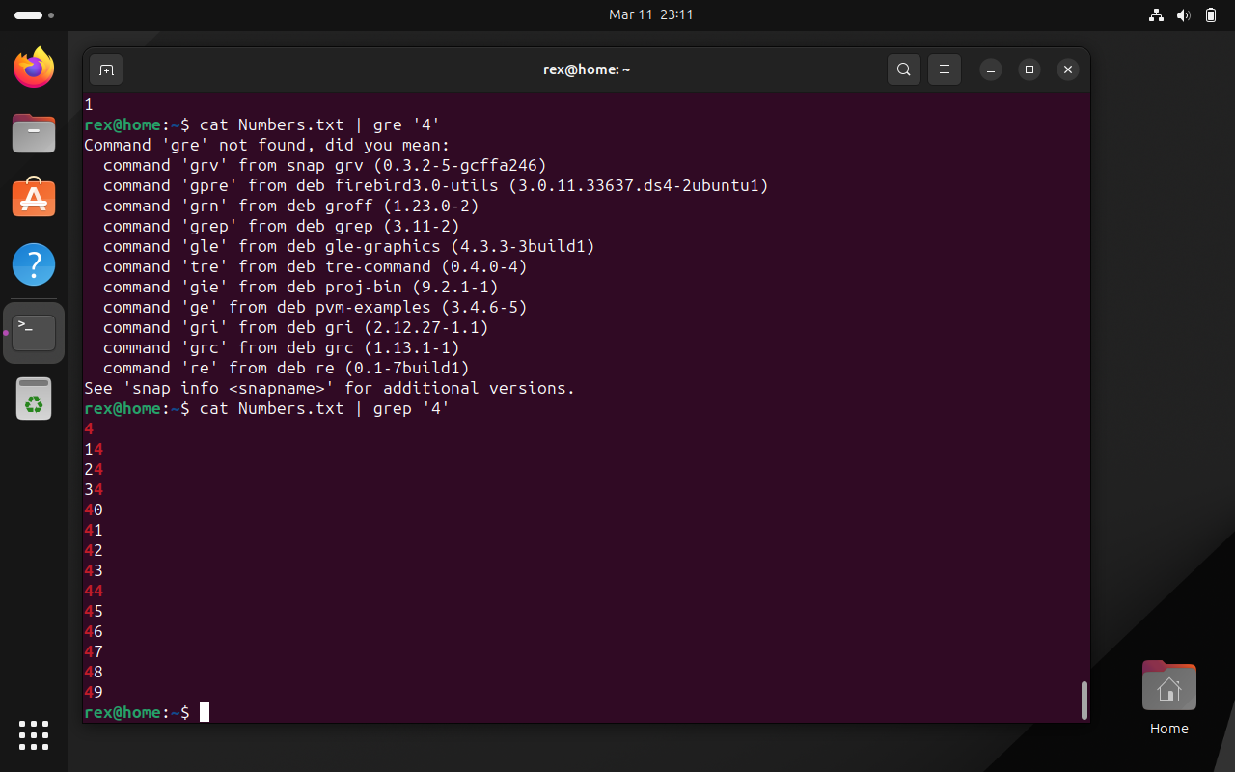

Q.3 create Student.txt file as given below

Rollno:name:marks

1111:Ram:87

2222:Sham:69

3333:Teena:58

4444:Priya:74

a. Display only details of sham

b. Display only marks of Priya

c. Display total number of lines in student.txt

Ans. 