**ASS -1**

1. In your home directory, create sets of empty practice files

* Create 6 files with names of the form songsX.mp3.
* Create 6 files with names of the form snapX.jpg.
* Create 6 files with names of the form filmX.avi.

In each set, replace X with the numbers 1 through 6. 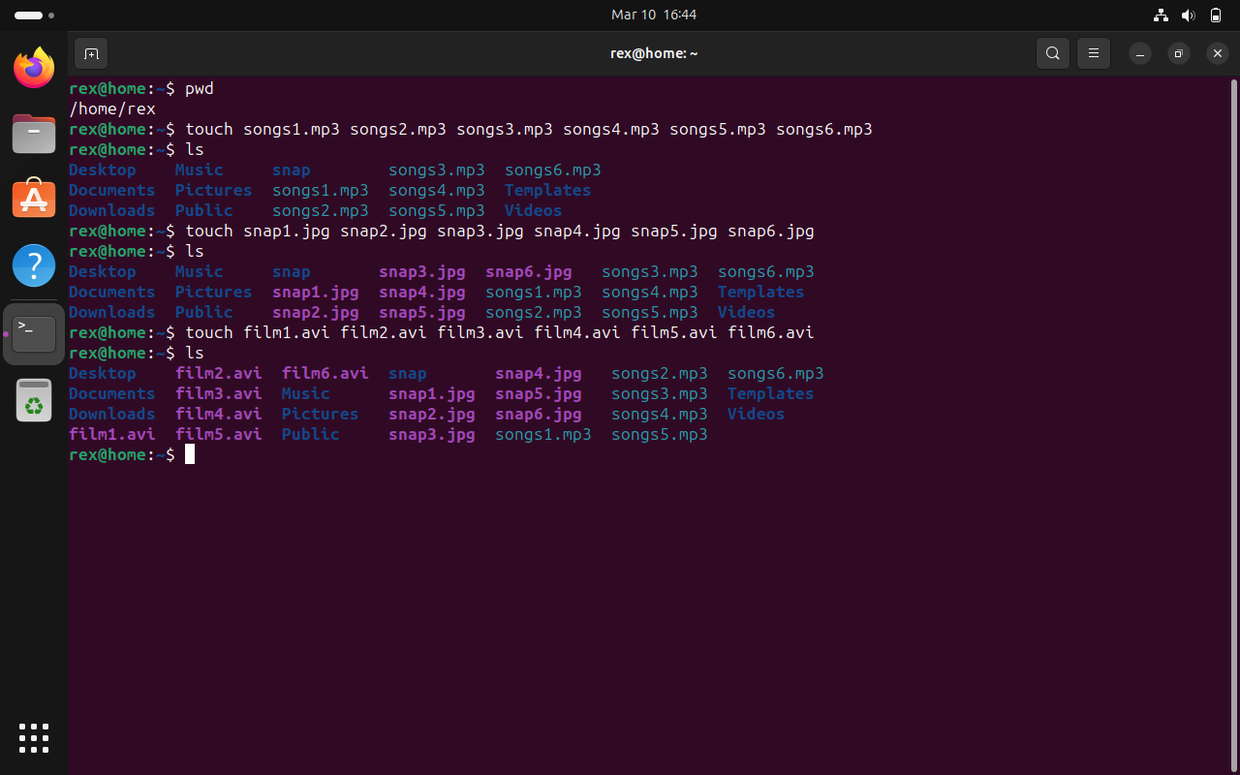

2. From your home directory,

* Move songs file into your Music subdirectory.
* Move snap file into your Pictures subdirectory.
* Move your movie files into Videos subdirectory

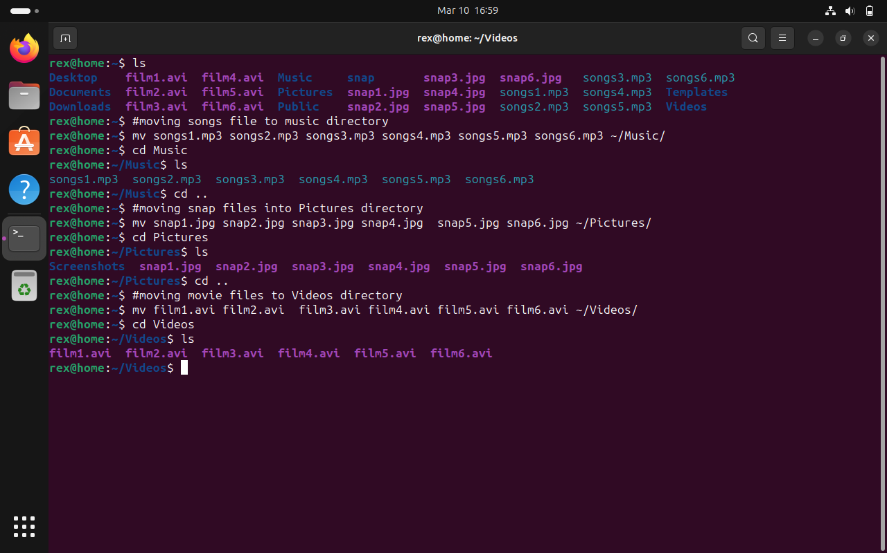

3. Create 3 subdirectories for organizing your files named friends,family,work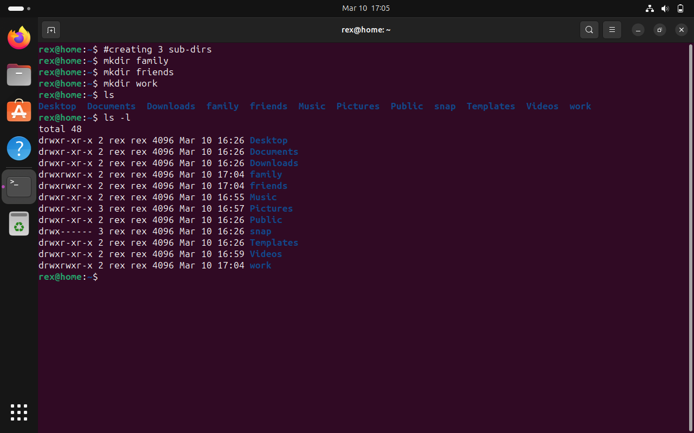

4. Copy files (all types ) containing numbers 1 and 2 to the friends folder.

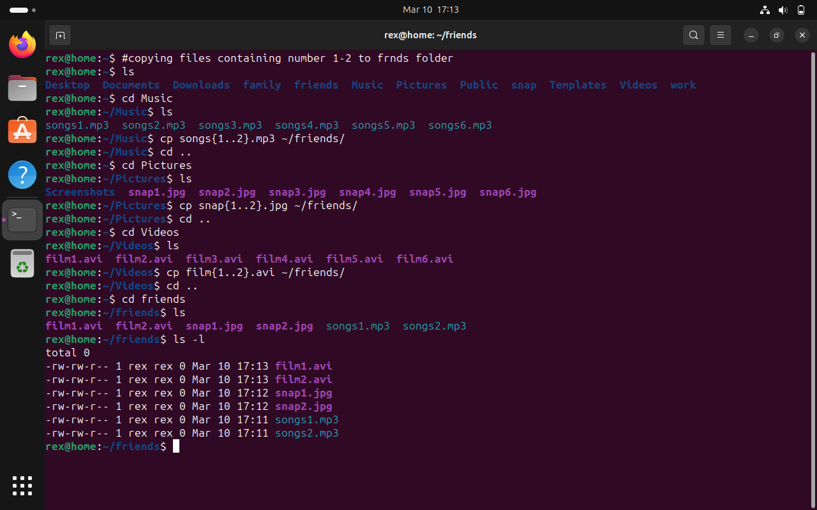

Copy files (all types) containing numbers 3 and 4 to the family folder. 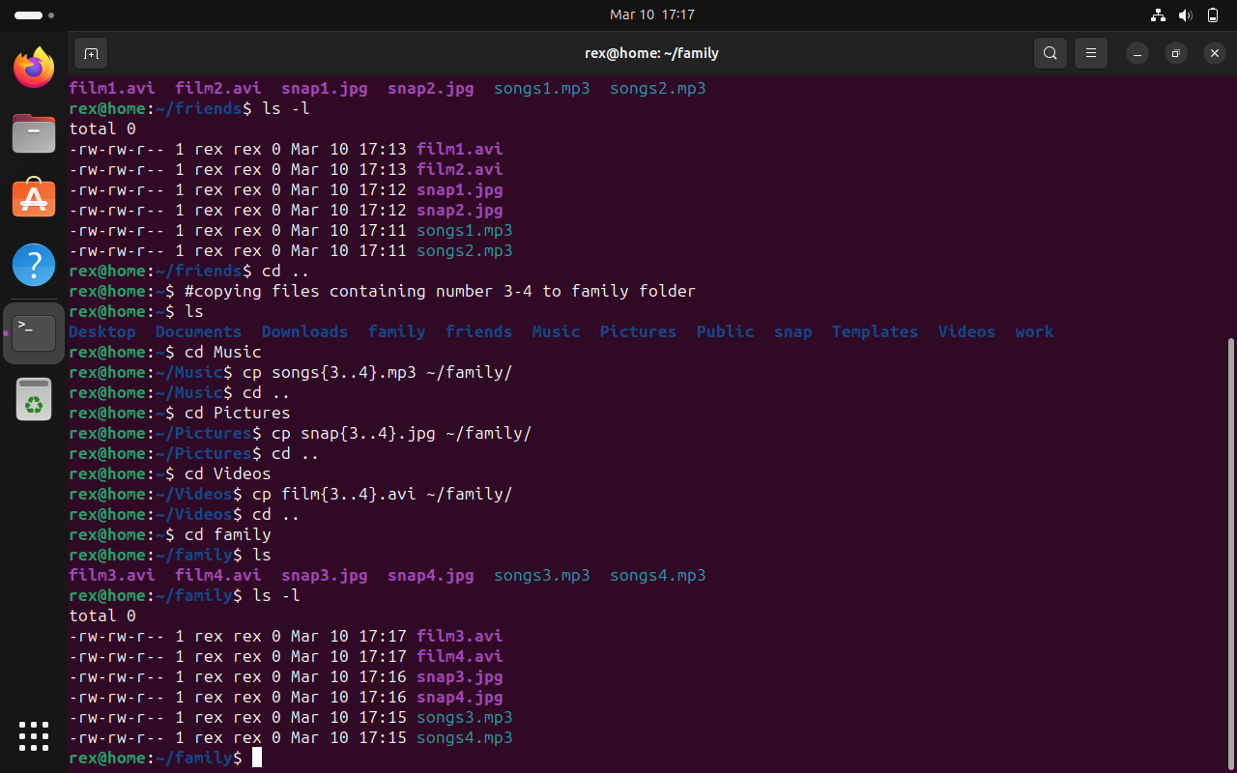

Copy files (all types) containing numbers 5 and 6 to the work folder. 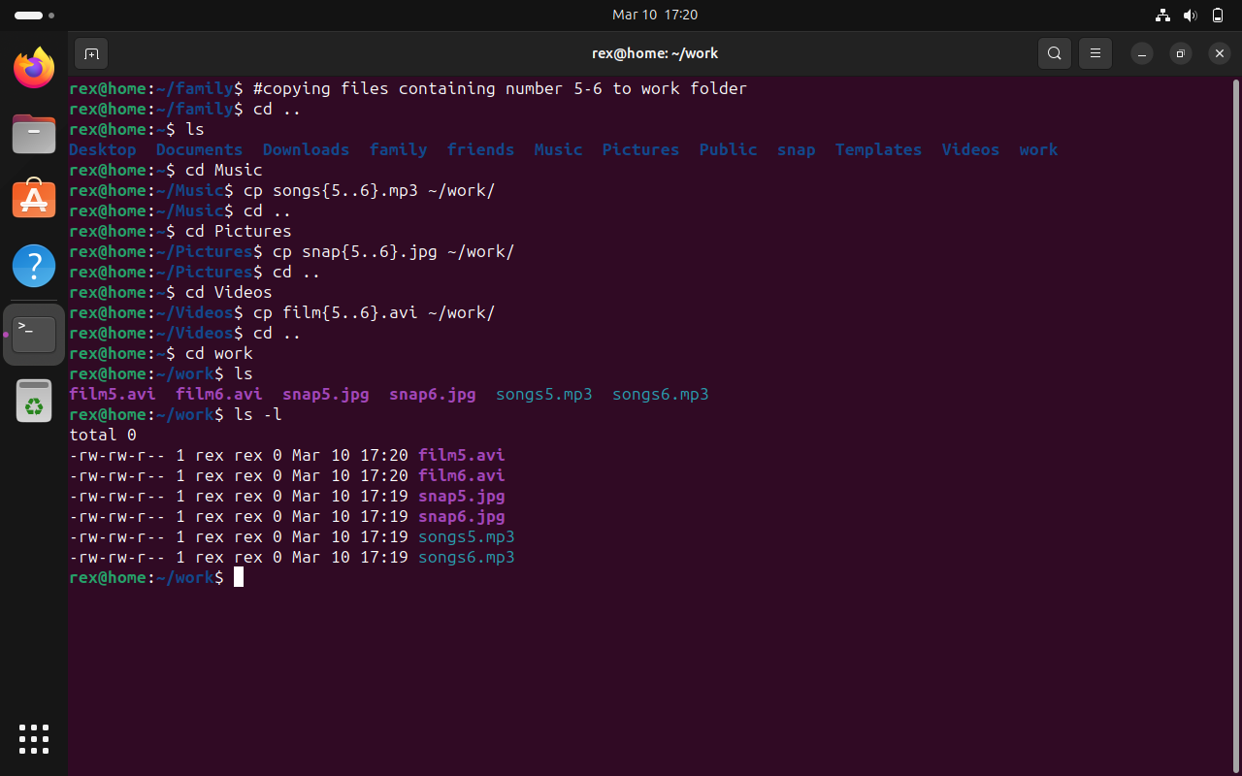

1. Delete all files in family subdirectory. 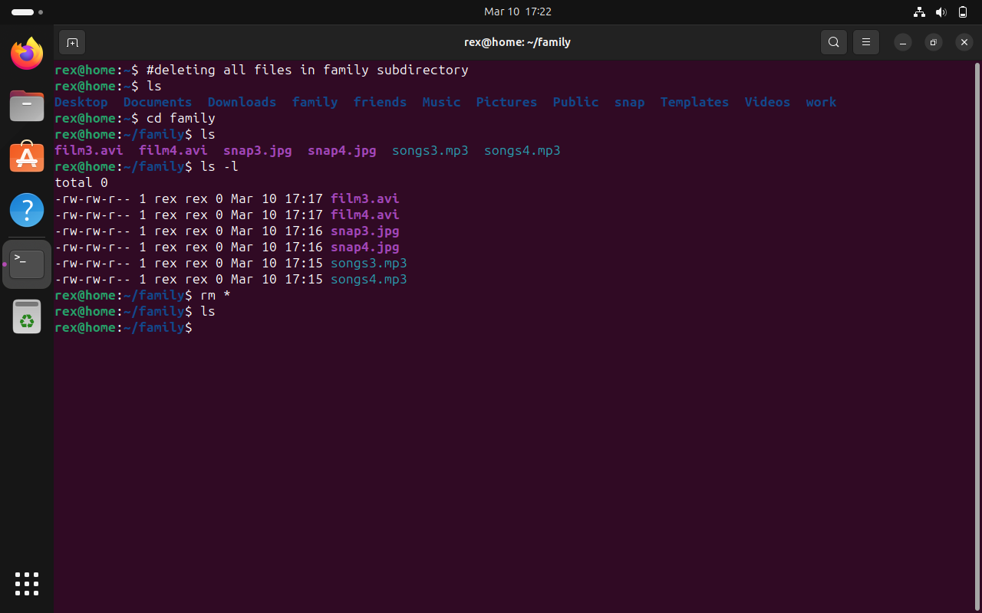

7. Delete friends subdirectory 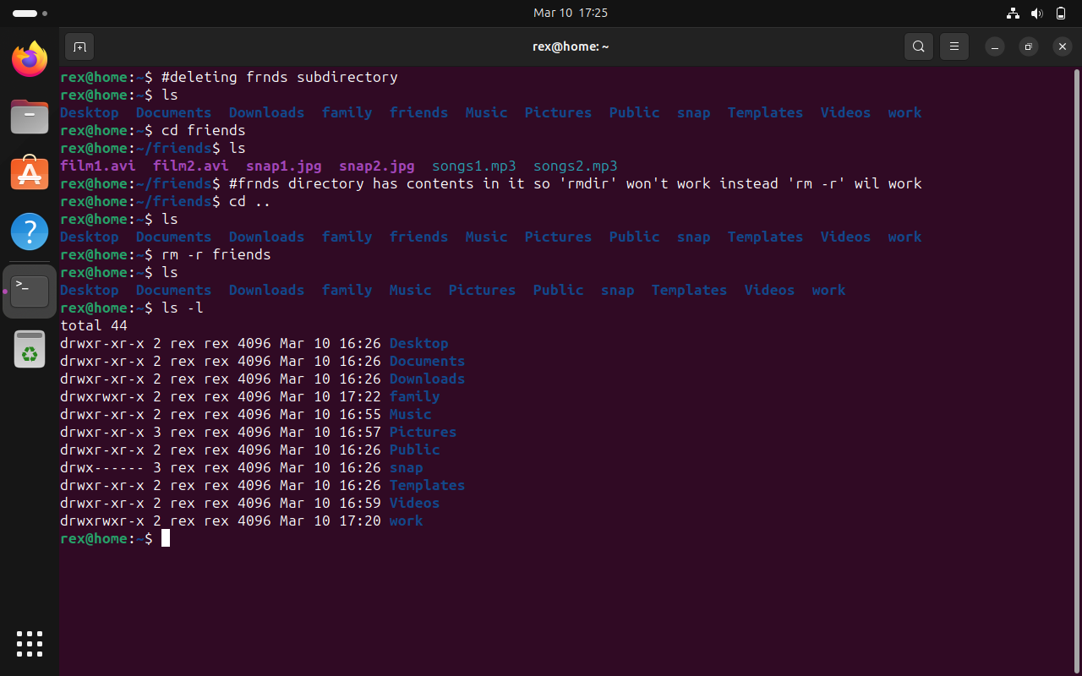

8. Create user tom, bob, sam, prince. 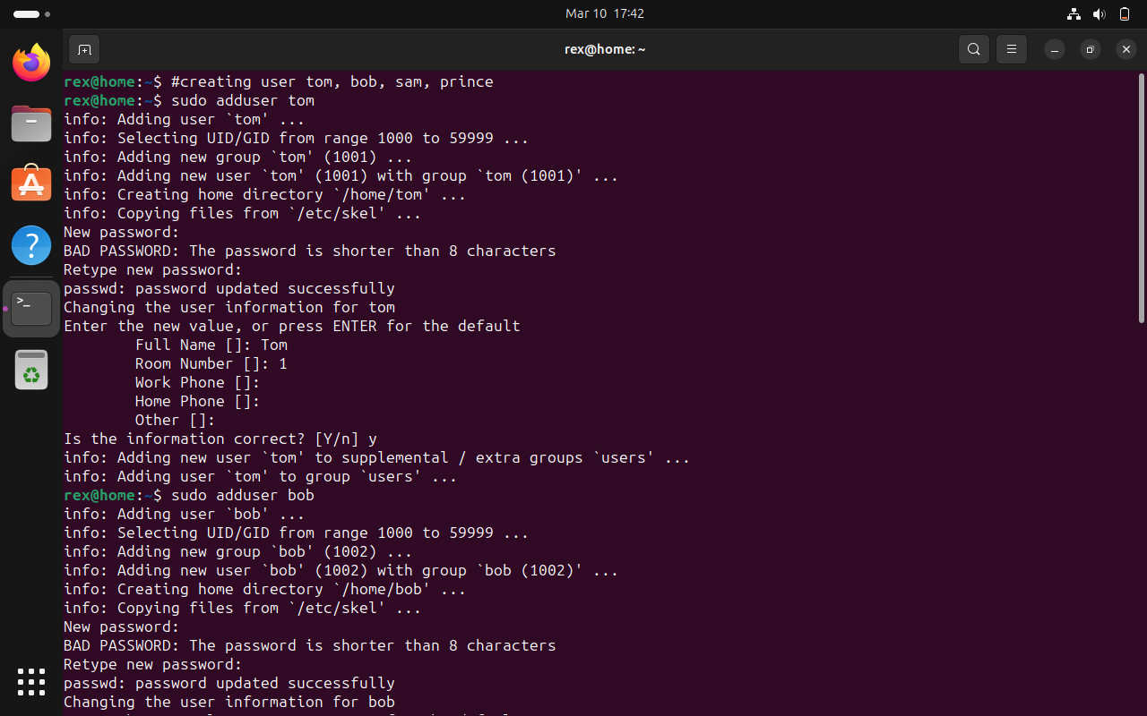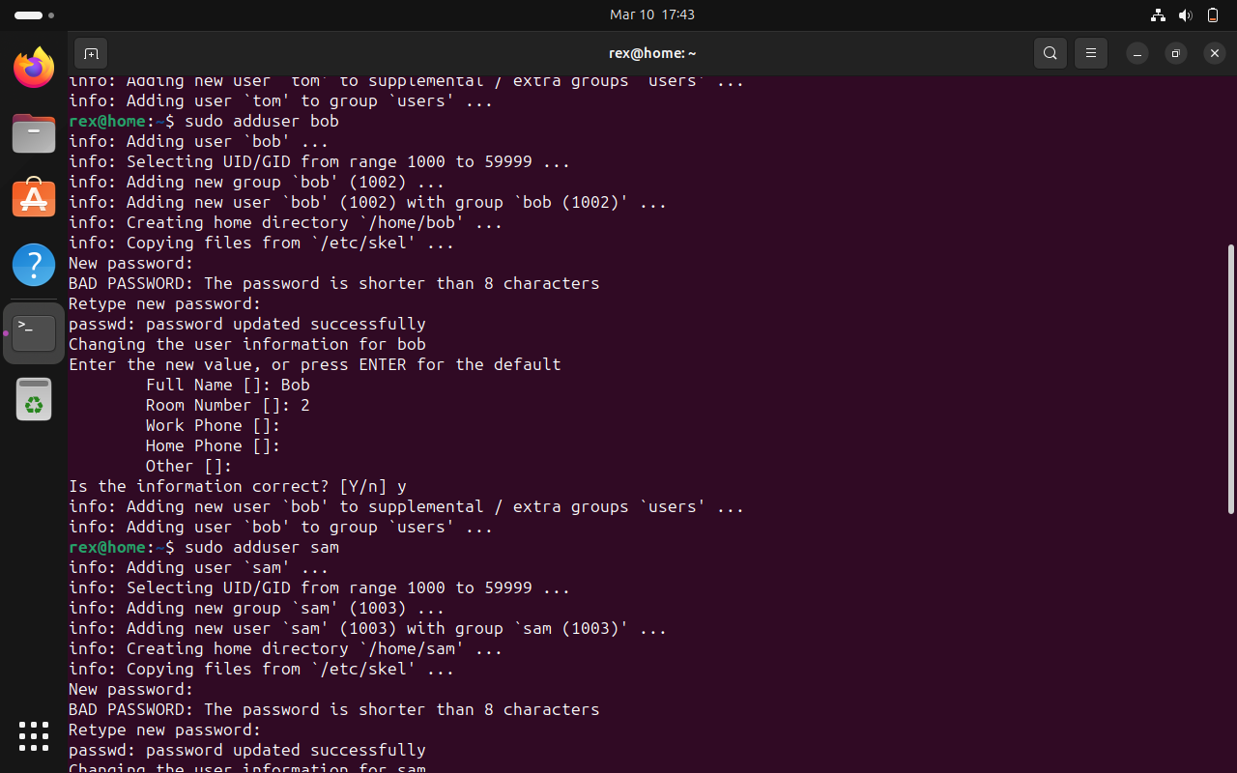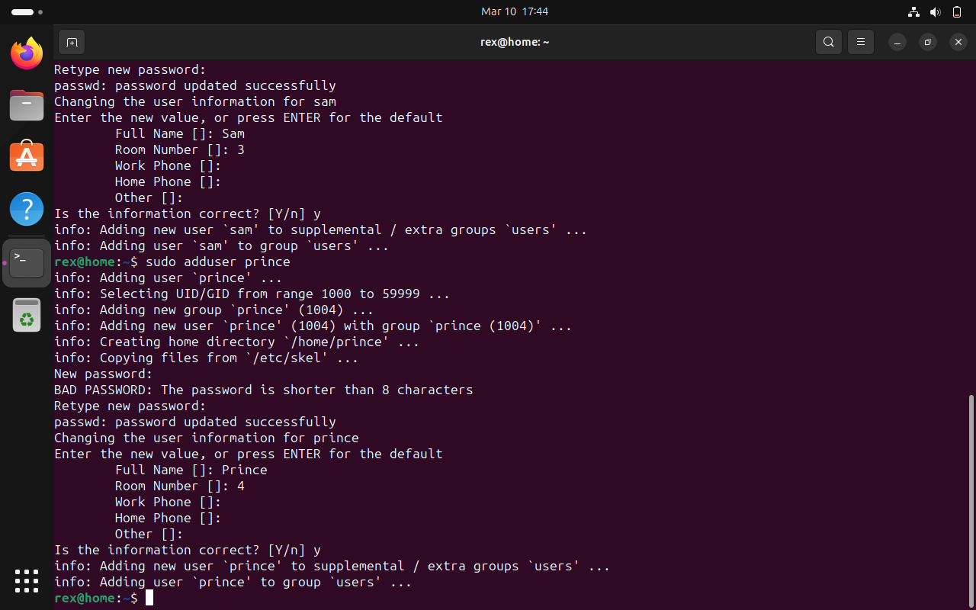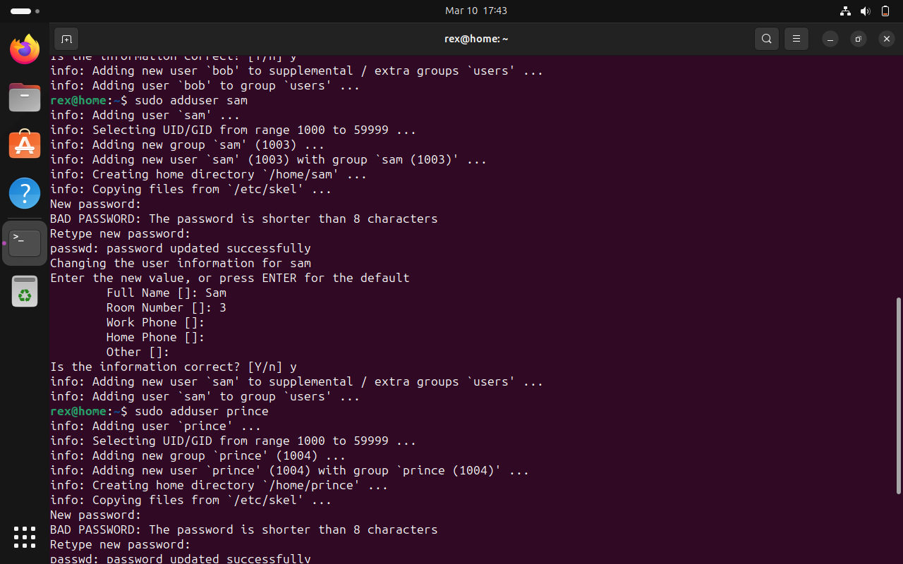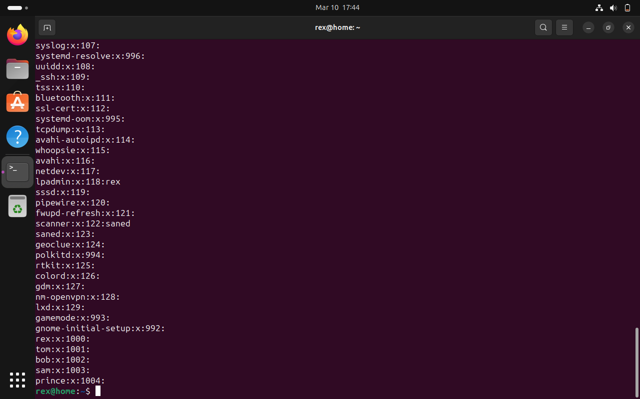

1. Create Group dac, dbda, ditiss 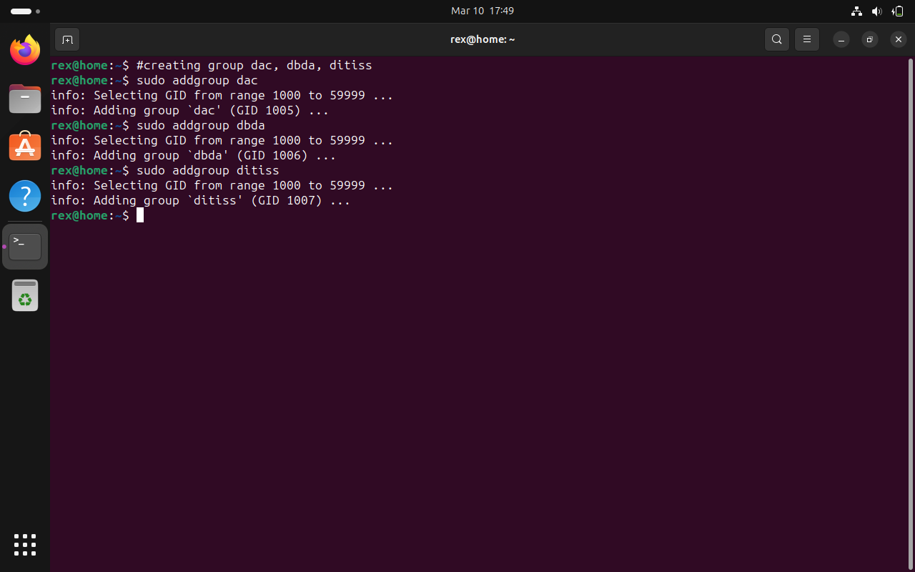

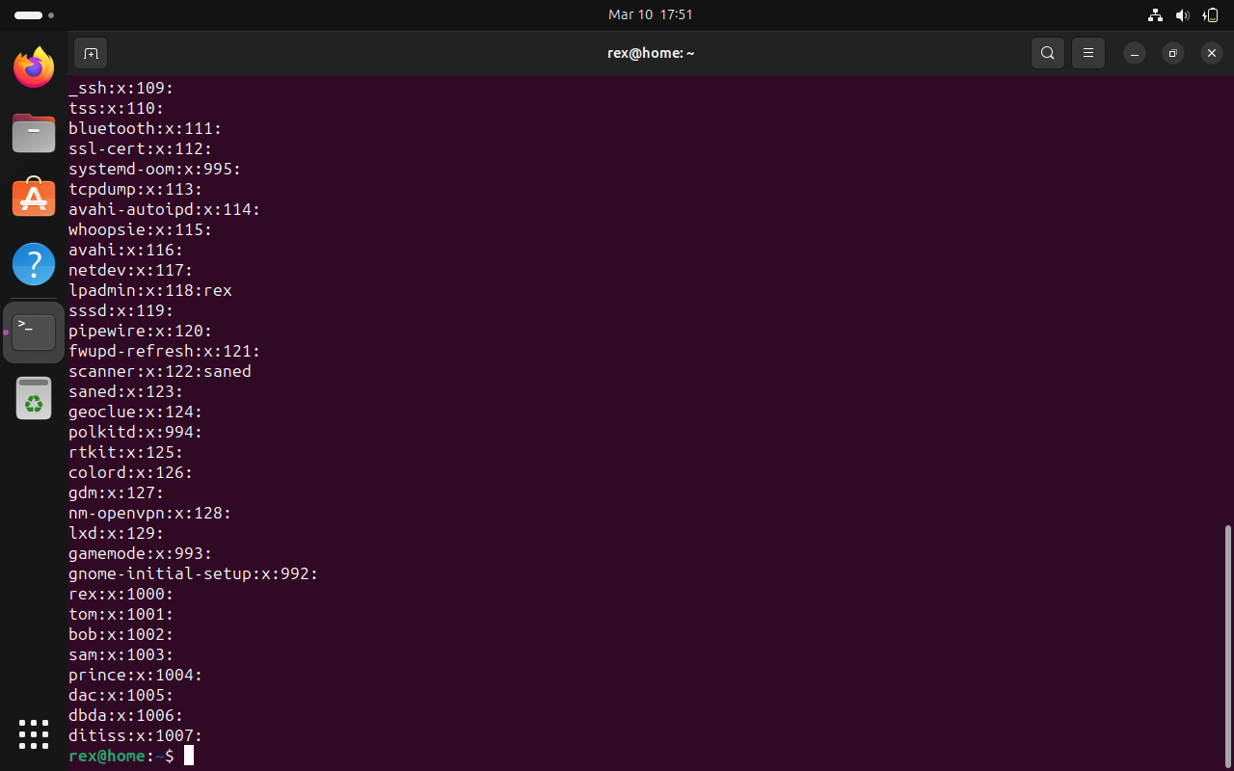

10. add user

Tom in dac 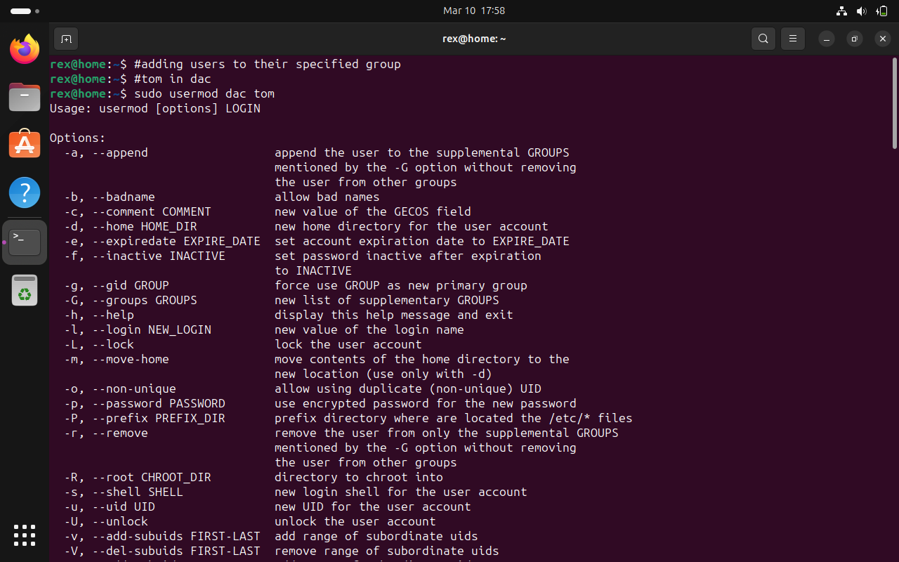

Bob in dbda 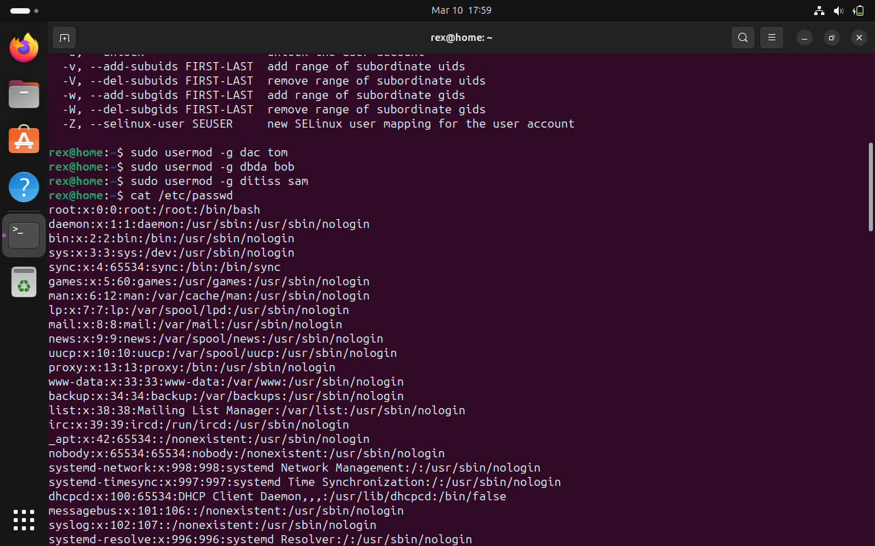

Sam in ditiss 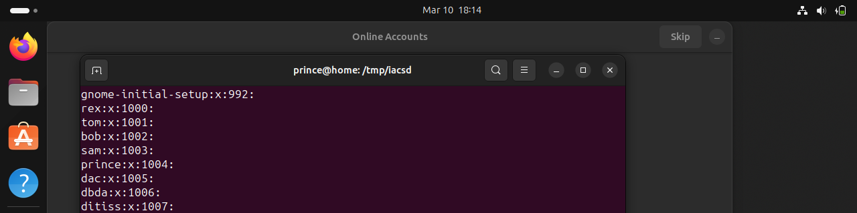

1. login as prince and create iacsd directory in /tmp and create 4 files in iacsd with name project-1 project-2 upto 4 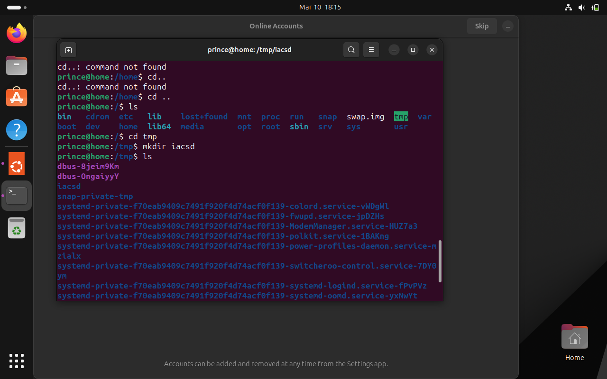

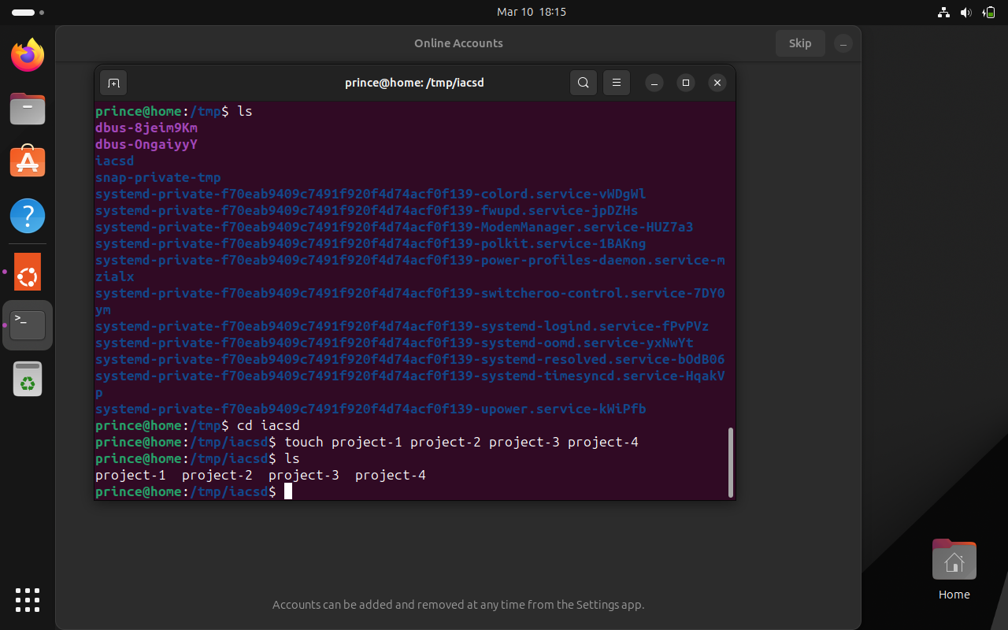

12. assign permissions to project files as below

Project-1 – tom should be owner of this 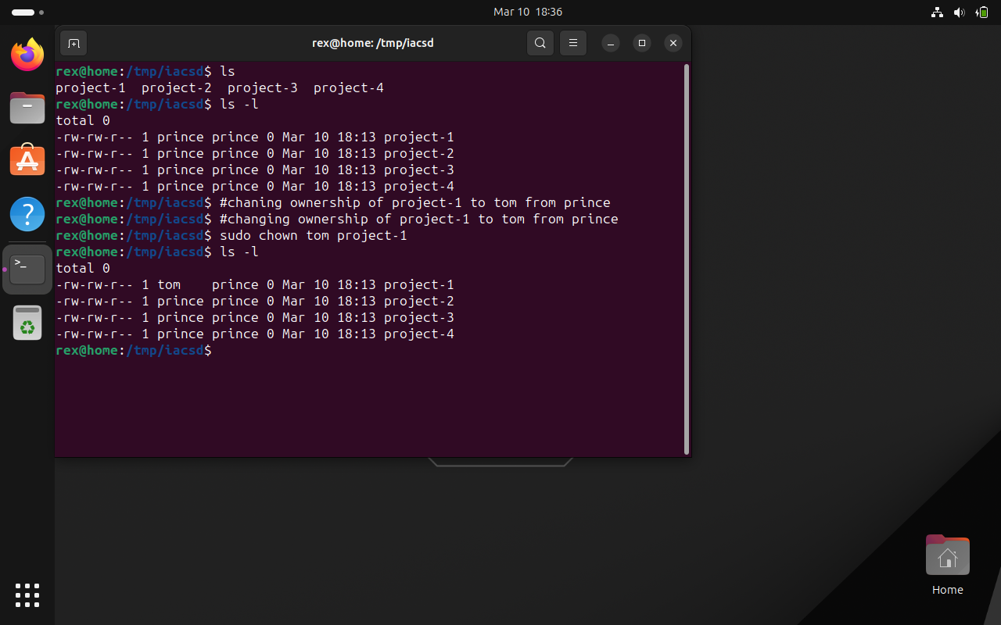

Project-2 – dac should be owner of this 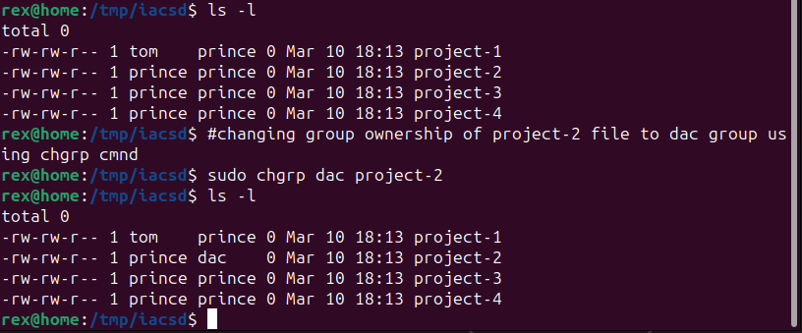

Project-3 --- others should not have any permission but tom should have rw access 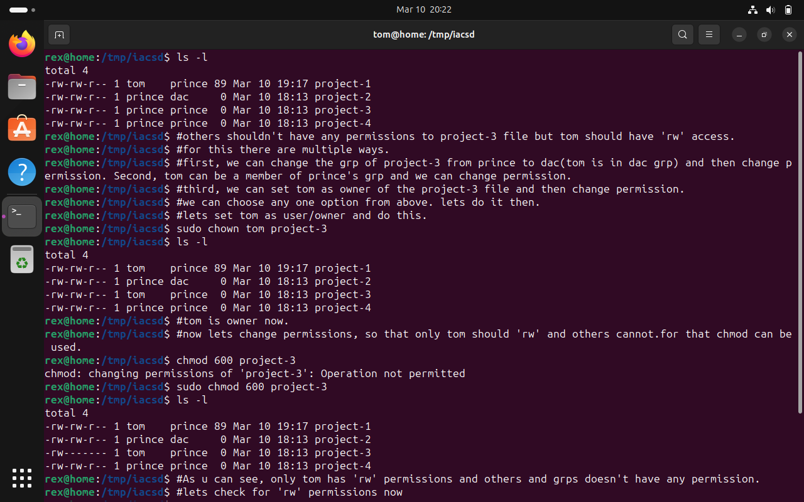 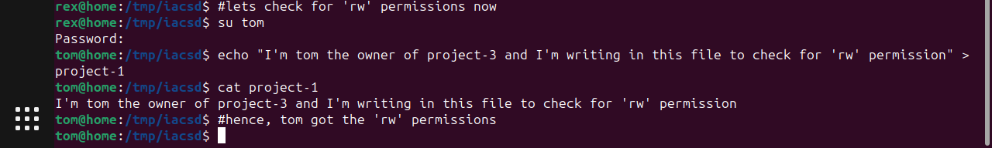

Project-4 – dbda group should have rwx permissions. 