.i 4

.o 1

.ilb a b c d

.ob t

.p 5

-110 1

01-- 1

-001 1

1110 1

0-00 1

.e

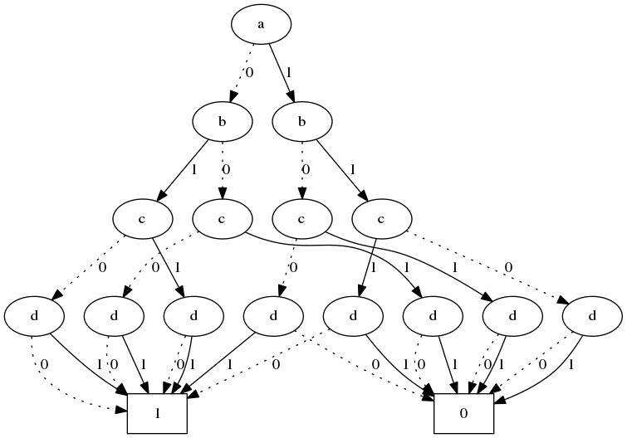

digraph OBDD { {rank=same 1}

{rank=same 2 3}

{rank=same 4 5 6 7}

{rank=same 8 9 10 11 12 13 14 15}

0 [label="0", shape=box]

1 [label="a"]

2 [label="b"]

3 [label="b"]

4 [label="c"]

5 [label="c"]

6 [label="c"]

7 [label="c"]

8 [label="d"]

9 [label="d"]

10 [label="d"]

11 [label="d"]

12 [label="d"]

13 [label="d"]

14 [label="d"]

15 [label="d"]

16 [label="1", shape=box]

1 -> 2 [label="0", style=dotted]

1 -> 3 [label="1", style=solid]

2 -> 4 [label="0", style=dotted]

2 -> 5 [label="1", style=solid]

3 -> 6 [label="0", style=dotted]

3 -> 7 [label="1", style=solid]

4 -> 8 [label="0", style=dotted]

4 -> 9 [label="1", style=solid]

5 -> 10 [label="0", style=dotted]

5 -> 11 [label="1", style=solid]

6 -> 12 [label="0", style=dotted]

6 -> 13 [label="1", style=solid]

7 -> 14 [label="0", style=dotted]

7 -> 15 [label="1", style=solid]

8 -> 16 [label="0", style=dotted]

8 -> 16 [label="1", style=solid]

9 -> 0 [label="0", style=dotted]

9 -> 0 [label="1", style=solid]

10 -> 16 [label="0", style=dotted]

10 -> 16 [label="1", style=solid]

11 -> 16 [label="0", style=dotted]

11 -> 16 [label="1", style=solid]

12 -> 0 [label="0", style=dotted]

12 -> 16 [label="1", style=solid]

13 -> 0 [label="0", style=dotted]

13 -> 0 [label="1", style=solid]

14 -> 0 [label="0", style=dotted]

14 -> 0 [label="1", style=solid]

15 -> 16 [label="0", style=dotted]

15 -> 0 [label="1", style=solid]

}