**Indian Institute of Information Technology, Bhopal**



**Digital Image Processing Lab**

**(CSE-312)**

**Submitted by:-**

**Nitin Gupta**

**20U02019**

**Submitted to:-**

**Dr. Bhupendra Singh Kirar**

**TUTORIAL-1**

**Q1. Read and display your coloured image using MATLAB.**

**CODE:-**

img=imread('c:\image\img.jpeg');

imshow(nitin_img);



**OUTPUT:-**

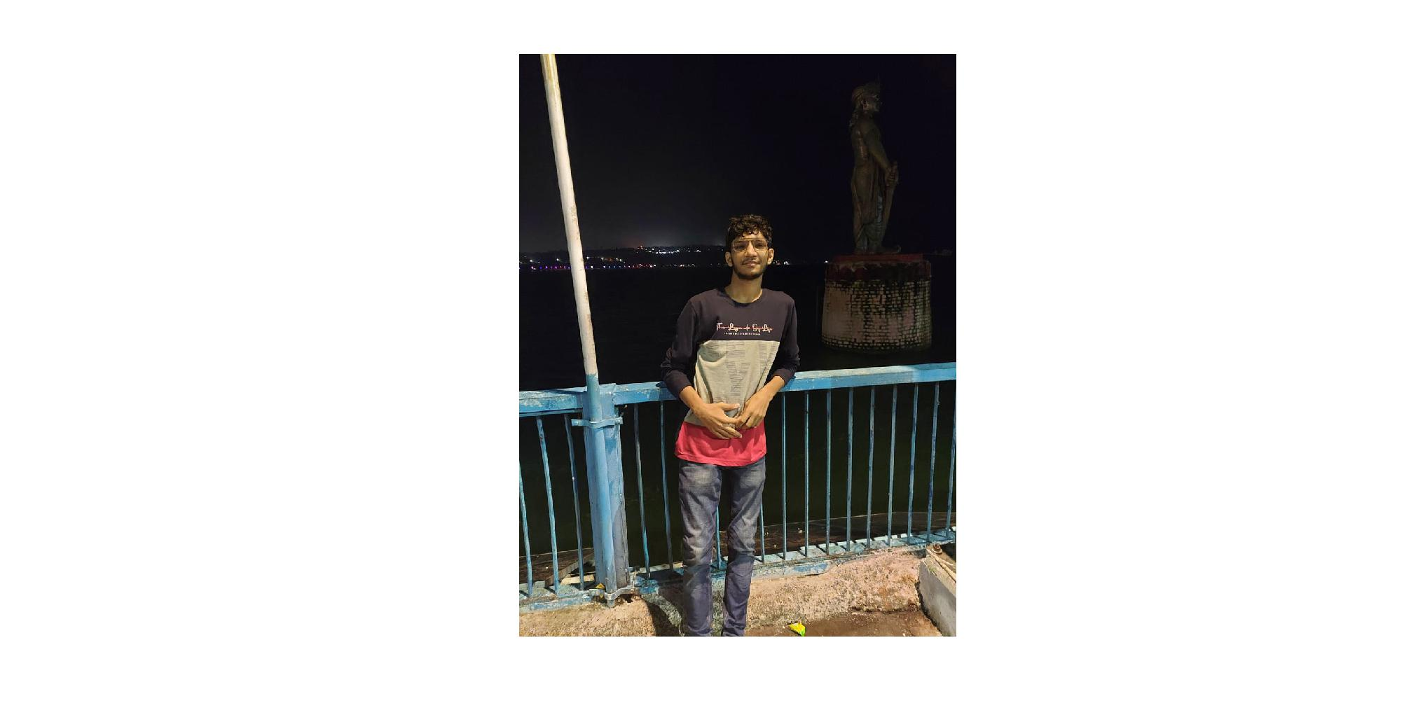

**Q2. Convert the rgb image to gray image.**

**CODE:-**

Nitin_img = imread(‘C:\image\img.jpeg’);

nitin_gray=rgb2gray(nitin_img);

imshow(nitin_gray);

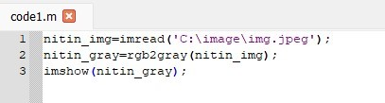

**OUTPUT:-**

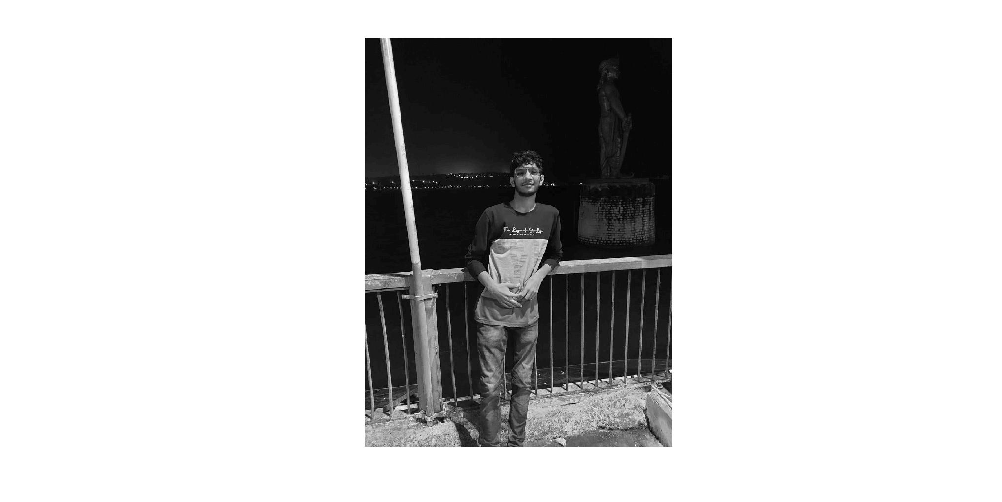

**Q3.Display rgb and gray image in same figure.**

**CODE:-**

nitin=imread('C:\image\img.jpeg');

gray_nitin=rgb2gray(nitin);

subplot(1,2,1);

imshow(nitin);

subplot(1,2,2);

imshow(gray_nitin);

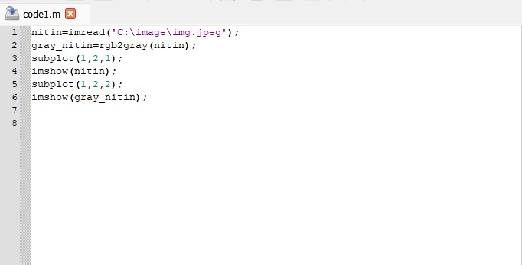

**OUTPUT:-**

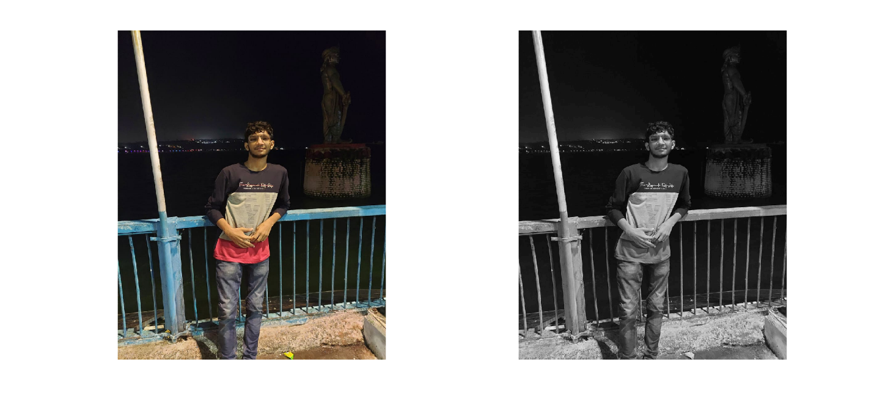

**Q4.Display all the information of the image.**

**CODE:-**

>> info=imfinfo('C:\image\img.jpeg');

>> info

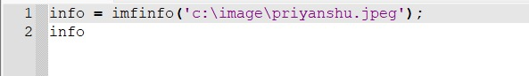

**OUTPUT:-**

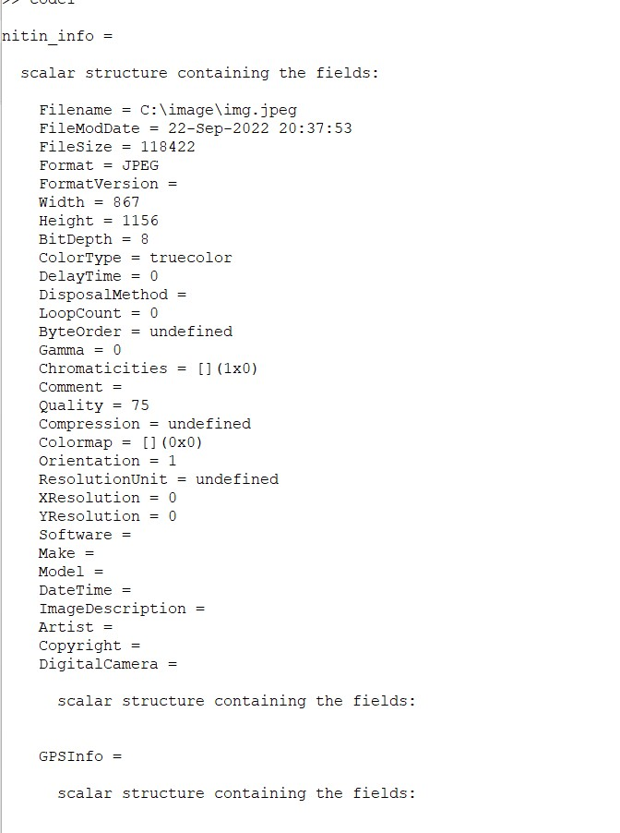

**Tutorial-3**

a) Take a picture and show it as it is.

b) Convert colourful image (RGB) to grey and show it.

c) Resize image to 256*256 pixels.

d) Display output grey images for different intensity resolution (256, 128, 64, 32, 16, 4, 2) in a single figure using subplot function.

**CODE:**

I1=imread('c:\image\img.jpeg');

I2 = imresize(I1,[256 256]);

I3 = rgb2gray(I1);

subplot(3,3,1), imshow(I1);

subplot(3,3,2), imshow(I3);

I3 = imresize(I3, [128,128]);

subplot(3,3,3), imshow(I3);

I4 = imresize(I3, [64,64]);

subplot(3,3,4), imshow(I4);

I5 = imresize(I3, [32,32]);

subplot(3,3,5), imshow(I5);

I6 = imresize(I3, [16,16]);

subplot(3,3,6), imshow(I6);

I7 = imresize(I3, [8,8]);

subplot(3,3,7), imshow(I7);

I8 = imresize(I3, [4,4]);

subplot(3,3,8), imshow(I8);

I9 = imresize(I3, [2,2]);

subplot(3,3,9), imshow(I9);

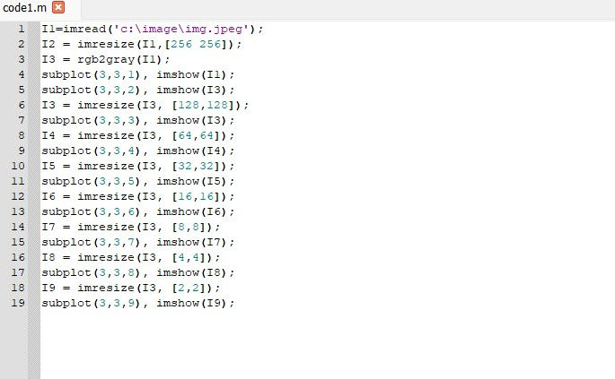

**OUTPUT:-**

