Assignment - 3

Problem : Perform Logical Operation On Two Images.

Code

% Name Nitin Gupta ; Scholar Number : 20U02019 ; Branch : CSE

% Read The Image

img_1=imread('circles.png');

img_2=imread('circbw.tif');

%SubPlot Object Initialise

subplot(3,3,3);

% resize images

img_1=imresize(img_1,[200 200]);

img_2=imresize(img_2,[200 200]);

% and operation

img_and=img_1&img_2;

% or operation

img_or=img_1|img_2;

% compliment

img_1_com=not(img_1);

img_2_com=not(img_2);

% XOR Of Image

img_xor=xor(img_1,img_2);

% NOR Of Image

img_nor=not(img_or);

% Nand of Image

img_nand=not(img_and);

subplot(3,3,1);

imshow(img_1);

title('Original Image 1')

subplot(3,3,2);

imshow(img_2);

title('Original Image 2')

subplot(3,3,3);

imshow(img_and);

title('And Image')

subplot(3,3,4);

imshow(img_or);

title('OR Image')

subplot(3,3,5);

imshow(img_1_com);

title('Not Of First Image');

subplot(3,3,6);

imshow(img_2_com);

title('Not Of Second Image');

subplot(3,3,7);

imshow(img_xor);

title('Xor of Image');

subplot(3,3,8);

imshow(img_nor);

title('Nor Of Images');

subplot(3,3,9);

imshow(img_nand);

title('NAND of Image');

Code

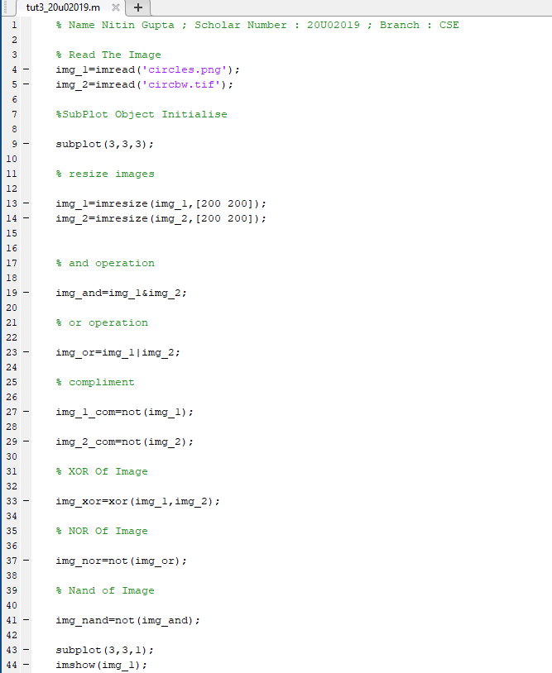

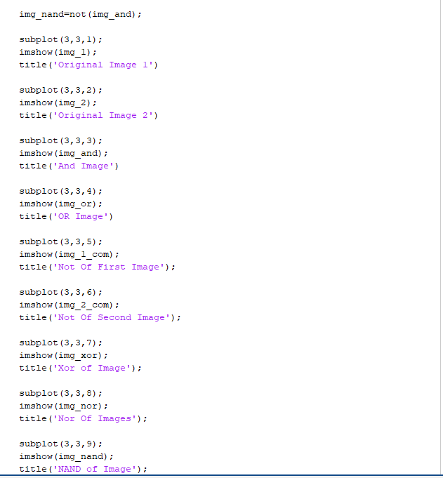

Output

