School Of Engineering and Technology Computer

Science And Engineering Department Navrachana University, Vadodara

Fourth Year B. Tech CSE (Semester 7)

Academic Year

2024-2025

ARVR

Deep Malaviya (21124009)

Course In-Charge: Darshan Parmar

Handball VR Game Development

**Introduction**

This project deals with the development of a basic handball game in Unity, whereby a player attempts to throw a ball into a defined boundary area to score points. The core objective is to simulate a simple and interactive interaction that also illustrates the way scores are tracked in Unity and collision detection is realized. Some key concepts that will be put into application through the realization of this project are the following: basic elements of game development, the interaction of physics, the limitation of boundaries, and the mechanics involved in keeping scores.

**Task 1: Setup of Unity project, configuration of VR environment.**

The first step was to create a new project in Unity and set it up for a VR project. It aids in building the base of immersive gameplay, which allows the user to interact with the elements of the game by using respective VR controls.

1. **Create Unity Project**
   * Launched Unity and selected a new 3D project.
   * Configured project settings such as project name, location, and template. Installed necessary packages, including VR SDKs, the selection of which was done based on compatible VR hardware.
2. **Setup VR Environment Integrated a VR SDK-for instance, OpenXR or Oculus SDK-into Unity to offer support for VR.**
   * Changed player settings to support VR rendering: enabled XR management and set stereo rendering. Designed a simple virtual reality environment with basic game elements: a floor plane, walls, scored boundary, Colliders, and Physics properties setup.
3. Setup VR Controls Configured the VR controller input system to recognize hand movements and button actions. Mapped player actions, like grabbing the ball and throwing it, so that such activities feel natural and respond well in VR.

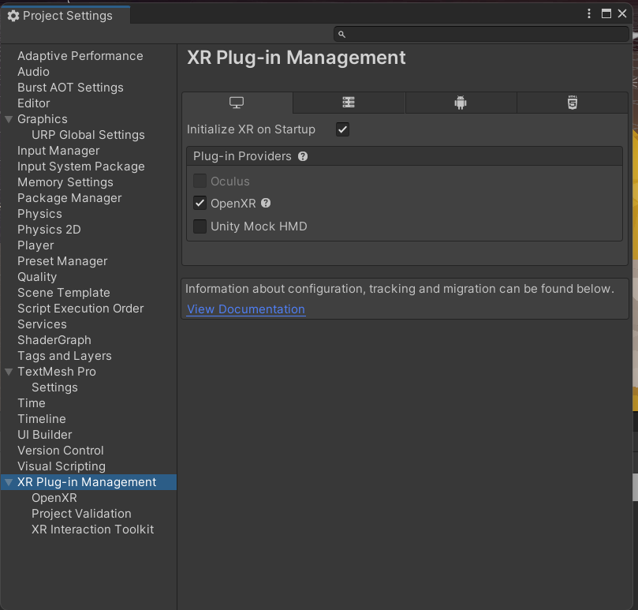

**Task 2: Adding of Ground Plane, Creating Skybox**

In this Step, a ground plane and skybox were added in order to construct a simple outdoor environment of the game.

**Ground Plane**

Created a 3D plane for the ground, then used a more realistic texture. Added Collider to interact with game objects.

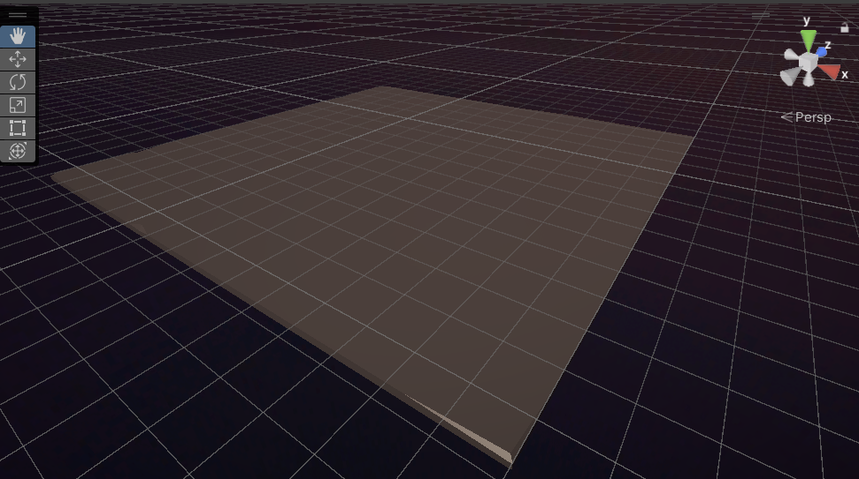

**Skybox**

Created a skybox to simulate open-air and adjusted the lighting for consistency in appearance.

Challenges and Solutions

This, of course, required to be sensitive with the adjustments of controls in VR and making physics interact in a realistic manner with the ball. Adding a skybox and some form of lighting setup for more immersion offered different complications that were resolved by tweaking the lighting setup. Finally, there was a need for performance optimization to make gameplay smooth, which was done through reducing the complexity of assets and adjusting settings.

**Task 3: Add Environmental Objects**

**Actions: -**

Environmental Assets: - To make the scene more captivating, I made variations of the natural features, such as trees, mountains, and buildings.

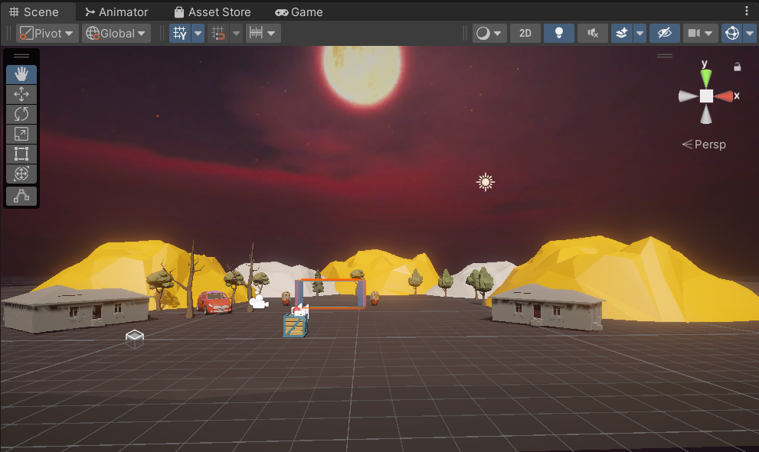

Grabbable Objects: - To make the interaction more dynamic, I made prefabs of balls that spawn on my hand.

**Challenges and Solutions**

In Task 3, finding appropriate environmental assets that looked good and fit the game's aesthetic was challenging. I explored various asset packs and carefully selected trees, rocks, and structures to create a cohesive environment. To enhance visual appeal, I adjusted the placement and scale of these objects, ensuring they blended naturally into the scene and contributed to an immersive experience.

**Task 4: Configure Lighting and Shadows**

**Directional Lighting:** Configured a directional light to simulate sunlight, adjusting its intensity and angle to cast realistic shadows across the environment.

**Real-Time Shadows:** Implemented real-time shadows for dynamic objects, which significantly improved the immersive quality of the game by providing depth and realism to interactions.

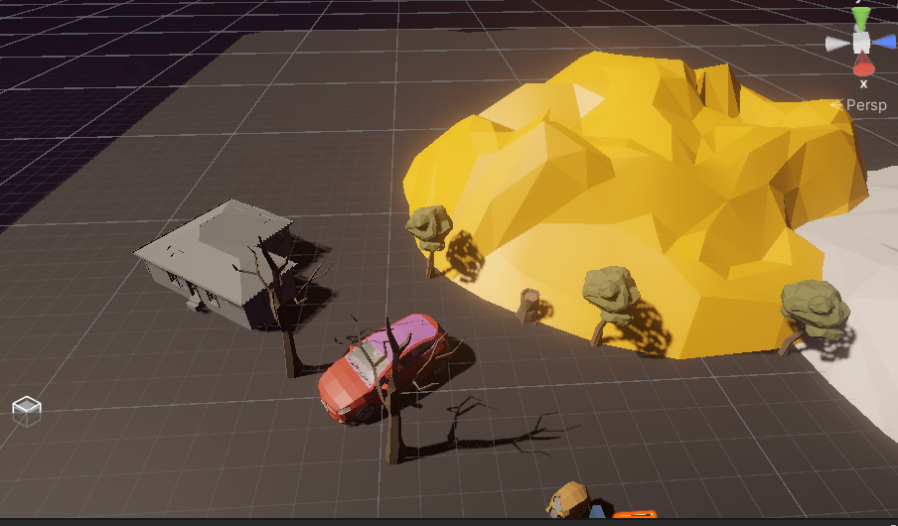

**Task 5: Add Audio**

**Sound Effects:** Added sound effects for actions such as throwing the ball and scoring, which helped to provide feedback to players and increase immersion in the game environment.

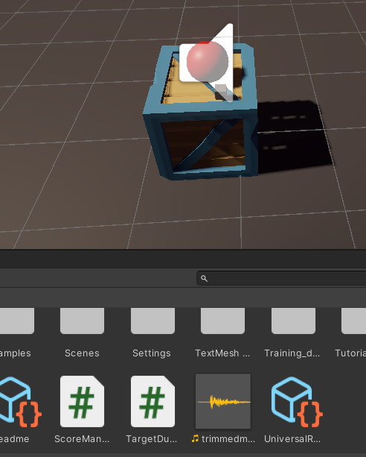

w**Task 6: Implement Basic VR Interaction**

**Controller Setup: Configured VR controllers to enable player interactions, mapping actions such as grabbing and throwing the ball to specific buttons for intuitive gameplay.**

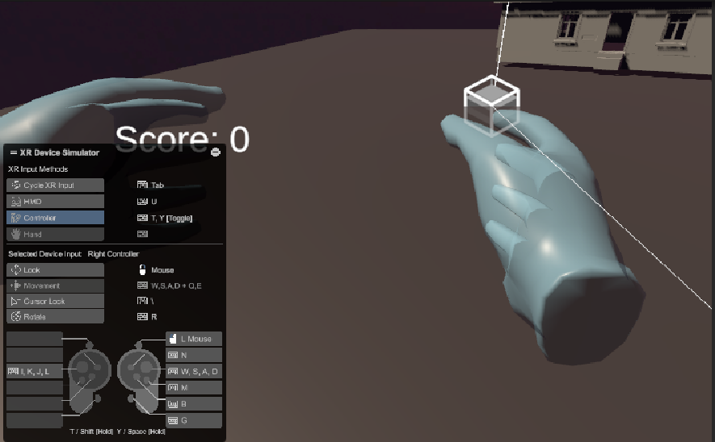

**Implemented basic interaction mechanics, allowing players to physically manipulate the ball and trigger score updates when successfully throwing it into the designated boundary.**

**Task 7: Write the VR Interaction Script**

**Interaction Script:** Created a C# script to manage object grasping, enabling players to hold objects and apply realistic physics when throwing.

**Smooth Movement:** Added algorithms to ensure smooth handling of grasped items, eliminating jitter and ensuring fluid, natural motion in VR.

Some Script

1)

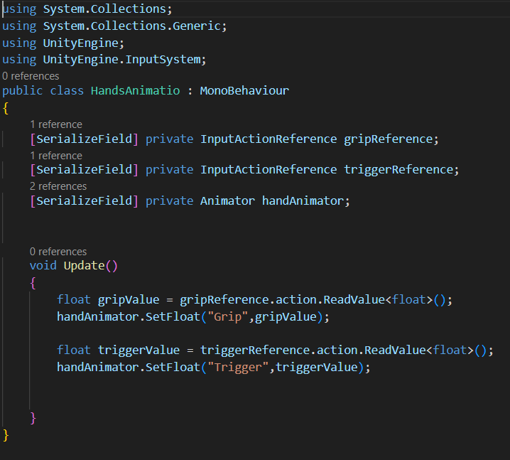

2)

3)

**Task 8: Create a Scoring Mechanism**

1. **Score System:** Designed a scoring system where players earn points for successfully throwing the ball into the boundary area, tracking each successful throw.
2. **UI Display:** Created an on-screen score display that updates in real time, allowing players to track their progress throughout the game.

Here Some Script

1)

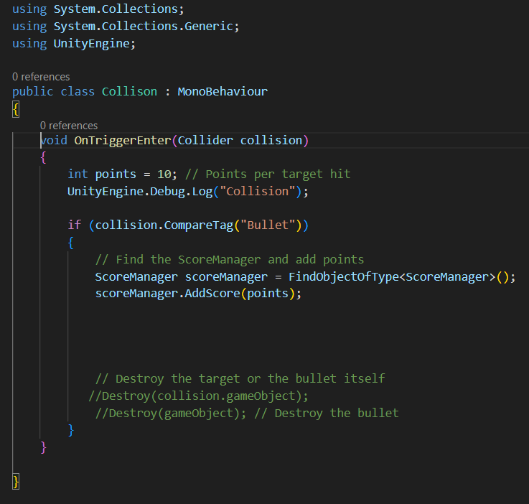

2)

Reference Link

<https://assetstore.unity.com/>

<https://www.youtube.com/watch?v=YBQ_ps6e71k>