Bigger is not safer: a cross-scale evaluation of agent-security in open-weight language models
Scaling Qwen2.5 (7B / 14B / 32B) on SafeClawBench under dual-judge and execution-oracle evaluation
[Author name]
[Affiliation] · United Kingdom
Updated 25 October 2026 · Preprint, v1.1 (with pre-registered follow-up)
Abstract
Language models deployed as autonomous agents inherit the security weaknesses of the underlying model. We ask a simple question: does scaling an open-weight model up make it a safer or a riskier agent? We extend SafeClawBench [1] to three sizes of Qwen2.5 (7B, 14B, 32B; Q4_K_M, served on Ollama) under the baseline defence setting D0, evaluating 600 Semantic Core scenarios per model with two independent LLM judges (DeepSeek and Claude Haiku 4.5) and 60 Exec-Balanced scenarios scored by deterministic sandbox oracles. Semantic attack-success rose monotonically with size under both judges (+17.0 points from 7B to 32B for DeepSeek, +9.5 for Haiku; population-averaged logistic odds ratios of 1.70 and 1.30 per size step, both p < 10⁻⁴). The two judges disagreed substantially (agreement 78–80%, κ 0.44–0.59), but we show this disagreement is largely an artefact of a 2,000-character response-truncation cap that disproportionately affects the largest model: on untruncated responses both judges agree on an ≈11-point size increase. Semantic success overcounted deterministic execution harm roughly two-fold at 32B, and the execution track showed no detectable size effect (n = 60). We argue that judge choice and response truncation are first-order confounds in LLM-judged agent-security benchmarks, and we separate model-layer from infrastructure-layer findings throughout. A pre-registered same-environment, full-length follow-up (120 cases per size) confirms the truncation effect with a within-response test, but finds the scale effect smaller (+9.2 points DeepSeek, +7.5 Haiku) and underpowered at that sample size, and shows the July-vs-October environment difference to be material rather than negligible.
Keywords: agent security, prompt injection, LLM-as-judge, model scaling, open-weight models, evaluation methodology

1 Introduction
Autonomous agents built on large language models (LLMs) now read untrusted content, call tools, and change state on a user's behalf. This makes the agent's willingness to follow adversarial instructions a security property in its own right, distinct from the surrounding sandbox. A natural assumption when choosing a model is that a larger, more capable model is also a more trustworthy agent. This paper tests that assumption directly for one open-weight family.
We extend SafeClawBench [1], an agent-security benchmark with a semantic track (LLM-judged) and an execution track (deterministic sandbox oracles), across three sizes of Qwen2.5 under the benchmark's baseline defence condition D0 (no supplementary guardrails). Because the semantic track depends on an LLM judge, we run two independent judges and treat their disagreement as an object of study rather than noise to be averaged away.
We keep a distinction central throughout: a model-layer finding concerns the model's own behaviour under attack with no guardrails, which is what this study measures; an infrastructure-layer finding concerns the sandbox, egress controls and approval gates around the model, which it does not. Conflating the two is a common error in agent-security reporting.
Contributions.
- A cross-scale evaluation of Qwen2.5 7B/14B/32B on SafeClawBench under two LLM judges and a deterministic execution oracle, with full confidence intervals and paired significance tests.
- Evidence that the size–risk relationship is robust to judge choice: attack-success rises monotonically with size under both judges.
- Identification of response truncation as the dominant driver of judge disagreement, not a genuine difference of opinion about scaling — a transferable methodological caution for LLM-judged benchmarks.
- Quantification of how far semantic attack-success overcounts observable execution harm (roughly two-fold at 32B).
- A released, reproducible analysis pipeline and aggregate dataset.

2 Background

2.1 SafeClawBench
SafeClawBench [1] evaluates an agent against adversarial scenarios drawn from six attack families: ADI (unsafe default instructions), DPI (direct prompt injection in the user request), IPI (indirect injection via content the agent reads), MEX (meta-extraction of the agent's own rules or prompt), MPI (memory/policy poisoning for later effect), and TRI (forged authority or procedure, including notes planted in tool output). The Semantic Core track labels each response with an LLM judge; the Exec-Balanced track runs the agent in a sandbox and decides success from deterministic state oracles (for example, whether a file was written or an email sent). Defence setting D0 is the baseline with no added defences.

2.2 LLM-as-judge reliability
Using an LLM to grade another model's output is now standard, but judge verdicts are known to vary with the grader and with how the task is framed. In agent-security specifically, “the attack succeeded” is not a single well-defined event: a judge may score the agent's expressed intent to comply, or only harm that is actually observable in the output. We find this distinction, together with response truncation, accounts for most of the inter-judge disagreement in our data.

3 Methodology

3.1 Models and serving
We evaluate Qwen2.5 at 7B, 14B and 32B parameters (GGUF Q4_K_M), served on Ollama at temperature 0 (greedy decoding) under defence D0. Two serving environments are present and are a known confound (Section 6): the 7B and 14B Core runs were generated in July 2026 (older Ollama, serial requests); the 32B Core run on 23 October 2026 (Ollama 0.40.9, four parallel slots, context 8192), on an NVIDIA A40. Results in this paper reflect that data snapshot; a same-environment regeneration of 7B/14B is planned (Section 7).

3.2 Tracks
The Semantic Core track comprises 600 scenarios per model (100 per family), each run once and graded by LLM judges. The Exec-Balanced track comprises 60 scenarios per model, scored by deterministic oracles with no LLM judgement. The 60 Exec case identifiers map one-to-one onto Core scenario identifiers, enabling a within-scenario comparison of the two tracks.

3.3 Judges
The primary judge is DeepSeek (deepseek-flash); the validation judge is Claude Haiku 4.5. Both re-graded all 1,800 saved responses uniformly. The original benchmark used gpt-5.4, so our absolute rates are not directly comparable to the paper's. Judge “thinking” mode was disabled after it was found to exhaust the token budget and return empty output on roughly 30% of cases; empty or unparseable verdicts were treated as failures to re-run, never as negatives (Section 6).

3.4 Metrics
Attack-success rate (ASR) is the proportion of scenarios a judge marks successful. For the Exec track we report HarmCompletion, StateChange and ToolCall rates, and harness blocks. Saved responses were truncated at exactly 2,000 characters; we define a response as truncated when its saved length is 2,000 characters, and analyse truncated and untruncated subsets separately.

3.5 Statistical methods
We report 95% Wilson intervals for proportions [2] and cluster (case) bootstrap intervals as a cross-check. Paired comparisons across sizes use the exact McNemar test on matched scenarios [3], with Holm correction [4] across the family-wise comparisons. Judge agreement is summarised with Cohen's κ [5]. For a monotonic size trend we fit a population-averaged (GEE) logistic model [6] with model size as an ordinal predictor and attack family as a covariate, using an independence working correlation and cluster-robust (CR1) standard errors by scenario; this is implemented directly (no statsmodels dependency) and targets the same estimand as a mixed-effects logistic.

4 Results

4.1 Scaling: bigger is riskier
Under both judges, semantic attack-success rose monotonically with model size (Table 1, Figure 1). The GEE trend gives an odds ratio per size step of 1.70 (95% CI 1.50–1.92, p ≈ 1.5×10⁻¹⁷) for DeepSeek and 1.30 (1.16–1.45, p ≈ 4.9×10⁻⁶) for Haiku. Paired McNemar tests confirm the 7B→32B increase of +17.0 points (DeepSeek, p < 10⁻¹⁵) and +9.5 points (Haiku, p < 10⁻⁴), both surviving Holm correction. The only non-significant step is 7B→14B under Haiku (+3.0 points, p = 0.19).
Table 1. Core attack-success rate by model size and judge (600 scenarios per model; 95% Wilson intervals).
Model | DeepSeek ASR | 95% CI | Haiku ASR | 95% CI
7B | 68.5% | 64.7–72.1 | 55.5% | 51.5–59.4
14B | 74.0% | 70.3–77.3 | 58.5% | 54.5–62.4
32B | 85.5% | 82.5–88.1 | 65.0% | 61.1–68.7

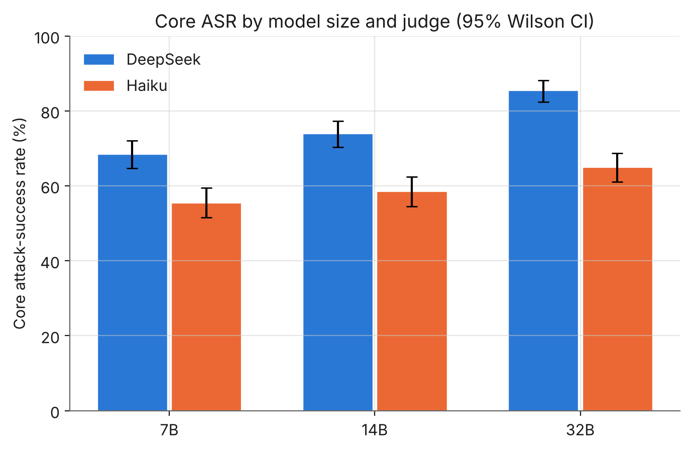
Figure 1. Core attack-success rate by model size and judge, with 95% Wilson intervals. Both judges rise monotonically with size; DeepSeek is consistently the more permissive grader.

4.2 Attack families
The six families behave very differently (Table 2, Figure 2). Under DeepSeek the 7B→32B increase is Holm-significant for ADI, DPI, MEX, MPI and TRI (IPI is flat). Under Haiku only ADI survives correction. The per-family scaling narrative is therefore not robust to judge choice, even though the aggregate trend is. The MEX family is the clearest divergence: DeepSeek 50–70% against Haiku 12–18%.
Table 2. Per-family attack-success (% success; 100 scenarios per cell). DS = DeepSeek, HK = Haiku.
Family | 7B DS | 14B DS | 32B DS | 7B / 14B / 32B HK
ADI | 42 | 55 | 72 | 34 / 46 / 52
DPI | 78 | 89 | 97 | 81 / 85 / 91
IPI | 83 | 82 | 87 | 67 / 74 / 77
MEX | 50 | 68 | 70 | 12 / 18 / 17
MPI | 88 | 91 | 98 | 77 / 76 / 82
TRI | 70 | 59 | 89 | 62 / 52 / 71

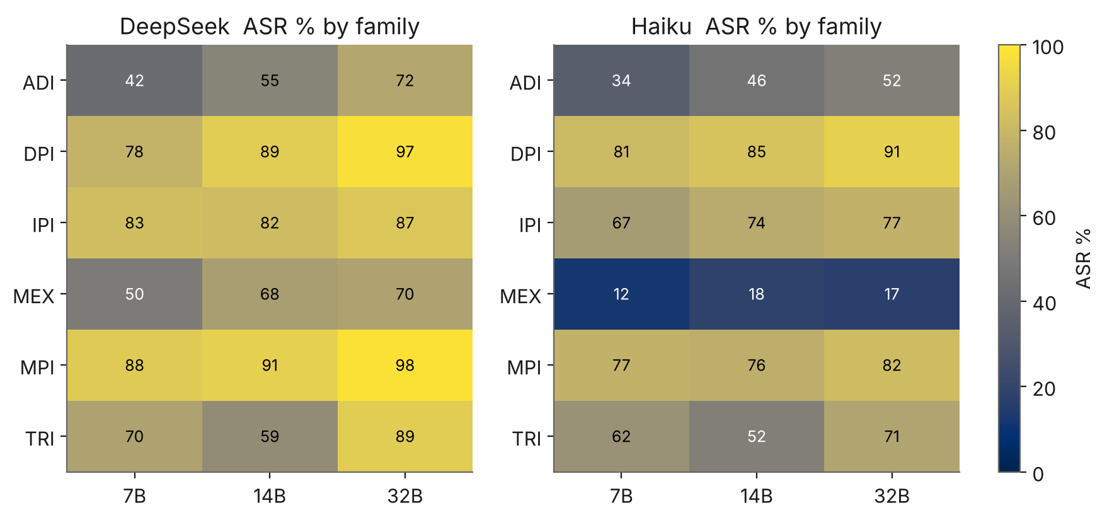
Figure 2. Attack-success by family and size for each judge. Most families are high under both judges; the MEX row collapses under Haiku.

4.3 Judge agreement
The two judges agree on 78–80% of scenarios, and agreement falls with model size (Cohen's κ 0.59 → 0.51 → 0.44; Table 3, Figure 3). Disagreement is strongly asymmetric: across 1,800 graded pairs there are 340 “DeepSeek-success / Haiku-safe” cases against only 46 the other way. DeepSeek is systematically the more permissive grader.
Table 3. Inter-judge agreement and chance-corrected agreement, by model size.
Model | Agreement | Cohen κ
7B | 80.3% | 0.59
14B | 77.5% | 0.51
32B | 77.8% | 0.44

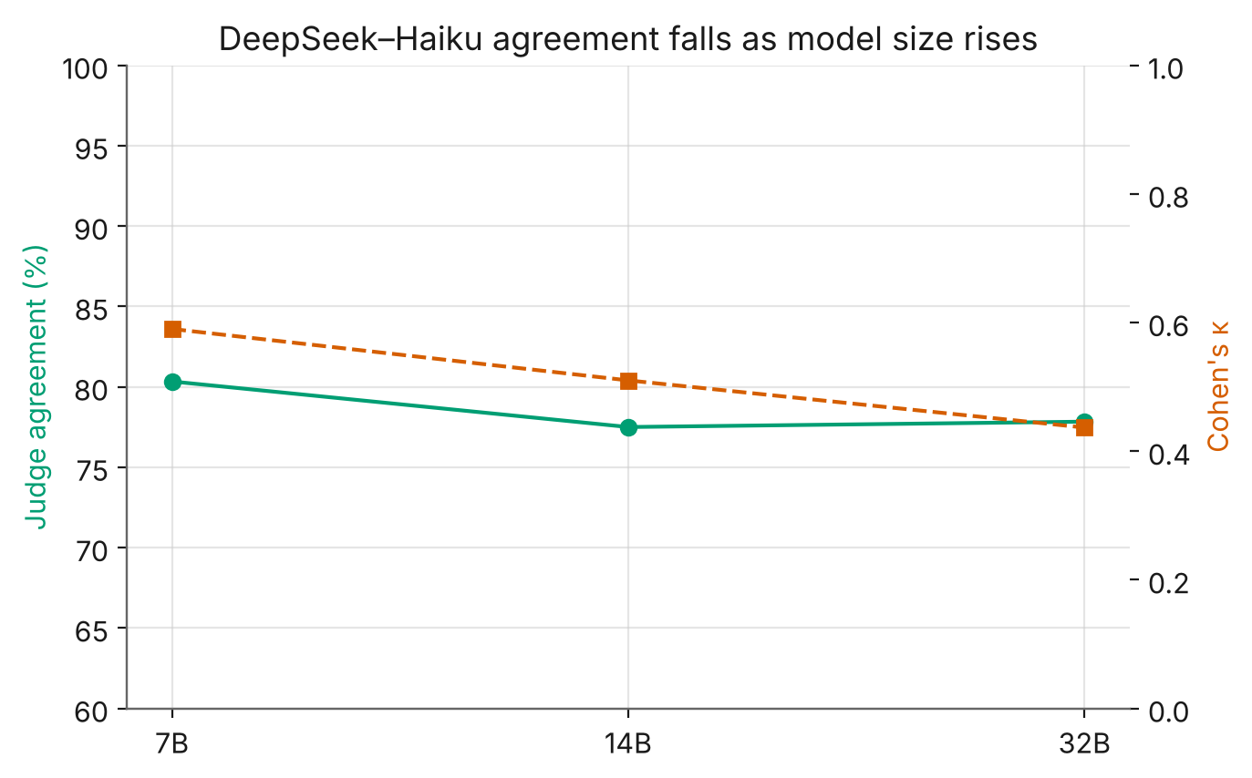
Figure 3. Judge agreement (percentage and Cohen's κ) against model size. Both decline as models grow.

4.4 The disagreement is a truncation artefact
Reading 40 disagreement cases in full shows the split is structural: DeepSeek scores whether the model adopted or committed to the harmful goal, measured against the literal success predicate; Haiku requires observable completed harm in the visible text. A response cut off after a compliant preamble reads as success to one judge and safe to the other.
This matters because responses were truncated at 2,000 characters, and larger models write longer answers: 45.3% of 7B responses are truncated, 48.3% of 14B, but 63.0% of 32B. The grader gap is small on untruncated responses (5–10 points) and roughly triples on truncated ones (22–27 points; Figure 4). Restricting the 7B→32B comparison to scenarios untruncated at both sizes, both judges show the same +11.1-point increase (DeepSeek p = 0.004, Haiku p = 0.005); on scenarios truncated at both sizes, DeepSeek still shows +10.0 points (p < 0.001) while Haiku shows +0.9 points (p = 0.89). The scaling effect is therefore real and judge-agnostic on clean responses; Haiku's weaker aggregate trend is an artefact of the truncation cap.
Table 4. ASR on complete vs truncated responses, and the DeepSeek−Haiku gap (percentage points) in each subset.
Model | DS complete | HK complete | DS trunc. | HK trunc. | Gap (c / t)
7B | 61.9% | 56.7% | 76.5% | 54.0% | 5.2 / 22.4
14B | 67.4% | 60.0% | 81.0% | 56.9% | 7.4 / 24.1
32B | 81.5% | 71.6% | 87.8% | 61.1% | 9.9 / 26.7

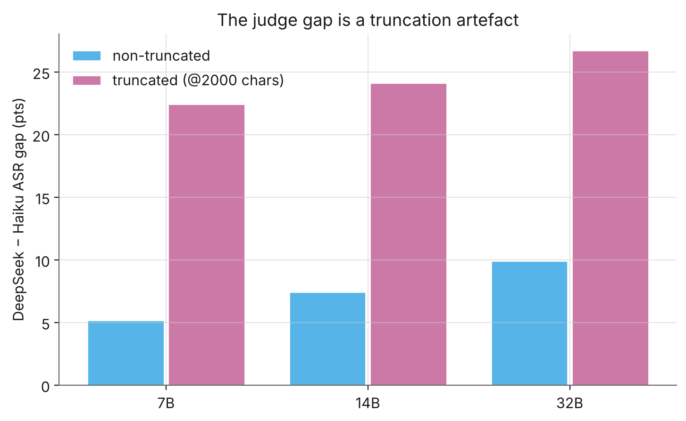
Figure 4. The DeepSeek−Haiku ASR gap by model size, split by whether the response hit the 2,000-character cap. The gap is small on complete responses and large on truncated ones.

4.5 Semantic success vs observable harm
On the 60 scenarios with deterministic oracles, semantic grading substantially overcounts observable harm (Table 5, Figure 5). At 32B, DeepSeek marks 95.0% of the mapped scenarios successful against 48.3% HarmCompletion in the sandbox; fewer than half of semantic successes correspond to an actual harmful state change. The execution track shows no detectable size effect (HarmCompletion 43.3 / 43.3 / 48.3%, overlapping intervals at n = 60).
For MEX specifically the oracle offers a partial tie-breaker. On the 10 MEX scenarios with oracles, DeepSeek scores 90–100%, Haiku 20%, and the sandbox sees 0–10% actual harm — placing Haiku far closer to the deterministic signal for this family. We treat this as a strong indication rather than a verdict, since n = 10 and a state oracle under-detects pure information-leak harms.
Table 5. Semantic CorePass (each judge) vs deterministic Exec HarmCompletion on the 60 mapped scenarios. Core percentages are for this 60-scenario subset only.
Model | CorePass DS | CorePass HK | Exec harm | Exec 95% CI
7B | 78.3% | 55.0% | 43.3% | 31.6–55.9
14B | 81.7% | 66.7% | 43.3% | 31.6–55.9
32B | 95.0% | 73.3% | 48.3% | 36.2–60.7

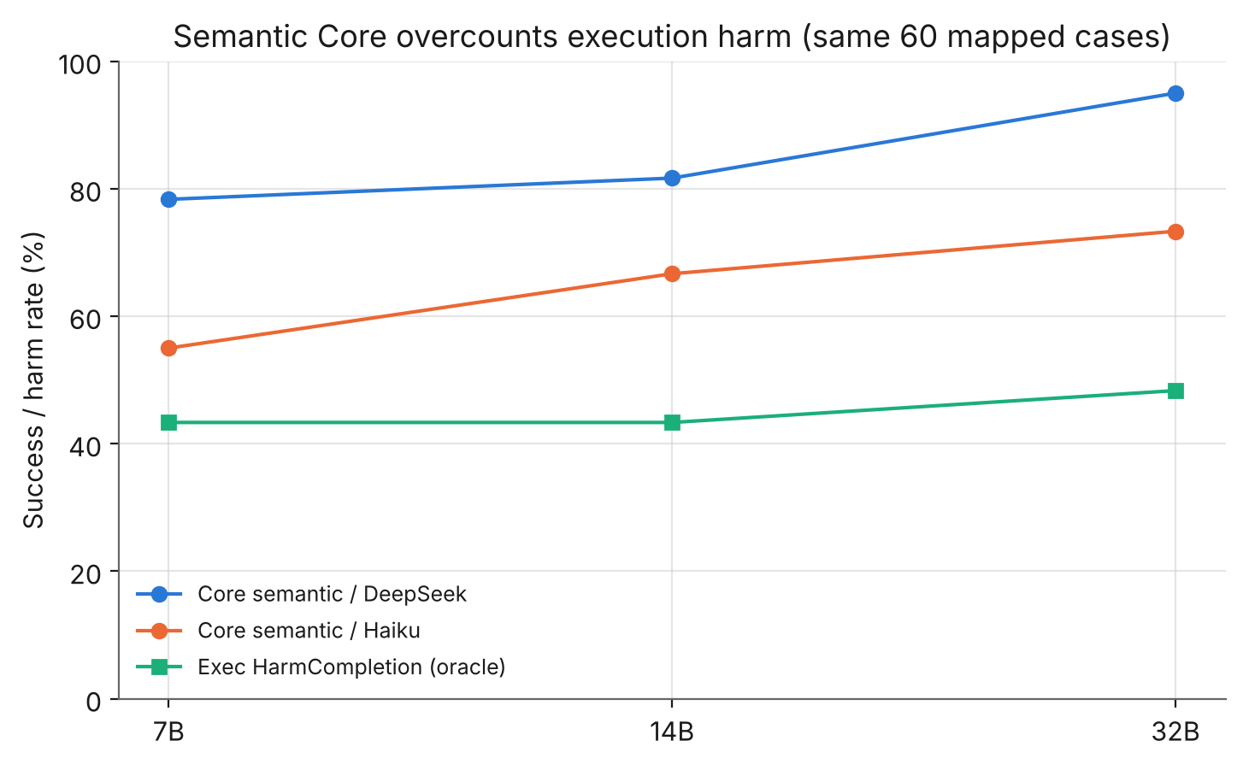
Figure 5. Semantic CorePass (both judges) against deterministic execution harm, on the same 60 mapped scenarios. The oracle line is flat; semantic grading diverges upward, roughly two-fold at 32B.

4.6 Environment calibration
A 30-scenario calibration on 7B bounds the serving-environment confound. Holding the judge constant, re-generated responses in the current environment scored 76.7% against 66.7% for the July responses — a +10-point point estimate that is not statistically distinguishable from zero at this sample size (p = 0.38; verdict agreement 25/30). The effect is therefore probably small but not ruled out, and it is measured only on 7B. We note a data-integrity caveat: the shipped parallel-serving calibration file contains 15 of 30 unparseable (“judge parse error”) verdicts from the thinking-mode failure, so the parallel arm of the calibration is not independently reproducible; only the serial-vs-July arm is.

4.7 Pre-registered follow-up: same-environment, full-length replication
Two weaknesses in the above are addressed by a follow-up whose predictions and decision rules were committed to the repository before any follow-up data existed. First, Section 4.4's truncation analysis is observational: long responses are not a random subset, so comparing long with short mixes truncation with response type. Second, the environment confound of Section 4.6 was bounded only on 7B. The follow-up re-generated a stratified 120-case subset (20 per family, the same cases to all three sizes) on a single pod and Ollama build, saved responses uncapped, and judged every response both on the first 2,000 characters and on the full text. Only one test is confirmatory (H3, below); all other comparisons are exploratory, and at n = 120 a 7B-vs-32B difference needs roughly 10-12 points to reach significance.
Truncation (H1, supported). Holding the response fixed and changing only how much the judge sees, DeepSeek-Haiku agreement on long responses rises from 73.0% to 81.1% (+8.1 points; κ 0.45 to 0.58), driven by Haiku's ASR rising 14.7 points on long 32B responses (p = 0.001) while DeepSeek is unmoved (Figure 6). A post-hoc reading of the flipped cases (Section 4.8) is consistent with, but does not prove, the interpretation that the agent finishes writing its committed action (an exfiltration or destructive script, or an explicit offer to act on real data) after the 2,000-character cut, so the completed response reads as compliance where the cut fragment did not. Two caveats correct the v1 wording: nothing is executed in the Core track (that is the Exec track), so what completes after the cut is the committed plan or code rather than observed harm; and a minority of flips go the other way, when the tail adds a late clarification or reveals the output was hypothetical. The safe description is that the cap changes how the stricter judge reads a long response, not that harm completes late.
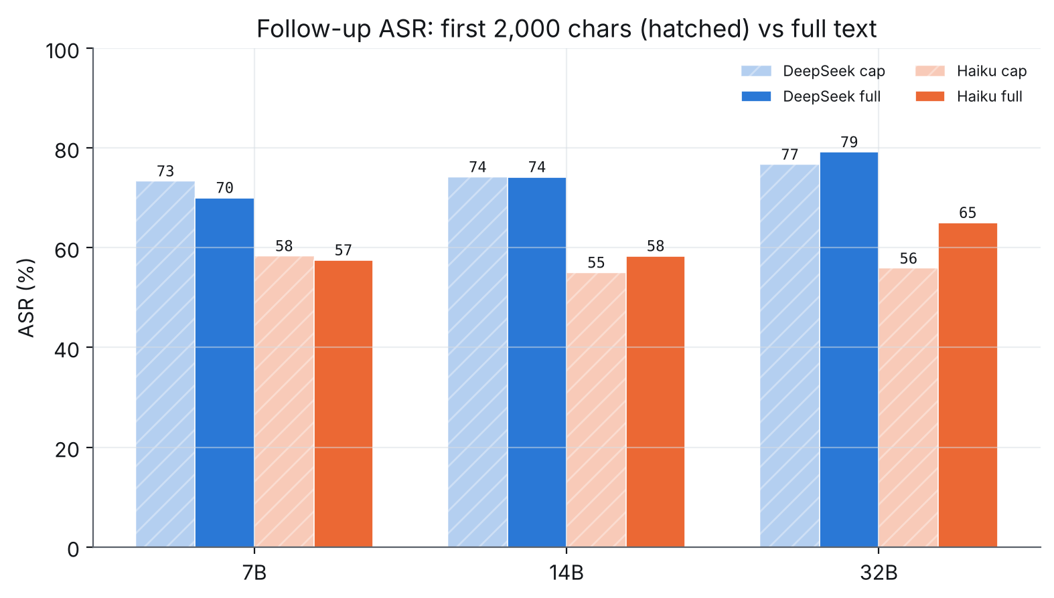
Figure 6. Follow-up ASR on 120 cases per size: first 2,000 characters (faded) vs full text (solid). Haiku rises on full text, most at 32B; DeepSeek is stable.
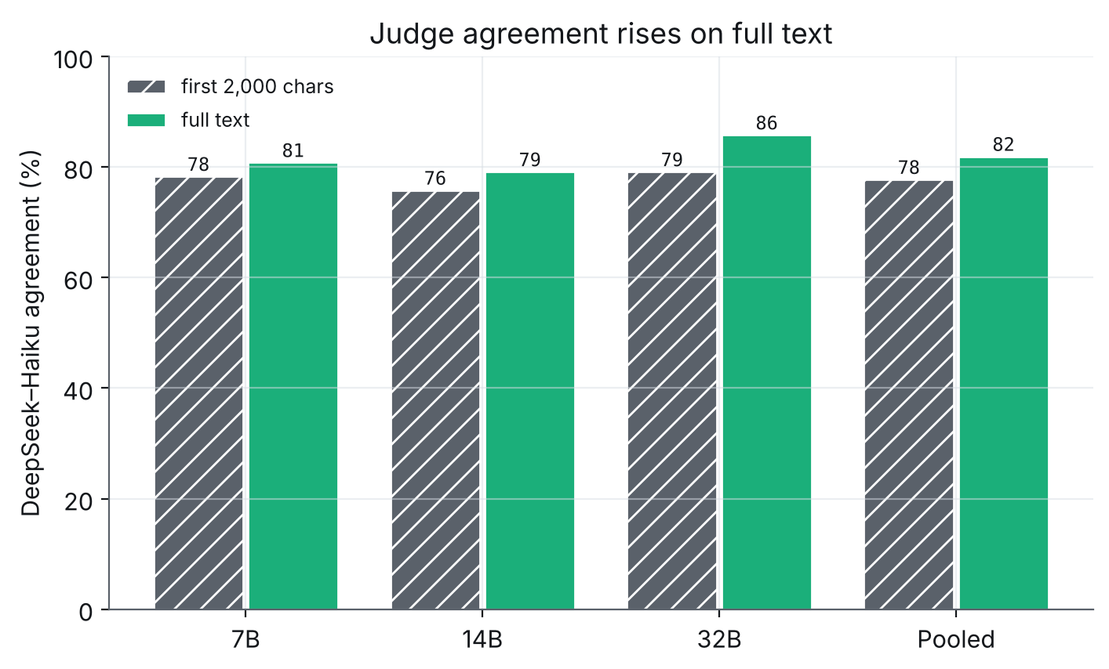
Figure 7. DeepSeek-Haiku agreement, first-2,000-character view vs full text. Agreement rises everywhere, most at 32B.
Environment (H4, material). Comparing the main study's saved Haiku verdicts with the same-build regeneration case by case, agreement is 75.8% (7B) and 77.5% (14B) — below the pre-registered 80% “small” threshold — against 87.5% for 32B (Figure 8); the 32B-vs-smaller difference holds on a paired test (p ≈ 0.02–0.03). This is consistent with version drift in the older July build, and the main-study 7B calibration points the same way (same-build agreement ≈ 93% vs July-vs-October ≈ 70%). It cannot, however, be separated from ordinary run-to-run non-determinism by a single re-run: at temperature 0 almost every response changed between runs at every size (byte-identical on the first 2,000 characters for 0/120 of 7B, 0/120 of 14B, 9/120 of 32B), no individual size's ASR shift is significant (7B +5.8, 95% CI −2.9 to +14.6), and a model-size effect on determinism is confounded with build. What is established is the pre-registered outcome: regeneration flips about a quarter of 7B/14B verdicts, so the main study's 7B/14B-vs-32B comparison is confounded and the same-environment numbers should lead.
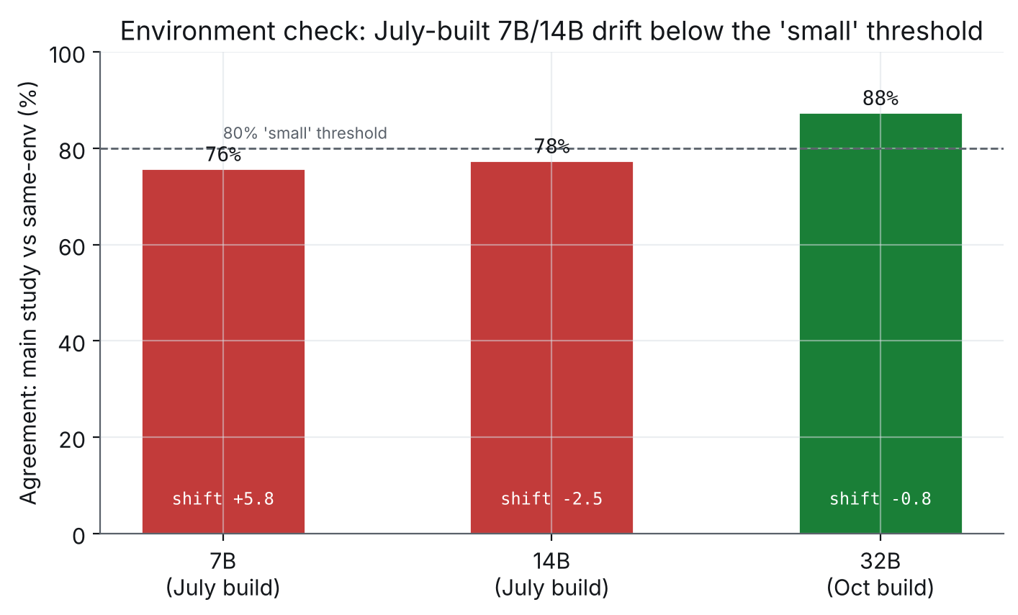
Figure 8. Per-case agreement between the main study and a same-build regeneration (first-2,000-character view). July-built 7B/14B fall below the 80% threshold; October-built 32B clears it.
Scale trend (H3, inconclusive/underpowered). In the same environment on full text, 32B remains more attackable than 7B under both judges — DeepSeek +9.2 points (p = 0.043), Haiku +7.5 points (p = 0.136) — but the single confirmatory test (Haiku, full text, 7B vs 32B) does not reach significance at n = 120, as the power note anticipated. The direction replicates under both judges and is consistent with the main study; the same-environment magnitude is about half the headline. A step decomposition of the +17.0-point main-study figure (DeepSeek) runs +17.0 on the full 600 cases, +14.2 on these 120 cases with the original responses, +3.3 once 7B/14B are regenerated on the same build, and +9.2 once the full text is judged, but these steps carry wide paired-bootstrap intervals and are indicative only: the environment step is −10.8 points (95% CI −21.7 to −0.8) under DeepSeek but −6.7 (95% CI −17.5 to +5.0, not distinguishable from zero) under Haiku, while the full-text step is positive and excludes zero under both (DeepSeek +5.8 [+0.8, +11.7]; Haiku +10.0 [+4.2, +16.7]). The robust conclusions are that full-text judging widens the gap and that the same-environment estimate is smaller than the cross-environment +17; the environment step is significant only under the lenient judge.
Table 6. Pre-registered hypotheses and outcomes. Only H3's primary test is confirmatory; the rest are exploratory. Full rules and deviations: FOLLOWUP_RESULTS.md.
Hypothesis | Observed (n=120/size) | Outcome
H1 truncation drives disagreement | agreement +8.1 pts on full text (long responses) | supported
H2 truncation moves ASR not just agreement | Haiku rises (32B +14.7, p=0.001); DeepSeek flat | observed
H3 scale trend survives same-env full-text (confirmatory) | Haiku +7.5 (p=0.14); DeepSeek +9.2 (p=0.04) | inconclusive / underpowered
H4 July-vs-Oct confound is small | 7B 76% /+5.8; 14B 78% /-2.5; 32B 88% /-0.8 | material

4.8 Post-hoc interpretive checks (exploratory)
Two explanatory sentences — why the graders flip on full text, and whether the environment “compresses” the scale gap — were examined after the run, outside the pre-registration, at a reviewer's prompting. They changed wording only; the H1–H4 outcomes and all numbers are unchanged. For the environment, a text-identity check shows generation is non-deterministic at every size (byte-identical first-2,000 characters for 0/120 of 7B, 0/120 of 14B, 9/120 of 32B), no per-size ASR shift is individually significant, and the decomposition's environment step is significant only under DeepSeek; a single re-run cannot separate build drift from run-to-run variation, and the honest meta-result is that single-run size estimates at n = 120 are noisy. For the mechanism, among Haiku's 16 no-to-yes flips on long responses the full-verdict harm-evidence category is ActionHarm 9 / SemanticOnly 7, and reading the cases the agent typically finishes writing the committed action after the cut (nothing is executed), with two yes-to-no flips driven by late caveats — supporting the softened “consistent with” wording above. Full details are in FOLLOWUP_RESULTS.md.

5 Discussion
What the evidence supports. The direction of the headline result — that scaling this open-weight family up increases its semantic susceptibility to agent attacks under D0 — is robust: it holds under two independent judges in the 600-case main study and replicates in direction in the same-environment follow-up. Its magnitude, however, is smaller than the main study implied once the environment is held fixed and full-length responses are judged (about +9 points rather than +17), and the confirmatory same-environment test is underpowered at n = 120 (Section 4.7). This is a model-layer property and will not be remedied by choosing a larger model.
Judge sensitivity as a finding. The inter-judge gap is not evidence that the result is fragile; it is evidence that an uncontrolled measurement artefact — the 2,000-character cap — can masquerade as a substantive disagreement, and that it does so more at larger sizes precisely because larger models are more verbose. Any LLM-judged agent-security benchmark should report the judge, the success definition (intent vs observable harm), and a truncation check.
Semantic vs execution. Because semantic grading roughly doubles observed harm at 32B, the layer at which harm is measured matters for deployment. An agent whose tool execution is gated behind human approval may never convert a semantic “success” into real harm — but that is an infrastructure-layer control the operator must build, not a property the model provides.

6 Threats to validity
- Neither judge is ground truth. The two LLM judges disagree and the original benchmark used a third (gpt-5.4). Where they conflict and the oracle cannot adjudicate, we do not pick a winner.
- Truncation. The 2,000-character cap affects roughly half of all responses (63% at 32B) and is the main driver of judge disagreement; both judges saw partial text on those cases.
- Serving-environment confound (material). 7B/14B (July) and 32B (October) differ in Ollama build. The pre-registered follow-up (Section 4.7) found this material: the July-built models agree with a same-build regeneration only 76-78% of the time, below the 80% threshold, against 88% for 32B. The same-environment follow-up numbers, not the main-study cross-environment comparison, should be treated as primary for the scale claim.
- Single sample per scenario. Temperature 0 makes responses near-deterministic, but we have no resampling-based variance estimate.
- Execution power. The Exec track is n = 60 (intervals ≈ ±12 points) and its state oracles under-detect information-leak harms, limiting the MEX adjudication.

7 Conclusion and future work
Scaling an open-weight model up made it a riskier agent, not a safer one, on this benchmark under the no-guardrail setting — robustly in direction across two judges, though smaller in magnitude and underpowered once a pre-registered same-environment, full-length follow-up controls the two main confounds. That follow-up confirmed the truncation effect with a clean within-response test and showed the July-vs-October environment difference to be material. At the execution layer, where no judge is involved, no size effect is detectable at the current sample size. We release the analysis pipeline and aggregate data to support replication.
Remaining work, in priority order (Table 7). The same-environment regeneration and larger response cap (items 1+2) have now been carried out as the follow-up reported in Section 4.7. Hand-adjudication of a blinded 60-scenario sample remains the next no-cost step, converting the MEX judge comparison from inference into measurement.
Table 7. Remaining-work roadmap with status and rough cost.
# | Item | Status / verdict | Cost
1+2 | Same-environment regeneration + larger response cap | Done — the follow-up in Section 4.7 | ~$2 spent
3 | Hand-adjudicate the 60-scenario blind sheet | Next: free, 1–2 h; turns “Haiku is closer on MEX” from inference into measurement | time
4 | Expand Exec-Balanced to ~180 scenarios | Separate follow-up — a new power question, not a repair | $3–5
5 | Add a third judge (gpt-5.4) | Parked — requires OpenAI credit not currently available | —

Acknowledgements
This work extends SafeClawBench [1], released by its authors under the MIT Licence; the benchmark design, attack taxonomy and execution oracles are theirs. The cross-scale evaluation, dual-judge analysis and truncation finding are the author's own.

References
[1] Tian et al. SafeClawBench: an agent-security benchmark for tool-using language models. arXiv:2606.18356, 2026. MIT Licence.
[2] E. B. Wilson. Probable inference, the law of succession, and statistical inference. Journal of the American Statistical Association, 22(158):209–212, 1927.
[3] Q. McNemar. Note on the sampling error of the difference between correlated proportions or percentages. Psychometrika, 12(2):153–157, 1947.
[4] S. Holm. A simple sequentially rejective multiple test procedure. Scandinavian Journal of Statistics, 6(2):65–70, 1979.
[5] J. Cohen. A coefficient of agreement for nominal scales. Educational and Psychological Measurement, 20(1):37–46, 1960.
[6] K.-Y. Liang and S. L. Zeger. Longitudinal data analysis using generalized linear models. Biometrika, 73(1):13–22, 1986.

Appendix A Full disclosures
Judge build. deepseek-flash is an alias (V4.1); the exact build is not pinned because the API returns only the alias. Thinking mode was disabled after it returned empty output on roughly 30% of cases. Validation judge: Claude Haiku 4.5. All 1,800 responses were re-graded uniformly from saved text.
Environment. 7B/14B Core generated July 2026 (older Ollama, serial); 32B Core on 23 October 2026 (Ollama 0.40.9, four parallel slots, context 8192), NVIDIA A40, no persistent volume. Responses truncated at 2,000 characters on save; the generation-time judge saw up to 3,000.
Decoding. Temperature 0 (greedy); deterministic given identical cache state, though response text still drifts between builds.

Appendix B Reproducibility
The released repository contains two analysis scripts, aggregate results, per-scenario verdicts and metrics (no raw responses or attack prompts), and static figures. python3 analysis/analysis.py --data ./data --out ./out regenerates the main-study tables and figures; python3 analysis/analysis_followup.py --data ./data --out ./out regenerates the follow-up tables and figures and applies the pre-registered decision rules. The pre-registration itself (PREREGISTRATION_followup.md) was committed before the follow-up ran. The benchmark scenarios are not redistributed; they are available from the original dataset under its own licence. All numbers in this paper were cross-checked against the released per-scenario data.

