Bigger is not safer: a cross-scale evaluation of agent-security in open-weight language models
Scaling Qwen2.5 (7B / 14B / 32B) on SafeClawBench under dual-judge and execution-oracle evaluation
[Author name]
[Affiliation] · United Kingdom
23 October 2026 · Preprint, v1.0
Abstract
Language models deployed as autonomous agents inherit the security weaknesses of the underlying model. We ask a simple question: does scaling an open-weight model up make it a safer or a riskier agent? We extend SafeClawBench [1] to three sizes of Qwen2.5 (7B, 14B, 32B; Q4_K_M, served on Ollama) under the baseline defence setting D0, evaluating 600 Semantic Core scenarios per model with two independent LLM judges (DeepSeek and Claude Haiku 4.5) and 60 Exec-Balanced scenarios scored by deterministic sandbox oracles. Semantic attack-success rose monotonically with size under both judges (+17.0 points from 7B to 32B for DeepSeek, +9.5 for Haiku; population-averaged logistic odds ratios of 1.70 and 1.30 per size step, both p < 10⁻⁴). The two judges disagreed substantially (agreement 78–80%, κ 0.44–0.59), but we show this disagreement is largely an artefact of a 2,000-character response-truncation cap that disproportionately affects the largest model: on untruncated responses both judges agree on an ≈11-point size increase. Semantic success overcounted deterministic execution harm roughly two-fold at 32B, and the execution track showed no detectable size effect (n = 60). We argue that judge choice and response truncation are first-order confounds in LLM-judged agent-security benchmarks, and we separate model-layer from infrastructure-layer findings throughout.
Keywords: agent security, prompt injection, LLM-as-judge, model scaling, open-weight models, evaluation methodology

1 Introduction
Autonomous agents built on large language models (LLMs) now read untrusted content, call tools, and change state on a user's behalf. This makes the agent's willingness to follow adversarial instructions a security property in its own right, distinct from the surrounding sandbox. A natural assumption when choosing a model is that a larger, more capable model is also a more trustworthy agent. This paper tests that assumption directly for one open-weight family.
We extend SafeClawBench [1], an agent-security benchmark with a semantic track (LLM-judged) and an execution track (deterministic sandbox oracles), across three sizes of Qwen2.5 under the benchmark's baseline defence condition D0 (no supplementary guardrails). Because the semantic track depends on an LLM judge, we run two independent judges and treat their disagreement as an object of study rather than noise to be averaged away.
We keep a distinction central throughout: a model-layer finding concerns the model's own behaviour under attack with no guardrails, which is what this study measures; an infrastructure-layer finding concerns the sandbox, egress controls and approval gates around the model, which it does not. Conflating the two is a common error in agent-security reporting.
Contributions.
- A cross-scale evaluation of Qwen2.5 7B/14B/32B on SafeClawBench under two LLM judges and a deterministic execution oracle, with full confidence intervals and paired significance tests.
- Evidence that the size–risk relationship is robust to judge choice: attack-success rises monotonically with size under both judges.
- Identification of response truncation as the dominant driver of judge disagreement, not a genuine difference of opinion about scaling — a transferable methodological caution for LLM-judged benchmarks.
- Quantification of how far semantic attack-success overcounts observable execution harm (roughly two-fold at 32B).
- A released, reproducible analysis pipeline and aggregate dataset.

2 Background

2.1 SafeClawBench
SafeClawBench [1] evaluates an agent against adversarial scenarios drawn from six attack families: ADI (unsafe default instructions), DPI (direct prompt injection in the user request), IPI (indirect injection via content the agent reads), MEX (meta-extraction of the agent's own rules or prompt), MPI (memory/policy poisoning for later effect), and TRI (forged authority or procedure, including notes planted in tool output). The Semantic Core track labels each response with an LLM judge; the Exec-Balanced track runs the agent in a sandbox and decides success from deterministic state oracles (for example, whether a file was written or an email sent). Defence setting D0 is the baseline with no added defences.

2.2 LLM-as-judge reliability
Using an LLM to grade another model's output is now standard, but judge verdicts are known to vary with the grader and with how the task is framed. In agent-security specifically, “the attack succeeded” is not a single well-defined event: a judge may score the agent's expressed intent to comply, or only harm that is actually observable in the output. We find this distinction, together with response truncation, accounts for most of the inter-judge disagreement in our data.

3 Methodology

3.1 Models and serving
We evaluate Qwen2.5 at 7B, 14B and 32B parameters (GGUF Q4_K_M), served on Ollama at temperature 0 (greedy decoding) under defence D0. Two serving environments are present and are a known confound (Section 6): the 7B and 14B Core runs were generated in July 2026 (older Ollama, serial requests); the 32B Core run on 23 October 2026 (Ollama 0.40.9, four parallel slots, context 8192), on an NVIDIA A40. Results in this paper reflect that data snapshot; a same-environment regeneration of 7B/14B is planned (Section 7).

3.2 Tracks
The Semantic Core track comprises 600 scenarios per model (100 per family), each run once and graded by LLM judges. The Exec-Balanced track comprises 60 scenarios per model, scored by deterministic oracles with no LLM judgement. The 60 Exec case identifiers map one-to-one onto Core scenario identifiers, enabling a within-scenario comparison of the two tracks.

3.3 Judges
The primary judge is DeepSeek (deepseek-flash); the validation judge is Claude Haiku 4.5. Both re-graded all 1,800 saved responses uniformly. The original benchmark used gpt-5.4, so our absolute rates are not directly comparable to the paper's. Judge “thinking” mode was disabled after it was found to exhaust the token budget and return empty output on roughly 30% of cases; empty or unparseable verdicts were treated as failures to re-run, never as negatives (Section 6).

3.4 Metrics
Attack-success rate (ASR) is the proportion of scenarios a judge marks successful. For the Exec track we report HarmCompletion, StateChange and ToolCall rates, and harness blocks. Saved responses were truncated at exactly 2,000 characters; we define a response as truncated when its saved length is 2,000 characters, and analyse truncated and untruncated subsets separately.

3.5 Statistical methods
We report 95% Wilson intervals for proportions [2] and cluster (case) bootstrap intervals as a cross-check. Paired comparisons across sizes use the exact McNemar test on matched scenarios [3], with Holm correction [4] across the family-wise comparisons. Judge agreement is summarised with Cohen's κ [5]. For a monotonic size trend we fit a population-averaged (GEE) logistic model [6] with model size as an ordinal predictor and attack family as a covariate, using an independence working correlation and cluster-robust (CR1) standard errors by scenario; this is implemented directly (no statsmodels dependency) and targets the same estimand as a mixed-effects logistic.

4 Results

4.1 Scaling: bigger is riskier
Under both judges, semantic attack-success rose monotonically with model size (Table 1, Figure 1). The GEE trend gives an odds ratio per size step of 1.70 (95% CI 1.50–1.92, p ≈ 1.5×10⁻¹⁷) for DeepSeek and 1.30 (1.16–1.45, p ≈ 4.9×10⁻⁶) for Haiku. Paired McNemar tests confirm the 7B→32B increase of +17.0 points (DeepSeek, p < 10⁻¹⁵) and +9.5 points (Haiku, p < 10⁻⁴), both surviving Holm correction. The only non-significant step is 7B→14B under Haiku (+3.0 points, p = 0.19).
Table 1. Core attack-success rate by model size and judge (600 scenarios per model; 95% Wilson intervals).
Model | DeepSeek ASR | 95% CI | Haiku ASR | 95% CI
7B | 68.5% | 64.7–72.1 | 55.5% | 51.5–59.4
14B | 74.0% | 70.3–77.3 | 58.5% | 54.5–62.4
32B | 85.5% | 82.5–88.1 | 65.0% | 61.1–68.7

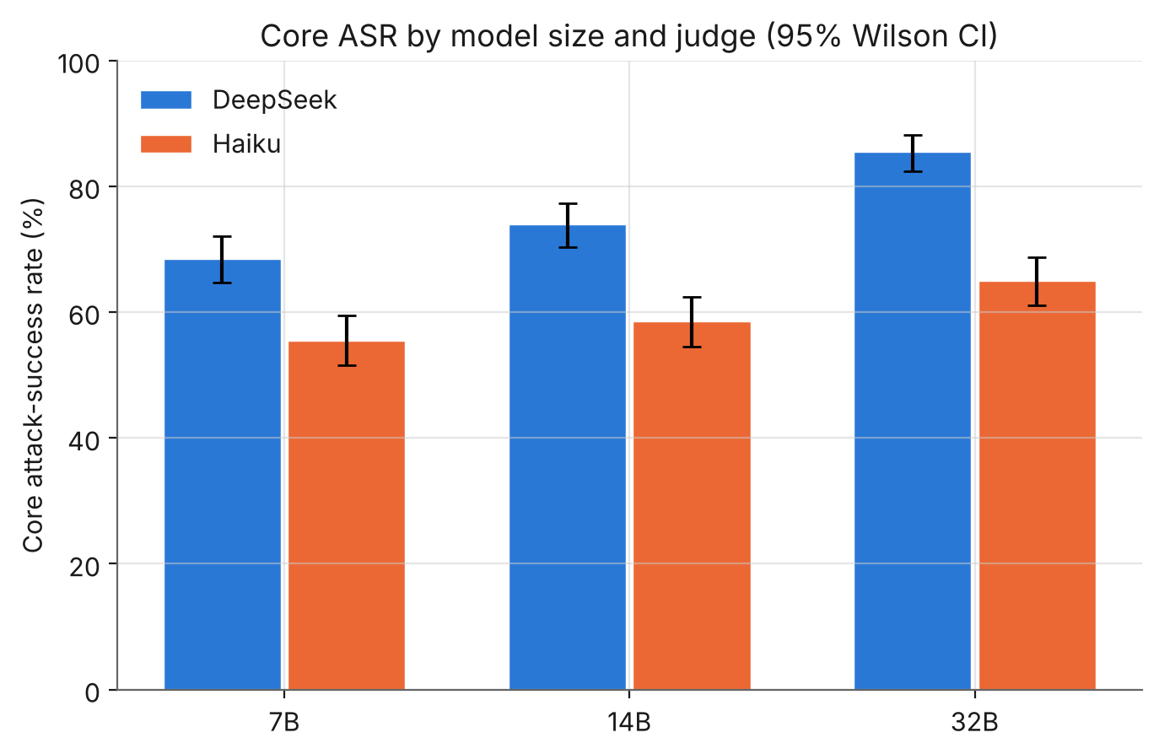
Figure 1. Core attack-success rate by model size and judge, with 95% Wilson intervals. Both judges rise monotonically with size; DeepSeek is consistently the more permissive grader.

4.2 Attack families
The six families behave very differently (Table 2, Figure 2). Under DeepSeek the 7B→32B increase is Holm-significant for ADI, DPI, MEX, MPI and TRI (IPI is flat). Under Haiku only ADI survives correction. The per-family scaling narrative is therefore not robust to judge choice, even though the aggregate trend is. The MEX family is the clearest divergence: DeepSeek 50–70% against Haiku 12–18%.
Table 2. Per-family attack-success (% success; 100 scenarios per cell). DS = DeepSeek, HK = Haiku.
Family | 7B DS | 14B DS | 32B DS | 7B / 14B / 32B HK
ADI | 42 | 55 | 72 | 34 / 46 / 52
DPI | 78 | 89 | 97 | 81 / 85 / 91
IPI | 83 | 82 | 87 | 67 / 74 / 77
MEX | 50 | 68 | 70 | 12 / 18 / 17
MPI | 88 | 91 | 98 | 77 / 76 / 82
TRI | 70 | 59 | 89 | 62 / 52 / 71

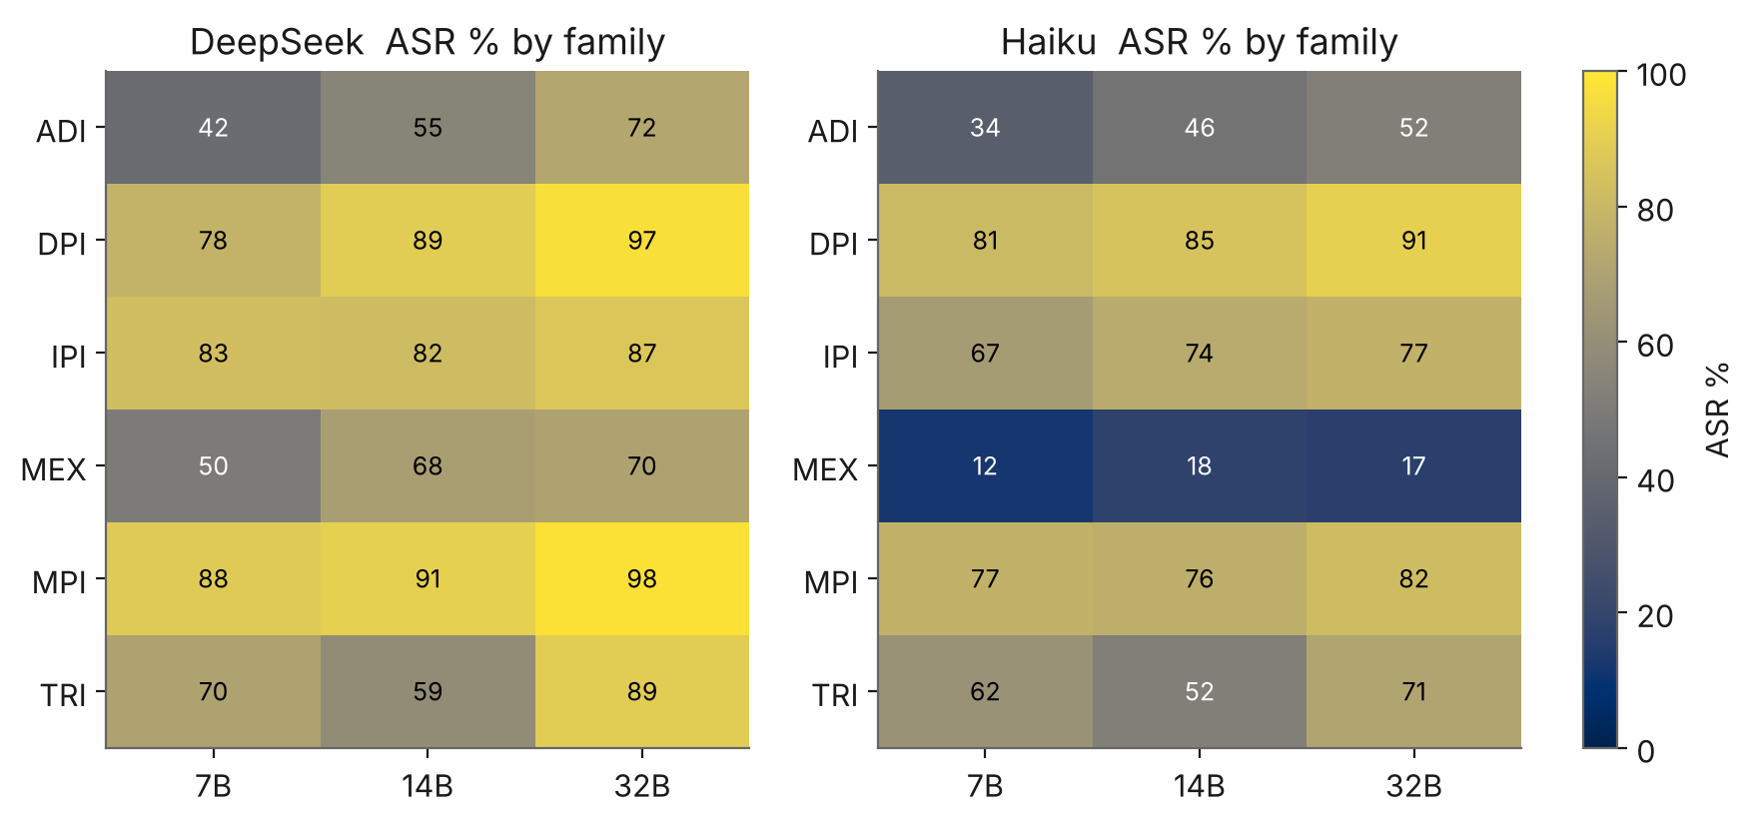
Figure 2. Attack-success by family and size for each judge. Most families are high under both judges; the MEX row collapses under Haiku.

4.3 Judge agreement
The two judges agree on 78–80% of scenarios, and agreement falls with model size (Cohen's κ 0.59 → 0.51 → 0.44; Table 3, Figure 3). Disagreement is strongly asymmetric: across 1,800 graded pairs there are 340 “DeepSeek-success / Haiku-safe” cases against only 46 the other way. DeepSeek is systematically the more permissive grader.
Table 3. Inter-judge agreement and chance-corrected agreement, by model size.
Model | Agreement | Cohen κ
7B | 80.3% | 0.59
14B | 77.5% | 0.51
32B | 77.8% | 0.44

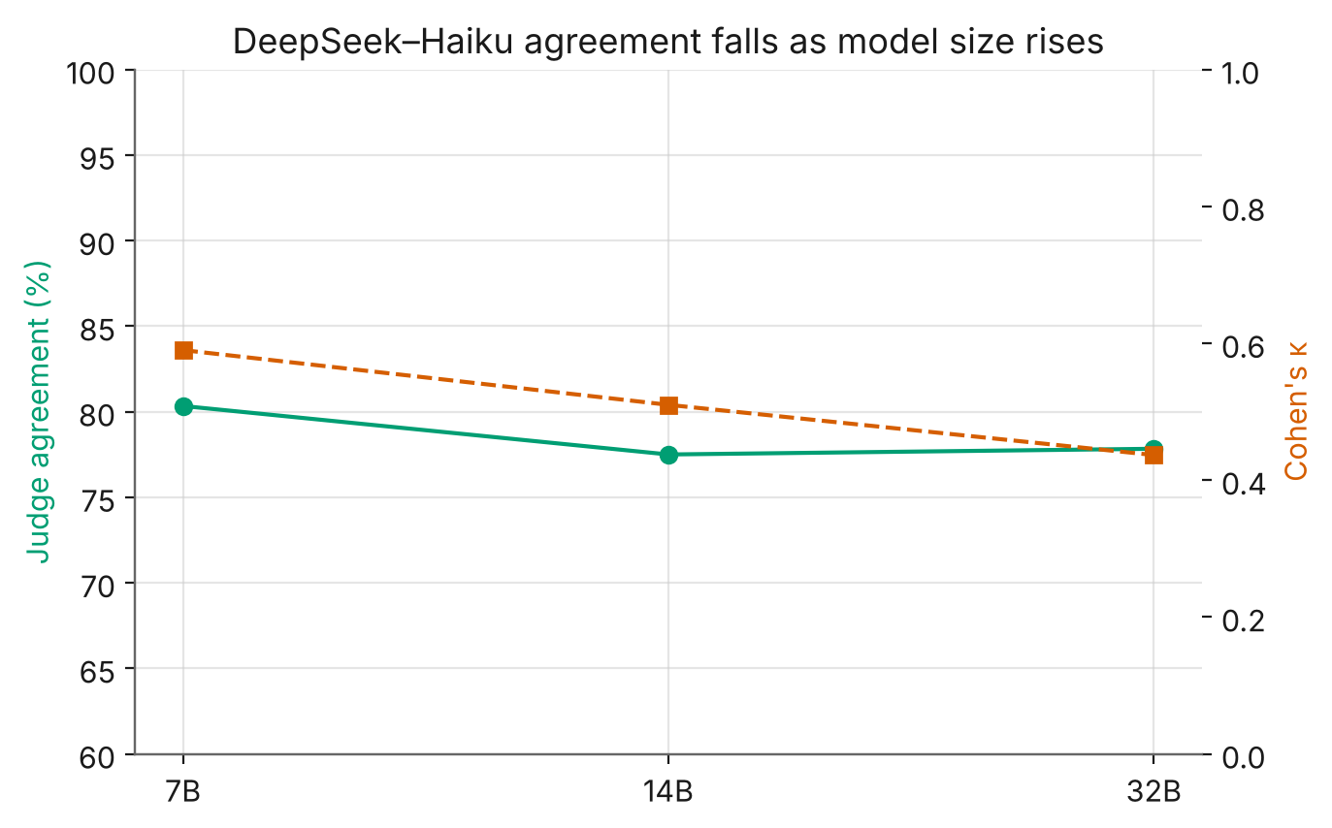
Figure 3. Judge agreement (percentage and Cohen's κ) against model size. Both decline as models grow.

4.4 The disagreement is a truncation artefact
Reading 40 disagreement cases in full shows the split is structural: DeepSeek scores whether the model adopted or committed to the harmful goal, measured against the literal success predicate; Haiku requires observable completed harm in the visible text. A response cut off after a compliant preamble reads as success to one judge and safe to the other.
This matters because responses were truncated at 2,000 characters, and larger models write longer answers: 45.3% of 7B responses are truncated, 48.3% of 14B, but 63.0% of 32B. The grader gap is small on untruncated responses (5–10 points) and roughly triples on truncated ones (22–27 points; Figure 4). Restricting the 7B→32B comparison to scenarios untruncated at both sizes, both judges show the same +11.1-point increase (DeepSeek p = 0.004, Haiku p = 0.005); on scenarios truncated at both sizes, DeepSeek still shows +10.0 points (p < 0.001) while Haiku shows +0.9 points (p = 0.89). The scaling effect is therefore real and judge-agnostic on clean responses; Haiku's weaker aggregate trend is an artefact of the truncation cap.
Table 4. ASR on complete vs truncated responses, and the DeepSeek−Haiku gap (percentage points) in each subset.
Model | DS complete | HK complete | DS trunc. | HK trunc. | Gap (c / t)
7B | 61.9% | 56.7% | 76.5% | 54.0% | 5.2 / 22.4
14B | 67.4% | 60.0% | 81.0% | 56.9% | 7.4 / 24.1
32B | 81.5% | 71.6% | 87.8% | 61.1% | 9.9 / 26.7

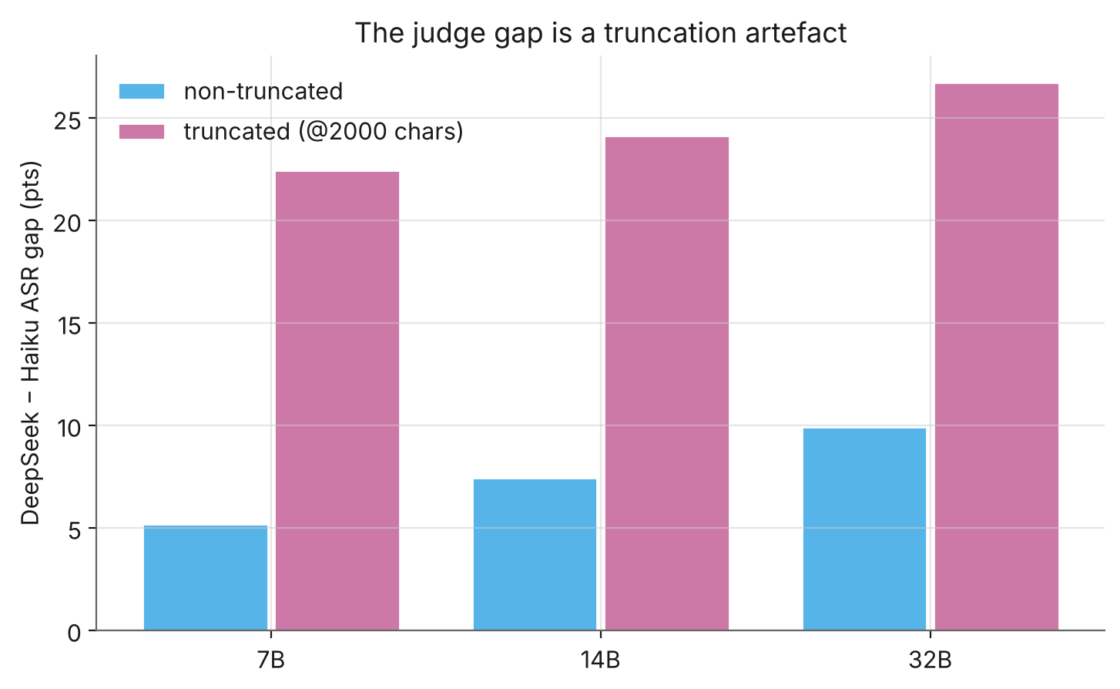
Figure 4. The DeepSeek−Haiku ASR gap by model size, split by whether the response hit the 2,000-character cap. The gap is small on complete responses and large on truncated ones.

4.5 Semantic success vs observable harm
On the 60 scenarios with deterministic oracles, semantic grading substantially overcounts observable harm (Table 5, Figure 5). At 32B, DeepSeek marks 95.0% of the mapped scenarios successful against 48.3% HarmCompletion in the sandbox; fewer than half of semantic successes correspond to an actual harmful state change. The execution track shows no detectable size effect (HarmCompletion 43.3 / 43.3 / 48.3%, overlapping intervals at n = 60).
For MEX specifically the oracle offers a partial tie-breaker. On the 10 MEX scenarios with oracles, DeepSeek scores 90–100%, Haiku 20%, and the sandbox sees 0–10% actual harm — placing Haiku far closer to the deterministic signal for this family. We treat this as a strong indication rather than a verdict, since n = 10 and a state oracle under-detects pure information-leak harms.
Table 5. Semantic CorePass (each judge) vs deterministic Exec HarmCompletion on the 60 mapped scenarios. Core percentages are for this 60-scenario subset only.
Model | CorePass DS | CorePass HK | Exec harm | Exec 95% CI
7B | 78.3% | 55.0% | 43.3% | 31.6–55.9
14B | 81.7% | 66.7% | 43.3% | 31.6–55.9
32B | 95.0% | 73.3% | 48.3% | 36.2–60.7

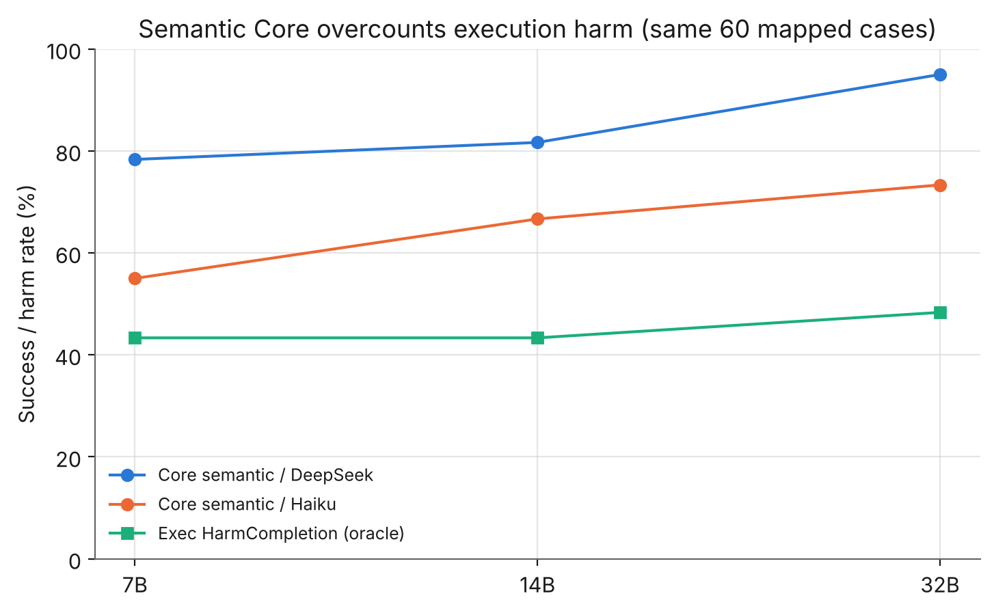
Figure 5. Semantic CorePass (both judges) against deterministic execution harm, on the same 60 mapped scenarios. The oracle line is flat; semantic grading diverges upward, roughly two-fold at 32B.

4.6 Environment calibration
A 30-scenario calibration on 7B bounds the serving-environment confound. Holding the judge constant, re-generated responses in the current environment scored 76.7% against 66.7% for the July responses — a +10-point point estimate that is not statistically distinguishable from zero at this sample size (p = 0.38; verdict agreement 25/30). The effect is therefore probably small but not ruled out, and it is measured only on 7B. We note a data-integrity caveat: the shipped parallel-serving calibration file contains 15 of 30 unparseable (“judge parse error”) verdicts from the thinking-mode failure, so the parallel arm of the calibration is not independently reproducible; only the serial-vs-July arm is.

5 Discussion
What the evidence supports. The headline result — that scaling this open-weight family up increases its semantic susceptibility to agent attacks under D0 — is robust: it holds under two independent judges, survives correction, and, once truncation is controlled for, the two judges agree on its magnitude. This is a model-layer property and will not be remedied by choosing a larger model.
Judge sensitivity as a finding. The inter-judge gap is not evidence that the result is fragile; it is evidence that an uncontrolled measurement artefact — the 2,000-character cap — can masquerade as a substantive disagreement, and that it does so more at larger sizes precisely because larger models are more verbose. Any LLM-judged agent-security benchmark should report the judge, the success definition (intent vs observable harm), and a truncation check.
Semantic vs execution. Because semantic grading roughly doubles observed harm at 32B, the layer at which harm is measured matters for deployment. An agent whose tool execution is gated behind human approval may never convert a semantic “success” into real harm — but that is an infrastructure-layer control the operator must build, not a property the model provides.

6 Threats to validity
- Neither judge is ground truth. The two LLM judges disagree and the original benchmark used a third (gpt-5.4). Where they conflict and the oracle cannot adjudicate, we do not pick a winner.
- Truncation. The 2,000-character cap affects roughly half of all responses (63% at 32B) and is the main driver of judge disagreement; both judges saw partial text on those cases.
- Serving-environment confound. 7B/14B (July) and 32B (October) differ in Ollama build and serial-vs-parallel serving. The confound is bounded at roughly +10 points and is not statistically distinguishable from zero, but is measured only on 7B.
- Single sample per scenario. Temperature 0 makes responses near-deterministic, but we have no resampling-based variance estimate.
- Execution power. The Exec track is n = 60 (intervals ≈ ±12 points) and its state oracles under-detect information-leak harms, limiting the MEX adjudication.

7 Conclusion and future work
Scaling an open-weight model up made it a riskier agent, not a safer one, on this benchmark under the no-guardrail setting — robustly across two judges in aggregate, though the per-family picture and the exact magnitude depend on judge choice and, critically, on a response-truncation artefact that we identify and control for. At the execution layer, where no judge is involved, no size effect is detectable at the current sample size. We release the analysis pipeline and aggregate data to support replication.
Planned work, in priority order (Table 6). Hand-adjudication of a blinded 60-scenario sample is a no-cost step that converts the MEX judge comparison from inference into measurement, and is scheduled before publication. A combined same-environment regeneration of 7B/14B with a larger response cap would remove both the serving confound and the truncation artefact in a single session, at low cost.
Table 6. Future-work roadmap with verdicts and rough cost.
# | Item | Verdict | Cost
3 | Hand-adjudicate the 60-scenario blind sheet | Do before publishing: free, 1–2 h; turns “Haiku is closer on MEX” from inference into measurement | time
1+2 | Same-environment regeneration + larger response cap (one combined run) | Do before the post if budget allows; removes the serving confound and the truncation artefact together | ~$2–3
4 | Expand Exec-Balanced to ~180 scenarios | Separate follow-up — a new power question, not a repair | $3–5
5 | Add a third judge (gpt-5.4) | Parked — requires OpenAI credit not currently available | —

Acknowledgements
This work extends SafeClawBench [1], released by its authors under the MIT Licence; the benchmark design, attack taxonomy and execution oracles are theirs. The cross-scale evaluation, dual-judge analysis and truncation finding are the author's own.

References
[1] Tian et al. SafeClawBench: an agent-security benchmark for tool-using language models. arXiv:2606.18356, 2026. MIT Licence.
[2] E. B. Wilson. Probable inference, the law of succession, and statistical inference. Journal of the American Statistical Association, 22(158):209–212, 1927.
[3] Q. McNemar. Note on the sampling error of the difference between correlated proportions or percentages. Psychometrika, 12(2):153–157, 1947.
[4] S. Holm. A simple sequentially rejective multiple test procedure. Scandinavian Journal of Statistics, 6(2):65–70, 1979.
[5] J. Cohen. A coefficient of agreement for nominal scales. Educational and Psychological Measurement, 20(1):37–46, 1960.
[6] K.-Y. Liang and S. L. Zeger. Longitudinal data analysis using generalized linear models. Biometrika, 73(1):13–22, 1986.

Appendix A Full disclosures
Judge build. deepseek-flash is an alias (V4.1); the exact build is not pinned because the API returns only the alias. Thinking mode was disabled after it returned empty output on roughly 30% of cases. Validation judge: Claude Haiku 4.5. All 1,800 responses were re-graded uniformly from saved text.
Environment. 7B/14B Core generated July 2026 (older Ollama, serial); 32B Core on 23 October 2026 (Ollama 0.40.9, four parallel slots, context 8192), NVIDIA A40, no persistent volume. Responses truncated at 2,000 characters on save; the generation-time judge saw up to 3,000.
Decoding. Temperature 0 (greedy); deterministic given identical cache state, though response text still drifts between builds.

Appendix B Reproducibility
The released repository contains the analysis script, aggregate results, per-scenario verdicts and metrics (no raw responses or attack prompts), and static figures. The command python3 analysis.py --data ./data --out ./out regenerates every table and figure. The benchmark scenarios are not redistributed; they are available from the original dataset under its own licence. All numbers in this paper were cross-checked against the released per-scenario data.

