**Univariate Multi-Step Ahead Prediction results**

Outlined below are results from the test done.

**Algorithms**

* Averaging baseline
* Naïve baseline
* LSTM
* MLP regressor
* XGBoost regressor

**Parameters**

* k = 5 – prediction horizon
* p = a variable from 1 to 15 times steps to evaluate the optimal.

**The Naïve baseline**

The last column of the p vector is repeated across the k vector for baseline evaluation. In these case iterating p values is not needed hence the value of k is equal to the value of p. K was taken to be 5 and p was also set at 5. Table 1 shows the prediction error across the prediction horizon (k). Figure 1 shown the test-prediction comparison at t+1 whereas Figure 2 shows the comparison at t+5.

pred_column = np.column_stack([x_test[:,x_test.shape[1]-1]])

y_pred = np.repeat(pred_array, k, axis=1)

Table 1: RMSE across k

|  |  |
| --- | --- |
| DAY | Prediction Error (RMSE) |
| 1 | 0.0455 |
| 2 | 0.0615 |
| 3 | 0.0649 |
| 4 | 0.0716 |
| 5 | 0.0796 |
| Overall prediction error | 0.0656 |

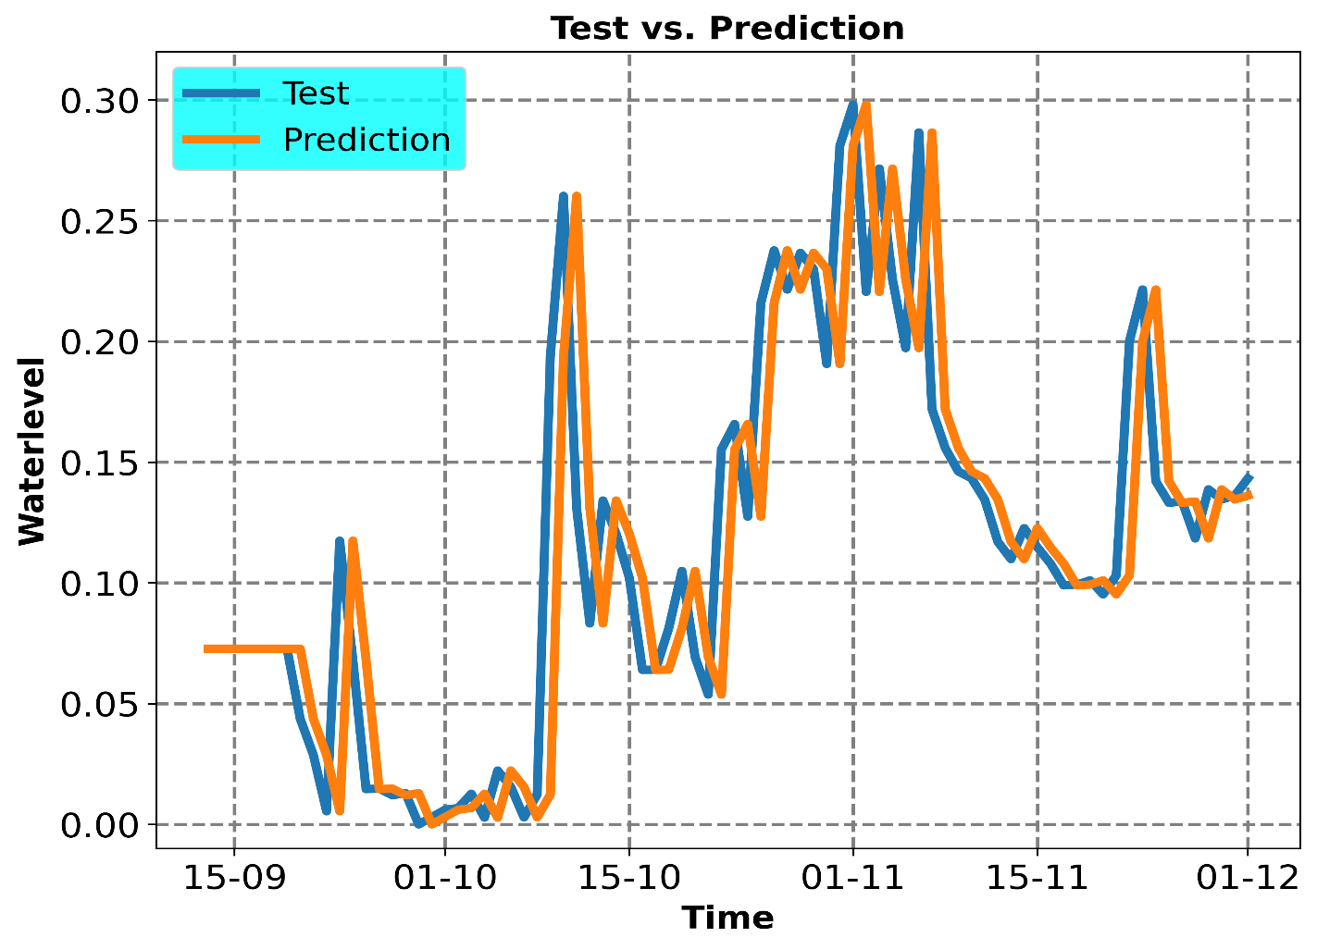

Figure 1: Prediction vs Test at (t+1)

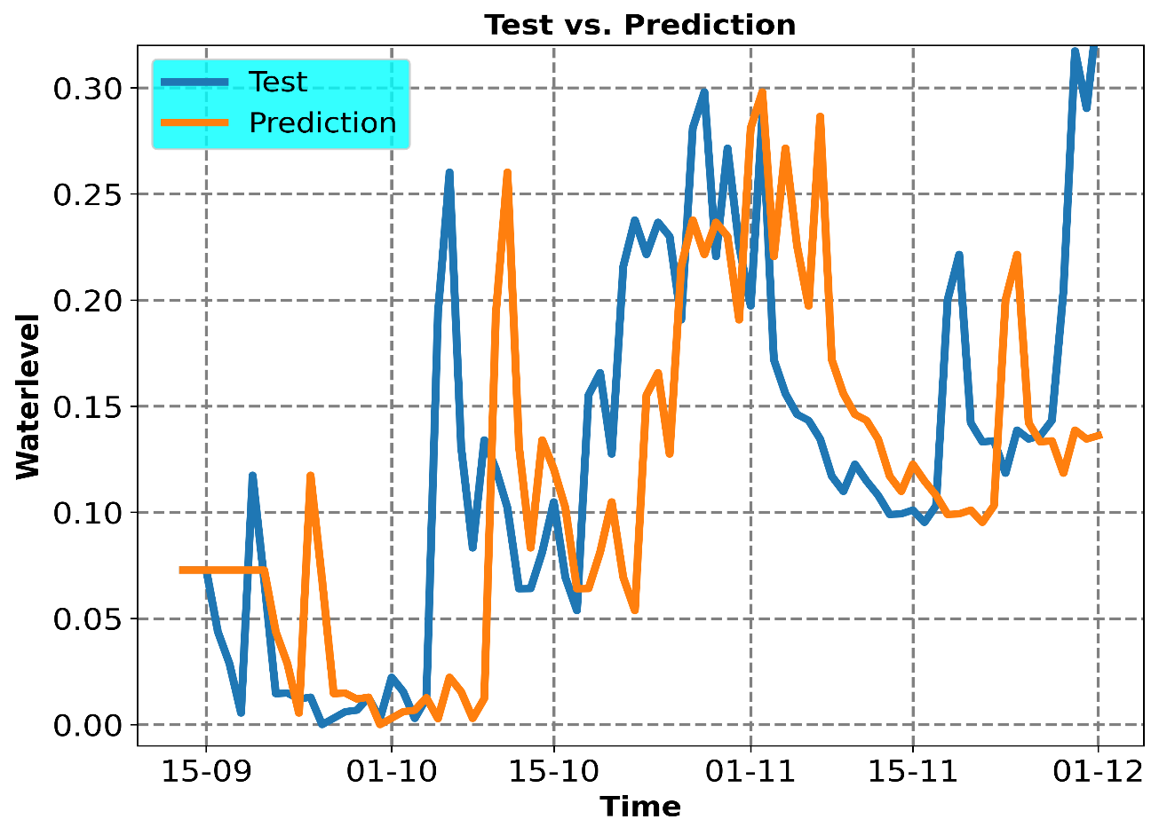

Figure 2: Prediction vs Test at (t+5)

**The Averaging baseline**

In this case the average of the optimal p is repeated across k for the baseline evaluation. The optimal p is realized by iterating over the range outlined under parameters. The threshold metric used to determine the optimality was the RMSE. K was set to 5 The optimal p was found to be 4 hence p was set to 4 during test. Table 2 shows the error result after experimentation and Figure 3 and 4 show some test-prediction comparison plots.

Table 2: RMSE across k

|  |  |
| --- | --- |
| DAY | Prediction Error (RMSE) |
| 1 | 0.0479 |
| 2 | 0.0562 |
| 3 | 0.0621 |
| 4 | 0.0692 |
| 5 | 0.0778 |
| Overall prediction error | 0.0635 |

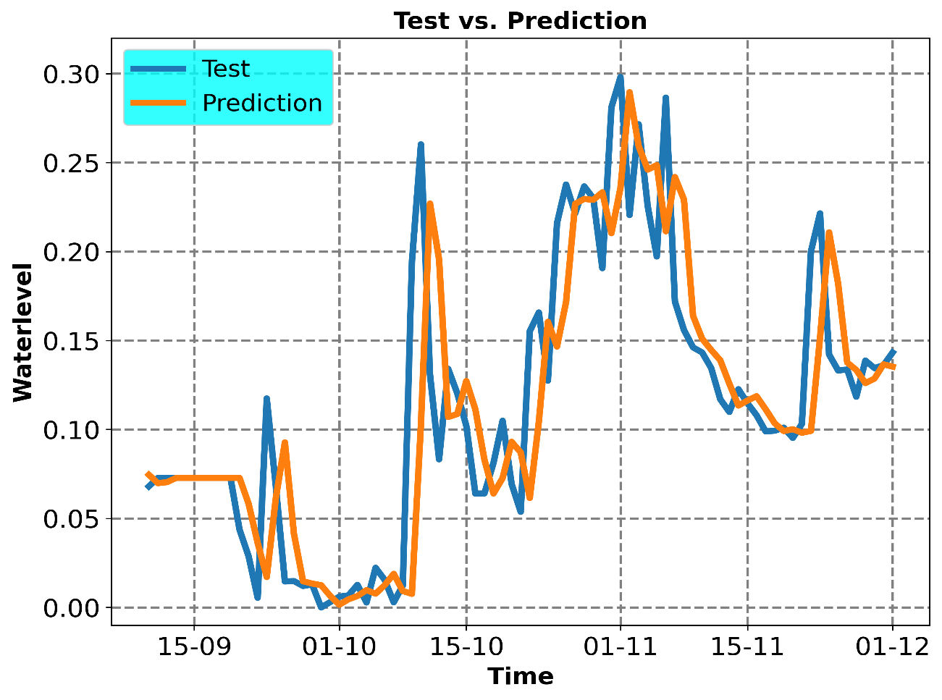

Figure 3: Prediction vs Test at (t+1)

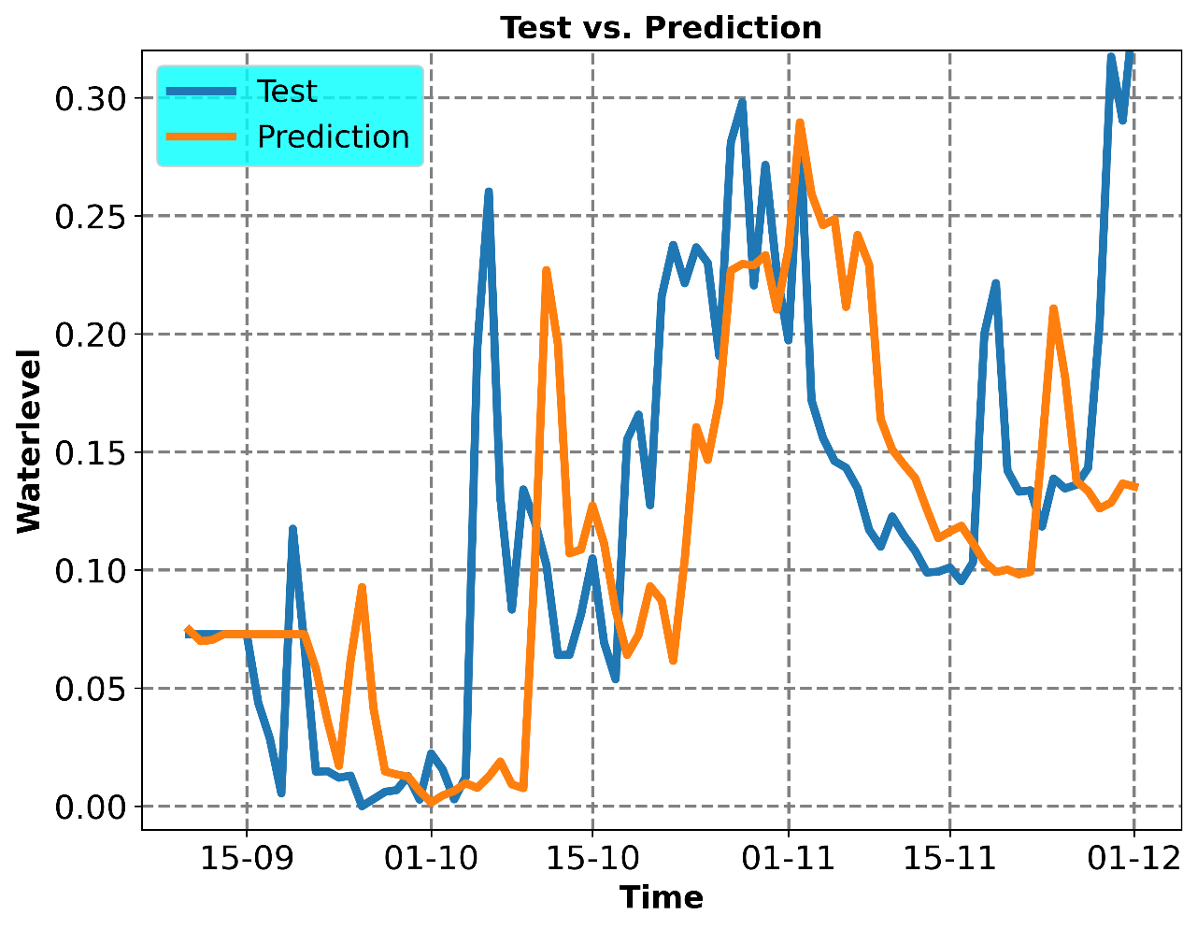

Figure 4: Prediction vs Test at (t+5)

**LSTM**

The optimum p was found to be 4.

Table 3: RMSE across k

|  |  |
| --- | --- |
| DAY | Prediction Error (RMSE) |
| 1 | **0.0465** |
| 2 | 0.0537 |
| 3 | 0.0604 |
| 4 | 0.0674 |
| 5 | 0.0741 |
| Overall prediction error | **0.0615** |

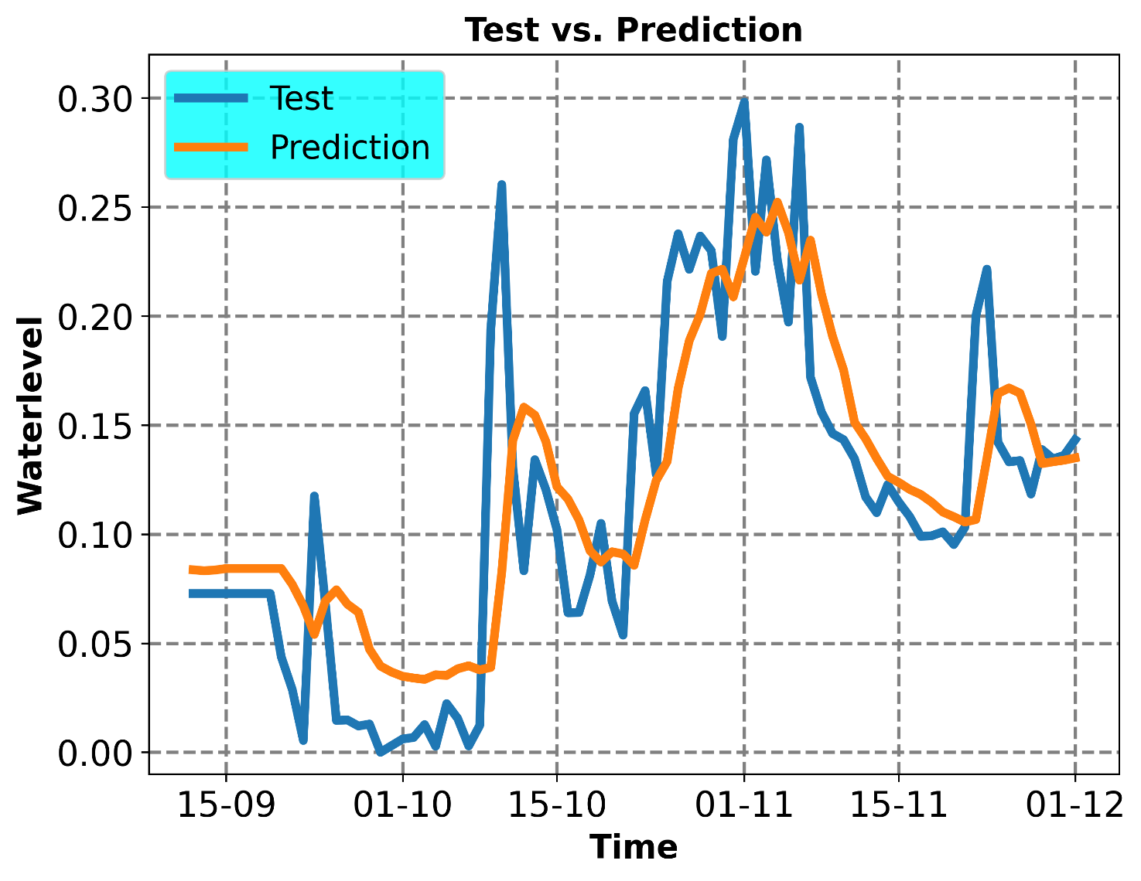

Figure 5: Prediction vs Test at (t+1)

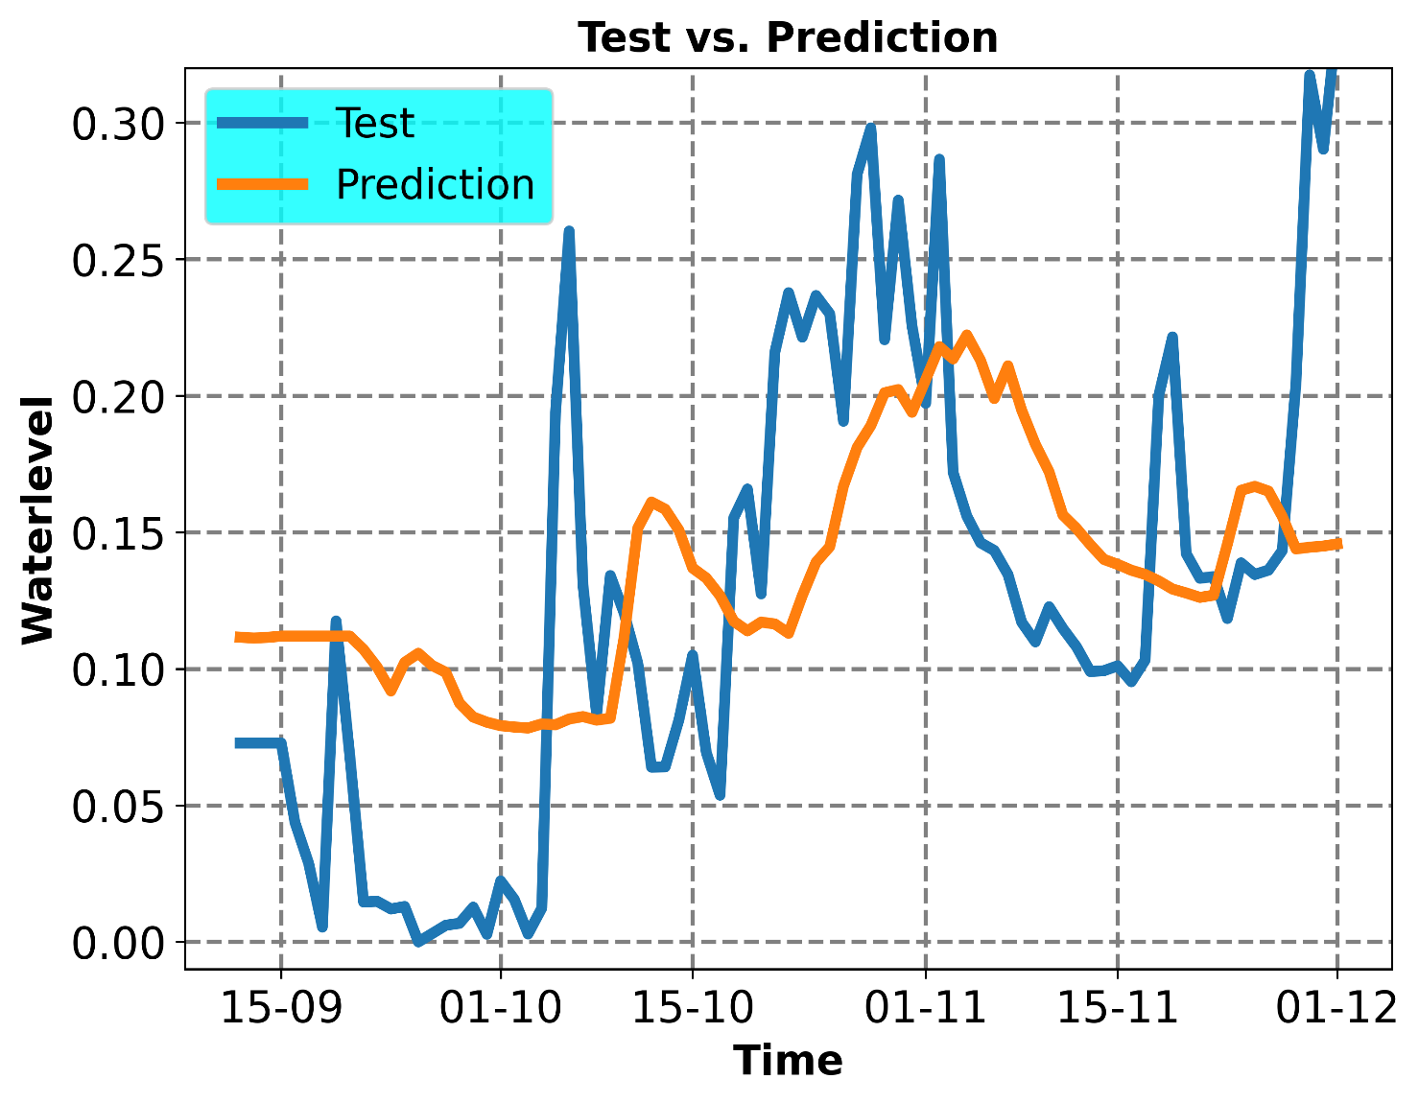

Figure 6: Prediction vs Test at (t+5)

**MLPRegressor**

The optimum p was found to be 7.

|  |  |
| --- | --- |
| DAY | Prediction Error (RMSE) |
| 1 | **0.0466** |
| 2 | 0.0571 |
| 3 | 0.0605 |
| 4 | 0.0677 |
| 5 | 0.0733 |
| Overall prediction error | **0.0627** |

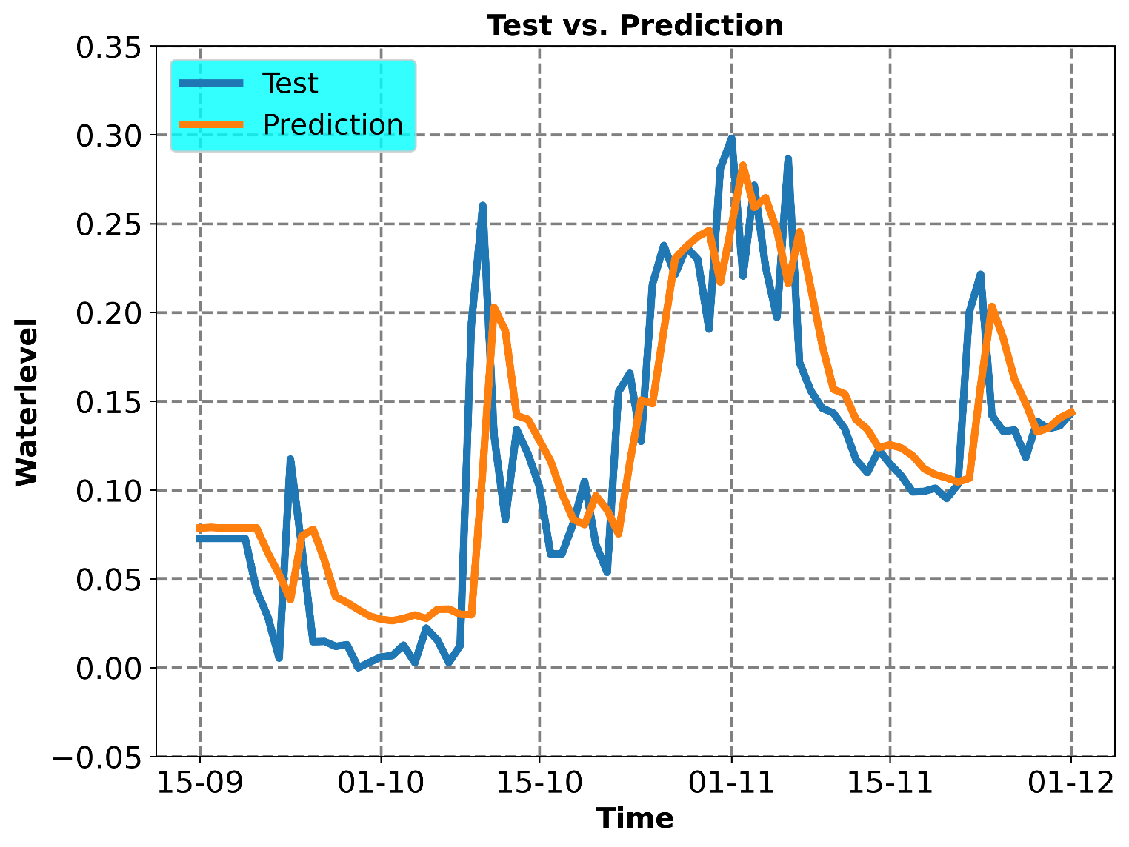

Figure 7: Prediction vs Test at (t+1)

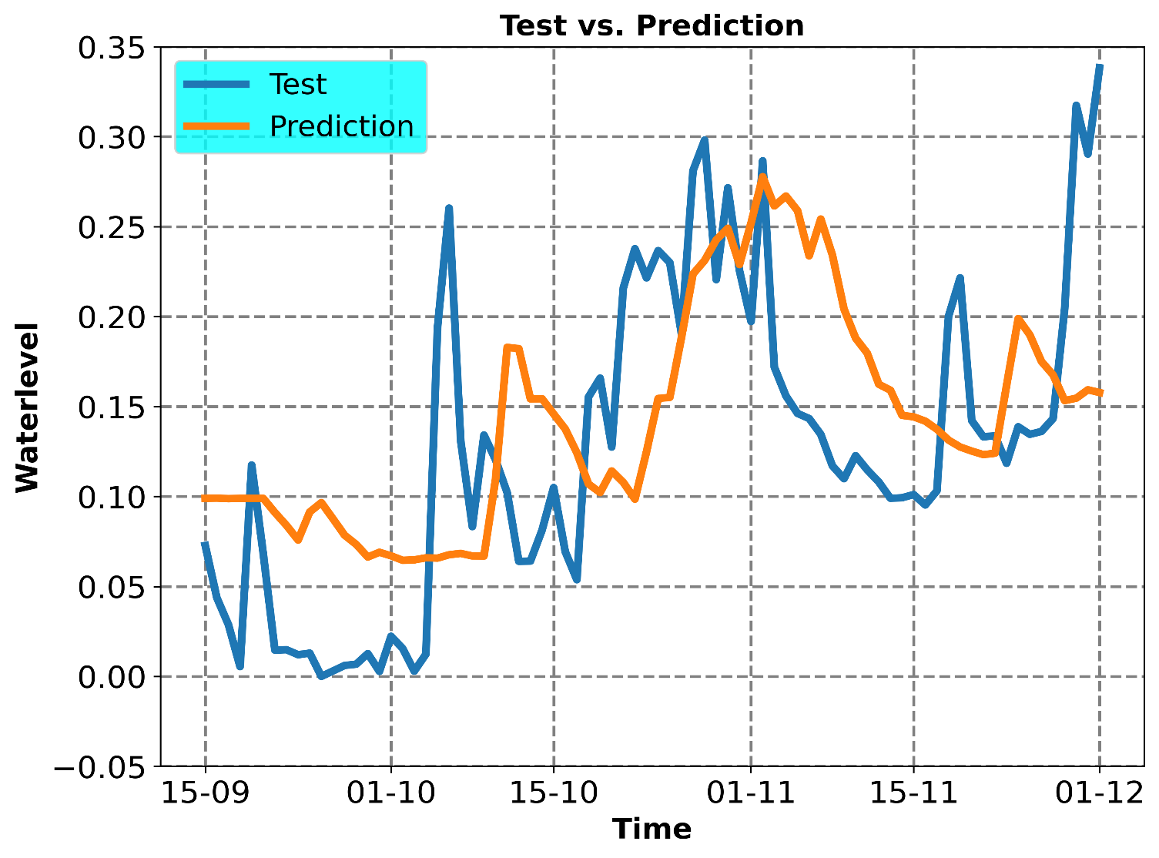

Figure 8: Prediction vs Test at (t+5)

**XGBoost Regressor**

The optimum p was found to be 4.

|  |  |
| --- | --- |
| DAY | Prediction Error (RMSE) |
| 1 | **0.0420** |
| 2 | 0.0567 |
| 3 | 0.0764 |
| 4 | 0.0877 |
| 5 | 0.0901 |
| Overall prediction error | **0.0730** |

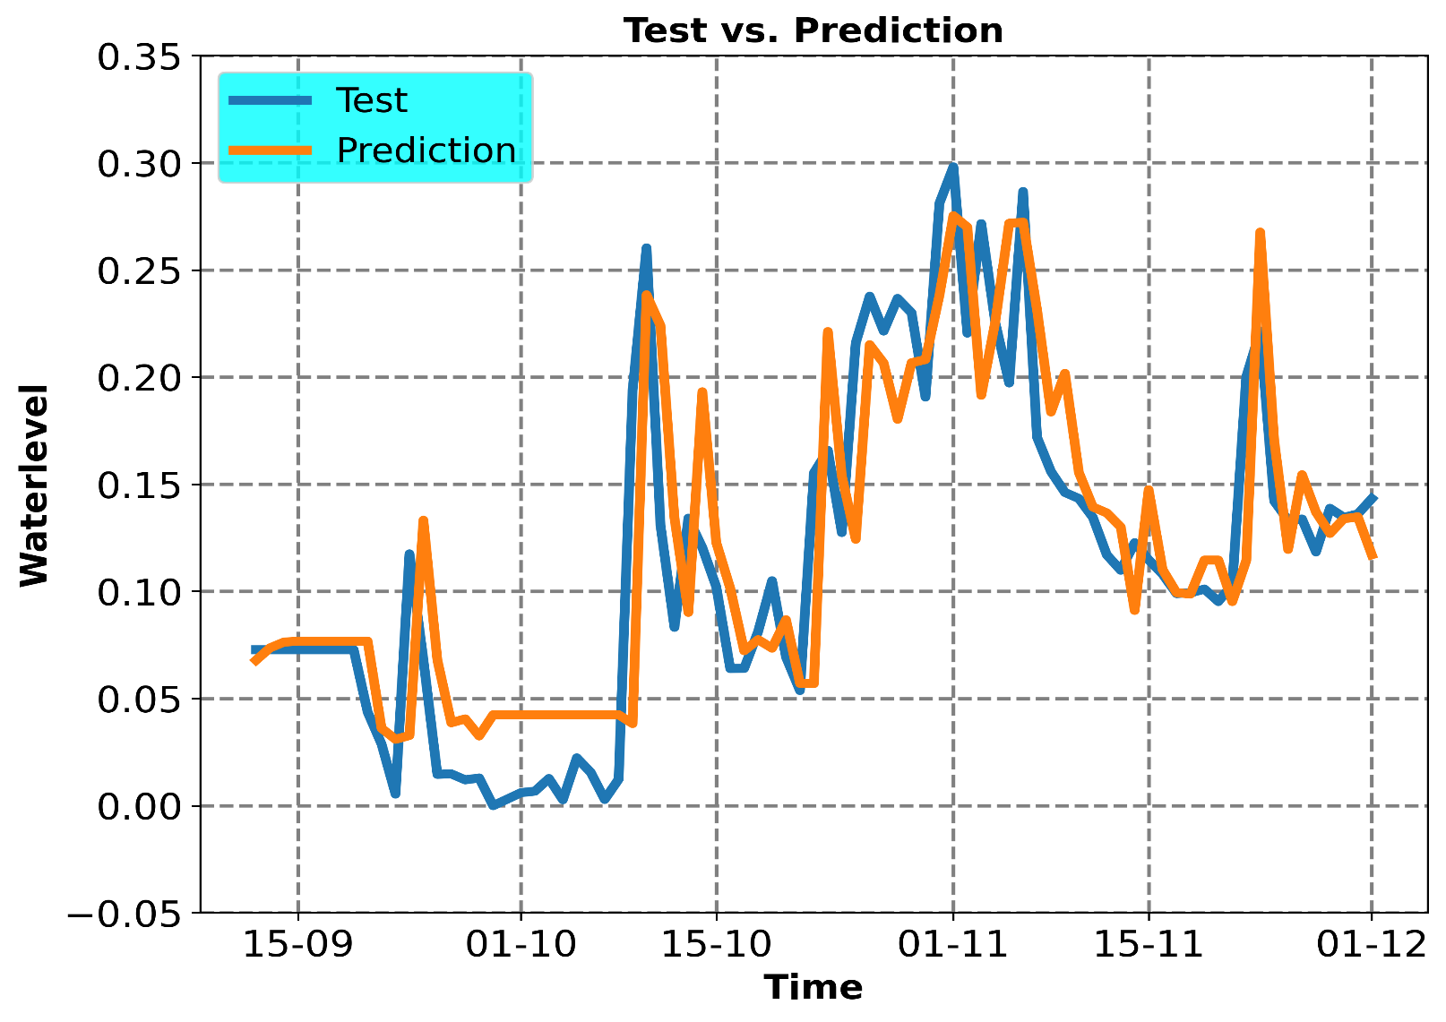

Figure 9: Prediction vs Test at (t+1)

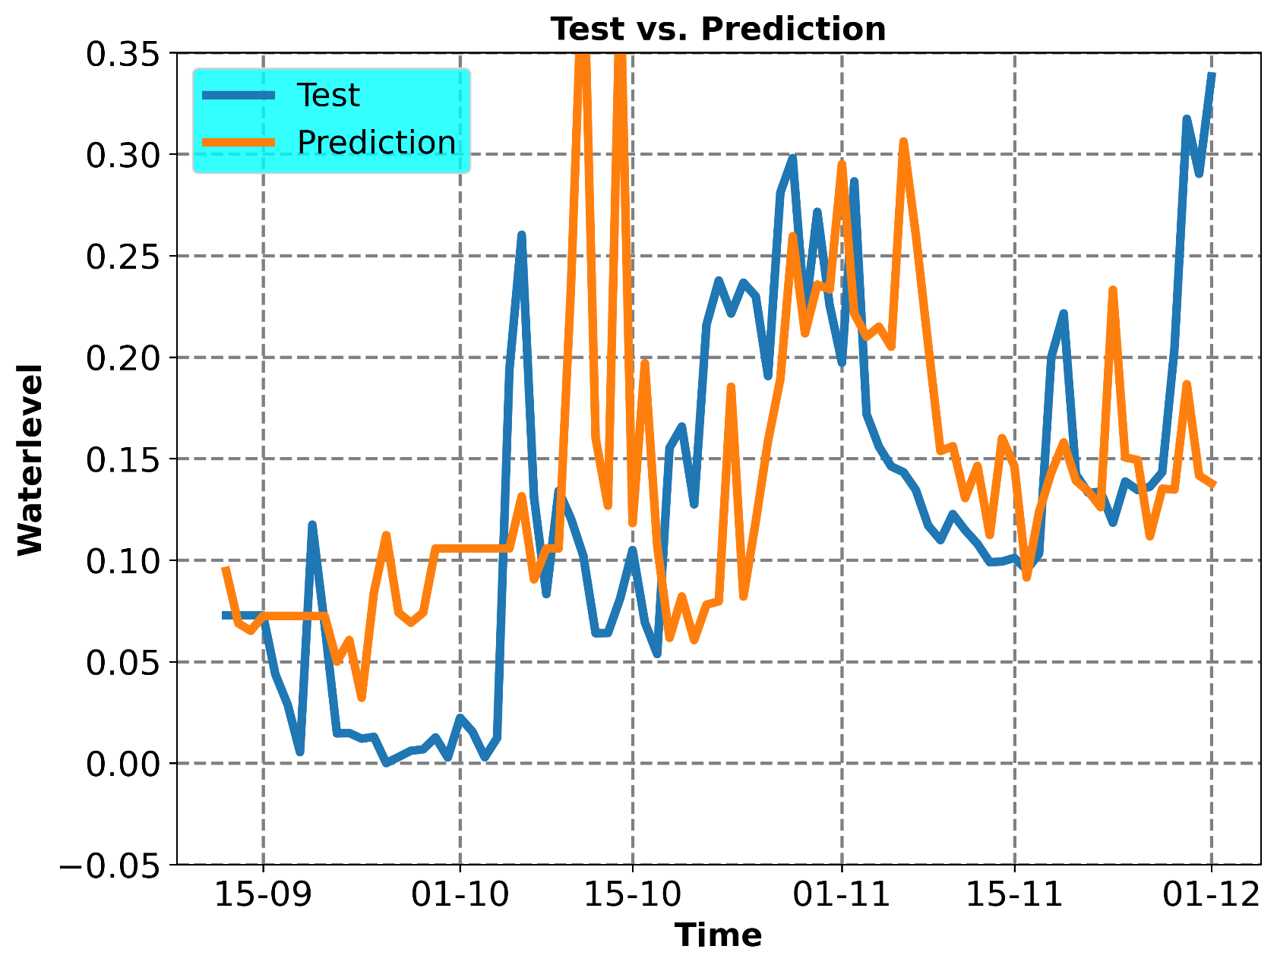

Figure 10: Prediction vs Test at (t+5)