CPELEC1 – Project Update

|  |  |  |  |
| --- | --- | --- | --- |
| Jan Carlo D. Rabacca  11106344 | Suzette Dela Cruz  11118113 | Marc Janssen Chiu  11114525 | Frank Gomendoza  11106395 |
|  |  |  |  |

# **Introduction**

Artificial Neural Networks is an approach to train a machine to accomplish tasks that sometimes we humans normally cannot do, some implementations were made to automated vehicles or even to social media nowadays wherein the machine can identify which person it is, Artificial Neural Networks is also being developed by google by training using YouTube videos wherein it has the capability of briefly describing a random picture. Neural Networks.

Artificial Neural Networks is modeled after a human’s brain, the ingenuity of neural networks is now being practical because of today’s power computers and now slowly taking over the traditional machine learning approaches [1].

# **Implementation**

For the project, Artificial Neural Networks will be implemented to train a machine to predict a student’s grade thus, the group chose to base the data from the subject ENGLRES & ENGLCOM wherein the latter is the pre-requisite subject. The inputs for the Artificial Neural Network is as follows (Refer to Figure 2):

1. CGPA
2. Pre-Requisite Subject Grades
3. Main Subject Grades
4. Timeslot

For the training data, the group utilized Google’s application of google documents wherein the group asked people to provide the necessary data for the implementation of the Artificial Neural Networks. As of date, the group managed to allot 80 correspondents where in Figure 1 is a sample of the first 20 correspondents.

The values for the ENGLCOM & ENGLRES are based from De La Salle University – Manila’s grading system where 0 incurs for a failing grade while 4 being the highest and incremental by 0.5. The CGPA is a direct value the correspondent’s CGPA, CGPA stands for Cumulative Grade Point Average, a necessary data to predict the grades of the users, and the CGPA is

incurred within the whole stay of the student in the university. Lastly, the timeslot where segregated into values of 1, 2 and 3 where 1 corresponds to a morning schedule, 2 being an afternoon schedule and 3 being an evening schedule which ranges from 6 P.M. to 9 P.M., the group determined that the schedule is a factor that might affect a student’s grade which is the reason why it was included for the necessary inputs

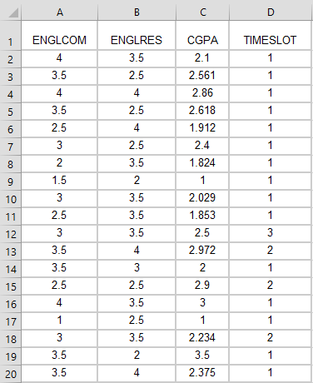

*Figure 1. Training Data*

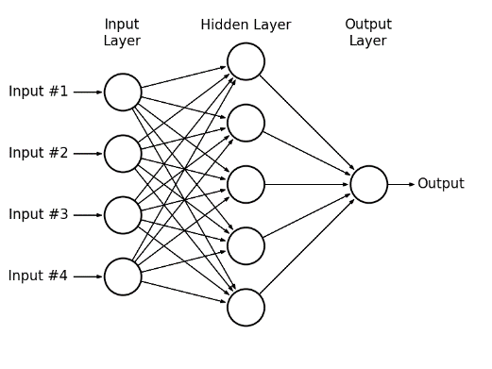

*Figure 2. Artificial Neural Network Diagram*

# **References**

[1] Coursera, 'Coursera - Free Online Courses From Top Universities', 2015. [Online]. Available: https://www.coursera.org/course/neuralnets. [Accessed: 24- Nov- 2015].a