**TERM PROJECT:**

**ARTIFICIAL NEURAL NETWORK –**

**NUMBER OF CLASSES PREDICTION**

BASALLOTE, Lawrence

CARANDO, Paolo Creas

LORENA, Neil John

ZABAT, Juan Paolo

______________________________________________

1. **INTRODUCTION**

Artificial Neural Network (ANN) is a computational tool modelled on the interconnection of neurons which exchanges information. It is used to estimate functions based on the number of sample data within a network using mathematical functions. ANN will be designed according to its application, such as data prediction through learning process.

The project will be implementing ANN to create a solution for an existing problem in the university. The problem is, sometimes, the number of classes offered during enlistment week is not enough to accommodate the students; resulting to students experiencing difficulty to apply for petition of classes.

The idea of the project is to build a network that can predict the number of sections of the succeeding courses based on the students’ grade of the pre-requisite course. By applying the artificial neural network, the machine must come up an output of the needed sections to accommodate the students.

1. **PROCEDURES**

The input data of the system are the grade of students’ in all of the sections of the pre-requisite course. Fig. 1. below is an example of the input data for the system. The first row data are the pre-defined quantity of the input data. The “150” value are the number of samples, “100” value are the number of students’ grades for all the sections of the pre-requisite course and “1” value as the output of the predicted number of classes for the succeeding course. The second row will be the input students’ grades. And the third row is the predicted output.



Fig. 1. Sample of input data

1. **RESULTS & DISCUSSION**

The group utilized “Neural Network Fitting Tool” in MATLAB. Fig. 2. presents the configured quantity for the training, validation and testing parameters. The overall samples used is 150 and 82 are allocated for training, 38 for validation and 30 for testing.

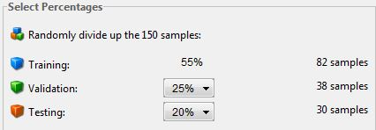

Fig. 2. Neural Network Fitting Tool

The Mean Squared Error (MSE) and similarity of the output from the sample data are shown in Fig. 3. After training the network, the group obtained a low MSE error for training. The MSE obtained for validation and testing are also close to 0 value. And for the similarity rate, the value obtained for training is close to 1.

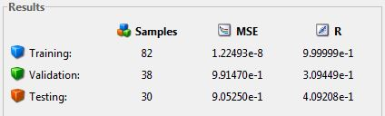

Fig. 3. Train, Validation and Test

The graph for training, validation and testing are shown in Fig. 4. Analysing the fourth plot or the all operations plot, it shows that the network was able to obtain a result comparable from the training data.

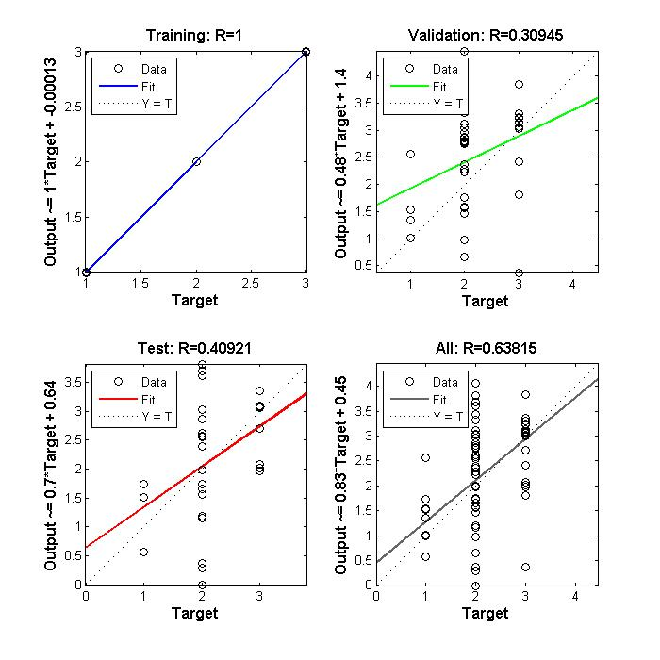

Fig. 4. Cost Function Plot

The Mean Squared Error (MSE) of the network decreases as the network increases its training iteration. It simply means that the network was able to learn and trained the sample data since it was able to reduce the MSE of the network (refer to Fig. 5 and 6).

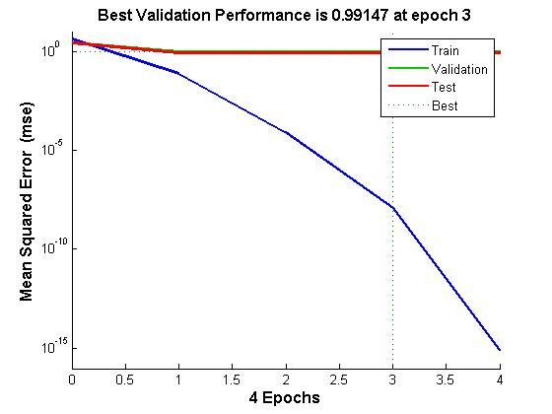

Fig. 5. Mean Squared Error (MSE)

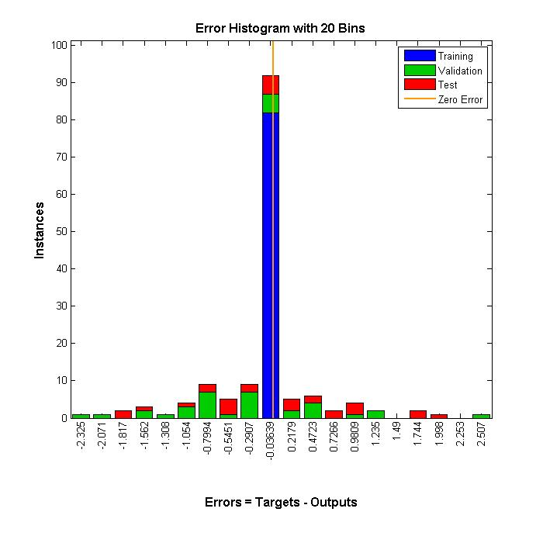

Fig. 6. Error Histogram

1. **BIBLIOGRAPHY**

[1] Doc.ic.ac.uk, 'Neural Networks', 2015. [Online]. Available: http://www.doc.ic.ac.uk/~nd/surprise_96/journal/vol4/cs11/report.html#What is a Neural Network.