Linear Regression
Ml Activity 1

Antonio, Daniel
Electronics and Communications Engineering Department
De La Salle University - Manila
Manila, Philippines

Eco, Lance Randall Lim
Electronics and Communications Engineering Department
De La Salle University – Manila
Manila, Philippines
lance_eco@dlsu.edu.ph

Tan, Sidney Sheldon Urlanda
Electronics and Communications Engineering Department
De La Salle University - Manila
Manila, Philippines
sidney_tan@dlsu.edu.ph

Zarzoso, Aaron John Pascua
Electronics and Communications Engineering Department
De La Salle University - Manila
Manila, Philippines
aaron_zarzoso@dlsu.edu.ph

Abstract—This document represent the student’s lab report for experiment 1 of the course LBYCP29.
Keywords—octave; matlab;coding;linux;operations;plots

Introduction
Matlab is a high level language created by MathWorks and is well-known as a computational software for various arithmetic operations as well as image processing, communications, control systems, and others [1]. Matlab is also a pay to use software which is why students are opt to use the free alternative “Octave”. Octave has a similar purpose and is cross compatible with Matlab [2]. This experiment deals with simulating linear regression through the software “octave” for the linux operating system environment. Linear regression is a technique that attempts to model the relationship between two variables by creating a linear equation to perceive data. One variable is considered as expository denoted as x, and the other variable is considered as dependent variable y [3].

Instructions/procedure

Procedure 1
Implement gradient descent using a learning rate of α = 0.07. Since Matlab/Octave and Octave index vectors starting from 1 rather than 0, you’ll probably use theta(1) and theta(2) in Matlab/Octave to represent θ₀ and θ_{1.}
Initialize the parameters to θ = 0 (i.e., θ₀ = θ₁ = 0), and run one iteration of gradient descent from this initial starting point. Record the value of θ₀ and θ₁ that you get after this first iteration. (To verify that your implementation is correct, later we’ll ask you to check your values of θ₀ and θ₁ against ours.)

Procedure 2
Continue running gradient descent for more iterations until θ converges. (this will take a total of about 1500 iterations). After convergence, record the final values of θ₀ and θ₁ that you get.
When you have found θ, plot the straight line fit from your algorithm on the same graph as your training data. The plotting commands will look something like this:
Hold on % Plot new data without clearing old plot
plot(x(:,2), x*theta, ‘-’) % remember that x is now a matrix with 2 columns
% and the second column contains the time info
legend(‘Training data’, ‘Linear regression’)
Note that for most machine learning problems, x is very high dimensional, so we don’t be able to plot h_{θ}(x). But since in this example we have only one feature, being able to plot this gives a nice sanity-check on our result.

Procedure 3
Finally, we’d like to make some predictions using the learned hypothesis. Use your model to predict the height for a two boys of age 3.5 and age 7.
Debugging If you are using Matlab/Octave and seeing many errors at runtime, try inspecting your matrix operations to check that you are multiplying and adding matrices in ways that their dimensions would allow. Remember that Matlab/Octave by default interprets an operation as a matrix operation. In cases where you don’t intend to use the matrix definition of an operator but you expression is ambiguous to Matlab/Octave, you will have to use the ‘dot’ operator to specify your command. Additionally, you can try printing x,y, and theta to make sure their dimensions are correct.

Data and results

1st Procedure

First Iteration:
Θ₁ = 0.0745
Θ₂ = 0.3800

1500th Iteration:
Θ₁ = 0.7502
Θ₂= 0.0639

2nd Procedure

Plot:
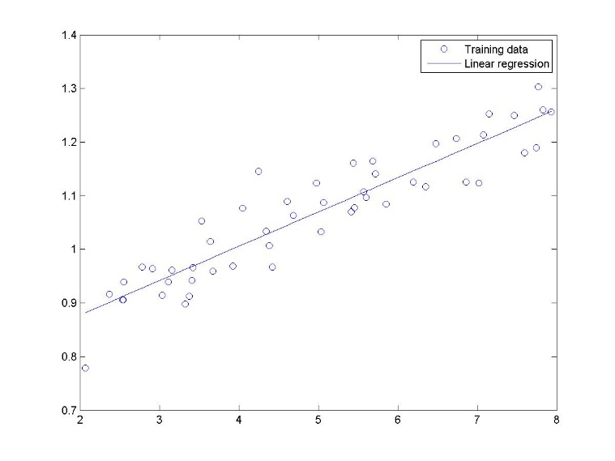

3rd Procedure
Age: 3.5 Height: 0.9739
Age: 7 Height: 1.1973

3D Plot
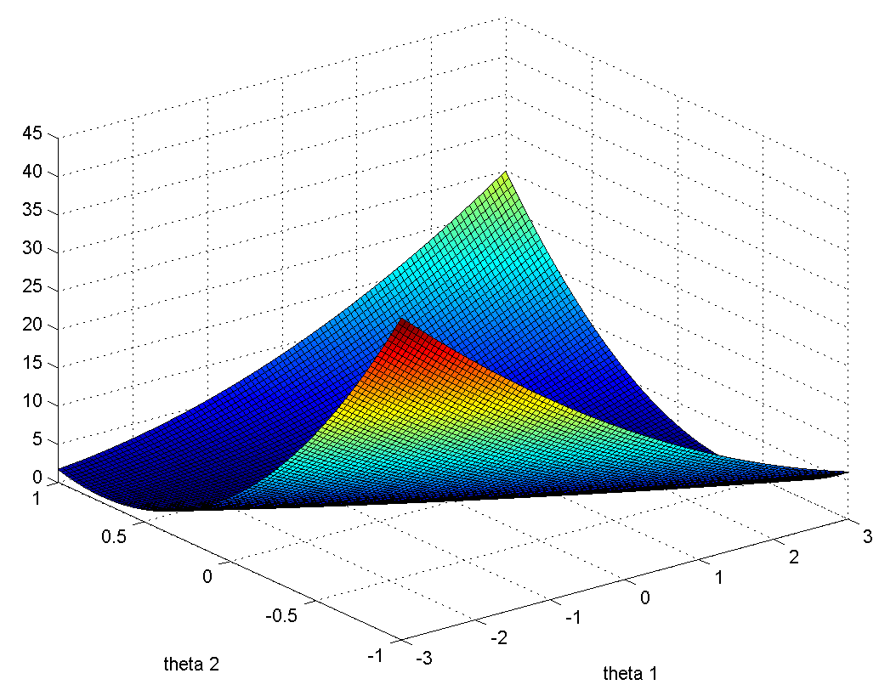

Question
What is the relationship between this 3D surface and the value of θ₀ and θ₁ that your implementation of gradient descent had found?
The relationship between this 3D surface and the value of the two theta is to show the graphic representation of the predicted height of the boys.

Height of 50 male people with age 10-20
AGE | HEIGHT(in) | AGE | HEIGHT(in)
10 | 56.7 | 16 | 69.1
11 | 57.2 | 16 | 66.4
11 | 55.9 | 16 | 66.4
11 | 59.1 | 16 | 68.1
11 | 59.1 | 16 | 65.7
12 | 57.9 | 16 | 69.8
12 | 56.3 | 17 | 68.3
12 | 50.3 | 17 | 70.2
12 | 52.1 | 17 | 67.7
13 | 59.8 | 17 | 65.4
13 | 63.7 | 17 | 69.9
13 | 64.5 | 18 | 69.9
14 | 63.2 | 18 | 68.9
14 | 57.4 | 18 | 68.1
14 | 65.7 | 18 | 72.3
14 | 65.5 | 18 | 69.8
14 | 50.1 | 19 | 69.7
14 | 67.2 | 19 | 71.1
14 | 66.7 | 19 | 73.2
14 | 65.1 | 19 | 72.4
15 | 70.3 | 20 | 72.7
15 | 66.0 | 20 | 69.1
15 | 64.2 | 20 | 70.8
15 | 68.2 | 20 | 70.3
16 | 67.1 | 20 | 74.1

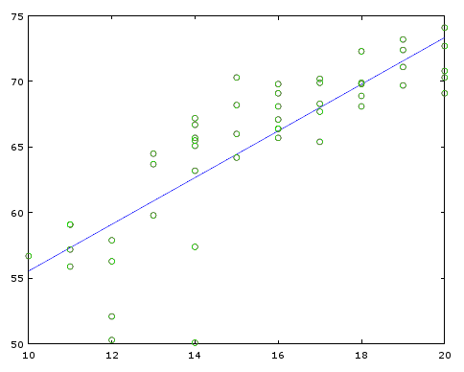

1st Procedure

First Iteration:
Θ₁ = 4.5762
Θ₂ = 71.996

1500th Iteration:
Θ₁ = 37.7697
Θ₂= 1.7786

Age: 12 Height: 57.9200
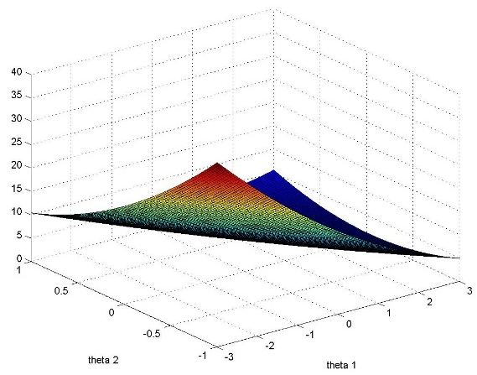
Age: 18 Height: 68.9100
Plot:

analysis and CONCLUSION
In this experiment, the students learned how to use and install the octave software in linux. In comparison with the use of Matlab for windows vs Octave on linux, the group agreed that it was more challenging to use octave than the user friendly Matlab in which the group is accustomed to. Simulating the linear regression was also hard to implement as students were not familiar with it. Overall, the tasks provided meaningful insights and experience for the students to use in their future careers.

References

- MathWorks. (N.A.). MATLAB - The Language of Technical Computing. [Online]. Available: http://www.mathworks.com/
products/matlab/
- Eaton, J. (N.A.). About GNU Octave. [Online]. Available: https://www.gnu.org/software/octave/about.html
- Y. Personnel, "Yale Education," Yale University,[Online].Available: http://www.stat.yale.edu/Courses/1997-98/101/linreg.htm

