Logistic Regression and Newton's Method
Laboratory Exercise 3

Antonio, Daniel
Electronics and Communications Engineering Department
De La Salle University - Manila
Manila, Philippines

Eco, Lance Randall Lim
Electronics and Communications Engineering Department
De La Salle University – Manila
Manila, Philippines
lance_eco@dlsu.edu.ph

Tan, Sidney Sheldon Urlanda
Electronics and Communications Engineering Department
De La Salle University - Manila
Manila, Philippines
sidney_tan@dlsu.edu.ph

Zarzoso, Aaron John Pascua
Electronics and Communications Engineering Department
De La Salle University - Manila
Manila, Philippines
aaron_zarzoso@dlsu.edu.ph

Abstract—This document represent the student’s lab report for experiment 2 of the course LBYCP29. It contains the procedures done in the implementation of logistic regression which is basically a classification rather than an estimation as compared with linear regression. It also contains the provision of own generated data since the procedures have provided its default data. The data that is generated by the students also underwent the same process of the implementation of logistic regression and as such the results are included as well.
Keywords—octave; matlab; logistic regression; Newton's method;

Introduction
The main software that is used in this particular experiment is octave. Octave is basically a programming software that is based on the manipulation and control of matrices in order to interpret data. This software deals with matrices in order to organize a specific given data such as college admission chances based on students scores on to exams which is the main problem of the experiment. Other interpretations of data is the identification of wheter an email is a spam or non-spam. Another interpretation of data is whether or not a transaction on a specific website is fraudulent or not. Also, we can say that the classification of whether or not a certain tumor is malignant or benign, All of these interpretations of data are possible in octave through logistic regression since all of them is nothing more than a classification which is what logistic regression is all about. Meanwhile, since all of the decisions with regard to this classifications are just simply a true or false, we can say that what we are trying to do is that we are predicting a certain variable say ‘y’ which either has a value of 0 or 1. There are also instances where y can have more than one value so basically it can be both. These two classes, as what they are called, is either a positive class or a negative class depending on what the programmer has assigned. For example, we can say that 0 means that the mail not a spam while 1 is that it is a spam. We can also assign that 0 means that a transaction is not fraudulent while 1 is that it is fraudulent. Finally, we can also assign that 0 means that a certain tumor is malignant while when it is 1 then the tumor is benign and therefore should be taken very seriously. In these particular set of cases, 0 is known to be the negative class since its premises are preceeded by a not. Notice not spam and not fraudulent are both 0. Meanwhile for the third case we can say that 0 is a negative class since it implies not benign and therefore malignant whichever case it is still negative. Consequently 1 is known to be the positive class.
In this particular experiment, the students implemented the application of logistic regression by utilizing Newton’s Method and classifying the chances of college admission based on the students scores on two exams. So basically this is definitely a case of logistic regression since it is a classification of whether or not a student is to be admitted to the college or not. So analyzing this case, we can say that the positive class which we will denote as 1 is that the student will be admitted to the college while the negative class which we will denote as 0 is that the student will not be admitted to the college.

Instructions/procedure

Procedure 3.1
- Plot the data.
- Load the data for the training examples into your program and add the x_0 = 1 intercept term into your x matrix.
- Before beginning Newton's Method, we will first plot the data using different symbols to represent the two classes. In Matlab/Octave, you can separate the positive class and the negative class using the find command.

Procedure 3.2
- Plot the Cost function J(θ).
- The cost function J(θ) is defined as

Procedure 3.3
Answer the ff. questions:
1. θ = _______________
2. The How many iterations were required for convergence? ________________
3. What is the probability that a student with a score of 20 on Exam 1 and a score of 80 on Exam 2 will not be admitted? ________________

Data and results

Procedure 2.0
- (a)
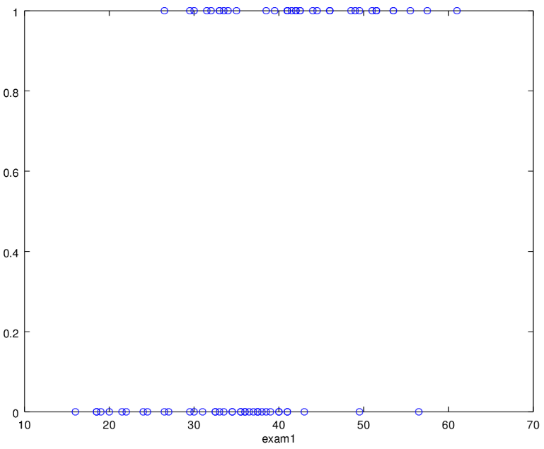
Fig. 1. Plot of the Raw data for exam1
(b)
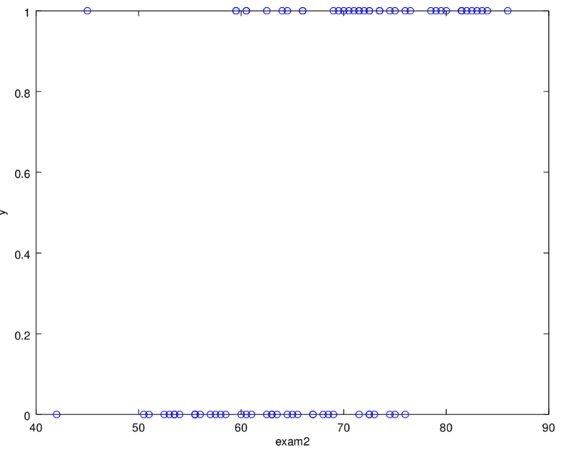
Fig. 2. Plot of the Raw Data for Exam2
- (a)
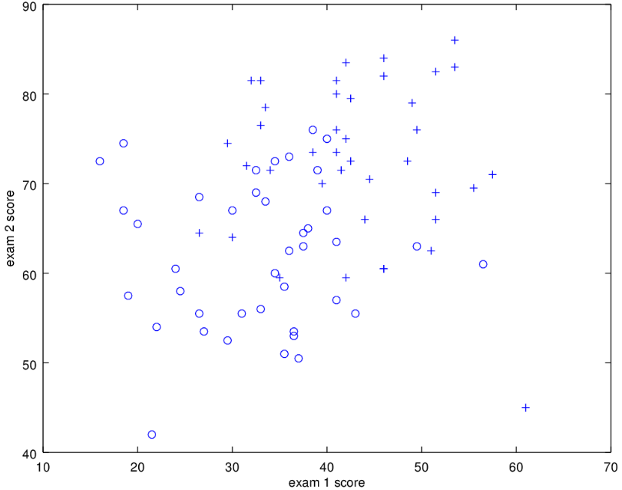
Fig. 3. Data Plot of the admitted and not admitted students based on their scores for exam 1 and exam 2.
(b)
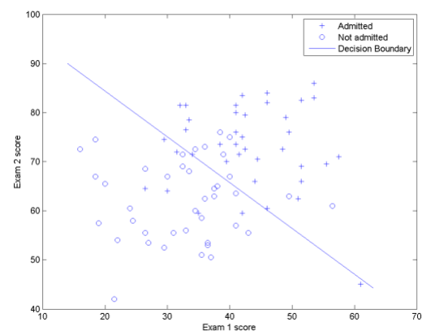
Fig. 4. Data Plot of the admitted and not admitted students based on their scores for exam 1 and exam 2 with a decision boundary.

Procedure 2.1
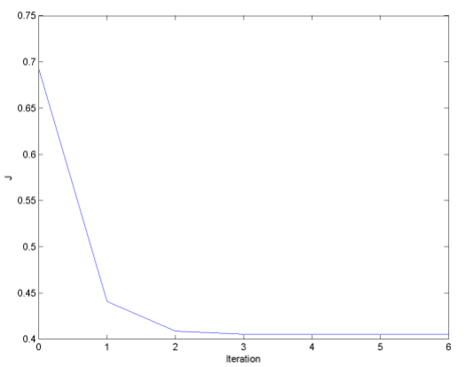
Fig. 5. Iteration vs J plot.

Codes
x = load('ml3x.dat');
y = load('ml3y.dat');
plot(x(:,1),y,'o');
xlabel('Exam 1')
ylabel('y')
print('plot1','-dpng');
plot(x(:,2),y,'o');
xlabel('Exam 2')
ylabel('y')
print('plot2','-dpng');
m = 80;
x = [ones(80,1),x];

% pos and neg
pos = find(y == 1);
neg = find(y == 0);
plot(x(pos,2), x(pos,3), '+');
hold on
plot(x(neg,2), x(neg,3), 'o');
xlabel('Exam 1 score')
ylabel('Exam 2 score')
print('plot3','-dpng');

%cost j
theta = zeros(size(x(1,:)))';
max = 7;
j = zeros(max,1);
for num = 1:max
z = x * theta;
g = 1.0 ./ (1.0 + exp(-z));
gradient = (1/m).*x'*(g-y);
H = (1/m).*x'*diag(g)*diag(1-g)*x;
j(num) = (1/m)*sum(-y.*log(g) - (1-y).*log(1-g));
theta = theta - H\ gradient;
end

% boundary line
plot_x = [ min(x(:,2)) - 2, max(x(:,2)) + 2 ];
plot_y = (-1./theta(3)).*(theta(2).* plot_x + theta(1));
plot(plot_x, plot_y)
legend('Admitted', 'Not admitted', 'Decision Boundary')
hold off
print('plot4', '-dpng');

%plot J
figure
plot(0:max-1, j, '-');
xlabel('Iteration'); ylabel('J')
print('plot5', '-dpng');

%probability
z = [1 20 80] * theta;
g = 1.0 ./ (1.0 + exp(-z));
prob = 1 - g;

Procedure 3.3
- The final values of θ = ____
𝜃 = [-16.378743410288784; 0.148340773724886; 0.158908451793460]

- How many iterations were required for convergence?
At least 3 iterations.

3. What is the probability that a student with a score of 20 on Exam 1 and a score of 80 on Exam 2 will not be admitted?
z = [1 20 80] * theta;
g = 1.0 ./ (1.0 + exp(-z));
prob = 1 - g;
prob = Probability = 0.6680

Own Data
Height and Weight of 50 people that want to enter a theme park ride, those below height 69 inches and weight 59 kilos are not suitable to enter.
HEIGHT(in) | WEIGHT | HEIGHT(in) | WEIGHT
56.7 | 35.3 | 69.1 | 59.9
57.2 | 30.9 | 66.4 | 70.2
55.9 | 35.5 | 66.4 | 71.1
59.1 | 36.1 | 68.1 | 80.0
59.1 | 32.6 | 65.7 | 69.7
57.9 | 33.5 | 69.8 | 68.8
56.3 | 40.7 | 68.3 | 73.5
50.3 | 36.3 | 70.2 | 76.6
52.1 | 34.2 | 67.7 | 59.9
59.8 | 33.2 | 65.4 | 60.5
63.7 | 40.1 | 69.9 | 66.3
64.5 | 42.3 | 69.9 | 72.6
63.2 | 44.1 | 68.9 | 82.3
57.4 | 41.1 | 68.1 | 78.3
65.7 | 46.1 | 72.3 | 78.3
65.5 | 50.4 | 69.8 | 79.5
50.1 | 51.6 | 69.7 | 69.9
67.2 | 49.5 | 71.1 | 68.9
66.7 | 50.6 | 73.2 | 69.9
65.1 | 61.7 | 72.4 | 79.9
70.3 | 49.5 | 72.7 | 88.3
66.0 | 51.7 | 69.1 | 78.9
64.2 | 69.9 | 70.8 | 68.5
68.2 | 68.7 | 70.3 | 90.5
67.1 | 56.5 | 74.1 | 90.6

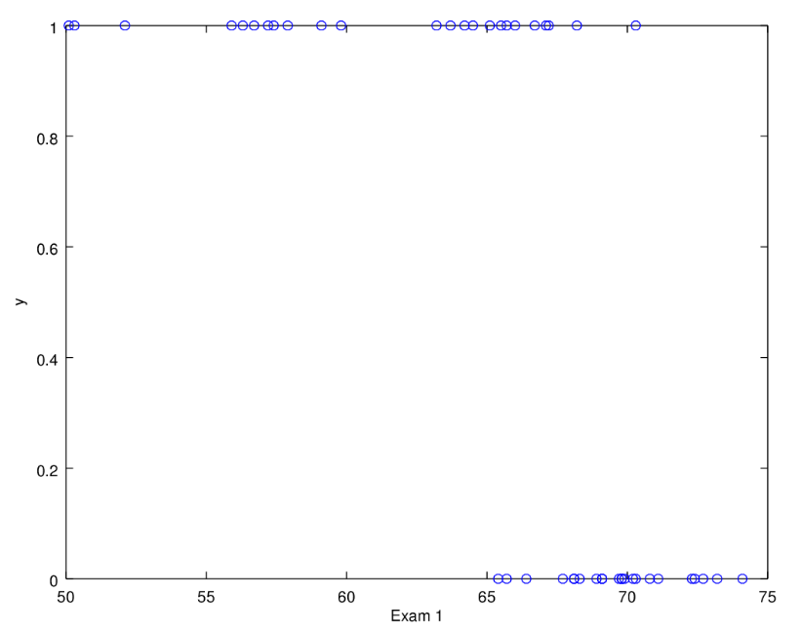
Fig. 6. Plot of the Raw data for height
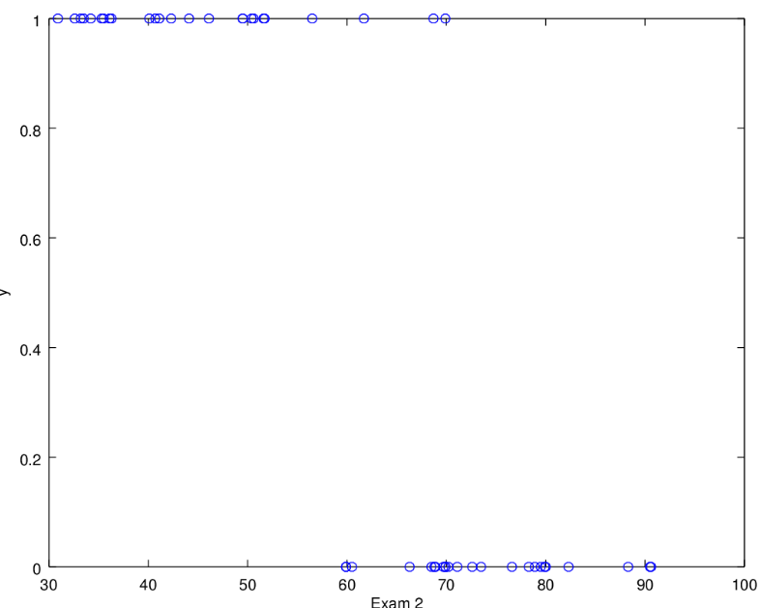
Fig. 7. Plot of the Raw Data for weight
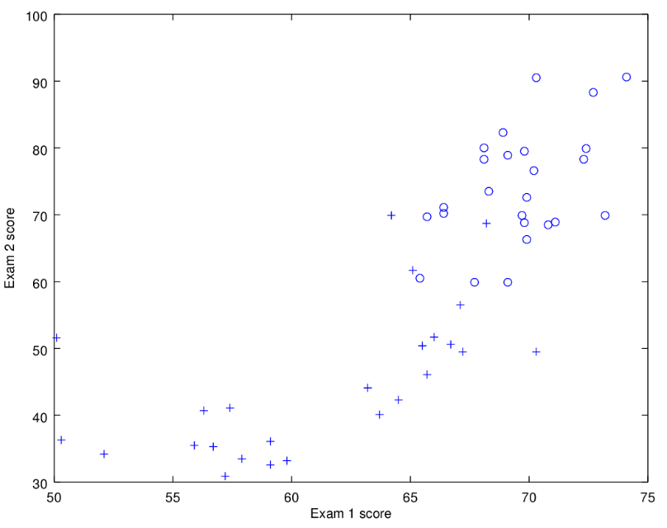

Fig. 8. Data Plot of the admitted and not admitted people based on their height and weight.
Fig. 5. Iteration vs J plot.

- The final values of θ = ____
55.18365
-0.60183
-0.24012

- How many iterations were required for convergence?
At least 3 iterations.

analysis and conclusion
In this experiment, the students was able to make use of the octave software in order to implement and analyze logistic regression models. This is in order for the students to differentiate how logistic regression is apart from linear regression. Just a quick recap, for purposes of comparison towards the current experiment which is logistic regression, linear regression from the first two experiments, the second one being a enhanced version of the first which is known to be as multivariate linear regression, is simply done by the formulation of graphs through the provision of two variables which is x and y. For multivariate linear regression, the students predicted the value of one or more responses from multiple predictors and thus it is called as multivariate. So as we can see, linear regression is nothing more than an estimation or an approximation of how much certain data deviate from the line that passes 0 which is the linear regression model. Meanwhile, in comparison with logistic regression, it is no longer that way. Logistic regression is not anymore as simple as an approximation of data since as what have been pointed out several times before, logistic regression is a classification of data rather than a approximation or estimation. On the other hand, the students also used Newton’s Method in this particular experiment. This method is utilized simply in order to minimize the cost function. So given a cost function since we are dealing with an optimization problem, to be specific we are dealing with how to minimize the cost in this particular experiment. So in order to make that possible we should apply the techniques of differentiation since it is through this process are we able to find the minimal cost. So we find the derivative of J(θ) and then set it equal to 0. Essentially what we are doing here is that we are finding the value of θ such that if we take the derivative of the cost function, it will be equal to zero. And that is how Newton’s method is applied in this particular experiment. Lastly, to summarize the essential aspects of this experiment; logistic regression, unlike linear regression which estimates data, is a classification of data. In logistic regression we predict a certain variable which either has one or two values. These are known to be the two classes which are either positive or negative denoted by 1 or 0 respectively. Note that it can be the either way around it would only depend on the assignment done by the programmer. Newton’s method is done in order to minimize the cost function. This is done through differentiation. We find the value of θ and then the cost function should equal zero.

References

- MathWorks. (N.A.). MATLAB - The Language of Technical Computing. [Online]. Available: http://www.mathworks.com/
products/matlab/
- Eaton, J. (N.A.). About GNU Octave. [Online]. Available: https://www.gnu.org/software/octave/about.html
- DLSU. (N.D.). Laboratory Exercise 3: Logistic Regression and Newton's Method. [File] Available: MLActivity3.pdf
- Andrew Ng. Stanford University, CS 229. Machine LearningCourse Materials. [Online]. Available: http://cs229.stanford.edu/materials
.html

