Multi-class Classification and Neural Networks
Lab Report #7

Sharrena Mae B. Camus (11227427)  shane_camus@yahoo.com | John Elijah B. Santos (11224436)  jebssantos@gmail.com
Angelica Grace D. Terrado(11235322)
angelica_terrado@dlsu.edu.ph

- ABSTRACT
Although there are many problems that have binary outcomes, it is even more apparent in reality the problems that have multiple outcomes. Cancer stages, sexuality, and voltage. A lot of times, it would be more convenient to use One vs. All Logistic Regression when dealing with situations that have several outcomes; this will be implemented in this experiment by classifying images of seemingly handwritten numbers with the help of Neural Networks.

- INTRODUCTION
As performed in the previous laboratory experiments, Logistic Regression is a method that is utilized when the classification of data is the goal given a set of data. Situations in which only two possible outcomes can be considered such as sick or not sick, male or female, night or day, Binary Logistic Regression is used. In reality though, most situations involve outcomes that are not limited to just two, but more such as levels of a certain disease, the weather, or certain times of day like morning, noon, afternoon, night, etc. Although it would be more convenient for a machine to process data that is limited to binary outcomes, majority real world dilemmas aren’t. This is where the Multiclass Logistic Regression comes in, also known as One vs. All Logistic Regression.

Multiclass Logistic Regression takes more possible outcomes into consideration by implementing more variables in the Regression algorithm. Its goal is still to classify the data but this time, in more than solely two classes. This kind of regression works very similar to Binary Logistic Regressions, works differently by simply taking one class at a time and considering everything else but the selected class as parts the negative class; this is done for all of the classes. The machine is then programmed to select the best fitting regression line depending on the query; each class has a corresponding regression line.

Although the decision line is based on the regression, Neural Networking can be utilized in order to emulate the thought process of the brain on a machine to enable the machine to arrive at a decision. This is a learning process that is done by connecting certain elements in the algorithm in order to solve a problem

- OBJECTIVES
- To be able to classify images of digits using logistic regression with high accuracy for both the training and testing sets
- To implement multiclass logistic regression in MatLab/Octave
- To incorporate Neural Networks

- DATA AND RESULTS

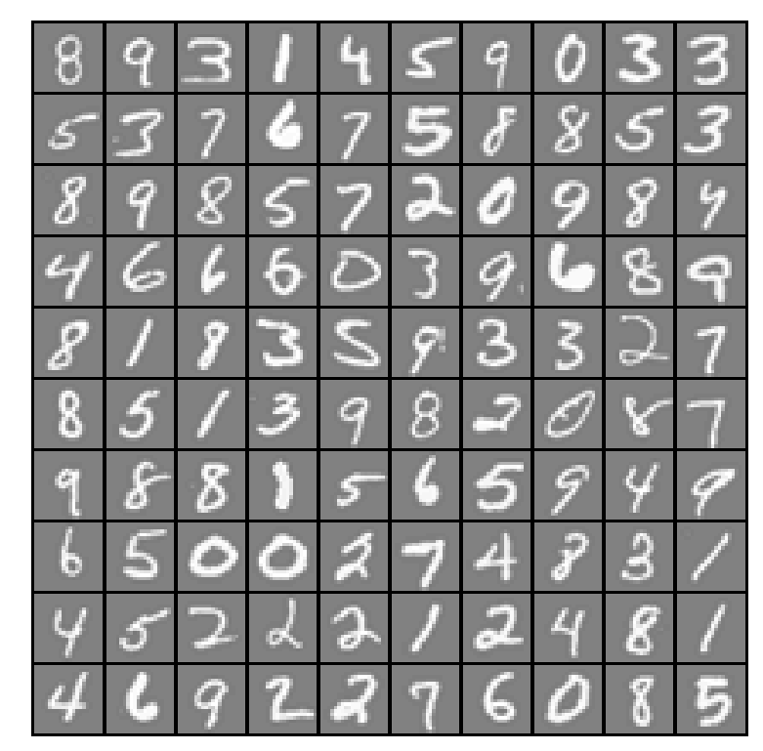
Fig.1. Example of dataset

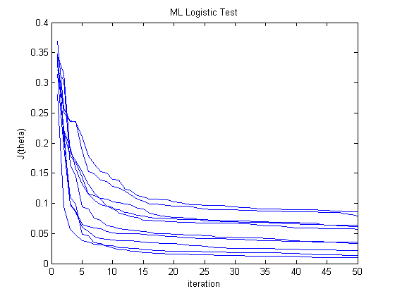
Fig. 2 Logistic Test per iteration

The training set accuracy for predicting the One vs. All Classification

The training set accuracy for the neural network

- ANALYSIS AND CONCLUSION
Based on the results attained from this experiment, it has been observed by the group that the accuracy of the program did not reach 100%. This was due to certain images of numbers that had certain discrepancies in the way they were written; it has been determined that the number 7 caused the most errors. Numbers 5 and 2 seemed to cause complications as well. Overall though, the group was able to successfully implement a vectorized multiclass logistic regression algorithm and code the corresponding prediction algorithms.

- REFERENCES
[1] Doc.ic.ac.uk, 'Neural Networks', 2015. [Online]. Available:
http://www.doc.ic.ac.uk/~nd/surprise_96/journal/vol4/cs11/report.html Introduction to neural networks. [Accessed: 26- Oct- 2015].

[2] Stanford, Multiclass Classification: One vs All. 2015.

- APPENDIX

lrCostFunction.m – Logistic Regression Cost Function
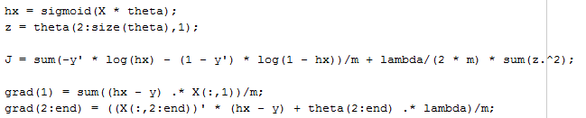

oneVsAll.m – Train a one-vs-all multi-class classifier
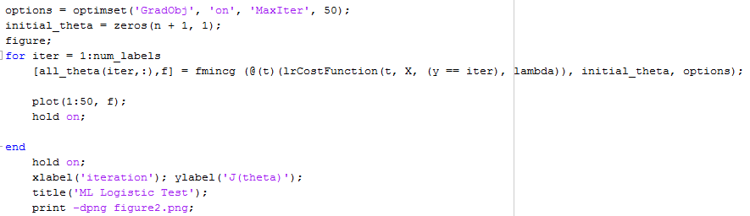

predictOneVsAll.m – Predict using a one-vs-all multi-class classifier
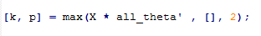

predict.m – Neural network prediction function
