Multi-class Classification and Neural Networks

Lab Report # 7

|  |  |  |  |
| --- | --- | --- | --- |
| Sidney Carlo P. Lopez (11222522)  sidneylopez18@gmail.com | |  | Jeremy B. Reccion (11210192)  jeremybreccion@yahoo.com |
| Carl Michael O. Sy (11208929)  carl.michael.sy@gmail.com | Wellington S. Villasin (11209534)  wellvill08@gmail.com | | |
|  |  | | |

*Abstract*— a training point is classified into classes in which the goal is to generate a function that when given new data, will predict the class in which the new data belongs.

Keywords—multiclass; classification; neural; networks; testing;data

1. INTRODUCTION

The last experiment was all about the testing and training of data that uses the function of logistic regression. In this experiment, we are to venture a new topic that is called Multi-class classification and neural networks. Multi-class is a one-vs-all logistic regression in which a training point is classified into classes in which the goal is to generate a function that when given new data, will predict the class in which the new data belongs [1].

A Neural Network is a data handling paradigm that is motivated by the way organic nervous systems, for example, the mind, process data. The key component of this worldview is the novel structure of the data processing framework. It is made out of an extensive number of interconnected processing components (neurons) working as one to take care of particular issues. Neural system, similar to individuals, learn by test cases. A Neural system is arranged for a particular application, for example, pattern recognition or information characterization, through a learning procedure. Learning in biological systems includes changes in accordance with the synaptic associations that exist between the neurons in which neural systems works the same way [2].

1. OBJECTIVES

* implement logistic regression and neural networks to recognize handwritten digits (from 0 to 9)
* Show the methods the group learned that can be used for classification tasks.
* extend previous implementation of logistic regression and apply it to one-vs-all classification
* implement a neural network to recognize handwritten digits using the same training set
* implement the feedforward propagation algorithm to use the weights for prediction

1. IMPLEMENTATION
2. Multi-class Classification: You are given a data set in ex3data1.mat that contains 5000 training examples of handwritten digits.



1. The code randomly selects 100 rows from X and passes those rows to the displayData function.

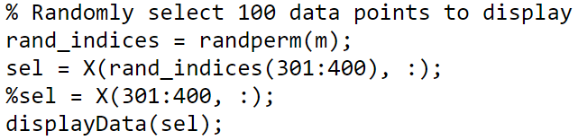

1. You will be using multiple one-vs-all logistic regression models to build a multi-class classifier. Since there are 10 classes, you will need to train 10 separate logistic regression classifiers.

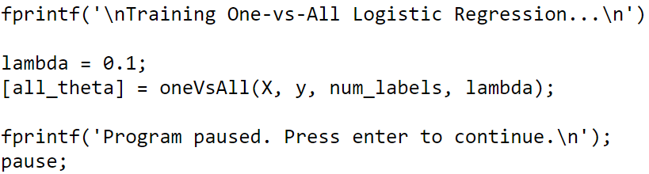

1. Write the unregularized cost function in the file lrCostFunction.m your implementation should use the strategy we presented above to calculate θ T x (i). You should also use a vectorized approach for the rest of the cost function.

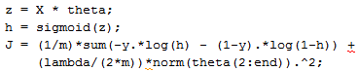

1. Implementing the gradient.



1. Train one classifier for each class. In particular, your code should return all the classifier parameters in a matrix Θ ∈ R K×(N+1) , where each row of Θ corresponds to the learned logistic regression parameters for one class. You can do this with a “for”-loop from 1 to K, training each classifier independently.

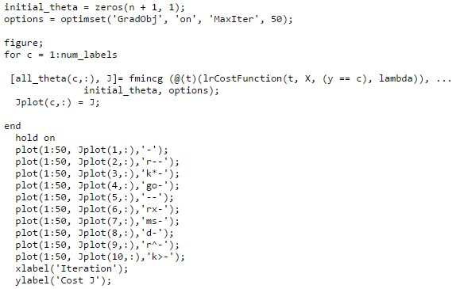

1. Predict the digit contained in a given image. For each input, you should compute the “probability” that it belongs to each class using the trained logistic regression classifiers.

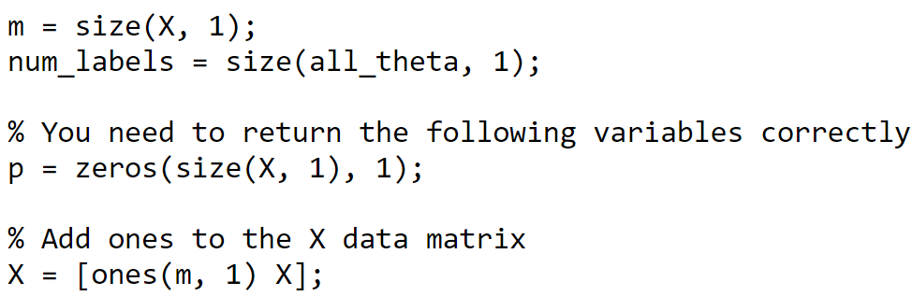

1. Neural Networks: Loading and Visualizing Data

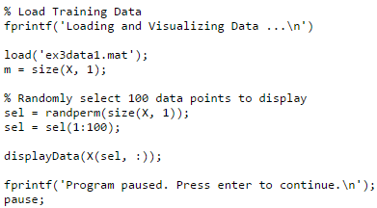

1. Loading Parameters

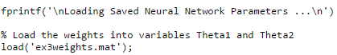

1. Implement Predict

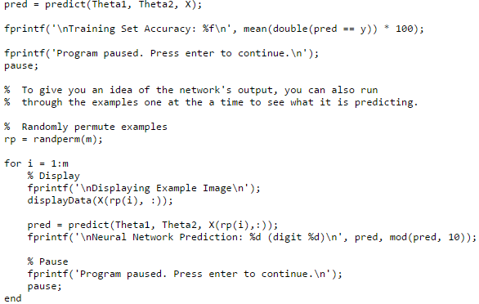

1. DATA AND RESULTS
2. Cost Plot

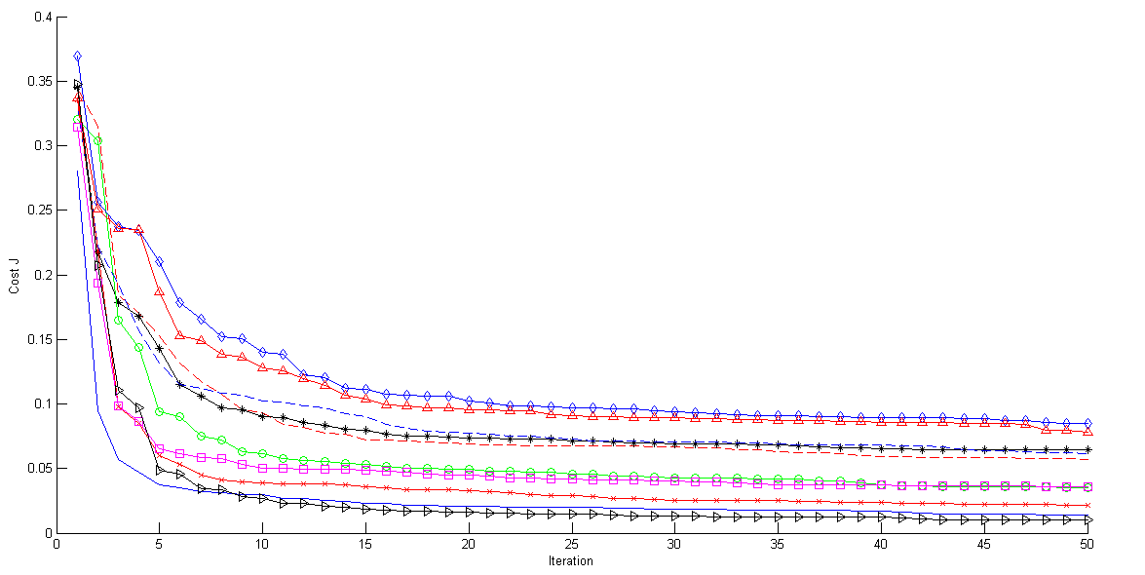

Fig. 1. Cost Plot

1. Data Set Examples

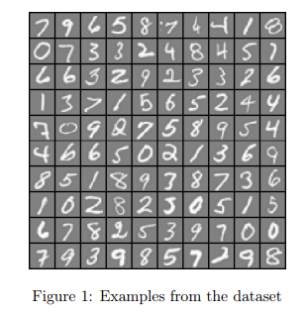

Fig. 2. Examples of Data Set

1. Multi-Class Training Set Accuracy

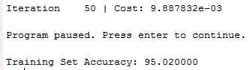

1. Neural Network Training Set Accuracy

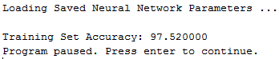

1. ANALYSIS AND CONCLUSION

REFERENCES

1. MIT.EDU, 'MIT', 2015. [Online]. Available: http://www.mit.edu/~9.520/spring09/Classes/multiclass.pdf. [Accessed: 27- Oct- 2015].
2. Doc.ic.ac.uk, 'Neural Networks', 2015. [Online]. Available: http://www.doc.ic.ac.uk/~nd/surprise_96/journal/vol4/cs11/report.html#What is a Neural Network. [Accessed: 27- Oct- 2015].