Multi-class Classification and Neural Networks
Laboratory Exercise 7

Antonio, Daniel
Electronics and Communications Engineering Department
De La Salle University - Manila
Manila, Philippines

Eco, Lance Randall Lim
Electronics and Communications Engineering Department
De La Salle University – Manila
Manila, Philippines
lance_eco@dlsu.edu.ph

Tan, Sidney Sheldon Urlanda
Electronics and Communications Engineering Department
De La Salle University - Manila
Manila, Philippines
sidney_tan@dlsu.edu.ph

Zarzoso, Aaron John Pascua
Electronics and Communications Engineering Department
De La Salle University - Manila
Manila, Philippines
aaron_zarzoso@dlsu.edu.ph

Abstract—This paper contains a study about multi-class neural learning focusing on the strategy of one-vs-all to reduce the problem of multi-class classification. It also contains a dataset that will be used for the classification as well as the model representation to represent our neural network. Also, this paper contains the different graphs corresponding to different learnings so as to differentiate each one from another which will be evident because there is indeed a big difference.
Keywords— multi-class classification; pattern recognition; machine learning; neural networks; matlab;

Introduction
Multiclass classification is the problem classifying instances into one or more than two classes. There are several strategies for reducing the problem of multiclass classification such as one-vs-all and one-vs-one. One-vs-all is a kind of strategy that involves training a single classifier per class with the samples of that particular class as positive and all other samples as negative. This strategy requires the base classifier to produce a real-valued score for its decision. One-vs-one is a kind of strategy that each receives the samples of a pair of classes from the original training set and it must learn to distinguish these two classes. Neural networks are used to estimate or approximate functions that can depend large number of inputs which is mostly unknown. It is simply presented as systems of interconnected neurons which exchange message to each other.

Instructions/procedure
- Multi-class Classification
  - Dataset
You are given a data set in ex3data1.mat that contains 5000 training examples of handwritten digits. The .mat format means that that the data has been saved in a native Octave/Matlab matrix format, instead of a text (ASCII) format like a csv-file. These matrices can be read directly into your program by using the load command. After loading, matrices of the correct dimensions and values will appear in your program's memory. The matrix will already be named, so you do not need to assign names to them.
% Load saved matrices from file
load('ex3data1.mat');
% The matrices X and y will now be in your Octave environment
There are 5000 training examples in ex3data1.mat, where each training example is a 20 pixel by 20 pixel grayscale image of the digit. Each pixel is represented by a floating point number indicating the grayscale intensity at that location. The 20 by 20 grid of pixels is \unrolled" into a 400-dimensional vector. Each of these training examples becomes a single row in our data matrix X. This gives us a 5000 by 400 matrix X where every row is a training example for a handwritten digit image.
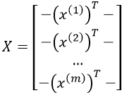
The second part of the training set is a 5000-dimensional vector y that contains labels for the training set. To make things more compatible with Octave/Matlab indexing, where there is no zero index, we have mapped the digit zero to the value ten. Therefore, a “0” digit is labeled as “10”, while the digits “1” to “9” are labeled as “1” to “9” in their natural order.
  - Visualizing the data
You will begin by visualizing a subset of the training set. In Part 1 of ex3.m, the code randomly selects selects 100 rows from X and passes those rows to the displayData function. This function maps each row to a 20 pixel by 20 pixel grayscale image and displays the images together. We have provided the displayData function, and you are encouraged to examine the code to see how it works. After you run this step, you should see an image like Figure 1.
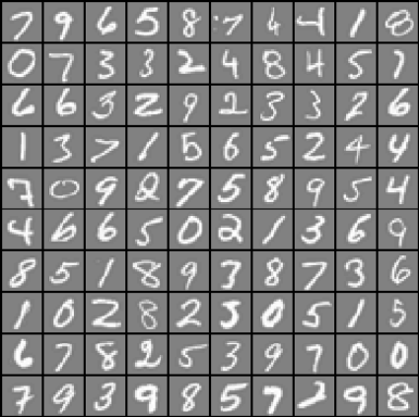
Figure 1: Examples from the dataset
  - Vectorizing Logistic Regression
1.3.1 Vectorizing the cost function
We will begin by writing a vectorized version of the cost function. Recall that in (unregularized) logistic regression, the cost function is
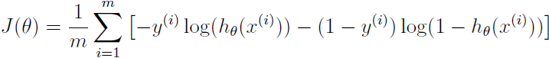
To compute each element in the summation, we have to compute h_{ϴ}(x^{(i)}) for every example i, where h_{ϴ}(x^{(i)}) = g(ϴ^{T}x^{(i)}) and g(z) = 1/(1+e^-z) is the sigmoid function. It turns out that we can compute this quickly for all our examples by using matrix multiplication. Let us define X and ϴ as
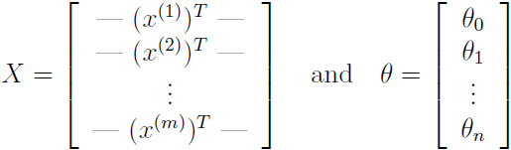
Then, by computing the matrix product Xϴ, we have
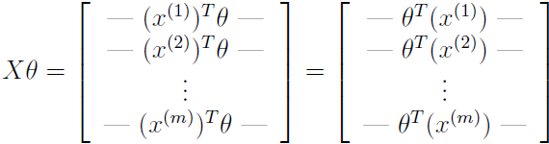
In the last equality, we used the fact that a^{T}b = b^{T}a if a and b are vectors. This allows us to compute the products ϴ^{T}x^{(i)} for all our examples i in one line of code.
Your job is to write the unregularized cost function in the file lrCostFunction.m Your implementation should use the strategy we presented above to calculate ϴ^{T}x^{(i)}. You should also use a vectorized approach for the rest of the cost function. A fully vectorized version of lrCostFunction.m should not contain any loops.
(Hint: You might want to use the element-wise multiplication operation (.*) and the sum operation sum when writing this function)
1.3.2 Vectorizing the gradient
Recall that the gradient of the (unregularized) logistic regression cost is a vector where the j^{th} element is defined as
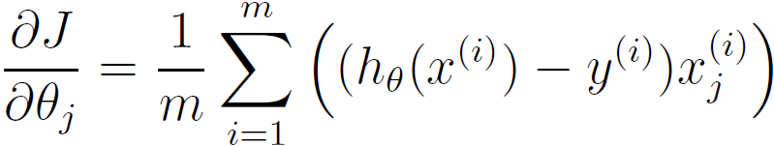
To vectorize this operation over the dataset, we start by writing out all the partial derivatives explicitly for all ϴ_{j},
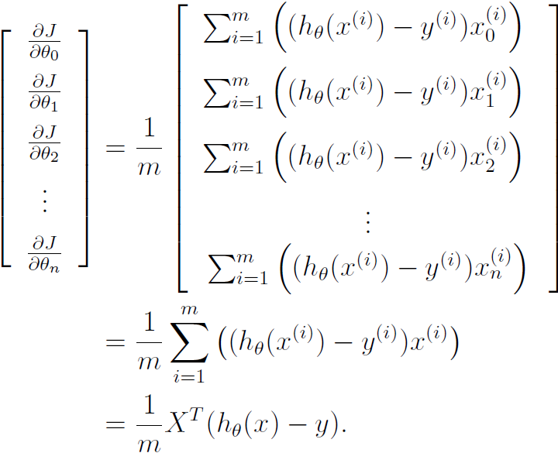
where
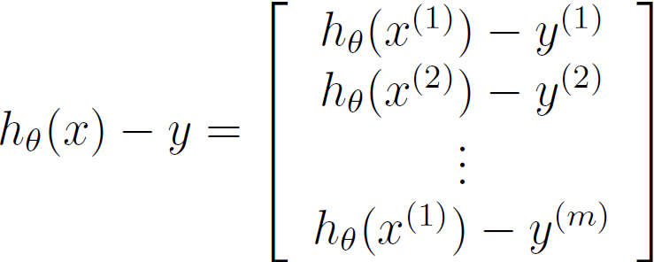
Note that x^{(i)} is a vector, while (h_{ϴ}(x^{(i)})-y^{(i)}) is a scalar (single number). To understand the last step of the derivation, let β_{i} = (h_{ϴ}(x^{(i)})-y^{(i)}) and observe that:
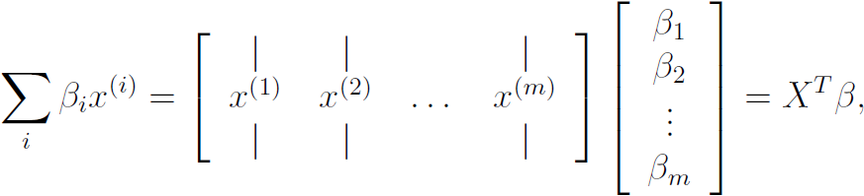
where the values β_{i} = (h_{ϴ}(x^{(i)})-y^{(i)})
The expression above allows us to compute all the partial derivatives without any loops. If you are comfortable with linear algebra, we encourage you to work through the matrix multiplications above to convince yourself that the vectorized version does the same computations. You should now implement Equation 1 to compute the correct vectorized gradient. Once you are done, complete the function lrCostFunction.m by implementing the gradient.
Debugging Tip: Vectorizing code can sometimes be tricky. One common strategy for debugging is to print out the sizes of the matrices you are working with using the size function. For example, given a data matrix X of size 100 x 20 (100 examples, 20 features) and ϴ, a vector with dimensions 20x1, you can observe that Xϴ is a valid multiplication operation, while ϴX is not. Furthermore, if you have a non-vectorized version of your code, you can compare the output of your vectorized code and non-vectorized code to make sure that they produce the same outputs.
1.3.3 Vectorizing regularized logistic regression
After you have implemented vectorization for logistic regression, you will now add regularization to the cost function. Recall that for regularized logistic regression, the cost function is defined as
Note that you should not be regularizing ϴ₀ which is used for the bias term.
Correspondingly, the partial derivative of regularized logistic regression cost for ϴ_{j} is defined as
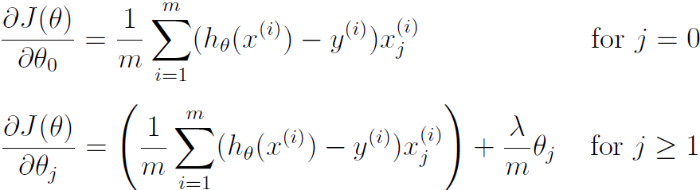
Now modify your code in lrCostFunction to account for regularization.
Once again, you should not put any loops into your code.
Octave Tip: When implementing the vectorization for regularized logistic regression, you might often want to only sum and update certain elements of ϴ. In Octave, you can index into the matrices to access and update only certain elements. For example, A(:, 3:5) = B(:, 1:3) will replaces the columns 3 to 5 of A with the columns 1 to 3 from B. One special keyword you can use in indexing is the end keyword in indexing. This allows us to select columns (or rows) until the end of the matrix. For example, A(:, 2:end) will only return elements from the 2nd to last column of A. Thus, you could use this together with the sum and .^ operations to compute the sum of only the elements you are interested in (e.g., sum(z(2:end).^2)). In the starter code, lrCostFunction.m, we have also provided hints on yet another possible method computing the regularized gradient.
  - One-vs-all Classification
In this part of the exercise, you will implement one-vs-all classification by training multiple regularized logistic regression classifiers, one for each of the K classes in our dataset (Figure 1). In the handwritten digits dataset, K = 10, but your code should work for any value of K.
You should now complete the code in oneVsAll.m to train one classifier for each class. In particular, your code should return all the classifier parameters in a matrix ϴ∈R^{Kx(N+1)}, where each row of ϴ corresponds to the learned logistic regression parameters for one class. You can do this with a “for”-loop from 1 to K, training each classifier independently. Note that the y argument to this function is a vector of labels from 1 to 10, where we have mapped the digit “0” to the label 10 (to avoid confusions with indexing).
When training the classifier for class k∈{1,…, K}, you will want a m-dimensional vector of labels y, where y_{j}∈0, 1 indicates whether the j-th training instance belongs to class k (y_{j} = 1), or if it belongs to a different class (y_{j} = 0). You may find logical arrays helpful for this task.
Octave Tip: Logical arrays in Octave are arrays which contain binary (0 or 1) elements. In Octave, evaluating the expression a == b for a vector a (of size mx1) and scalar b will return a vector of the same size as a with ones at positions where the elements of a are equal to b and zeroes where they are different. To see how this works for yourself, try the following code in Octave:
a = 1:10; % Create a and b
b = 3;
a == b % You should try different values of b here
Furthermore, you will be using fmincg for this exercise (instead of fminunc). fmincg works similarly to fminunc, but is more more efficient for dealing with a large number of parameters.
After you have correctly completed the code for oneVsAll.m, the script ex3.m will continue to use your oneVsAll function to train a multi-class classifier.
1.4.1 One-vs-all Prediction
After training your one-vs-all classifier, you can now use it to predict the digit contained in a given image. For each input, you should compute the “probability” that it belongs to each class using the trained logistic regression classifiers. Your one-vs-all prediction function will pick the class for which the corresponding logistic regression classifier outputs the highest probability and return the class label (1, 2,...., or K) as the prediction for the input example.
You should now complete the code in predictOneVsAll.m to use the one-vs-all classifier to make predictions.
Once you are done, ex3.m will call your predictOneVsAll function using the learned value of ϴ. You should see that the training set accuracy is about 94.9% (i.e., it classifies 94.9% of the examples in the training set correctly).
- Neural Networks
  - Model representation
Our neural network is shown in Figure 2. It has 3 layers - an input layer, a hidden layer and an output layer. Recall that our inputs are pixel values of digit images. Since the images are of size 20x20, this gives us 400 input layer units (excluding the extra bias unit which always outputs +1). As before, the training data will be loaded into the variables X and y.
You have been provided with a set of network parameters (ϴ⁽¹⁾,ϴ⁽²⁾) already trained by us. These are stored in ex3weights.mat and will be loaded by ex3_nn.m into Theta1 and Theta2. The parameters have dimensions that are sized for a neural network with 25 units in the second layer and 10 output units (corresponding to the 10 digit classes).
% Load saved matrices from file
load('ex3weights.mat');
% The matrices Theta1 and Theta2 will now be in your Octave
% environment
% Theta1 has size 25 x 401
% Theta2 has size 10 x 26
You could add more features (such as polynomial features) to logistic regression, but that can be very expensive to train.
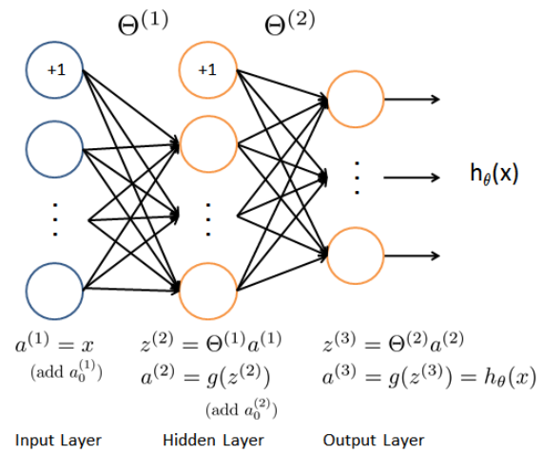
Figure 2. Neural network model.
  - Feedforward Propagation and Prediction
Now you will implement feedforward propagation for the neural network. You will need to complete the code in predict.m to return the neural network's prediction. You should implement the feedforward computation that computes h_{ϴ}(x^{(i)}) for every example i and returns the associated predictions. Similar to the one-vs-all classification strategy, the prediction from the neural network will be the label that has the largest output (h_{ϴ}(x))_{k}.
Implementation Note: The matrix X contains the examples in rows. When you complete the code in predict.m, you will need to add the column of 1's to the matrix. The matrices Theta1 and Theta2 contain the parameters for each unit in rows. Specifically, the first row of Theta1 corresponds to the first hidden unit in the second layer. In Octave, when you compute z⁽²⁾ = ϴ⁽¹⁾a⁽¹⁾, be sure that you index (and if necessary, transpose) X correctly so that you get a^{(l)} as a column vector.
Once you are done, ex3_nn.m will call your predict function using the loaded set of parameters for Theta1 and Theta2. You should see that the accuracy is about 97.5%. After that, an interactive sequence will launch displaying images from the training set one at a time, while the console prints out the predicted label for the displayed image. To stop the image sequence, press Ctrl-C.

Data and results

Multi-class Classification
- Dataset
load(‘ex3data1.mat’);
- Visualizing the data
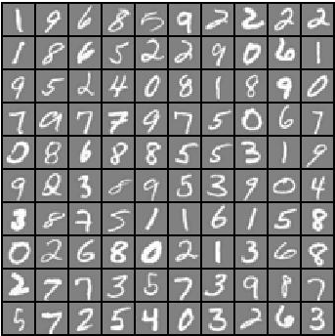
Figure 3: Examples from the dataset (own simulation).
- Vectorizing Logistic Regression
h = sigmoid(X * theta);
costPositive = -y' * log(h);
costNegative = (1 - y') * log(1 - h);
J = (1/m) * (costPositive – costNegative);
c1. Vectorizing the cost function
c2. Vectorizing the gradient
grad = (1/m) * (X' * (h - y)) + ((lambda / m) * thetaFiltered
c3. Vectorizing regularized logistic regression
thetaFiltered = [0; theta(2:end)];
reg = (lambda / (2*m)) * (thetaFiltered' * thetaFiltered);
J = (1/m) * (costPositive - costNegative) + reg;
Final Code for lrCostFunction:
% ======= YOUR CODE HERE =======
h = sigmoid(X * theta);
costPositive = -y' * log(h);
costNegative = (1 - y') * log(1 - h);
thetaFiltered = [0; theta(2:end)];
reg = (lambda / (2*m)) * (thetaFiltered' * thetaFiltered);
J = (1/m) * (costPositive - costNegative) + reg;
grad = (1/m) * (X' * (h - y)) + ((lambda / m) * thetaFiltered);
- One-vs-all Classification
% ======= YOUR CODE HERE =======
initial_theta = zeros(n + 1, 1);
options = optimset('GradObj', 'on', 'MaxIter', 50);
num = 0;
for iter = 1:num_labels
[all_theta(iter,:),f,i] = fmincg(@(t)(lrCostFunction(t, X, (y== iter), lambda)), initial_theta, options);
figure;
plot(1:50,f);
end
d1. One-vs-all Prediction
% ===== YOUR CODE HERE =====
A = sigmoid(X * all_theta');
[x, p] = max(A, [], 2);

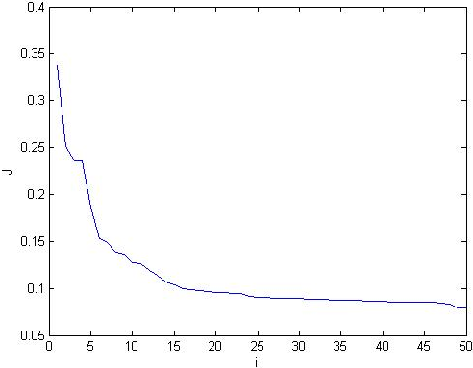
Figure 4: Plot of Cost of digit 9 (Hard to learn).
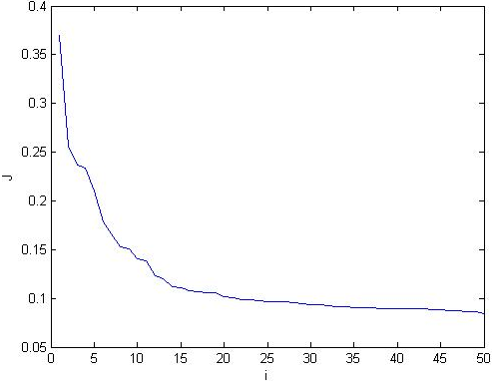
Figure 5: Plot of Cost of digit 8 (Hard to learn).
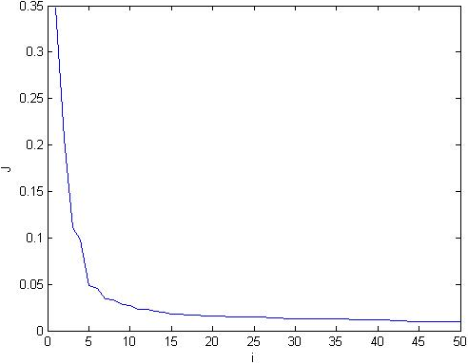
Figure 6: Plot of Cost of digit 0 (Easy to learn).
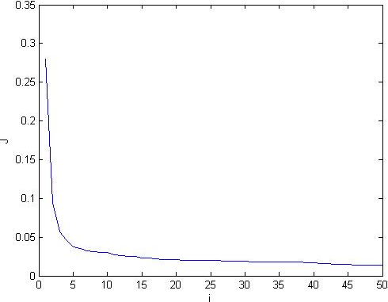
Figure 7: Plot of Cost of digit 1 (Easy to learn).
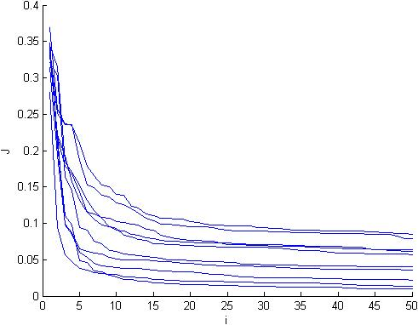
Figure 8: Combined cost plot of digits 1-10 (Plot of J).

Neural Networks
- Model representation
- Feedforward Propagation and Prediction
% ======= YOUR CODE HERE =======
a1 = [ones(m, 1), X];
z2 = Theta1 * a1';
a2 = sigmoid(z2);
a2 = [ones(1, size(a2, 2)); a2];
z3 = Theta2 * a2;
a3 = sigmoid(z3);
[val, p] = max(a3', [], 2);

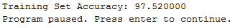

Figure 9: Displayed imaged which was successfully predicted as 0.

analysis and conclusion
In this experiment, the students was able to make use of the matlab software in order to implement multi-class classification and neural networks. So basically what the group did is that we used logistic regression and neural networks to recognize digits from 0 to 9. We visualize the data in particular the subset of the whole training set. By doing this we obtain a table which is 10x10 and contains the digits from 0-9. Then we vectorize logistic regression by using multiple one-vs-all logistic regression models to build a multi-class classifier. The reason for using a vectorized logistic regression model is to ensure that the training is efficient. Meanwhile, we also vectorize the cost function and the gradient. Vectorizing the cost function is simply done by directly coding a vectorized version of the cost function. On the other hand, the gradient is vectorized by defining all the partial derivatives explicitly all for θ_{j.} Now we add regularization to our cost function in order to guard against the problem of overfitting.

We now proceed to the main objective of this experiment which is the implementation of the one-vs-all classification. We are implementing this kind of strategy since we are dealing with multiple digits which is from 0-9 and so one-vs-all will best fit this. The implementation is done by training multiple regularized logistic regression classifiers. After this we now predict what digit is displayed in the image. This can be done after the one-vs-all classifier has been trained. The function that defines the one-vs-all prediction works by picking the class for which the corresponding logistic regression classifier outputs the highest probability and return the class label as the prediction for the input example.

Meanwhile, in order to improve the recognition of the digits, we implement the use of neural networks since logistic regression cannot solely form more complex hypotheses since it is only a linear classifier. So we use neural networks in order to accomplish this task. Neural networks are able to represent complex models that form non-linear hypotheses. We then implement the feedforward propagation algorithm to use our weighs for prediction.

After the implementation of the feedforward algorithm, the prediction from the neural network will be the label that has the largest output of h_{θ}(x) which is similar to the one-vs-all classification strategy that was done using the logistic regression classifier.

References
- MathWorks. (N.D.). MATLAB - The Language of Technical Computing. [Online]. Available: http://www.mathworks.com/
products/matlab/
- Eaton, J. (N.D.). About GNU Octave. [Online]. Available: https://www.gnu.org/software/octave/about.html
- N.A. (N.D.). Programming Exercise 3: Multi-class Classification and Neural Networks. [File] Available: ex3.pdf

