Ethernet and ARP protocols
Goal
Study of Ethernet and ARP protocols.

Procedure 1
- Start up the Wireshark packet sniffer;
- Enter the following URL into your browser: https://www.mat.unical.it/informatica/Reti_e_sicurezza_informatica
- Stop Wireshark packet capture.
You should detect in Wireshark screen the GET request packet that was sent from your browser
Questions
Analyzing the GET request packet sent from your browser:
- What is the 48-bit Ethernet address of your computer?
- What is the 48-bit Ethernet address of destination computer? Is this its real address? Motivate.
Analyzing the response packet of previous request:
- What is the 48-bit Ethernet address of your computer?
- What is the 48-bit Ethernet address of destination/source computer? What computer has this as its Ethernet address? Motivate.
Procedure 2
- Clear your ARP cache (Windows: arp –d *; Linux: arp –d *);
- Start up the Wireshark packet sniffer;
- Enter the following URL into your browser : http://www.wintriks.it;
- Stop Wireshark packet capture as soon as the webpage is loaded.
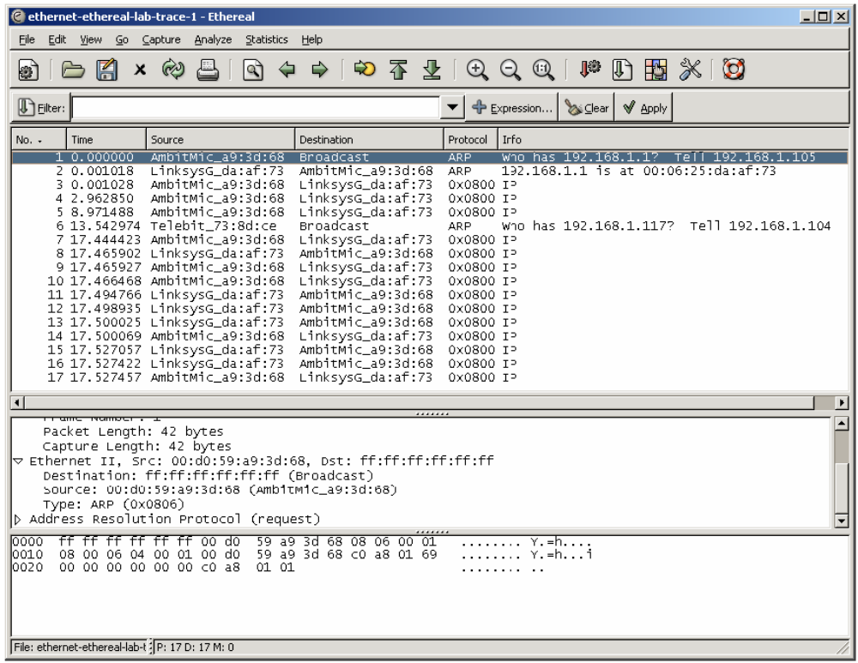

Questions
- Detect in Wireshark screen the ARP request packet that was sent!
- What are the values for the source and destination addresses containing the ARP request message?
- Find the response packets (.. is at ..) and analyze their structure
- Show ARP cache (Windows: arp –a, Linux: arp)

TCP protocol
Goal
Study the behavior of TCP analyzing a “trace” of the TCP segments sent and received from your computer to a remote server.
Procedure
- Start up your web browser. Go the http://gaia.cs.umass.edu/wiresharklabs/alice.txt and retrieve an ASCII copy of Alice in Wonderland. Store this file somewhere on your computer.
- Next go to http://gaia.cs.umass.edu/wireshark-labs/TCP-wireshark-file1.html. You should see a screen that looks like:

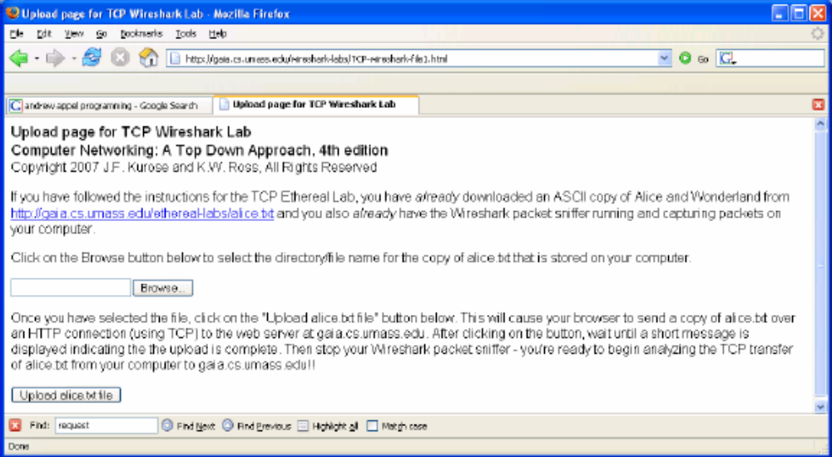

- Use the Browse button in this form to enter the name of the file (full path name) on your computer containing Alice in Wonderland (or do so manually). Don’t yet press the “Upload alice.txt file” button.
- Now start up Wireshark and begin packet capture.
- Returning to your browser, press the “Upload alice.txt file” button to upload the file to the aia.cs.umass.edu server. Once the file has been uploaded, a short congratulations message will be displayed in your browser window.
- Stop Wireshark packet capture. Your Wireshark window should look similar to the window shown below:
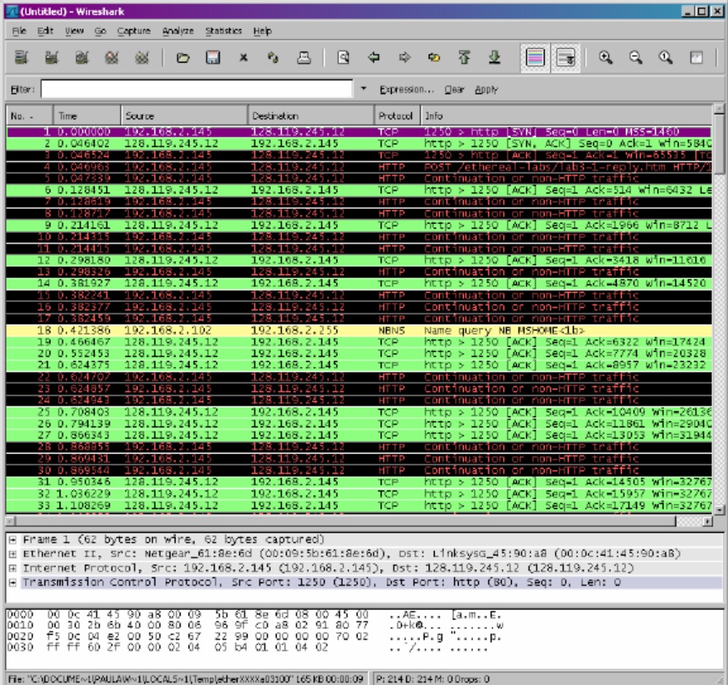
If you are unable to run Wireshark on a live network connection, you can download a packet trace file from https://www.mat.unical.it/informatica/Reti_di_Calcolatori?action=AttachFile&do=get&target=tcp-trace. Save this file to your computer and open it by Wireshark with the Open command in the File menu.
Questions:
Filter the packets displayed in the Wireshark window by entering “tcp” into the display filter specification window towards the top of the Wireshark window. What you should see is series of TCP and HTTP messages between your computer and gaia.cs.umass.edu.
- What is the IP address and TCP port number used by the client computer (source) that is transferring the file to gaia.cs.umass.edu?
- What is the IP address of gaia.cs.umass.edu? On what port number is it sending and receiving TCP segments for this connection?
If you have been able to create your own trace, answer the following question:
- What is the IP address and TCP port number used by your client computer (source) to transfer the file to gaia.cs.umass.edu?
Now, select Analyze->Enabled Protocols and uncheck the HTTP box and select OK. You should now see an Wireshark window that looks like:
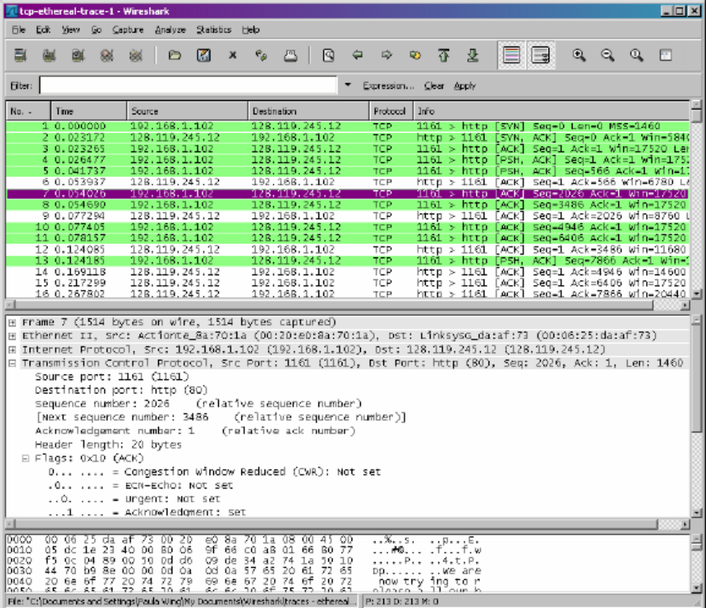
- What is the sequence number of the TCP SYN segment that is used to initiate the TCP connection between the client computer and gaia.cs.umass.edu? What is it in the segment that identifies the segment as a SYN segment?
- What is the sequence number of the SYN/ACK segment sent by gaia.cs.umass.edu to the client computer in reply to the SYN? What is the value of the ACKNOWLEDGEMENT NUMBER field in the SYN/ACK segment? How did gaia.cs.umass.edu determine that value? What is it in the segment that identifies the segment as a SYN/ACK segment?
- Re-enable the display of the IP protocol from the menu Analyze/Protocols.What is the sequence number of the TCP segment containing the HTTP POST command
- Consider the TCP segment containing the HTTP POST as the first segment in the TCP connection. What are the sequence numbers of the first six segments in the TCP connection (including the segment containing the HTTP POST)? At what time was each segment sent? When was the ACK for each segment received? Given the difference between when each TCP segment was sent, and when its acknowledgement was received, what is the RTT value for each of the six segments? What is the EstimatedRTT value after the receipt of each ACK? Assume that the value of the EstimatedRTT is equal to the measured RTT for the first segment, and then is computed using the EstimatedRTT equation seen in class.
- What is the length of each of the first six TCP segments?
- Are there any retransmitted segments in the trace file? What did you check for (in the trace) in order to answer this question?
- How much data does the receiver typically acknowledge in an ACK? Can you identify cases where the receiver is ACKing every other received segment?
- What is the throughput (bytes transferred per unit time) for the TCP connection? Explain how you calculated this value
Let’s now examine the amount of data sent per unit time from the client to the server. Rather than (tediously!) calculating this from the raw data in the Wireshark window, we’ll use one of Wireshark’s TCP graphing utilities - Time-Sequence-Graph(Stevens) - to plot out data.
Select a TCP segment in the Wireshark’s “listing of captured-packets” window. Then select the menu : Statistics->TCP Stream Graph-> Time-SequenceGraph(Stevens). You should see a plot that looks similar to the following plot:
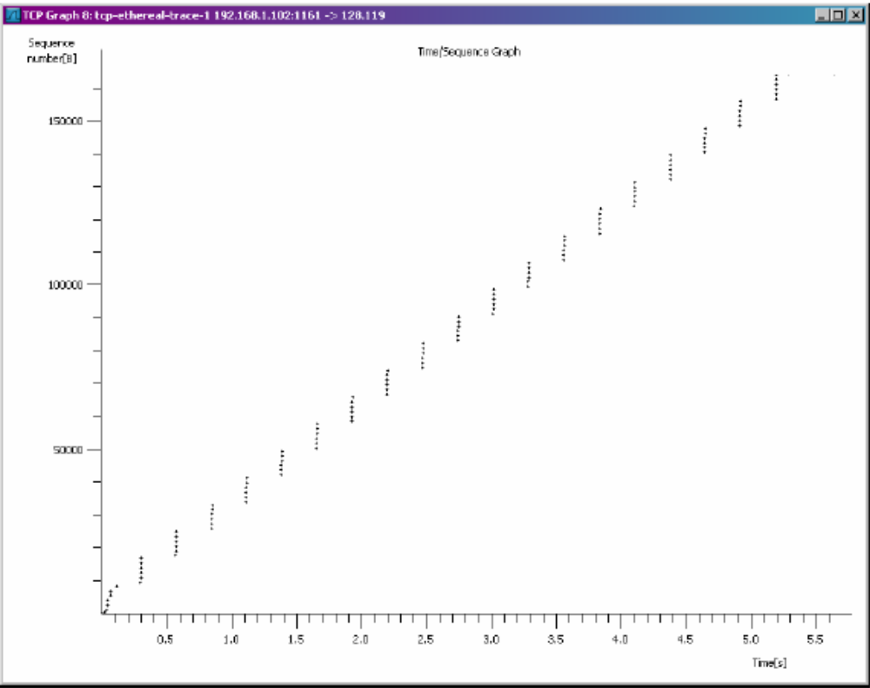
Here, each dot represents a TCP segment sent, plotting the sequence number of the segment versus the time at which it was sent.
- Use the Time-Sequence-Graph(Stevens) plotting tool to view the sequence number versus time plot of segments being sent from the client to the gaia.cs.umass.edu server. Can you identify where TCP’s slowstart phase begins and ends, and where congestion avoidance takes over? Comment on ways in which the measured data differs from the idealized behavior of TCP that we’ve studied.
- Answer each of two questions above for the trace that you have gathered when you transferred a file from your computer to gaia.cs.umass.edu.
UDP protocol
Goal
Study of UDP transport protocol.
Procedure
Now start up Wireshark and begin packet capture and do something that will cause the sending and receiving of UDP packets from your host. what to do?
First, If you are unable to run Wireshark on a live network connection, you can download a packet trace file from https://www.mat.unical.it/informatica/Reti_di_Calcolatori?action=AttachFile&do=get&target=udp-trace.pcap. Save this file to your computer and open it by Wireshark with the Open command in the File menu
Stop Wireshark packet capture and filter the UDP packets sending and receiving from your host. Select one of these UDP packets and expand the fields in the detail window.
Questions
- Select one packet. From this packet, determine how many fields there are in the UDP header. Name these fields
- From the packet content field, determine the length (in bytes) of each of the UDP header fields.
- The value in the Length field is the length of what? Verify your claim with your captured UDP packet.
- What is the maximum number of bytes that can be included in a UDP payload?
- What is the largest possible source port number?
- What is the protocol number for UDP? Give your answer in both hexadecimal and decimal notation.
- Search “UDP” in Google and determine the fields over which the UDP checksum is calculated.
- Examine a pair of UDP packets in which the first packet is sent by your host and the second packet is a reply to the first packet. Describe the relationship between the port numbers in the two packets.
Extra Credit
- Capture a small UDP packet. Manually verify the checksum in this packet. Show all work and explain all steps.
IP protocol
Goal
Study of the IP protocol. In particular we will analyze IP packets generated during an execution of the command tracert (traceroot with linux). Remember that this command has a different behavior between linux and windows. In Linux, traceroot to the destination host sends a series of UDP packets; in Windows, the tracert command sends ICMP messages. This distinction is necessary to understand the differences between packets detected using two different operating systems. A similarity in the functioning is still present. Both commands (tracert and traceroute) send packets with a TTL value of the field that varies in packages. In general, the sequence of packets that is sent on the network has the TTL field modified according to the following scheme:
- The first message has TTL = 1;
- The second message has TTL = 2, etc...
In this process, each router that is passed must decrement the TTL in each received datagram up to TTL=1. When TTL=1 the router returns an ICMP message (Time To Live exceeded). With this procedure, the system is able to identify the next steps that a packet follows in its path on the network to reach the destination.
Procedure
- Start up Wireshark and begin packet capture.
- From the Windows command console, run "tracert hostname";
- When tracert command ends, stop Wireshark packet capture
In your trace, you should be able to see the series of ICMP Echo Request sent by your computer and the ICMP TTL-exceeded messages returned to your computer by the intermediate routers.
Questions
- Select the first ICMP Echo Request message sent by your computer, and expand the Internet Protocol part of the packet in the packet details window. What is the IP address of your computer?
- How many bytes are in the IP header? How many bytes are in the payload of the IP datagram? Explain how you determined the number of payload bytes.
- Has this IP datagram been fragmented? Explain how you determined whether or not the datagram has been fragmented.
Sort the traced packets according to IP source address. Identify the ICMP messages sent by your computer e rispondere alle seguenti domande:
- Which fields in the IP datagram change from one datagram to the next?
- Which fields stay constant?
- Which of the fields must stay constant? Which fields must change? Why?
- Describe and justify the pattern you see in the values in the Identification field of the IP datagram;
Find the series of ICMP TTLexceeded replies sent to your computer:
- What is the value in the Identification field and the TTL field?
- Do these values remain unchanged for all of the ICMP TTL-exceeded replies sent to your computer by the nearest (first hop) router? Why?

Web Browsing (DNS, TCP, HTTP)
Goal
In this exercise, we analyze what happens on the transport and application layers during an HTTP transaction.
Procedure
- Start Wireshark
- Start a web browser and enter the URL of a website of your choice but do not press ENTER.
- Start Wireshark packet capture.
- Access the website by pressing ENTER in the browser web page.
- Once page is loaded, stop capture. Save the capture file.
- Save the displayed web page for later reference.

Protocol Analysis Questions
To answer the following questions, start Wireshark and open the packet capture file created above.
1. Protocols Captured
- Examine the protocol column in the top pane of the Wireshark window. Confirm that you have captured DNS, TCP, ICMP and HTTP packets.
2. Ethernet frame, IP packet, and UDP datagram
- Examine the frame for the first DNS packet sent by the client.
- Identify the Ethernet and IP address of the client. Is in IP header (we will study in detail later).
- Examine the UDP header of the first DNS packet sent by the client
- Identify the source and the destination port number. Is the destination port 53? What type of application layer protocol is in the payload?
3. DNS
- Examine the DNS query message in the DNS packet sent by the client.
- What field indicates whether the message is a query or a response?
- What information is carried in the body of the query?
- What is the query transaction ID?
- Identify the fields that carry, the type and class of the query.
- Now consider the packet that carries the DNS response to the above query.
- What should the Ethernet and IP addresses for this packet be? Verify that these addresses are as expected.
- What is the size of the IP packet and UDP datagram that carry the response? Is it longer than the query?
- Confirm that the transaction ID in the response message is correct.
- How many answers are provided in the response message? All answers have the same TTL? What is the TTL in DNS replies?
4. HTTP GET
- Identify the frame that carries the “HTTP GET” message.
- Confirm that the sequence and acknowledgement values in the TCP header are as expected.
- Examine the flag bits in the TCP header. Can you explain why the two flag bits are set?
- What are the lengths of the TCP segment and payload?
- Now consider the contents of the “GET” message.
- Scroll down the third pane in the Wireshark window and compare the decoded text with the contents of the HTTP message in the second window.
- Count the number of octets in the message and verify that this number is consistent with the length information in the TCP header.
- What is the next sequence number that is expected in the next segment from the server? What number of acknowledgement?

5. HTTP Response
- Find response packet.
- How much time elapses between the capture of the GET message and the capture of the corresponding Response message?
- Determine whether the server responds with an HTTP response message or simply with a TCP ACK segment. Verify that the sequence number in the segment from the server is as expected.
- Now consider the segment that contains the HTTP response message.
- What is the length of the payload in the TCP segment?
- Examine whether any of the flags are set and explain why they are set.
- What acknowledgement number is expected in the next segment from the client?
- Now consider the HTTP response message.
- What is the result code in the response message?
- Highlight the “data” section of the HTTP response message. Scroll down the third pane in the Wireshark window and compare the decoded text with the contents of the web page that was displayed on your screen.

