**Letsencrypt certificate request**

In order to obtain a valid certificate from Letsencrypt we should perform 2 steps

# Obtain a valid Domain

1. **Request letsencrypt certificate using Certbot**

**Obtain a valid domain**

**Register** is a service which allows users to get a domain. Some of them are free

* 1. Connect to <https://freenom.com/> website
  2. Look for a domain name and select one of those are free
     + Attention: use **.tk** as top level domain during your research
  3. Finalize your “purchase” and get access to your domain control panel
  4. Login on <https://my.freenom.com/>
  5. Go to <https://my.freenom.com/clientarea.php?action=domains> and click on your domain name
  6. Click on **“manage domain”** and then on **“manage freenom DNS”**. Do not modify anything; we will update our DNS server later.

# Request letsencrypt certificate using Certbot

1. Install Certbot  
   sudo apt install Certbot
2. Request a valid certificate

sudo certbot -d **YOUR_DOMAIN** --manual --preferred-challenges dns certonly

1. Follow the instructions on the console
2. Finally, your certificate request will be forwarded and Certbot will ask you to add a new DNS TXT record to your domain dns

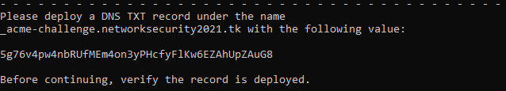

1. Come back to the freenom website under the **“manage freenom DNS”** configurationtab and add a new record using the parameters obtained by Certbot
   1. **Name**: the one provided from Certbot
   2. **Type**: TXT
   3. **TTL**: 900
   4. **Target**: the one provided from Certbot
2. Click on “**Save changes**”
3. Go on <https://toolbox.googleapps.com/apps/dig/#TXT> and look for   
   _acme-challenge.<<your_domain_name>
4. Wait until your txt record is visible on some servers as suggested by Certbot
5. When txt record is visible on some DNS server, come back on Certbot shell and press ***Enter*** in order to complete the process
6. At the end of the process your certificate will be visible on

/etc/letsencrypt/live/<<YOUR_DOMAIN>>/ folder, containing the following files:

* 1. cert.pem
  2. privkey.pem
  3. chain.pem
  4. fullchain.pem