
COLLEGE OF INFORMATION TECHNOLOGY
IT113 – System Administration & Maintenance
Assessment III
Proposed Title:
AgriDataSys: Cloud-Based Farm Information and Maintenance System

Overview
AgriDataSys is a cloud-based farm management solution designed to help farmers organize records, track crop cycles, manage equipment maintenance, and generate predictive yield insights. The system integrates historical farm data with external datasets (such as government agricultural statistics and weather forecasts) to provide farmers with actionable recommendations. It features a web dashboard, mobile-friendly access, and automated reporting tools.
1.1 Purpose and Scope

Purpose
The purpose of this document is to describe the technical design of AgriDataSys, outlining the system requirements, architecture, modules, user interface, and processing logic. It serves as a blueprint for developers, stakeholders, and users to understand how the system will be implemented and maintained.

Scope
The scope of AgriDataSys covers the following functional areas:
- Crop Record Management – Centralized storage and tracking of farm records.
- Crop Cycle Tracking – Monitoring planting-to-harvest timelines with reminders.
- Predictive Analytics – Forecasting yields and resource needs using historical and external data.
- Equipment Maintenance Scheduling – Logging machinery usage and scheduling servicing.
- Reporting – Generating financial, productivity, and performance reports for farmers and cooperatives.

1.2 Project Executive Summary
AgriDataSys is a cloud-based farm information and maintenance system designed to modernize agricultural record-keeping and decision-making. The project addresses the limitations of traditional manual methods by providing farmers with a centralized platform for crop cycle tracking, expense management, predictive yield analysis, and equipment maintenance scheduling.
From a management perspective, the project is expected to be completed within
12 weeks. Key deliverables include a functional prototype capable of supporting up to 100 farmers, a predictive analytics engine for yield forecasting, a web dashboard with reporting features, and mobile-friendly access. The system will reduce inefficiencies, improve farm productivity, and enable proactive maintenance planning, resulting in longterm cost savings and sustainability for agricultural communities.
The conceptual framework:
Framework | Description
Emerging Technology | Cloud computing for centralized access, predictive analytics for yield forecasting, web dashboards for usability
Operational | Rule-based recommendations during initial deployment, predictive analytics activated after sufficient data collection
Technical | Open-source technologies (Python, React.js, PostgreSQL) to minimize development costs and ensure scalability
Economic | Positive ROI expected within the first two years through improved yield, reduced resource waste, and better planning

1.2.1 System Overview
AgriDataSys allows farmers to log crop details, expenses, and harvest data. It tracks crop cycles, predicts yields using historical data, and schedules equipment maintenance. The system provides alerts and reports to guide farmers in decisionmaking.

High-Level Architecture Diagram (conceptual)
- Farmers (Users) - Input data via web dashboard
- Database Layer - Stores records, crop cycles, and equipment logs
- Analytics Engine - Processes historical data and external datasets for predictions
- Web Dashboard - Displays crop timelines, yield forecasts, and reports • Notification System - Sends reminders via email/SMS

1.2.2 Design Constraints
- Dependence on Internet Connectivity Since AgriDataSys is cloud-based, farmers need stable internet access to use the system effectively. Limited connectivity in rural areas may reduce adoption and usability.
- Digital Literacy Requirement The system assumes that farmers or cooperative staff have basic computer and mobile literacy. Training programs may be necessary to ensure smooth usage.
- Data Reliability Predictive analytics depend on accurate historical farm records and external datasets. Incomplete or inconsistent data entry may reduce the accuracy of forecasts.
- Resource Trade-Offs Balancing system complexity with ease of use is critical. Advanced features (e.g., predictive analytics) must remain simple enough for nontechnical users to operate without confusion.

1.2.3 Future Contingencies
- Scalability Concerns As more farmers adopt the system, the database may face performance issues. A contingency plan includes migrating to scalable cloud infrastructure to handle larger data volumes.
- Integration Challenges with External Agencies Government agricultural databases or subsidy programs may not provide open APIs. As a workaround, the system should support manual data import/export (CSV, Excel).
- Offline Access Requirement In areas with poor connectivity, farmers may need offline access. A contingency plan is to develop a lightweight offline mode that syncs data once internet becomes available.
- Alternative Deployment Models If cloud hosting costs become prohibitive, a hybrid deployment (local cooperative servers + cloud backup) can be considered to reduce expenses while maintaining reliability.

1.3 Document Organization
This Systems Design Document is organized into the following major sections:
- Introduction – Provides the purpose, scope, executive summary, system overview, design constraints, and future contingencies.
- System Architecture – Describes the modules, subsystem design, and user interface layouts.
- Feasibility Study – Discusses operational, technical, schedule, and economic feasibility, including a Gantt chart and cost-benefit analysis.
- User Interface Mockups – Presents conceptual designs of the login page, dashboard, reporting, and maintenance modules.
- Conclusion and Recommendations – Summarizes the project’s expected impact, sustainability, and potential for future expansion.
- References and Glossary – Provides supporting documents, standards, and definitions of terms used in the system.
This organization ensures clarity, logical flow, and easy navigation for stakeholders reviewing the system design.

1.4 Points of Contact
The following are the key points of contact for the AgriDataSys project:
- Project Manager – Oversees planning, scheduling, and execution of the project.
- System Proponent – Agricultural Cooperative Head or Department of Agriculture representative, responsible for advocating system adoption.
- User Organization – Farmers and cooperative staff who will use the system for record-keeping and decision-making.
- Quality Assurance (QA) Manager – Ensures testing, validation, and compliance with standards.
- Security Manager – Handles data protection, privacy, and compliance with agricultural data regulations.
- Configuration Manager – Manages updates, version control, and system documentation.

1.5 Project References
The following references and deliverables have been consulted and produced prior to this point in the development of AgriDataSys:
- Department of Agriculture (Philippines). (2024). Agricultural Statistics and Crop Production Reports.
- Food and Agriculture Organization (FAO). (2023). Digital Agriculture and DataDriven Farming Practices.
- Internal feasibility study on farm record management and predictive analytics.
- Documentation on cloud deployment strategies and open-source database systems.
- Research papers on agricultural decision support systems and cost-benefit analysis in farming.

1.6 Glossary
Term /  Abbreviation | Definition
AgriDataSys | The proposed cloud-based farm information and maintenance system.
Analytics Engine | Software component that processes historical farm data and external datasets to generate predictions.
API | Application Programming Interface – a way for different software systems to communicate.
CBA | Cost-Benefit Analysis – a financial evaluation comparing project expenses against expected benefits.
Cloud Hosting | Deployment model where the system is hosted on remote servers accessible via the internet.
CSV | Comma-Separated Values – a file format used for importing/exporting tabular data.
Crop Cycle Tracker | Comma-Separated Values – a file format used for importing/exporting tabular data.
Database  (PostgreSQL) | The relational database system used to store farm records and analytics data.
Dashboard | The main user interface displaying crop cycles, yield forecasts, and reports.
PWA | Progressive Web App – a web application optimized for mobile devices with offline capabilities.
ROI | Return on Investment – a measure of financial gain compared to project costs.
UI | User Interface – the visual design and interaction layer of the system.
User Organization | Farmers and cooperative staff who will use the system for recordkeeping and decision-making.

2. SYSTEM ARCHITECTURE
AgriDataSys is designed as a modular, cloud-based architecture that integrates farm record management, crop cycle tracking, predictive analytics, equipment maintenance scheduling, and reporting. The system ensures scalability, reliability, and ease of use for farmers and cooperatives.

A. Operational Feasibility
AgriDataSys is reliable because it automates manual record-keeping and provides predictive insights. Farmers can access the system anytime via a web browser, ensuring efficiency in planning and resource management. The system reduces human error, improves transparency, and enhances productivity.

B. Technical Feasibility
Resources Needed During Development:
- Software: Python (analytics), React.js (front-end), PostgreSQL (database), Django/Flask (backend framework).
- Hardware: Cloud-hosted servers with scalable storage and processing capacity.
- Human Resources: Developers (backend, frontend), data analysts, QA testers, and project manager.
- Other Tools: Reporting libraries, chart visualization tools, and secure authentication modules.

C. Schedule Feasibility
The project is expected to be completed in 12 weeks.
Sample Gantt Chart Timeline:
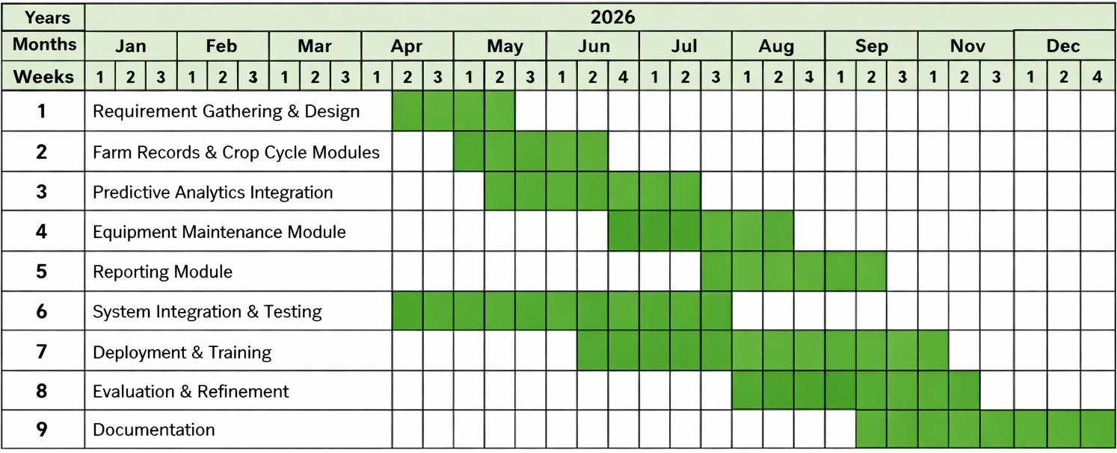

D. Economic Feasibility
AgriDataSys requires an initial investment in development and cloud hosting but provides significant long-term benefits through improved yield forecasting, reduced losses, and better resource management.
Cost-Benefit Analysis (5-Year Projection):
Year | Costs (₱) | Benefits (₱) | Net Gain (₱)
1 | 250,000 | 300,000 | +50,000
2 | 100,000 | 400,000 | +300,000
3 | 100,000 | 450,000 | +350,000
4 | 120,000 | 500,000 | +380,000
5 | 120,000 | 550,000 | +430,000

The five-year projection shows a steady increase in net gain, beginning with modest returns in Year 1 and achieving full profitability by Year 3. The initial investment covers development, cloud infrastructure, and user training, while subsequent years benefit from automation and data-driven decision-making. By Year 5, AgriDataSys demonstrates strong financial sustainability, with cumulative savings from reduced manual labor, fewer crop losses, and optimized resource allocation. The system’s scalability ensures that as more farmers adopt the platform, operational costs remain stable while benefits continue to grow. Overall, the Cost-Benefit Analysis confirms that AgriDataSys is economically feasible, offering a high return on investment and long-term value for agricultural communities.

Assessment Rubric:

Criteria (%) | 100 | 90 | 80 | 70
Accuracy | Accurate, comprehensive, and sufficiently specific user requirements and  technical specification. | Accurate user requirements and technical specification that cover most aspects of the system. | User requirements and technical specification cover only some aspects of the system, and miss some significant aspects, or  characterize them inaccurately. | Insufficient user requirements and technical specification: meeting the stated requirements and specifications does not solve the stated problem.
Organization | All information is easy to find and important points stand out | Can find information with slight effort. | Information difficult to locate. | Very hard to find information.
Completeness | All major system components are identified. | Most major system components are identified. | Only some system components are identified. Some major components are missing. | Non-  representative, or missing system components.
Diagrams and  Illustrations | Diagrams and  illustrations are neat, accurate and add to the reader's understanding of the topic. | Diagrams and  illustrations are accurate and add to the reader's understanding of the topic. | Diagrams and  illustrations are neat and accurate and sometimes add to the reader's understanding of the topic. | Diagrams and  illustrations are not accurate OR do not add to the reader's understanding of the topic.

Prepared by: Reviewed:

GINEO B. JUEGO, MIT GILDA J. TAUPA, DIT
Instructor III Program Chairperson

