CHAPTER III
METHODOLOGY
In this chapter it presented the methods and procedure employed by the researchers to conduct the study, aligning with the project’s objectives. It outlined and elaborated on the specific actions and tasks undertaken to complete the project.
Research Design
The researcher uses a development and descriptive method approach in obtaining the system desired in this study. The researcher utilized a range of data collection techniques such as interviews using Direct/Interview method, survey, observations, and analysis of existing documents. The methods used by the researchers enabled to gather and acquire the essentials information and data necessary of constructing the study and understanding the questions.
Research Methodology
The Agile Model is a process model within the Software Development Life Cycle (SDLC) that emphasizes iterative development, customer collaboration, and flexible responses to change. Liyanage (2021). Agile software development goes beyond specific frameworks like Scrum, Feature-Driven Development (FDD), or Extreme Programming (XP), and beyond practices such as Pair Programming (PP), Test-Driven Development (TDD), stand-ups, sprints, and planning sessions. It serves as an umbrella concept that encompasses a variety of methods and techniques, all rooted in the values and principles outlined in the Agile Manifesto. The essence of Agile lies in applying these principles to guide decisions based on the context at hand. What sets Agile apart from other approaches is its emphasis on collaboration solutions emerge through teamwork among self-organizing, cross-functional groups that select and adapt practices suited to their situation. Trivedi (2021). By applying the Agile programming method, the researchers were able to simplify and improve the process of developing both the application and the web-based system. This approach encouraged transparency, upheld quality standards, and ensured that the project stayed organized and detailed. Agile also allowed for faster development cycles, better adaptability to changing requirements, stronger teamwork, and a higher-quality final product through continuous feedback and step-by-step improvements.
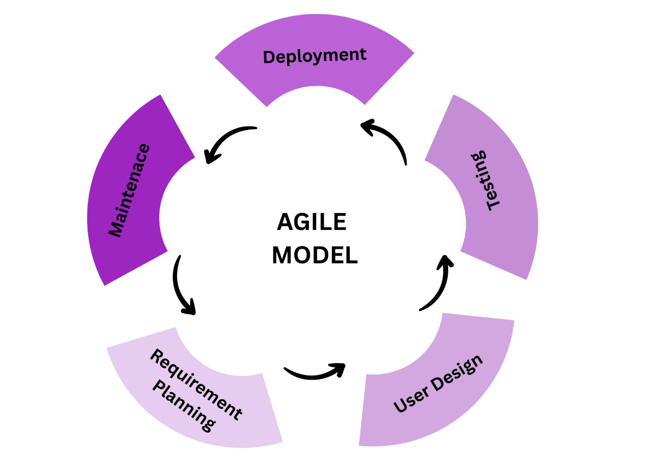
Figure 3.1
Agile Software Development Life Cycle Model
Phase 1: Requirements Planning
During the initial phase of project planning, the researcher listed the key requirements and identified possible challenges. They also prepared proactive solutions to handle these challenges during the development process.
The requirements planning phase began with consultations at Governor Mariano Villafuerte Community College, where the researcher engaged with the program head, instructors, students, and the identified client. Through these discussions, the researcher identified the school’s pressing challenges, particularly in inefficiencies such as delays inretrieving materials, inconsistrencies in course content distribution, and limited oppurtunities for interactive learning. These issues hindered effective teaching and learning, consumed significant time and resources, and prevented timely identification of struggling students.
Teachers emphasized the need for a centralized system that would allow them to record in grading sheets, accommodating both automatically checked online quizzes and manual recorded assessments, while also monitoring student performance in one platform. Students expressed the importance of consistent access to learning materials and support mechanisms that could help them comprehend lessons more effectively. Administrators highlighted insights into institutional policies and performance monitoring needs. These consultations established the foundation for the LearnSync project, ensuring that the system’s design directly responds to the school’s needs.
From these the functional requirements were defined teachers must be able to upload text-based materials, create quizzes, assign activities, and record scores, while students should access these resources and interact with an AI assistant that provides summaries, guided explanations, and adaptive feedback strictly from teacher-uploaded content. Accuracy of AI responses, and ease of use for both teachers and students.
Figure 3.1 show as the hardware requirements to successfully implemented and utilized the system. Computer hardware refers to the physical components that make up a computer system and enable it to perform essential functions, such as input, output, processing and storage. Susnja and Smalley (2026).
Table 3.1
Hardware Requirements for LearnSync: A Cloud-Based AI Academic Assistant for Student Performance Development
Hardware Requirements
Hardware | Minimum | Recommended
Processor | At least Dual Core processor | Core i3 and above, latest generation processor
RAM | 8GB | 16 GB or more
Storage | 128 GB SSD | 256 GB SSD or higher
The processor, RAM, and storage each play a distinct role in supporting the system’s performance. The processor acts as the central unit that enables the learning management platform and the AI academic assistant to run smoothly. While a Celeron processor can handle basic tasks such as uploading modules and accessing files, a Core i3 or higher is recommended to efficiently process AI assistant, generate summaries, and provide adaptive feedback without delays. RAM, on the other hand, ensures responsiveness and multitasking capabilities. With multiple students and teachers accessing the system simultaneously through the LAN, a minimum of 8 GB allows basic functionality, but 16 GB or more is necessary to prevent lags and ensure real-time performance when handling quizzes, modules, and AI responses.
Storage capacity is equally critical, as it houses lesson modules, quizzes, student records, and AI training data. An SSD provides faster file access compared to traditional HDDs, ensuring quick retrieval of instructional materials. While 128 GB is sufficient for initial deployment, 256 GB or higher is recommended to accommodate scalability, supporting larger datasets, more subjects, and future expansion of the system. Altogether, these hardware requirements guarantee that LearnSync can function as a lightweight, offline AI-powered learning management system tailored to low-resource environments. Meeting the minimum specifications ensures usability, while the recommended specifications provide sustainability and scalability, aligning with the project’s goal of bridging digital divides and enhancing teaching and learning.
Table 3.2
Software Requirements for LearnSync: A Cloud-Based AI Academic Assistant for Student Performance Development
Software Requirements
Software | Minimum | Recommended
Operating System | Windows 10/Android 10 | Windows 11/android 10 and above
Internet | 2Mbps and above
Language | Python, html, CSS, JS
Database | PostgeSQL
Table 3.2 Software requirements needed to ensure compatibility and run the system efficiently and effectively. software, instructions that tell a computer what to do. Software comprises the entire set of programs, procedures, and routines associated with the operation of a computer system. Britannica (2026).
The system design to ensure compatibility and efficient operation, the system requires specific software components. At minimum, the operating system should be Windows 11 or Android 10 and above, with the latest stable release recommended for enhanced security and performance. The system must function with internet access required, though a stable mobile data or broadband connection is advisable for smoother data transfer and real-time interactions. The programming languages used in development include Python, HTML, CSS, and JavaScript, and it is recommended to utilize updated versions of these languages to maintain compatibility with modern frameworks and libraries. For data management, PostgreSQL serves as the database system, providing reliable storage and retrieval of information, and more strict security and structure with the latest stable release recommended to ensure optimal performance and security. Overall, these software requirements are essential to guarantee that the system runs effectively, supports scalability, and delivers a seamless user experience.
. The researcher developed a Gantt chart, presented as Figure 3.2, to serve as a guide for project implementation. This chart highlighted the key milestones necessary to ensure that tasks were completed within the designated timeframe and that the overall project advanced according to the deadlines set by the researcher.

Activities | Month | January |  |  |  | February |  |  |  | March |  |  |  |  | April
 | Week | 1 | 2 | 3 | 4 | 1 | 2 | 3 | 4 | 1 | 2 | 3 | 4 | 1 |  | 2 | 3 | 4
Brainstorming, identification of possible topics
Identification of Possible Client
Client Interview and Data Gathering
Analysis of Gathering Data
Proposing of Titles
Drafting of Chapter 1-3
Design And Development Phase
Planning of System Design
Analysis of Main Function
Designing of Database and Initial Interface
Proposal Defense
Coding of the System
System Evaluation of Capstone Adviser
Drafting of chapter 4-5
Final Checking
Pre-final Defense
Revision on Documents
Revision on Documentation
Final Defense
Implementation
Turnover of the System
Submission of Final Copies of Chapter 1-5

Figure 3.2
Gant Chart of the Development of “Learnsync: An Offline Lan-based Learning Management System with AI Academic Assistant”

Phase 2: User Design
The user design phase focuses on creating a practical and user-friendly interface by involving end-users in the design process. Researchers and developers collaborate to identify user needs, workflows, and preferences, ensuring the system is intuitive and efficient. This stage often includes prototypes, wireframes, and mock-ups that allow users to visualize the system and provide feedback before full development. By engaging users early, potential issues can be addressed, resulting in a final product that is accessible, reliable, and aligned with its intended tasks.
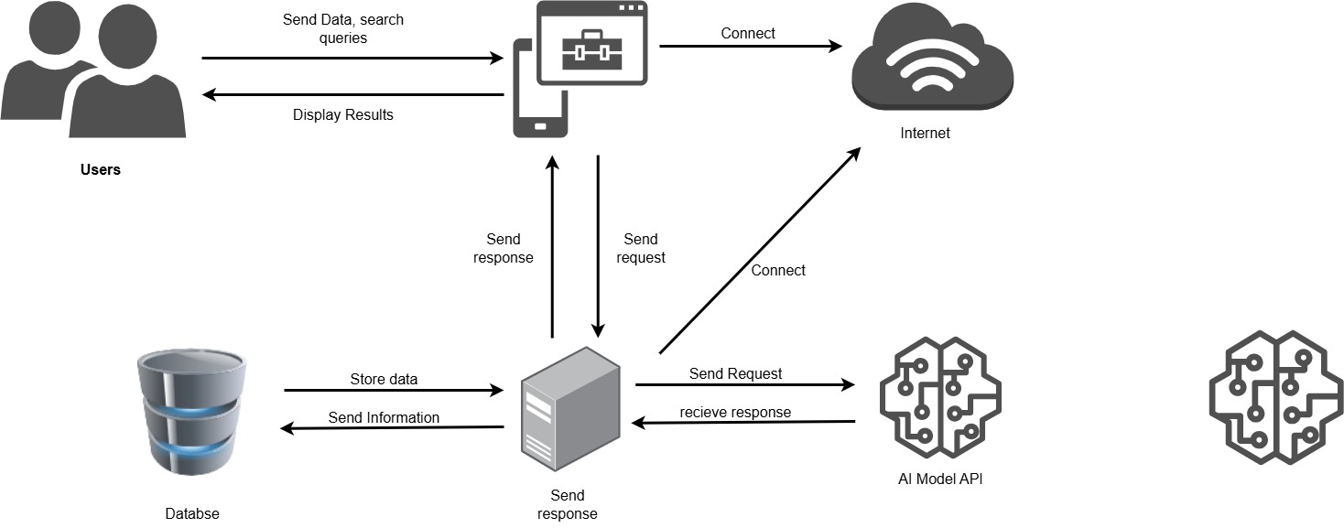
Figure 3.3
LEARNSYNC: A Cloud-Based AI Academic Assistant for Student Performance Development
Figure 3.3 illustrates the core architecture of the Learnsync: A Cloud-Based AI Academic Assistant for Student Performance Development. It highlights the main components involved in the interaction between the user and the system, including the devices, web system platform, server, database.
The process begins when the user (student or teacher) accesses the system through various devices such as smartphones, tablets, or desktop computers. These devices act as the interface, allowing students to interact with lessons, quizzes. Teachers use the same interface to upload content, record scores and grades, and monitor student progress. The client devices connect to the system via web browsers. They handle user inputs such as activities submissions, quiz answers, and AI assistant queries. These inputs are packaged into requests and sent to the server for processing.
The server acts as the central processing unit of the system. It receives requests from client devices, processes the application logic checking quiz answers, running AI generation, and manages communication between the user interface and the database. In LearnSync, the server also hosts the AI academic assistant, which provides adaptive feedback, guided explanations, and performance monitoring. While the database stores all persistent information, including user profiles, lesson modules, activity submissions, progress tracking, and quiz results. It communicates with the server to retrieve and update data in real time, ensuring accuracy and availability across the system. For LearnSync, this centralized database eliminates fragmented records and combines both online and offline scores in one platform, making grades and compilation of activities and assessments available for teacher in one place, and for the awareness of students.
This guide shows how the system flows user’s client devices server database back to users. Each component plays a vital role in ensuring smooth interaction, centralized resource management, and efficient learning delivery. This architecture is adapted to a cloud-based system, directly addressing GMVCC’s learning challenges while still providing modern AI-driven educational support.
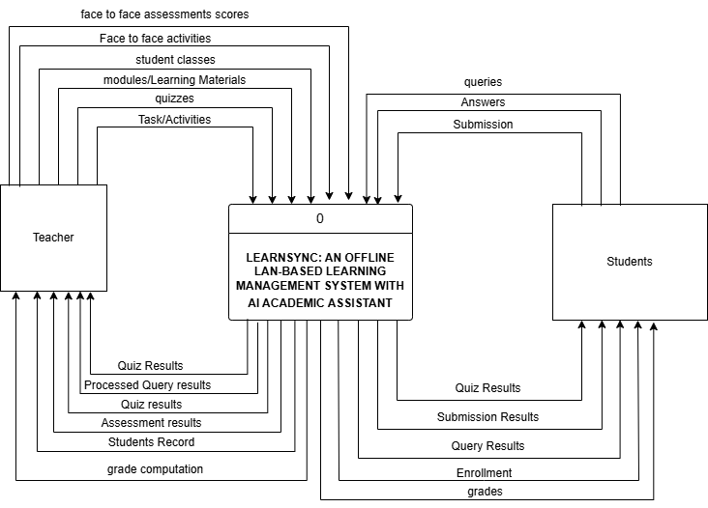
Figure 3.4
Context Diagram of Learnsync: A Cloud-Based AI Academic Assistant for Student Performance Development

The 3.4 context diagram of LearnSync:A Cloud-Based AI Academic Assistant for Student Performance Development shows how teachers and students interact with the system through a local network. At the center is the LearnSync platform, which acts as the hub for communication, data storage, and AI assistant support.
On the teacher’s side, the system allows them to manage classes, upload modules and learning materials, create quizzes and activities, and record student results. Teachers also receive processed outputs such as quiz results, submissions, assessment records, and AI query responses, as well as face to cace assessments and activities which help them evaluate performance and provide feedback efficiently.
On the student’s side, learners connect to the system to access enrollment information, modules, and activities. They submit answers, upload tasks, and attempt quizzes. Students also benefit from the AI assistant by sending queries and receiving contextual responses that guide their learning. The system returns results such as quiz scores, submission feedback, and query outputs, ensuring that students can track their progress.
Overall, the diagram highlights a two-way flow of information: teachers provide content and assessments, while students engage with the materials and submit work. The LearnSync system processes these interactions, integrates AI support, and delivers results back to both sides. This design emphasizes efficiency, unified accessibility, and automated feedback loops, making it a practical solution for learning challenges involving interactions and students comprehesion.
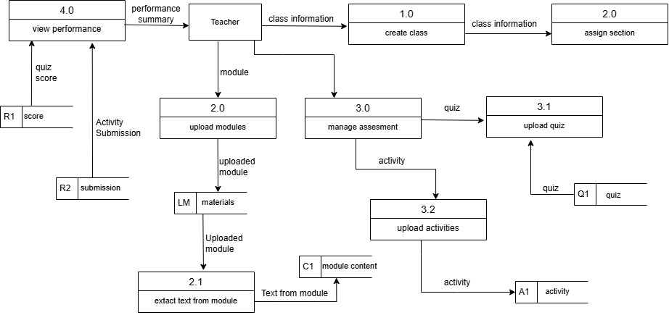
Figure 3.5
Data Flow Diagram for Teacher

Figure 3.5 illustrates the Data Flow Diagram (DFD) of the Teacher Module, showing how data moves within the system and how the teacher interacts with different processes and data elements. The diagram presents the core instructional and administrative functionalities of the module, beginning with class creation and section assignment, followed by the uploading of modules, management of assessments, and monitoring of student performance.
The process starts with Create Class (1.0), where the teacher establishes a new class to organize students and learning materials. Once the class is created, the teacher proceeds to Assign Section (2.0), grouping students into appropriate sections for better management. After sections are assigned, the teacher can Upload Modules (2.0), which serve as the primary learning materials (LM). Within this process, the system can also Extract Text from Module (2.1), converting module content (C1) into usable formats for for retrieval of data by AI Assistant.
The next major function is Manage Assessment (3.0), where the teacher oversees different evaluation tools. This includes Upload Module (3.1) for assessment-linked materials, Upload Activities (3.2) for student tasks (Act1), and the creation of quizzes (Q1) to measure student understanding. These assessment components ensure that students are continuously evaluated through structured activities and quizzes.
Lastly, the teacher can View Performance (4.0), which consolidates student outcomes. This process retrieves Scores (R1) from quizzes and activities, as well as Submissions (R2) from student work. By analyzing these results, the teacher gains insights into student progress, engagement, and overall performance.
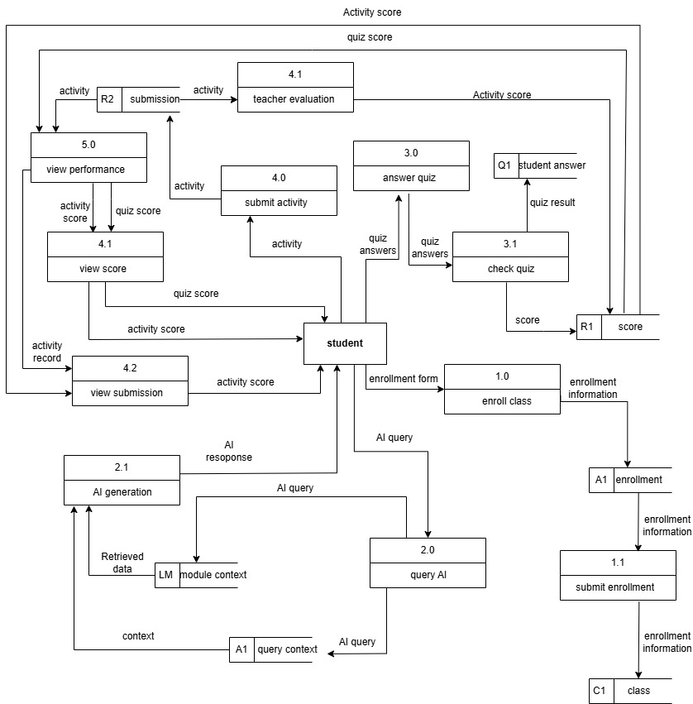
Figure 3.6
Data Flow Diagram for Student
Figure 3.6 illustrates the Data Flow Diagram (DFD) for the Student Module, showing how student interactions progress through the system and how data is exchanged among processes and data stores to support learning activities. The flow begins with the enrollment process, where the student initiates participation through Enroll Class (1.0) and submits details via Submit Enrollment (1.1). These records are stored in the Enrollment (A1) data store and linked to the Class (C1) data store, establishing the student’s access to the course.
Once enrolled, the student may interact with the AI assistant through Query AI (2.0). The query context is retrieved from the enrollment data and processed by AI Generation (2.1), where the Language Model (LM) provides tailored responses to support learning. This step highlights the integration of AI into the system, enabling students to receive contextualized guidance and assistance that complements traditional instruction.
The next stage involves quiz interaction, where the student answers assessments through Answer Quiz (3.0). Responses are recorded in the Student Answer (Q1) data store and evaluated by Check Quiz (3.1), producing a Score (R1) that delivers immediate feedback. Beyond quizzes, students engage in activity submission and teacher evaluation. Through Submit Activity (4.0), assignments are forwarded to Teacher Evaluation (4.1), where teachers assess the work. Results are stored in the Submission (R2) data store, and students can access both their scores and submissions via View Score (4.1) and View Submission (4.2), ensuring transparency in evaluation.
The system supports performance monitoring through View Performance (5.0), which consolidates scores, submissions, and AI interactions into a comprehensive overview of student progress. Overall, the DFD demonstrates a structured and integrated flow of data between the student, AI system, and teacher. It highlights how the platform supports interactive learning through enrollment management, AI-assisted queries, automated quiz scoring, teacher-led evaluation, and performance tracking. This ensures a balanced environment where automation enhances efficiency while teachers provide qualitative oversight, resulting in a comprehensive and student-centered educational experience.
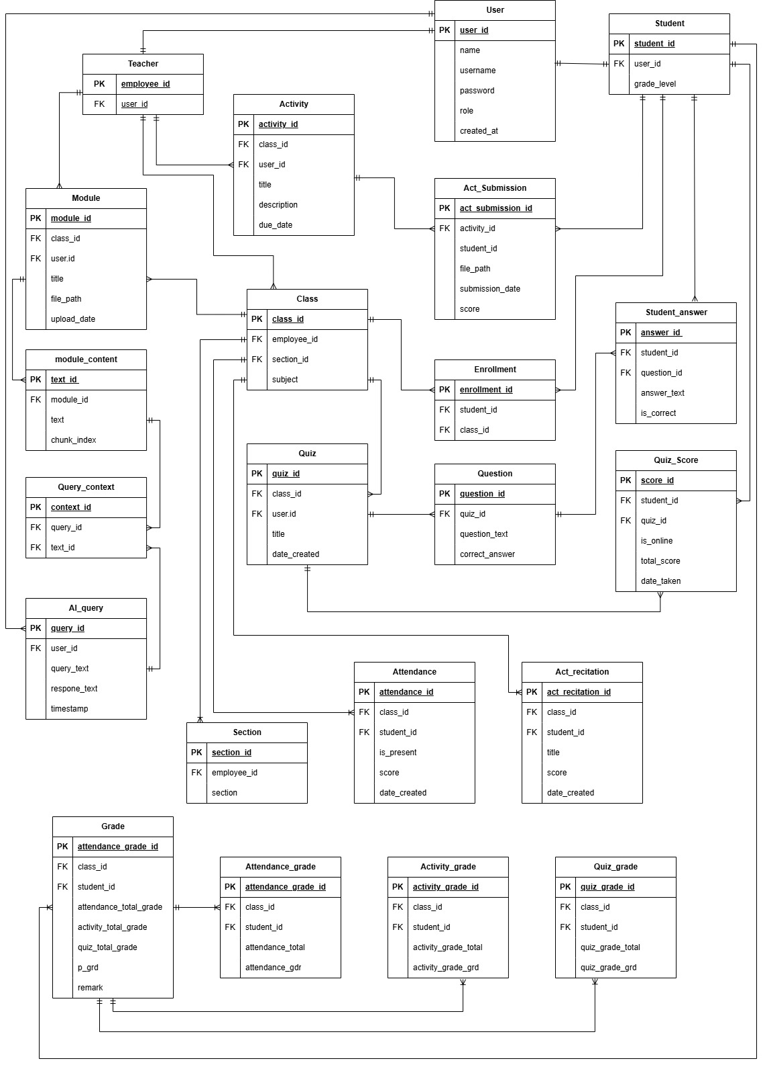 Figure 3.7
Entity Relationship Diagram of “Learnsync: An Offline Lan-based Learning Management System with AI Academic Assistant”
The Entity-Relationship Diagram (ERD) of the Learnsync: An Offline Lan-based Learning Management System with AI Academic Assistant illustrates how the database is organized to support teaching, learning, and assessment. At the center of the design is the Users entity, which stores essential information such as login credentials, names, roles, and account creation dates. This central table connects directly to both Teachers and Students, ensuring that every participant in the system is properly identified and managed. Teachers are linked to classes they handle, while students are tied to their accounts through their student ID number.
The academic structure is represented by the Classes and Enrollment entities. A class is defined by subject and section, and it is associated with a teacher. Students join classes through the enrollment table, which serves as a bridge between learners and their assigned subjects. Learning materials are organized in the Modules entity, which stores uploaded files and metadata such as titles and dates. To enhance accessibility, module content is broken down into smaller chunks through the Module content entity, allowing for easier retrieval and processing.
Learning activities are managed through the Activities entity, which contains assignments and tasks created by teachers. Student responses are stored in the Submissions entity, including file paths, submission dates, and scores. Assessments are handled by the Quizzes entity, which is linked to specific classes and teachers. Each quiz contains multiple Questions, and student responses are recorded in the student answers entity, marking whether answers are correct. Final results are summarized in the Scores entity, which tracks total scores and completion dates.
Attendance, activities and quizzes were recorded independently for each table and computed through grade table that is associated with each students and stores result for faster retrieval and reduced repeatitive computation in the background process of the application.
Beyond traditional learning, the ERD also integrates AI support through the AI query and Query context entities. These tables log user queries to the AI assistant, store responses, and connect queries to relevant module content, enabling intelligent, context-aware assistance.
The ERD demonstrates a well-structured system where users are at the core, classes and enrollments define academic organization, modules and activities deliver content, quizzes and scores measure performance, and AI queries provide additional support. The design ensures data integrity, scalability, and complete tracking of student progress, making it an effective backbone for a modern educational platform.

NOTES
Liyanage, N. (2025). The Agile Model in SDLC: A Flexible Approach to Software Development. https://medium.com/@nld.anuradha/the-agile-model-in-sdlc-a-flexible-approach-to-software-development-664bf60ad9dc
Trivedi, A. (2021). Agile Methodology. https://www.academia.edu/63919942/Agile_Methodologies?fbclid=IwY2xjawRAIZtleHRuA2FlbQIxMABicmlkETEydmk1cjRsdDFWZk82NU9Uc3J0YwZhcHBfaWQQMjIyMDM5MTc4ODIwMDg5MgABHvQ6Dfn7XK_3dhFuTtc9uMGIsc5dOqtKui0bGKNxlSaZVT6CrxqAMl2wCefp_aem_bssED0NwwM7QVJPQsUvAsg
Susnjare, S., & Smalley, I. (n.d). What is Computer Hardware https://www.ibm.com/think/topics/hardware?fbclid=IwY2xjawRAIqVleHRuA2FlbQIxMABcmlkETEydmk1cjRsdDFWZk82NU9Uc3J0YwZhcHBfaWQQMjIyMDM5MTc4ODIwMDg5MgABHgdrV4MoZvt9r4vcwwKZkNYz6QkEZZduSAqZk12L8wC7Ld3PP-sit6S2M4Tb_aem_4-z4V3zfkIiJ6GsBmE2fzQ
Britannica. (2026). Software. https://www.britannica.com/technology/software/software

