**Lab exam Big Data&AI**

**Part 1**

I anticipate a 2/5

I give you 3/5 for the module

I reworked the dockerfile to ensure the requirements.txt file is not done over all the time.

I used docker compose up –build, docker compose down and docker compose restart

**Part 2**

To search for agent 2 I used kubectl get nodes and got the following output:

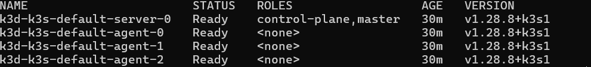

So I implemented it in the frontend service yml.