Firstly, I did know a bit of HTML, because of a participation in a school event. So I started by mapping out the bare bones structure of the web sites homepage. This was the first version that I came up with. My thought process was to firstly map out the page I wanted on a paper, and then execute it into a simple structure on HTML.
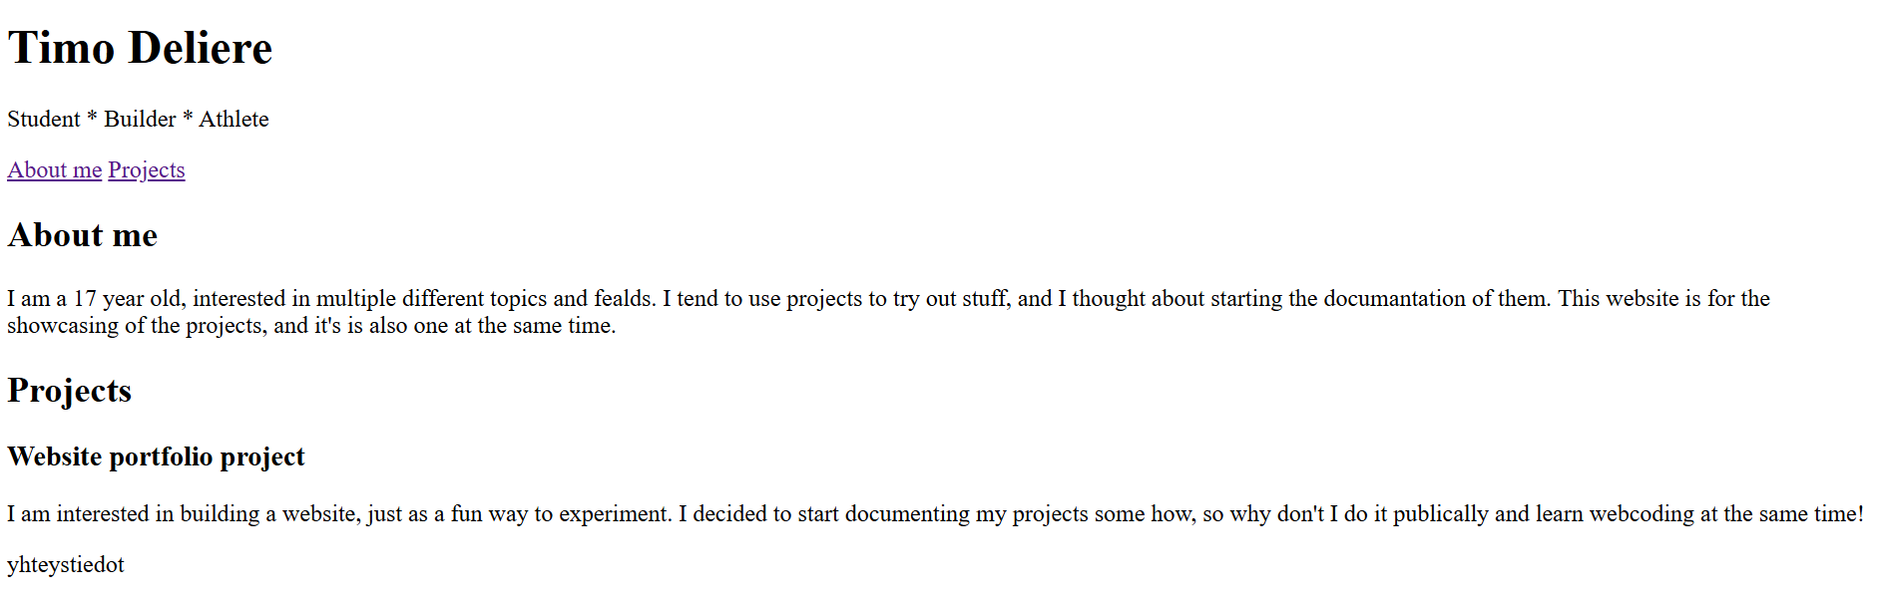
While building this I learned to use the attribute <nav>, with it I also learned to make IDs for sections. This made possible to get a simple navigation tool into the website.
My next step, was to start using css. CSS is a completely new language for me, so I had to start learning it to be able of achieving what I wanted. This is the part of projects I like, learning something new to accomplish something! With what I learned I was able to make my page look a little nicer. Thought, it is still really bad for a professional looking portfolio page. With this addition I also added image placeholders, until I get propper pictures for my projects. This happened using HTML
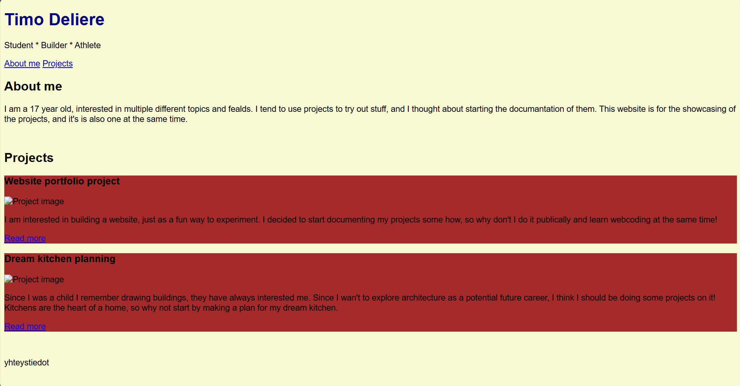
HTML code: (Laita tähän esimerkiksi linkki joka, johtaa sitten toiselle sivulle, jossa näytetään koodit eri vaiheissa) Koodi on tässä vain väliaikaisesti, jotta se säilyy.
<!DOCTYPE html>
<html>
<head>
<title> TD's project portfolio </title>

<link rel="stylesheet" href="style.css">
</head>

<body>

<header>
<h1>Timo Deliere </h1>
<p>Student * Builder * Athlete</p>

<nav>
<a href="#About_me">About me</a>
<a href="#Projects">Projects</a>
</nav>

</header>

<main>
<section id="About_me">
<h2> About me</h2>
<p> I am a 17 year old, interested in multiple different topics and fealds.
I tend to use projects to try out stuff, and I thought about starting the documantation of them.
This website is for the showcasing of the projects, and it's is also one at the same time.
</p>
</section>

<section id="Projects">
<h2>Projects</h2>
<div id="project-card">
<h3>Website portfolio project</h3>
<img src="" alt="Project image">
<div id="project-summary">
<p>I am interested in building a website, just as a fun way to experiment.
I decided to start documenting my projects some how, so why don't I do it publically
and learn webcoding at the same time!
</p>
</div>
<a href="Toinen dokusivu, jossa nettisivudoku kokonaisuudessaan">
Read more
</a>
</div>

<div id="project-card">
<h3>Dream kitchen planning</h3>
<img src="" alt="Project image">
<div id="project-summary">
<p>Since I was a child I remember drawing buildings, they have always interested
me. Since I wan't to explore architecture as a potential future career, I
think I should be doing some projects on it! Kitchens are the heart of a home,
so why not start by making a plan for my dream kitchen.
</p>
</div>
<a href="Toinen dokusivu, jossa keittiönsuunnittelu projektin doku">
Read more
</a>

</div>
</section>
</main>

<footer> yhteystiedot </footer>

</body>
</html>

