Methodology of Project
This AI-powered Swachhta monitoring system operates through dual data streams — CCTV camera feeds and citizen-reported uploads, both of which trigger auto-report generation. The system uses deep learning, smart alerts, and real-time dashboards to ensure cleaner public spaces and encourage civic participation.

- Dual Data Acquisition
  - CCTV Feeds (Automated Monitoring)
    - Live feeds or periodic snapshots from public cameras.
    - Captures waste, bins, littered areas, and vegetation.
  - Citizen Uploads (Crowdsourced Reporting)
    - Citizens upload images via mobile/web interface.
    - Each upload includes a timetable, location, optional category, and remarks.

- Auto-Report Generation (No Manual Gatekeeping)
  - AI-Powered Reports (from CCTV)
    - YOLOv8 processes the feed and detects cleanliness violations.
    - Violation reports are automatically generated with:
      - Violation type
      - Location data
      - Cleanliness score
      - Image snapshot
  - Citizen-Triggered Reports
    - Every valid citizen uploads a report instantly.
    - No AI moderation needed — fast-track logging and staff assignment.
Result: Dual auto-reporting ensures both proactive (AI) and reactive (public) cleanliness monitoring.

- Task Assignment & Cleaning Workflow
  - Violation reports (from either source) are assigned to staff/admins based on:
    - Violation category
    - Geo-tag and zone priority

  - Staff receive tasks with image + location and clean the site.
  - They upload "cleanup proof" images after resolution.

- Feedback & User Notification Loop
  - System compares new image (AI/manual) to verify the cleanup.
  - Once confirmed:
    - Citizen reporters receive feedback:
      - Notification: ⬛“ Your reported issue has been cleaned!”
      - Before/after image (optional)
      - Feedback form (thumbs up/down)
  - Negative feedback re-initiates cleanup or flags for review.

- Predictive Cleanliness Risk Analysis
  - Uses:
    - Festival/calendar patterns
    - Public footfall data
    - Location types
    - Historical violation trends
  - Generates risk heatmaps for proactive action by municipal authorities.

- Admin Dashboard Capabilities
  - Unified view of:
    - AI-generated and citizen-uploaded reports
    - Cleanup task progress
    - Real-time cleanliness map
    - User feedback and staff response logs
  - Manual override for false positives/negatives

- Gamified Citizen Participation (Optional)
  - "Spot & Solve" module:
    - Badges or points for users who report valid violations.
    - Leaderboard for top reporters.
    - Community engagement and reward options.

Scalability & Government Integration
  - Runs on existing public infrastructure (CCTV, mobile).
  - Easily deployable across:
    - Schools, bus stops, post offices, smart cities
  - Compatible with APIs from:
    - Swachh Bharat Mission
    - LiFE (Lifestyle for Environment)
    - MyGov platforms

Flow of the System
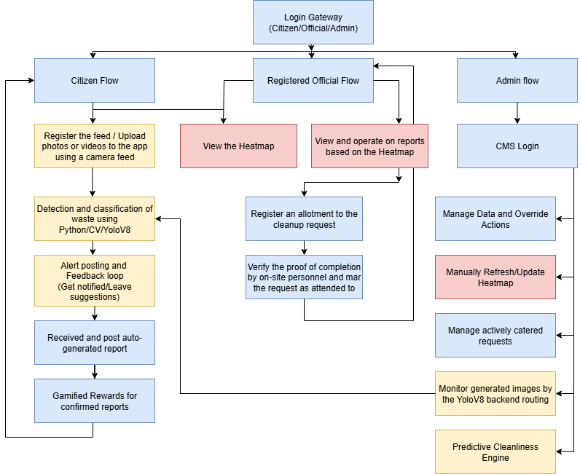

START: User Access
  - User lands on Web/Mobile Platform
  - Decision Node: Role
▶ Citizen
▶ Official (NGO/Govt/Volunteer)
▶ Admin (System Manager)

- Citizen Flow
  - Registration/Login
    - Creates account or logs in
  - Submit Violation Report
    - Uploads:
      - Image
      - Auto-location (GPS)
      - Optional: Category + Remarks
    - Instant Auto-Report Created (No moderation)
    - Stored in Report Database
  - View Public Cleanliness Heatmap
    - Citizen views:
      - Nearby reported issues (crowdsourced + AI)
      - Cleanup status (open/resolved)
      - Risk zones (from prediction model)

  - Feedback After Cleanup
    - If their report is resolved:
      - Gets notified with before/after images
      - Submits thumbs up/down
      - Negative? → Flags the report for re-verification
  - Gamified Rewards
    - Earns points for valid reports
    - Leaderboard of top contributors

- Official (NGO / Volunteer / Gov Body) Flow
  - Registration/Login
    - Registers as Official Role
    - Assigned to zone/area of operation
  - Access Real-Time Heatmap
    - Sees:
      - AI and Citizen reports (open only)
      - Location + Image + Violation type
      - Prioritized by:
        - Geo-zone
        - Severity
  - Claim Cleanup Task
    - Selects open report
    - Accepts/Confirms cleanup
    - Task assigned in backend
    - Receives route/location map + original image
  - Perform Cleanup + Upload Proof
    - Uploads “after cleanup” image
    - System auto-verifies (AI or Admin)
      - If verified: Marked Resolved
      - Else: Flagged for review

- Admin Flow (via CMS Panel)
  - Admin Login (CMS Interface)
    - Full access to:
      - User roles
      - Reports & moderation
      - System settings
      - Heatmap data
      - Task logs
  - Manage Data & Override Actions
    - Monitor:
      - Citizen uploads
      - CCTV AI detections
      - Feedback flags
    - Can:
      - Manually verify/reject reports
      - Reassign cleanup tasks
      - Edit zone data and heatmap thresholds
  - CCTV Feed (Automated Loop)
    - Live/interval snapshots processed via YOLOv8

    - Detects:
      - Litter, overgrowth, bins, etc.
    - Auto-generates violation reports
    - Feeds into:
      - Heatmap
      - Report DB
      - Official task list
  - Predictive Cleanliness Engine
    - Uses:
      - Historical data
      - Footfall trends
      - Festival/calendar dates
    - Generates:
      - Risk heatmaps
      - Zone priority suggestions
      - Shown to:
        - Admins
        - Officials
        - Citizens (read-only)

Core Shared Modules Report Database
    - Stores:
      - AI Reports (CCTV)
      - Citizen Reports
      - Cleanup status
      - Images, timestamps, location Real-Time Heatmap
    - Layers:
      - Open issues (red)
      - In progress (yellow)
      - Resolved (green)
      - Predictive hotspots (purple)

Feedback & Verification Loop
    - Applies to:
      - Citizen feedback
      - AI confidence score
      - Admin override
    - If flagged → routed back to Admin or Official

