In this project, you'll have the opportunity to demonstrate your new web development skills by re-creating a webpage from a design prototype.

This is a common workflow for front-end web developers. Typically, you'll be provided with a design prototype that needs to be translated into an actual, functional website.

The design prototype used in this project (which you can see in the image below) is inspired by trading cards and features a fish you might recognize from a popular animated film. You’ll be creating a card like this and swapping out the fish with an animal of your choice.

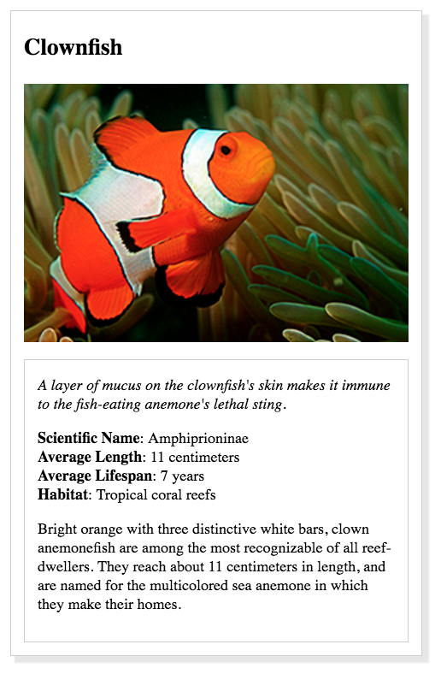

In most cases, designers only provide you with the design prototype and nothing else. For this project, we've also provided you with the HTML. We've done this so you can focus on the main point of this project—which is to demonstrate your ability to add style to a page using CSS.