Analysis of Variational Quantum Classifiers for Binary Classification using Quantum Simulators
Daniil D. Shvetsov¹[0009-0004-2913-8940] and Anton I. Kanev²[0000-0002-0678-7700]
Bauman Moscow State Technical University, Moscow, Russia
¹shdd22u351@student.bmstu.ru
²aikanev@bmstu.ru
Abstract. This paper investigates the training of quantum binary classifiers using quantum simulators with limited computational resources. It demonstrates that, although memory size remains the primary limitation for simulators, modern classical computing systems can effectively simulate quantum schemes, achieving classification accuracy comparable to classical models within fewer epochs in short time frames when constrained to a small number of qubits. Additionally, it is shown that training time scales exponentially with the number of qubits even when the number of weights does not change, although training time also scales linearly with the number of qubits.
Keywords: quantum machine learning, quantum neural networks, binary classification, variational quantum circuit, quantum simulator.
- Introduction
Due to recent breakthroughs in quantum machine technologies, the task of designing and testing of quantum circuits that will be subsequently implemented on said devices has become more relevant than ever before. Despite the existence of the option to test quantum circuits on real quantum computers provided by companies like IBM, Google, Microsoft, and others, access to such services remains limited.
Nevertheless, the use of quantum simulation technologies comes with its own set of difficulties, with the primary technical limitation in the form of RAM utilization: the simulation program must store the entire state vector of the quantum circuit in memory, the size of which grows exponentially with the number of qubits. In addition to this, the execution time of simulations is a significant constraint because of the computational difficulty of simulating quantum behavior on binary systems. This is especially true for quantum machine learning algorithms, where the complexity of optimization procedures substantially increases computational costs.
As such, one of the objectives of this paper is to compare the execution speed and efficiency of a number of optimization algorithms within the context of quantum machine learning on personal computers with varying levels of computational power.
The term "quantum machine learning" used above will refer to the use of quantum circuits in processing of classical data. This area is among the most studied within the broader scope of utilization of machine learning principles in quantum computing, and includes a number of research papers in the fields of binary [1], one-class [2], and multi-class classification [3]. Most of the studies on the subject employ variational quantum classifiers, or VQCs, which demonstrate results comparable to classical machine learning algorithms. Therefore, this work will mainly study binary classification models based on variational quantum circuits.
- Variational Quantum Classifiers
Variational Quantum Classifiers have achieved widespread adaptation due to the relative ease with which they can be run on modern Noisy Intermediate-Scale Quantum devices [4] and their perspective use for machine learning with limited quantum resources.
A variational quantum scheme is composed from three main elements: the feature map, the ansatz and the optimizer. The feature map is used to transform classical data into their quantum counterparts for the subsequent training process [5]. This process is especially important when working with less common data types, such as speech [6] and LIDAR data [7]. To achieve this, a variational quantum scheme usually starts with a set of qubits, all of them in the state $\left|\left.0\right\rangle \right.$. After that a Hadamard gate is applied to each qubit, creating an equal superposition between $\left|\left.0\right\rangle \right.$ and $\left|\left.1\right\rangle \right.$. Then, typically, parameterized phase shift gates are applied to the qubits based on the input parameters, changing the phase of the qubit but not the probability of measuring $\left|\left.0\right\rangle \right.$ or $\left|\left.1\right\rangle \right.$, thus encoding the classical data into a quantum state.
Among the most widespread feature maps, the two most used are ZFeatureMap and ZZFeatureMap. The main characteristic of ZFeatureMap is its simplicity: each feature of the dataset is encoded using a single phase shift gate on a single distinct qubit, as shown in Fig. 1.
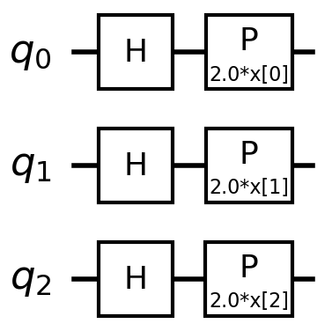
Fig. 1. ZFeatureMap for 3 qubits
In contrast, the ZZFeatureMap entangles qubits, as shown in Fig. 2, enabling the modeling of feature interactions and potentially enhancing the classification capability of the quantum model. Alternatively, by entangling qubits in the feature map, one can reduce the size of the ansatz, thus reducing training time. However, employing the 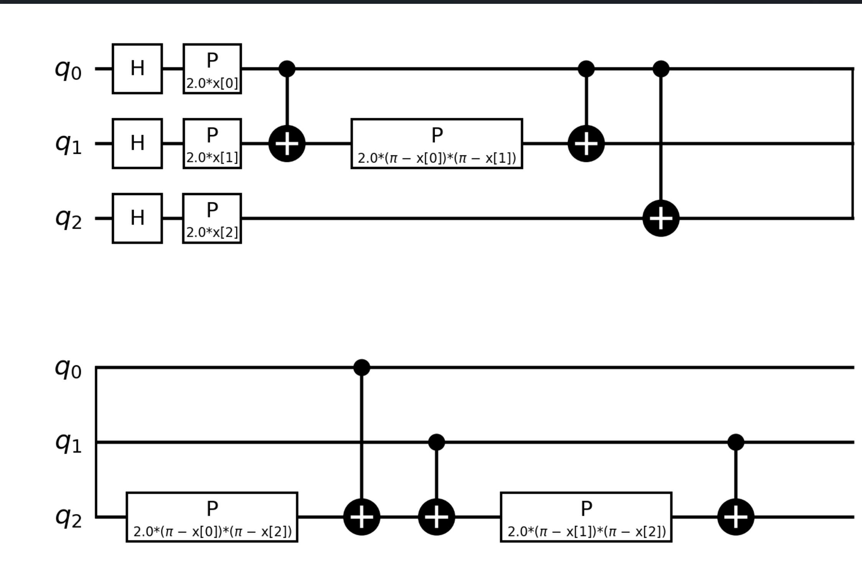ZZFeatureMap increases the circuit depth and implementation complexity, as well as reduces noise robustness.

Fig. 2. ZZFeatureMap for 3 qubits
The ansatz is a parametric quantum circuit that is directly utilized during the training process. Ansatz consists of a sequence of quantum gates with configurable weights, usually in the form of rotation operation gates, that enable the modeling of complex functions and interactions between data features, with feature interactions implemented through qubit entanglement. Additionally, rotational gates that are not diagonal in the computational basis combine amplitudes from the different basis states in nontrivial ways, thus changing the norm. because of this, the architecture of the Ansatz is crucial in achieving a well performing model.
One of the simplest but nonetheless effective ansatzes is the RealAmplitudes ansatz that consists of a sequence of uniform CNOT gates and layers of rotations around the Y-axis. This ansatz is characterized by its use of only the real amplitudes of the quantum states, which potentially simplifies its implementation and lowers the hardware requirements of the quantum computer, while still allowing for a certain amount of flexibility in the modeling of complex functions by repeating the layer multiple times, as seen in Fig. 3.
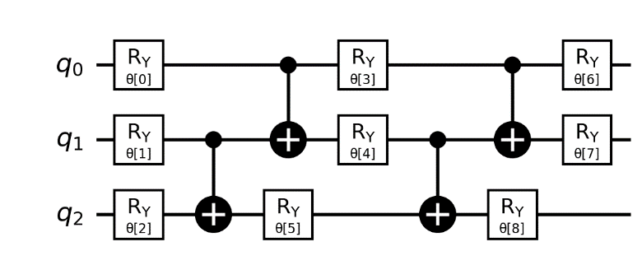
Fig. 3. RealAmplitudes Ansatz for 3 qubits with two repetitions
Despite the many upsides of the RealAmplitudes scheme, its simplicity may lead to a worsening in the quality of the resulting model, so a more complex alternative to it can be found in the EfficientSU2 ansatz [8], which, in addition to the rotations around the Y-axis consists of layers of Z-axis rotational gates, as is shown in Fig. 4. This makes the resulting quantum scheme substantially more effective and flexible in modeling complex functions, but does increase the number of parameters by a factor of two.
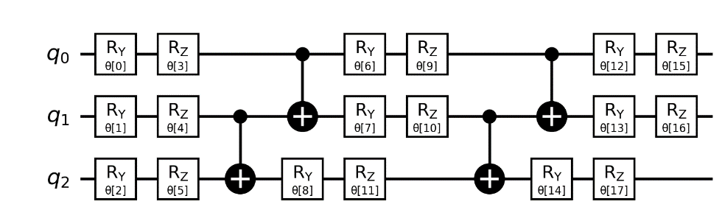
Fig. 4. EfficientSU2 ansatz for 3 qubits with two repetitions
Finally, the training process of quantum variational classifiers, similar to neural networks, is carried out through the minimization of a loss function using optimization algorithms. The training is performed by changing the weights in the ansatz, denoted using the Ѳ symbol. The main methods of minimization used in quantum machine learning include:
- The Limited-memory Broyden–Fletcher–Goldfarb–Shanno (L-BFGS) algorithm – an iterative optimization method designed for solving large-scale unconstrained nonlinear problems. It belongs to the family of quasi-Newton methods, which approximate the Hessian matrix of the objective function to guide the search for a local minimum. Unlike classical BFGS, L-BFGS maintains a limited amount of memory by storing only a few vectors that represent recent updates, making it particularly suitable for high-dimensional problems where storing the full Hessian is computationally infeasible. The algorithm iteratively updates the solution estimate by computing search directions based on these approximations and employs line search techniques to determine optimal step sizes, ensuring convergence under suitable conditions.
- The Constrained Optimization BY Linear Approximation (COBYLA) algorithm - a derivative-free optimization method designed for solving nonlinear constrained problems where gradient information is unavailable or expensive to compute. It employs a sequential approximation approach, constructing linear models of the objective function and constraints within a trust region framework. At each iteration, COBYLA generates a new candidate point by solving a linear programming subproblem that approximates the original problem locally, then updates the model based on the evaluated function values. This process continues iteratively, balancing exploration and refinement within the trust region until convergence criteria are met.
- Research Objective
The primary two factors influencing the efficiency of quantum circuit simulation are the amount of available RAM, which is necessary for storing the quantum state vector and the system's overall performance, which depends on numerous elements such as processor clock speed, RAM bandwidth, cache sizes, and other hardware characteristics.
The amount of available RAM does not directly influence the speed of the training and or simulation process, save for the cases where the state vector takes up so much space there is not enough left for the other system processes. Nevertheless, it remains the primary, if not the only hardware limiting factor on the number of qubits a simulator can run. Assuming that the circuit consists of N qubits, each entangled with the others—as is the case for ansatz used in VQCs — the amount of memory required to store the state vector is:
$M=2×P×2^{N}$ (1)
where P is the amount of memory necessary to store one real number in whatever language the simulator is using.
Thus, the initial step of the research involves determining the technical limitations to the complexity of simulated quantum circuits, specifically the maximum number of qubits in a quantum circuit a system with a certain amount of ram can handle, as well as evaluating the performance of various personal computers capable of simulating quantum circuits. For this purpose, the StateVector AerSimulator from the IBM Qiskit library will be employed.
The second step in investigating the efficiency of quantum circuit simulation, following the assessment of the system's technical limitations, involves examining the temporal aspect of training VQCs for different numbers of qubits and optimization algorithms. The metric used to show the training speed of the model will be called Epoch Time Per Weight (ETPW) and calculated using the following formula:
$ETPW=\frac{P}{E×C×W}\sum_{i=1}^{E}{T_{i}}$ (2)
where E is the number of epochs measured, C is the number of records in the training dataset, T_{i} is the duration of a single epoch, W is the number of weights used in the ansatz and P is the number of epochs required per “step”. This variable is introduced due to the iterative nature of the COBYLA algorithm, which sequentially explores basis sets, performing an update for each parameter before moving on to new weights.
This metric provides a way to compare how long one epoch of a certain combination of optimizers and ansatz take on a specific system regardless of the number of weights and the dataset used, thus providing a more objective comparison between them.
The third step of the research is to determine the effectiveness of the resulting models trained using the simulator with limited computational resources compared to classical classification algorithm on the same dataset that has significantly more features then the maximum number of qubits in the simulator.
Using a dataset with a number of features significantly exceeding the available qubits is motivated by the desire to explore the potential advantages of quantum machine learning in handling high-dimensional data. Although current quantum hardware is limited in the number of qubits, many real-world datasets are inherently high-dimensional, containing complex feature interactions that are challenging for classical algorithms as well. Applying dimensionality reduction techniques such as PCA allows us to evaluate how well quantum classifiers can capture complex data structures and whether they can offer advantages over classical methods, even when operating with a limited number of qubits relative to the original data dimensionality.
- Research Results
For the investigation of the technical limitations of quantum algorithm simulation, two computing systems were utilized:
- A personal computer equipped with a Ryzen 9 7950X processor, featuring a base clock speed of 4.0 GHz and 16 GB of LPDDR5 RAM with a speed of 6400 MT/s.
- A personal computer powered by an Intel Core i7-11700K processor, with a base clock speed of 2.5 GHz and 64 GB of DDR4 RAM operating at 2667 MT/s.
The performance of these systems will be compared using the FLOPS (floating-point operations per second) metric to evaluate their computational capabilities in the context of quantum simulation tasks.
Fig. 5. Results of FLOPS measurement depending on the number of utilized threads with personal computers (1) and (2)

As can be seen in Fig. 5, the FLOPS measurement almost doubles each time for the first 8 threads, which is as expected, considering that both processors have 8 cores, but after that the performance increase slows down considerably, with the increase from 8 to 16 threads being slightly more than the increase seen between any of the first eight.
As for the maximum number of qubits in a circuit, the IBM Qiskit library allocates 8 bytes for one real number, thus, according to formula (1), PC (1) with 16 GB of RAM can handle up to 29 qubits and PC (2) with 64 GB of RAM can simulate up to 31 qubits.
Having obtained the FLOPS metric, we measured and compared the ETPW metric, defined using formula (2), between PC (1) and (2) using the COBYLA and the L_BFGS optimizer. To do this, we used a quantum circuit consisting of a ZFeatureMap with one repetition and an EfficientSU2 ansatz with three repetitions. To train the circuits, a dataset with 1000 records in it has been generated.
As seen in Fig. 6, despite the linear increase in efficiency with each new thread seen in Fig. 5, the ETPW metric shows that on low numbers of qubits, about 11-12 qubits, lower numbers of threads produce lower training times. And even when the number of qubits increases past 12, the difference between the best ETPW is only about four times as low compared to the single-threaded attempt. This result can likely be explained by the fact that the overhead associated with managing multiple threads outweighs the benefits provided by parallelization at lower numbers of qubits.
From Fig. 5, Fig. 6a and Fig. 6c it can be observed that the average difference in ETPW between PC (1) and PC (2) almost exactly matches the difference in their FLOPS score with a 1.05 average increase at 1 threads, 1.16 increase at 6 threads, a 1.29 increase at 11 threads and a 1.26 increase at 16.

Fig. 6. ETPW measurements for: (a) COBYLA Optimizer on PC (1); (b) L_BFGS Optimizer on PC (1); (c) COBYLA Optimizer on personal computer (2); (d) L_BFGS Optimizer on PC (2), presented on a logarithmic scale
In addition to this, from Fig. 6a and Fig. 6b it can also be seen that the COBYLA optimizer displays significantly better Epoch time at lower numbers of qubits, with the highest being an almost 10 times increase in speed, though at higher levels the difference is nowhere near as substantial. This can be attributed to the fact that the COBYLA algorithm only computes the linear approximation of the gradient, while L_BFGS computes gradient of the objective function at each iteration. Because of this, it is also important to note that COBYLA will in general have a slower convergence compared to L_BFGS and it has a tendency to experience a deterioration in performance as problem dimensionality increases, proven by the data in Fig 6.
Separately, a comparison between the ETPW metric for quantum classifiers containing an EfficientSU2 and RealAmplitudes ansatz has been performed. As can be seen in Fig. 7, the RealAmplitudes ansatz is marginally better than the EfficientSU2 ansatz, while the ETPW can be seen to increase linearly with the number of weights in the circuit, as the ETPW for EfficientSU2 with 3 repetitions is 3 times higher than EfficientSU2 with 1 repetition at higher numbers of qubits, the same being observed with 6 repetitions.

Fig. 7. ETPW measurements using the COBYLA algorithm with different ansatz
As both RealAmplitudes ansatz and EfficientSU2 ansatz have almost identical training times, both have been used to compare with a classical binary classification algorithm. To train the classical and quantum classifiers, the ECG5000 [9] dataset was selected, containing 5000 ECG measurement records in 140 consecutive points. From this dataset, 500 normal and 500 anomalous records were chosen to form a training dataset of 1000 records, and similarly, 1000 records were selected for the validation dataset.
Then, the dataset values were normalized using the formula:
$X=\frac{X-X_{min}}{X_{max}-X_{min}}×2×π$ (3)
where $X_{min}$ is the minimum value among all measurements; $X_{min}$ is the maximum value among all measurements.
The formula (3) results in values ranging from 0 to 2π thus encompassing the whole Bloch sphere, which results in the best possible encoding using the ZFeatureMap.
The dimensionality of the resulting dataset was then reduced using PCA [10], and the final features were used to train a perceptron, similar to other studies performed using electrocardiograph data [11] with one hidden layer, the number of units in which was equal to half the number of dataset features, as well as the quantum variational classifiers. To compare VQCs with similar training times, an EfficientSU2 ansatz with two repetitions and a RealAmplitudes ansatz with four repetitions have been used.
As seen in Table 1, the VQC with the RealAmplitudes Ansatz performs significantly worse compared to both the classical model and the VQC with the EfficientSU2 ansatz. At the same time, the VQC with EfficientSU2 produces results with accuracy comparable to the perceptron while requirement almost twice as few training epochs.
Table 1. Results of perceptron and variational quantum classifier training
Number of features | Maximum achieved accuracy |  |  | Number of epochs
Number of features | Perceptron | RA | SU2 | Perceptron | RA | SU2
5 | 0.9686 | 0.622 | 0.964 | 18 | 11 | 10
6 | 0.9639 | 0.631 | 0.971 | 19 | 10 | 10
7 | 0.9715 | 0.642 | 0.969 | 18 | 10 | 9
- Conclusion
As part of the conducted study, a series of experiments were implemented to model and simulate variational quantum classifiers with various feature map, ansatzes and optimizers. Technical limitations of using simulators depending on the number of qubits were analyzed, and the performance of two personal computers were evaluated based on their computational characteristics. The ZFeatureMap was chosen as the primary feature map scheme, and the ansatzes RealAmplitudes and EfficientSU2 were used, allowing for a comparison of their impact on training quality and convergence speed.
The experiments showed that using the EfficientSU2 scheme provides higher accuracy and faster convergence compared to RealAmplitudes. An optimal balance between the number of features in the dataset and training time was achieved with 5–7 features. For optimization algorithms, L_BFGS and COBYLA were tested, with a preference given to L_BFGS due to its more stable performance as the number of qubits increased as well as better convergence.
To evaluate classification effectiveness, the ECG5000 dataset was used, followed by dimensionality reduction via PCA. The results demonstrated that quantum variational classifiers achieve comparable or better accuracy metrics to classical models with twice as few training epochs. All experiments were conducted on quantum circuit simulators, confirming the potential of using simulators for exploring quantum circuit designs.

References
- Kakız, M., Guler, E., Çavdar, T., Şanal, B.: Binary Classification with Variational Quantum Circuit. In: Proceedings of the IEEE Conference. (October 2023)
- Park, G., Huh, J., Park, D. K.: Variational quantum one-class classifier // Machine Learning: Science and Technology. 2023. Vol. 4, No 1. P. 015006.
- Zhou, J., Li, D., Tan, Y. et al. A multi-classification classifier based on variational quantum computation. Quantum Inf Process 22, 412 (2023).
- Xu, Z., Yu, W., Zhang, C., Chen, Y.: Quantum Convolutional Long Short-Term Memory Based on Variational Quantum Algorithms in the Era of NISQ. Information 15(4), 175 (2024).
- Yano, H., Suzuki, Y., Itoh, K. M., Raymond, R., Yamamoto, N.: Efficient Discrete Feature Encoding for Variational Quantum Classifier. IEEE Transactions on Quantum Engineering 2, 1–14 (2021).
- Kanev, A., Shapovalova, V.: Speech Enhancement and Denoising Audio for Hard-of-Hearing People in Universities. In: Proceedings of the 2024 6th International Youth Conference on Radio Electronics, Electrical and Power Engineering (REEPE 2024). (2024)
- Grishin, I.A., Krutov, T.Y., Kanev, A.I., Terekhov, V.I.: Individual Tree Segmentation Quality Evaluation Using Deep Learning Models LIDAR Based. Optical Memory and Neural Networks. 32(S2), S270–S276 (2023).
- Dao, H. L.: Exploring new variational quantum circuit ansatzes for solving SU(2) matrix models. arXiv preprint arXiv:2503.13368 (2025).
- Timeseriesclassification ECG5000 dataset, https://www.timeseriesclassification.com/description.php?Dataset=ECG5000, last accessed 2025/04/28
- Castells, F., Laguna, P., Sörnmo, L., Bollmann, A., Roig, J. M.: Principal component analysis in ECG signal processing. EURASIP Journal on Advances in Signal Processing 2007, 1–21 (2007)
- Savalia, S., Emamian, V.: Cardiac Arrhythmia Classification by Multi-Layer Perceptron and Convolution Neural Networks. Bioengineering 5(2), 35 (2018).

