**Analytical investigation and Experimental verification of thermal performance of Pin-fins-Heat-Sink with wings**

**Project Synopsis**

BE Project(22-23)

**Bachelor of Engineering**

Mechanical Engineering

**Submitted by**

|  |  |  |
| --- | --- | --- |
| 2407 | Ankit Kathait |  |
| 2410 | Arindam Dey |  |
| 2421 | Kartik Sharma |
| 2446 | Saheel Kumar |

Guided by

**Prof. R. B. Gurav**



**Department of Mechanical Engineering**

**Army Institute of Technology**



**Savitribai Phule Pune University**

2022-23

**Statement about the Problem:**

* A heat sink is a heat exchanger that transfers the heat generated by an electronic or a mechanical device to a fluid medium, often air or a liquid coolant, where it is dissipated away from the device, thereby allowing regulation of the device’s temperature at optimal levels.
* In computers, heat sinks are used to cool central processing units or graphics processors.
* Under the present investigation, attempts have been made to maximize the the heat removal through heat sink by varying the angle of wing in a ‘pin fin heat sink with wing’.

**Relevance-Why is the topic chosen?**

While working on a project, my laptop started heating at a rapid pace. So we looked up for various factors that could have caused this issue and we came across the heat sink and since the BE project topic selection was ongoing, we decided to go with this topics and R B Gurav sir helped us to narrow down our scope and go with pin-fin-heat-sink.

**Objective:**

Electronic devices have been designed to handle large-scale, labor-intensive processes and have been put to more sophisticated purposes as technology has advanced. Consequently, the following goals are specified for this study:

1. use of correct geometry to dissipate a considerable quantity of heat produced by such processes
2. Setting final operational and geometric parameters to achieve maximum heat dissipation

**Scope:**

The utilisation of air-cooled heat sinks was the main focus at first. However, as electronic equipment has expanded and its range of applications has expanded, so too has the generation of heat flux. As a result, using alternative dielectric fluids like water has become common. However, the dielectric fluid is still operating in a single-phase mode, and the continued creation of sophisticated electronic gadgets amplifies the heat fluxes above 100 W/cm2, necessitating the development of two-phase cooling systems. A general approach for improving heat loss is to increase the heat transfer area, but this idea is constrained by physical constraints.

**Literature Survey:**

**Aerothermal performance improvement by array of pin-fins with spiral wings(2021):**

Shyy Woei Chang, Pey-Shey Wu, Bei Sheng Wei

As a core module of the enhanced compact heat exchanger, the array of hollow pin-fins with the spiral wings is proposed to promote the heat transfer performance of a channel flow. The simulated flow results assist to interpret the measured aerothermal performances of the present pinfin channel with the following salient points concluded.

The trajectories of the streamlines are skewed by the spiral wings toward the downstream pin-row until the flow impinges onto the channel sidewall.

**Effects of splitter shape on thermal-hydraulic characteristics of plate-pin-fin heat sink (PPFHS)(2019):**

E. Hosseinirad a , M. Khoshvaght-Aliabadi b,⇑ , F. Hormozi a

Previous studies Razavi et al. (2015) and Sajedi et al. (2016) have shown that the use of thin straight plates connected to pin-fins as splitters can weaken the flow separation and decrease the pressure drop through plate-pin-fin heat sinks (PPFHSs). In the current study, two new configurations of splitter, namely arched and wavy, are proposed to improve the overall hydrothermal performance of PPFHSs. In addition to the forward arrangement studied previously, the backward arrangement of splitters is also investigated here. The case under the consideration to implement the current idea is a PPFHS equipped with rectangular plate-fins and square pin-fins. Hence, six enhanced models are examined, and the obtained results are evaluated as compared with the smooth case.

**Experimental investigation of enhanced performance of pin fin heat sink with wings(2019):**

Vishwjeet Choudhary, Manoj Kumar, Anil Kumar Patil

The present study deals with the experimental research of heat transfer and air flow behaviour of pin fin heat sink with and without wings under forced convection. For inline and staggered arrangements of pin fins, the fin pitch ratio (S/D) and the wing size ratio (Lw/D) are varied for the Reynolds number range of 6800–15,100. The heat transfer rate and frictional losses are increased by decreasing the (S/D) and (Lw/D) ratios. The optimum performance corresponds to the the pin fin heat sink with wings having (S/D) ratio of 2 and (Lw/D) ratio of 0.2.

**Splitter plate application on the circular and square pin fin heat sinks(2016):**

R. Sajedi , B. Osanloo, F. Talati, M. Taghilou

this work is devoted to present a numerical analysis for studying effect of splitter on the hydrothermal behavior of a pin fin heat sink. The concept of application of pins in the heat sinks arises from increasing the heat transfer area to reach maximum rate of heat losses in a limited space. On the other hand, flow separation behind the pin will enhance the pressure drop. To avoid or weaken the flow separation and reduce the pressure drop through the heat sink, a thin plate is located on the back of the pin

**Proposed work, appropriate engineering approach and methodology:**

The suggested approach that was chosen for the issue at hand:

1. Modelling of geometry for various arrangements, shapes and angles.
2. Heat transfer analysis for each arrangement on software as well as on physical apparatus.
3. Comparison of Results obtained from software with the practical results obtained.
4. Conclusion

**Hardware and Software:**

**Physical apparatus:**

1. Thermocouple
2. 8 channel digital temperature indicator
3. Heater
4. Circuit wiring : flexible
5. Wattmeter
6. Supports and frame
7. Hot wire Anemometer

**Software used:**

1. Fusion 360
2. SolidWorks
3. Ansys Fluent

**Contribution to the Society:**

* In his article for EE Times, Dagan explained, “Pin fin technology provides cost-effective heat sink solutions for medium and high-volume applications due to low associated tooling charges and minimal waste of raw materials.”
* For example, the ATS family of standard and custom pin fin heat sinks are all available for less than $2.00, with the vast majority of heat sinks available for less than a dollar.
* This means that engineers can find high-efficiency heat sinks and save money in the budget, which can be put to other design considerations, such as higher-powered fans to increase airflow, better heat sinks attachments, or additional chips and other board components.
* This is particularly beneficial for the growing maker market, which is working on new technology or enhancing current technology but generally with far smaller budgets than traditional OEM

**Gantt & Pert Chart:**

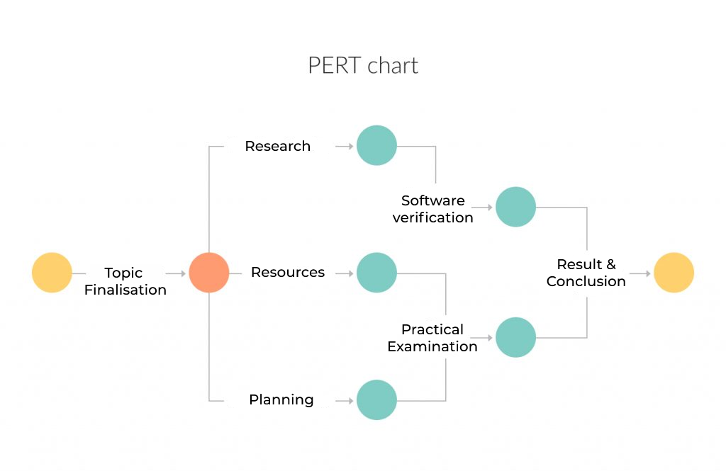

**Proposed Expenditure:**

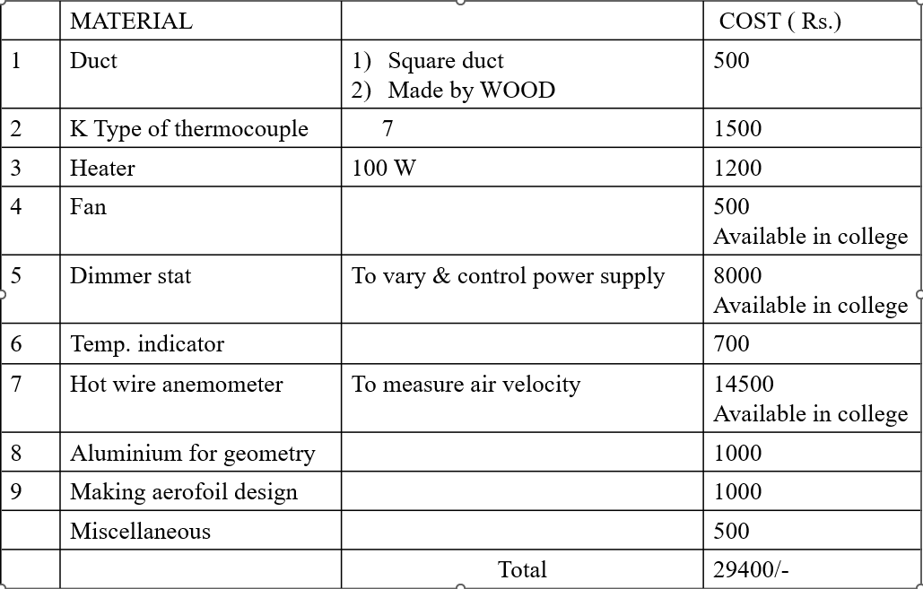

**Conclusion**:

Finalization of operational and geometric parameters for maximum heat dissipation.

**References**:

[1] A.A. Zukauskas, Heat transfer from tubes in cross flow, Adv. Heat Tran. 8 (1972) 116–133.

[2] R.L. Webb, Air-side heat transfer in finned tube heat exchangers, Heat Tran. Eng. 1 (1980) 33–49.

[3] E.M. Sparrow, J.W. Ramsey, C.A.C. Altemani, Experiments on in-line pin fin arraysand performance comparisons with staggered arrays, Transactions of the ASME Journal of Heat Transfer 102 (1980) 44–50.

[4] I. Mudawar, Recent advances in high-flux two-phase thermal management, J. Therm. Sci. Eng. Appl. ASME 5 (2013) 12–21.

[5] S.A. El-Sayed, S.M. Mohamed, A.M. Abdel-latif, A.E. Abouda, Investigation of turbulent heat transfer and fluid flow in longitudinal rectangular-fin arrays of different geometries and shrouded fin array, Exp. Thermal Fluid Sci. 26 (2002) 879–900.

[6] S.E. Razavi, B. Osanloo, R. Sajedi, Application of splitter plate on the modification of hydro-thermal behavior of PPFHS, Appl. Therm. Eng. 80 (2015) 97–108.

[7] R. Sajedi, B. Osanloo, F. Talati, M. Taghilou, Splitter plate application on the circular and square pin fin heat sinks, Microelectron. Reliab. 62 (2016) 91–101.

[8] S.M. Hosseini Hashemi, S.A. Fazeli, H. Zirakzadeh, M. Ashjaee, Study of heat transfer enhancement in a nanofluid-cooled miniature heat sink, Int. Commun. Heat Mass Transf. 39 (2012) 877–884.