Guide to Compiling the threads program on Cloud9 - J. deBettencourt - 8/9/16

Below is a summary of how I compiled the threads.v0.c program and then tested it with

different numbers of loop iterations to find values where indexing thread completion

became problematic.

Screenshot of my Cloud 9 desktop.

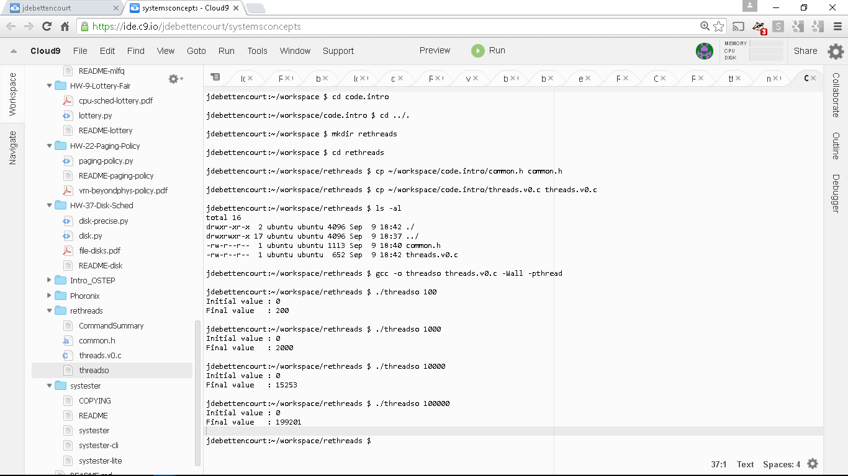

Notes:

1. I copied the files: **common.h** and **threads.v0.c** from a directory **code.intro** where they were first uploaded; these are the two files needed.

2. The file **threadso** is my compiled version of **threads.v0.c** created with the compile directive:

**gcc -o threadso threads.v0.c -Wall -pthread**

3. The file **CommandSummary** is a text file (shown above) that contains examples of the following commands I used: **cd, mkdir, cp, ls, gcc**, and the **./*exefile parameters*** execution command along with example outputs for various parameter values (100, 1000, 10000, and 100000).

4. Note that the output above shows counter problems for my execution of the 10000 and 100000 thread process examples.

Remember that these commands need to be run in a bash shell command line window, like below.

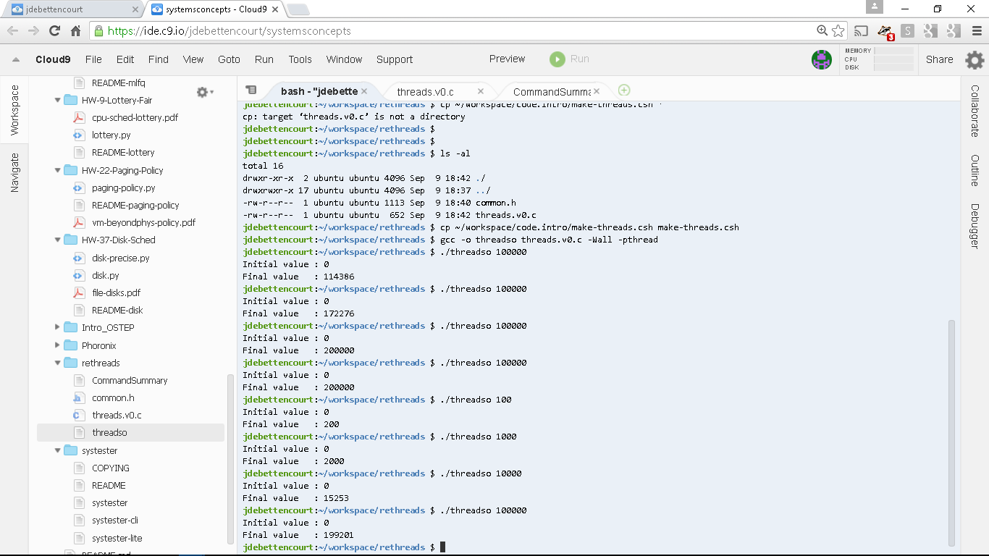

An alternative way to use the c9 desktop is to have only two windows like in this example, rather than the default 3 pane version.